**A data-driven dynamic net-energy analysis of global and national sustainable energy transition paths**

By

Dénes Csala

A Dissertation Presented to the

Masdar Institute of Science and Technology in

Partial Fulfillment of the Requirements for the Degree of

Doctor of Philosophy

in

Interdisciplinary Engineering

© 2016 Masdar Institute of Science and Technology

All rights reserved

**A data-driven dynamic net-energy analysis of   
global and national sustainable energy transition paths**

By Dénes Csala

A Dissertation Presented to the Masdar Institute of Science and Technology in   
Partial Fulfillment of the Requirements for the Degree of

Doctor of Philosophy in Interdisciplinary Engineering

July 2016

© 2016 Masdar Institute of Science and Technology

All rights reserved

AUTHOR’S DECLARATION

I understand that copyright in my thesis is transferred to

Masdar Institute of Science and Technology.

Author ____________________________________

RESEARCH SUPERVISORY COMMITTEE MEMBERS

Dr. Sgouris Sgouridis, Chair, ___________________________________________________

Masdar Institute of Science and Technology

Dr. Elie Azar, _______________________________________________________________

Masdar Institute of Science and Technology

Dr. Iyad Rahwan, ____________________________________________________________

Massachusetts Institute of Technology

Dr. Thomas W. Malone, _______________________________________________________ Massachusetts Institute of Technology

**Abstract**

This dissertation offers a comprehensive methodology for engineering the sustainable energy transition (SET) on all scales. It presents the results of the first, net-energy based model that can generate global and national sustainable energy transition paths, i.e. time series of energy generation capacity installation rates for all renewable energy sources for the period 2015-2100. These paths comply by design with the greenhouse gas emissions limits put forward by the International Panel on Climate Change (IPCC) in their RCP2.6 global warming scenario (Representative Concentration Pathway with radiative forcing of +2.6W/m2), equivalent to a 66% confidence of limiting global warming to 2 degrees Celsius compared to preindustrial era (1850) levels or a long-term stable carbon dioxide concentration in the atmosphere of approximately 410 ppm, currently the accepted upper limit to avoid catastrophic change to human life on Earth. Our energy-driven results provide an alternative to existing economic, cost-based models and analyses. First, we develop a mathematical framework and a differential equation-based, recursive, numerical model for the top-down calculation of global sustainable energy transition paths, followed by a bottom-up calculation of regional and/or national paths. We create a dynamic global trade network for energy carriers ranking the countries based on their renewable resource export potential. Taking into account the extant energy trade history, we construct an influence matrix, based on which the resources are distributed each year among the countries in energy deficit. After adjusting for storage, we calculate the investment obtained through the bottom-up up model and contrast the results with the global case. Finally, we develop an interactive data visualization to facilitate the easy exploration of the simulation data. The outcome of this research can help nations plan their energy transitions well ahead – in terms of tangible renewable energy deployment targets, infrastructure expansions and energy investment rates via an easy-to-use online interface – as early action has been proven to be very critical for meeting the planetary climate target.

*This research was supported by the Government of Abu Dhabi to help fulfill the vision of the late President Sheikh Zayed Bin Sultan Al Nayhan for sustainable development and empowerment of the UAE and humankind.*

**Acknowledgments**

This dissertation would not have been possible without the guidance and the help of several individuals who in one way or another contributed and extended their valuable assistance in the preparation and completion of this study.

First and foremost, I would like to thank Dr. Sgouris Sgouridis, my advisor, who not only provided valuable simple guidance throughout my study, but shaped and started me on my life path as an academic. Indeed, these were the most valuable lessons a fresh researcher can wish for and will be never forgotten. Hope to climb some big mountains together – both figuratively and literally.

To Majd مجد , who has gone through the ordeal of becoming my wife throughout my PhD – even though at times this thesis might have received more love than her ☺ There are no words to express my gratitude to thank for tolerating my mood swings on grumpy mornings and making sure I did not forget to eat or sleep in the last weeks (months…) of the writing. Exciting times ahead of us and flowers will be always blue.

Hatalmas köszönet az „otthoni” családomnak – anyu, apu és Huni, akiknek a folyamatos és önzetlen, végtelen földrajzi távolságokat is áthidaló támogatása nélkül ez a munka nem jöhetett volna létre. Ugyanakkor kedves barátomnak Daninak, aki Abu Dhabiban, Ammanban, Bostonban és Csíkszeredában is meglátogatott egy-egy kirándulással egybekötött eszmefuttatásra.

I would also like to thank for Dr. Scott Kennedy and Dr. Thomas Malone who gave me very helpful feedback and guidance during my semester at MIT and Dr. Iyad Rahwan for his valuable input on critical thinking and the importance of communicating research in an accessible and aesthetic way.

Last but not least, my thanks also go to Bharat for tolerating me as a roommate, Tanmay and Jesse for the discussions and squash sessions, as well as the other members of my research group and the Masdar Institute community, Daye and Pio in particular.

Denes Csala Masdar City, Abu Dhabi, May 2016

Contents

1 INTRODUCTION 31

1.1 Summary 31

1.2 Research objective 33

1.2.1 Research context, importance & significance 33

1.2.2 Research questions 34

1.3 Research significance 36

1.4 Methodological overview 37

1.5 Dissertation structure 42

2 GLOBAL CLIMATE CHANGE AND EMISSIONS CONTEXT AND REGIONAL CONSIDERATIONS 47

2.1 Current global climate change policy scene 47

2.2 Societal emissions modeling through the Kaya Identity 49

2.2.1 Population 51

2.2.2 GDP per capita and per capita power 51

2.2.3 Energy intensity of the economy & energy return on energy invested 53

2.2.4 Emissions intensity of energy 57

2.2.5 Review of Kaya Identity factors and comparison of rates of change 58

2.3 Climate policy levers to control global and national emissions 62

2.3.1 Controlling the energy intensity of the economy through power per capita modeling 63

2.3.2 Controlling emissions intensity of energy through fossil fuel phase-out 67

3 OVERVIEW OF CLIMATE-ENERGY-ECONOMY MODELS AND HISTORICAL ENERGY TRANSITIONS 72

3.1 Overview of the integrated assessment modeling mindset and review of example models 73

3.1.1 IAM structure and criticisms 76

3.2 Economic production functions as the engines of IAMs 83

3.2.1 Constant elasticity of substitution functions (CES) 83

3.2.2 Example of a CES application for technological transition 85

3.3 CES energy technology transition fallacy 89

3.4 Policy implications of the CES fallacy 93

3.5 Alternative approaches to CES-based IAM modeling 95

3.6 Dynamic climate-energy-economy models 100

4 MODELING GLOBAL AND REGIONAL SUSTAINABLE ENERGY TRANSITIONS: PRINCIPLES, THEORY AND DYNAMICS 107

4.1 Theoretical considerations on energy investment during SET 108

4.2 Components of the SET energy-economy system and its endogenous dynamics 111

4.2.1 Fossil energy sub-system 112

4.2.2 Renewable energy sub-system 113

4.2.3 Energy economy sub-system 114

4.3 Formal definition of SET and its 3 principles 115

4.3.1 SET principle I – system carrying capacity constraint 116

4.3.2 SET principle II – smooth net energy availability constraint 117

4.3.3 SET principle III – energy investment planning constraint 118

4.4 Classification of energy sources considered in this analysis 118

4.5 Development of the SET unified dynamic equation 120

4.5.1 Societal energy demand and EROEI under SET 120

4.5.2 Dynamics of fossil fuels under SET 124

4.5.3 Dynamics of renewables under SET 124

4.5.4 Scale-limited low-carbon energy resource options 125

4.5.5 Global transition feasibility index (TFI) 130

4.5.6 Illustrative global SET example 132

4.6 Converting the global SET into the networked, regional NETSET 134

4.6.1 Theoretical foundations and overview of the conversion process 134

4.6.2 Transitioning from primary energy demand to electricity 142

4.6.3 Emissions distribution and subsequent regional fossil consumption 147

4.6.4 Regional renewable EROEIs and geographic resource distribution 159

4.6.5 Estimating storage requirements under NETSET 177

4.6.6 Incorporating energy trade into NETSET 179

4.6.7 NETSET resource allocation algorithm 188

4.6.8 NETSET energy cost estimation and sensitivity analysis 192

4.6.9 Visual NETSET algorithm overview 193

5 ENGINEERING A GLOBAL SET: APPLIED ANALYSIS & RESULTS 207

5.1 Global SET experiment design 207

5.2 Global SET results discussion 208

5.3 Global SET simulation graphs 216

5.3.1 Global cumulative installed renewable capacity 216

5.3.2 Global renewable energy installation rates 218

5.3.3 Global renewable energy installation rates (% of total) 220

5.3.4 Global renewable energy investment rate (ɛ) 222

5.3.5 Global SET simulation envelopes 224

5.3.6 Global SET histograms 226

5.3.7 Feasible global SET paths 229

5.3.8 Additional global SET sensitivity plots 231

5.4 Global SET parameter tables 237

6 NETWORKED SET – TRANSFORMING THE GLOBAL SET INTO COUNTRY-LEVEL TRANSITIONS: EXPLORATORIUM, APPLIED ANALYSIS & RESULTS 238

6.1 Guidelines for reading the NETSET transition graphs 238

6.2 A brief presentation of the Sustainable Energy Transitions Exploratorium (SETE) 243

6.3 On the importance of country influence in NETSET 245

6.4 NETSET simulation results 255

6.4.1 NETET parameter settings and key assumptions 255

6.4.2 NETSET for the United Arab Emirates domestic net demand 256

6.4.3 NETSET for the United States domestic net demand 262

6.4.4 NETSET for the United Arab Emirates total net demand 265

6.4.5 NETSET for the United States total net demand 267

6.4.6 NETSET for the United Kingdom total net demand 268

6.4.7 NETSET for China total net demand 269

6.4.8 NETSET for Argentina total net demand 270

6.4.9 NETSET for Germany total net demand 271

6.5 Comparing the NETSET results with global SET 272

7 IMPLICATIONS AND CONCLUSIONS 280

List of Tables

Table ‎2‑1. Signum of 1st and 2nd derivatives of the Kaya Identity factors source: own work, data source: WDI, year: 2013 59

Table ‎3‑1. IAM models and functional formulations used for economic growth and climate damages 74

Table ‎4‑1. Regional distribution of reserves unburnable before 2050 for the 2 °C scenarios with and without CCS source:(McGlade and Ekins, 2015), data source: TIAM-UCL Integrated Assessment Model 154

Table ‎5‑1. Parameter specifications for resource distribution and EROEI 237

Table ‎5‑2. Parameter specifications for lifetime, learning and capacity factor 237

Table ‎5‑3. Parameter specifications for storage 237

Table ‎5‑4. Evolution assumptions for scale-limited resources 237

Table ‎6‑1. Country influence vector for q=4, p=3 246

Table ‎6‑2. Country influence vector for q=8, p=3 248

Table ‎6‑3. Country influence vector for q=4, p=5 251

Table ‎6‑4. Top of the trade cost vector of UAE in year 2015 for q=4, p=3 256

Table ‎6‑5. Top of the trade cost vector of USA in year 2015 for q=4, p=3 263

Table ‎6‑6. Top of the trade cost vector of USA in year 2015 for q=1, p=5 264

List of Figures

Figure ‎1‑1. Methodological structure for developing sustainable energy transition paths. source: own work 39

Figure ‎2‑1. Expected global warming based on the INDC pledges submitted to the UNFCCC before the COP21 source: Climate Interactive, data source: En-ROADS Climate Policy model (Jones et al., 2013), year: 2015 49

Figure ‎2‑2. Evolution of the population for the 12 most populous countries of the world source: own work, data source: WDI, year: 2013 51

Figure ‎2‑3. Evolution of societal per capita power demand and per capita GDP for 1990, 2000 and 2010, for all countries with available data. Log-log regressions fitted, coefficients of determination shown in the top left corner of each plot. source: own work, data source: WDI, years: 1990, 2000, 2010 52

Figure ‎2‑4. Distribution of per capita power demand per countries of the world. Values shown are averaged over the 2010-2015 period. The global average, weighted by population is 2276 W/capita. source: own work, data source: WDI, years: 2010-2015 52

Figure ‎2‑5. Evolution of GDP/capita and GDP growth rate for the top 12 countries and 12 most populous countries of the world source: own work, data source: WDI, year: 2013 53

Figure ‎2‑6. Evolution of energy use per 1000$ GDP for the top 12 countries and 12 most populous countries of the world source: own work, data source: WDI, year: 2013 54

Figure ‎2‑7. Comparing energy flow profiles of different energy types Fossil fuels (left), Renewables and other capital intensive fuels, including nuclear and large hydro (right) source: left (Murphy et al., 2011), right: own work 56

Figure ‎2‑8. Evolution of emissions intensity of energy for the top 12 countries and 12 most populous countries of the world source: own work, data source: WDI, year: 2013 58

Figure ‎2‑9. Evolution of the components of the IPAT identity for countries and regions Legend: FSU – Former Soviet Union, D1 – developed, D2 – developing, D3 – least developed countries F – CO2 emissions flux (rate) from fossil fuel combustion and industrial processes, P – Population, gp – GDP per capita PPP hp –emissions intensity of the economy, ep – a energy intensity of the economy, f – emissions intensity of energy source: (Raupach et al., 2007), data source: EIA 61

Figure ‎2‑10. Expected per capita and total societal power demand profiles source: own work, data source: WDI, EIA, UNSD 64

Figure ‎2‑11. Distribution of per capita power demand per countries of the world for 2010-2015 and 2100. Values shown in the darker pink shaded histogram are the current distribution, averaged over the 2010-2015 period. The global average, weighted by population is 2276 W/capita. The light pink histogram is the expected distribution in 2100, after transforming the countries’ current demand through a demand multiplier function. The global average modifies to 3954 W/capita source: own work, data source: WDI, years: 2010-2015, own assumptions and calculations for 2100 65

Figure ‎2‑12. Evolution of per capita power demand per countries of the world for 2000-2100, after applying the demand transformation *D2100*. source: own work, data source: WDI, years: 2000-2015, own assumptions and calculations for 2100 66

Figure ‎2‑13. Trajectory for applying the demand transformation *D2100* function. source: own work 67

Figure ‎2‑14. Global fossil phase-out trajectories mapped through Hubbert emissions equivaleny for early start (2015, 2020, 2025) and late start (2020, 2030, 2040) retraction profiles, under 3 different emissions caps: 510, 990 and 1505 GtCO2, respectively, as per the median value and the confidence bounds for the IPCC 66% ± 16% RCP2.6 scenario, approximately corresponding to 2 °C. The business-as-usual, proven reserves-based fossil depletion Hubbert curves are also shown for reference. source: own work. Last available emissions value is average of EIA and BP data 70

Figure ‎3‑1. Substitution quantities of fossil (F) and RE (R) and corresponding carbon tax levels modeled using CES function for a constant output and variable: initial shares (a), elasticities of substitution (σ), and rates of decrease of RE cost (ζ). source: own work 87

Figure ‎3‑2. Substitution quantities of fossil (F) and RE (R) and corresponding carbon tax levels modeled using CES function for increasing output at rate (γ)=3% and variable: initial shares (a), elasticities of substitution (σ), and rates of decrease of RE cost (ζ). source: own work 88

Figure ‎3‑3. Industrial Production Structure in GTECM-C utilizing technology bundles source: : (Cai et al., 2015) 90

Figure ‎3‑4. Carbon price estimations from various IAM models source: own work, data sources: see graph annotations, data is presented as processed, after unit conversions 91

Figure ‎3‑5. Historical Energy Transitions Data and S-curve fits source: own work, data sources: 96

Figure ‎3‑6 Using a Dynamic Elasticity Energy Model with linear and exponential decrease of the elasticity (ρ) for constant output source: own work 97

Figure ‎3‑7 Using a Dynamic Elasticity Energy Model with linear and exponential decrease of the elasticity (ρ) for increasing output source: own work 98

Figure ‎3‑8 A sustainable energy transition trajectory resulting from GEMBA source: (Dale et al., 2012b) 103

Figure ‎3‑9 Causal loop diagram of the global energy-economy system implementation in GEMBA source: (Dale et al., 2012b) 104

Figure ‎3‑10 Energy-economy system interactions as a circuit diagram (analogous to a stock and flow model) in GEMBA source: (Dale et al., 2012b) 105

Figure ‎4‑1. Energy transition inflexion point: where the declining share of fossil fuels is matched by that of renewables source: own work, data source: concept 108

Figure ‎4‑2. EROEI = *f* (cumulative production) source: own work 109

Figure ‎4‑3. Causal loop diagram of the fossil energy sub-system source: (Sgouridis and Csala, 2014) 112

Figure ‎4‑4. Causal loop diagram of the renewable energy sub-system source: (Sgouridis and Csala, 2014) 113

Figure ‎4‑5. Classification of energy sources used in SET (without the regenerated energy part) and NETSET source: own work 119

Figure ‎4‑6. Weighting distributions for the relative feasibility of: RE EROEI *f(x)*, net energy demand *g(x)*, peak renewable energy investment ratio *h(x)*, and average renewable energy investment ratio *k(x)*. source: own work for (S. Sgouridis et al., 2015) 132

Figure ‎4‑7. Example of a successful sustainable energy transition source: own work for (S. Sgouridis et al., 2015), data source: EIA, BP, UNSD, WDI 134

Figure ‎4‑8. Illustrative Sankey-diagram of primary and secondary and tertiary energy flows and consumption sectors source: own work 143

Figure ‎4‑9. Sankey-diagram with 4 energy generation levels, with Regenerated Electricity explicitly depicted source: own work 145

Figure ‎4‑10. Percentage reduction in primary energy requirements as a result of fuel switching, for the globe source: own work, data: (Jacobson and Delucchi, 2009), year: 2050 146

Figure ‎4‑11. Minimum share of liquid fuels based on the maximum electrification rate of sectors in each country source: own work, data: (Jacobson and Delucchi, 2009), year: 2050 147

Figure ‎4‑12. Left: Evolution Global GHG emissions distributed by country and regions source:(Elzen et al., 2013), data source: EDGAR 4.2 FT2010 Right: Global historical GHG emissions of countries grouped by the Kyoto protocol (1997) source: (Peters et al., 2012), data source: EIA 148

Figure ‎4‑13. Global GHG emissions predictions by sector, for countries and regions, under business as usual (BAU) Legend: Other developed – OECD sans OECD Europe and US, Other developing – Non-OECD sans India and China source: (Csala, 2015), data source: EIA International Energy Outlook, year: 2013 149

Figure ‎4‑14. Left: Global GHG emissions paths of EU, US and China, and the rest of the world represented to fit into 2°C, Right: The US trajectory under a population based (“Equity”) and a present-day emissions rate-based (“Inertia”) national carbon cap – “Inertia” included on the Left, source:(Peters et al., 2015), data source: UNFCCC INDCs, year: 2015 152

Figure ‎4‑15. The share of carbon quotas of countries allocated under different weights (*0,0.5,1*) to fit into 2°C, source: (Raupach et al., 2014) 152

Figure ‎4‑16. Largest interregional fluxes of GHG emissions embedded in trade source:(Davis and Caldeira, 2010), data source: Global Trade Analysis Project (GTAP) 153

Figure ‎4‑17.Coal trade (imports: left, exports: right) of the United States (top) and Germany (bottom), averaged over the years 2010-2015 source: own work, data: UN COMTRADE, year: 2010-2015 157

Figure ‎4‑18.Oil trade under a Hubbert retraction governed by EROEI and stationary fossil energy trade (imports: top) of the United States (left) and Germany (right) and exports (bottom) of Canada (left) and Saudi Arabia (right) source: own work, data: UN COMTRADE until 2015, forecasted until 2020, Hubbert until 2050, year: 2000-2050 158

Figure ‎4‑19.Global distribution of PV (top), CSP (middle) and Wind (bottom) resources by resource class and resource availability in each class source: own work, data: NREL 161

Figure ‎4‑20. Distribution of PV (top), CSP (middle) and Wind (bottom) resources by resource class and resource availability in each class for Iceland (left) and Jordan (right) source: own work, data: NREL 162

Figure ‎4‑21. Distributions of global, yearly available photovoltaic energy (pink, left axis) and energy generated by existing installations (blue, right axis) binned into different NREL power classes. A secondary horizontal axis shows the corresponding insolation values of each class. The energy resource potential data is calculated based on available GIS GHI insolation data from NREL while the generation data is the average of the BP and EIA databases for 2014. Both datasets are cross-sectioned into countries and then summarized again by class. The dashed lines represent mean values for the two distributions. The energy values have been calculated assuming a 10% overall plant efficiency and covering 1.5% of productive land in each country. source: own work, data: NREL 163

Figure ‎4‑22. Distributions of global, yearly available solar thermal energy (pink, left axis) and energy generated by existing installations (blue, right axis) binned into different NREL power classes. A secondary horizontal axis shows the corresponding insolation values of each class. The energy resource potential data is calculated based on available GIS DNI insolation data from NREL while the generation data is the average of the BP and EIA databases for 2014. Both datasets are cross-sectioned into countries and then summarized again by class. The dashed lines represent mean values for the two distributions. The energy values have been calculated using 6 hours of storage with a 31MW/km2plant power density. source: own work, data: NREL 164

Figure ‎4‑23. Distributions of global, yearly available wind energy (pink, left axis) and energy generated by existing installations (blue, right axis) binned into different power classes. The energy resource potential data is calculated based on available GIS wind power density data from NREL while the generation data is the average of the BP and EIA databases for 2014. Both datasets are cross-sectioned into countries and then summarized again by class. The dashed lines represent mean values for the two distributions. The energy values represent the totals for onshore and off-shore wind power and have been obtained from the GIS data using a 5MW/km2 turbine power density, a 90m hub height, taking into account all available resources located at 0-100 miles from available infrastructure and roads on the onshore and 5-50 nautical miles out on the sea, for shallow and transitional waters. source: own work, data: NREL 165

Figure ‎4‑24. Global distribution of photovoltaic energy resources into to resource quality deciles (as in Figure ‎4‑21) with countries made explicit. source: own work, data: NREL 167

Figure ‎4‑25. Global distribution of solar thermal energy resources into to resource quality deciles (as in Figure ‎4‑22) with countries made explicit. source: own work, data: NREL 168

Figure ‎4‑26. Global distribution of wind energy resources into to resource quality deciles (as in Figure ‎4‑23) with countries made explicit. source: own work, data: NREL 168

Figure ‎4‑27. Global distribution of photovoltaic energy resources into to resource quality deciles (as in Figure ‎4‑21) with countries made explicit. source: own work, data: NREL, year: 2014 169

Figure ‎4‑28. Global distribution of solar thermal energy resources into to resource quality deciles (as in Figure ‎4‑22) with countries made explicit. source: own work, data: NREL, year: 2014 170

Figure ‎4‑29. Global distribution of wind energy resources into to resource quality deciles (as in Figure ‎4‑23) with countries made explicit. source: own work, data: NREL, year: 2014 170

Figure ‎4‑30. Global distribution of photovoltaic energy resources into to resource quality deciles (as in Figure ‎4‑21) with countries made explicit. source: own work, data: NREL, year: 2000 171

Figure ‎4‑31. Global distribution of wind energy resources into to resource quality deciles with countries made explicit. source: own work, data: NREL, year: 2000 171

Figure ‎4‑32. Example of an intermittent, renewable energy-based system with storage charging and discharging cycles source: (Makhijani et al.) 177

Figure ‎4‑33. Conceptual definition of the residual load duration curve source: (Ueckerdt et al., 2015) 179

Figure ‎4‑34. Electricity trade network of Europe source: own work, data: UN COMTRADE, year: 2014 181

Figure ‎4‑35. Country importance/influence matrix calculated for 189 countries with q=4 and p=3 source: own work, data: UN COMTRADE, years: 1962-2014 185

Figure ‎4‑36. Clustered country importance/influence matrix calculated for 189 countries with q=4 and p=3 source: own work, data: UN COMTRADE, years: 1962-2014 186

Figure ‎5‑1. (a) SET-compliant primary energy supply evolution (in PWh) for providing 2000W average net power per capita by 2100 to a population of 10.8 billion. Fossil fuel emissions comply with a 990 Gt CO2 cap peaking in 2020 and phased-out by 2075. The dashed line represents the net available energy while the values above it the energy investment in building and operating the energy system (“seed”). (b) RE portfolio installation rate profile (in TWp/year). (c) Installed RE Capacity (in TWp). 209

Figure ‎5‑2. Envelopes of SET-compliant RE installation rates over the RE composite EROEI range of 6.67 to 60 (in 2014) and a per capita net power demand range of 667-6000 W/person (in 2100), under early, early/partial and late fossil fuel phase-out strategies and for three fossil emission caps: 510 (a,b,c), 990 (d,e,f), and 1505 (g,h,i) Gt CO2. The Transition Feasibility Index is a normalized composite measure of the relative difficulty of each trajectory. The solid lines draw the highest TFI (most feasible) trajectory in each group. 211

Figure ‎5‑3. Contour maps of SET-compliant installed RE capacity (in TWp) until 2100 for different trajectories of net primary power demand (shown in Figure ‎2‑10) assuming a composite initial RE EROEI of 20. The trajectories are identified by the net desired supply in year 2100. Each map depicts a combination of a fossil fuel phase-out strategy (early, fuel switch and late) and a fossil emission cap: 510 (a-c), 990 (d-f), 1505 (g-i) Gt CO2 as shown in Figure ‎2‑14. The cross-section indicated by the dashed line corresponds to Figure ‎5‑1c. source: own work 216

Figure ‎5‑4. Contour maps of SET-compliant RE capacity (in TWp) until 2100 for a range of composite RE EROEI values assuming the 2000W/capita energy demand trajectory. Each map depicts a combination of a fossil fuel phase-out strategy (early, fuel switch and late) and a fossil emission cap: 510 (a-c), 990 (d-f), 1505 (g-i) Gt CO2 as Figure ‎2‑14. The cross-section indicated by the dashed line corresponds to Figure ‎5‑1c. source: own work 217

Figure ‎5‑5. Contour maps of SET-compliant RE capacity installation rate (in TWp/year) until 2100 for different trajectories of net primary power demand (shown in Figure ‎2‑10) assuming a composite initial RE EROEI of 20. The trajectories are identified by the net desired supply in year 2100. Each map depicts a combination of a fossil fuel phase-out strategy (early, fuel switch and late) and a fossil emissions cap: 510 (a-c), 990 (d-f), 1505 (g-h) Gt CO2) Figure ‎2‑14. The cross-section indicated by the dashed line corresponds to Figure ‎5‑1b. source: own work 218

Figure ‎5‑6. Contour maps of SET-compliant RE capacity installation rate (in TWp/year) until 2100 for a range of composite RE EROEI values assuming the 2000W/capita energy demand trajectory. Each map depicts a combination of a fossil fuel phase-out strategy (early, fuel switch and late) and a fossil emission cap: 510 (a-c), 990 (d-f), 1505 (g-i) Gt CO2 as shown in Figure ‎2‑14. The cross-section indicated by the dashed line corresponds to Figure ‎5‑1b. source: own work 219

Figure ‎5‑7. The year-to-year rate of change of the RE capacity installations (growth rate) for SET-compliant RE trajectories until 2050 for different net power demand levels (667-6000) by 2100 under early, early/partial and late fossil fuel phase-out strategies and for three fossil emission caps: 510 (a-c), 990 (d-f), 1505 (g-i) Gt CO2 from Figure ‎2‑14. 220

Figure ‎5‑8. The year-to-year rate of change of the RE capacity installation rate (growth rate) for SET-compliant RE trajectories until 2050 for different composite EROEIs (6.67-60) for 2000 W/person net primary power demand by 2100 under early, early/partial and late fossil fuel phase-out strategies and for three fossil emission caps: 510 (a-c), 990 (d-f), 1505 (g-i) Gt CO2 from Figure ‎2‑14. 221

Figure ‎5‑9. Contour maps of SET-compliant RE investment rate (in %p/year) until 2100 for different trajectories of net primary power demand (shown in Figure ‎2‑10) assuming a composite initial RE EROEI of 20. The trajectories are identified by the net desired supply in year 2100. Each map depicts a combination of a fossil fuel phase-out strategy (early, fuel switch and late) and a fossil emissions cap: 510 (a-c), 990 (d-f), 1505 (g-h) Gt CO2) from Figure ‎2‑14, calculated as per ( ‎4‑8 ). source: own work 222

Figure ‎5‑10. Contour maps of SET-compliant RE investment rate (in %/year) until 2100 for a range of composite RE EROEI values assuming the 2000W/capita energy demand trajectory. Each map depicts a combination of a fossil fuel phase-out strategy (early, fuel switch and late) and a fossil emission cap: 510 (a-c), 990 (d-f), 1505 (g-i) Gt CO2 as shown in Figure ‎2‑14, calculated as per ( ‎4‑8 ). source: own work 223

Figure ‎5‑11. Full envelope of renewable capacity installation rates encountered in the simulation exercise. Each map depicts a combination of a fossil fuel phase-out strategy (early, fuel switch and late) and a fossil emission cap: 510 (a-c), 990 (d-f), 1505 (g-i) Gt CO2 as shown in Figure ‎2‑14. source: own work 224

Figure ‎5‑12. Density plot of renewable capacity installation rates under a combination of a fossil fuel phase-out strategy (early - green, fuel switch – brown and late - pink) and a fossil emission cap: 510 (a), 990 (b), 1505 (c) Gt CO2. source: own work 224

Figure ‎5‑13. Full envelope of renewable energy investment rates encountered in the simulation exercise. Each map depicts a combination of a fossil fuel phase-out strategy (early, fuel switch and late) and a fossil emission cap: 510 (a-c), 990 (d-f), 1505 (g-i) Gt CO2 as shown in Figure ‎2‑14. source: own work 225

Figure ‎5‑14. Density plot of renewable energy investment rates under a combination of a fossil fuel phase-out strategy (early - green, fuel switch – brown and late - pink) and a fossil emission cap: 510 (a), 990 (b), 1505 (c) Gt CO2. source: own work 225

Figure ‎5‑15. Histograms of average renewable energy investment rates (in % per year on horizontal axis vs. encountered frequencies on the vertical axis) under a combination of a fossil fuel phase-out strategy (early – first column, fuel switch – second column and late – third column) and a fossil emission cap: 510 (first row), 990 (second row), 1505 (third row) Gt CO2. These histograms represent the frequencies of average renewable energy investment rates as a fraction in the total of the simulation envelope. We have also included row-wise (fourth column) and column-wise (fourth row) averages, as well as an absolute total (subplot p). source: own work 226

Figure ‎5‑16. Histograms of peak renewable energy investment rates (in % per year on horizontal axis vs. encountered frequencies on the vertical axis) under a combination of a fossil fuel phase-out strategy (early – first column, fuel switch – second column and late – third column) and a fossil emission cap: 510 (first row), 990 (second row), 1505 (third row) Gt CO2. These histograms represent the frequencies of peak renewable energy investment rates as a fraction in the total of the simulation envelope. We have also included row-wise (fourth column) and column-wise (fourth row) averages, as well as an absolute total (subplot p). source: own work 227

Figure ‎5‑17. Histograms of peak renewable capacity installation rates (in TWp per year on horizontal axis vs. encountered frequencies on the vertical axis) under a combination of a fossil fuel phase-out strategy (early – first column, fuel switch – second column and late – third column) and a fossil emission cap: 510 (first row), 990 (second row), 1505 (third row) Gt CO2. These histograms represent the frequencies of peak renewable capacity installation rates as a fraction in the total of the simulation envelope. We have also included row-wise (fourth column) and column-wise (fourth row) averages, as well as an absolute total (subplot p). source: own work 228

Figure ‎5‑18. Histograms of peak renewable energy investment rates (in % per year on horizontal axis vs. encountered frequencies on the vertical axis) under a combination of a fossil fuel phase-out strategy (early – first column, fuel switch – second column and late – third column) and a fossil emission cap: 510 (first row), 990 (second row), 1505 (third row) Gt CO2. These histograms represent the frequencies of peak renewable energy investment rates as a fraction in the total of the simulation envelope. We have also included row-wise (fourth column) and column-wise (fourth row) averages, as well as an absolute total (subplot p). source: own work 229

Figure ‎5‑19. Sensitivity map the normalized transition feasibility index (TFI) of all energy trajectories against varying demand and EROEI values. source: own work 230

Figure ‎5‑20. (a) SET-compliant primary energy supply evolution (in PWh) for providing 2000W average net power per capita by 2100 to a population of 10.8 billion. Fossil fuel emissions comply with a 510 Gt CO2 cap peaking in 2020 and phased-out by 2040. The dashed line represents the net available energy while the values above it the energy investment in building and operating the energy system (“seed”). (b) RE portfolio installation rate profile (in TWp/year). (c) Installed RE Capacity (in TWp). 231

Figure ‎5‑21 Left: The ERoEI evolution of all RE resources and the composite weighted average ERoEI (black line) as output of the model accounting for their cumulative deployment. Right: Modeled (solid lines) and historical capacity additions of the three RE technologies used for initialization and calibration. 232

Figure ‎5‑22. Comparison of RE diffusion rates over the next century, expressed as a share of total primary energy source: own work based on data published by references, the model used and the scenario in the graph legend. 233

Figure ‎5‑23. Sensitivity diagram of TFI values to EROEI, Demand, emissions cap and fossil phase-out trajectory. 233

Figure ‎5‑24. Weighting distributions for the relative feasibility of: RE EROEI f(x), net energy demand g(x), peak renewable energy investment ratio h(x), and average renewable energy investment ratio k(x). The dotted lines show two alternative profiles to demonstrate the sensitivity of the TFI to the shape of the curve. 234

Figure ‎5‑25. Sensitivity map the normalized transition feasibility index (TFI) of all energy trajectories against varying demand and EROEI values. 235

Figure ‎5‑26. Sensitivity map the normalized transition feasibility index (TFI) of all energy trajectories against varying demand and EROEI values using an alternative demand transfer function *g*. 236

Figure ‎5‑27. Sensitivity map the normalized transition feasibility index (TFI) of all energy trajectories against varying demand and EROEI values using an alternative EROEI transfer function *f* and an alternative demand transfer function *g*. 236

Figure ‎6‑1. Argentinian natural gas flows. Used as an example for violin plot. source: own work for the Sustainable Energy Flows Exploratorium, years: 1980-2030 239

Figure ‎6‑2. Romanian energy dynamics. Used as an example for color-coding energy sources. source: own work for the Sustainable Energy Flows Exploratorium, years: 2000-2100 240

Figure ‎6‑3. French renewable energy production, consumption and trade. Used as an example for trade flow balance. source: own work for the Sustainable Energy Flows Exploratorium, years: 2000-2100 241

Figure ‎6‑4. User Interface of the Sustainable Energy Transition Exploratorium at http://netset.csaladen.es part 1, source: own work for the Sustainable Energy Flows Exploratorium 242

Figure ‎6‑5. User Interface of the Sustainable Energy Transition Exploratorium at http://netset.csaladen.es part 2, source: own work for the Sustainable Energy Flows Exploratorium 245

Figure ‎6‑6. User Interface of the Sustainable Energy Transition Exploratorium at http://netset.csaladen.es part 3, source: own work for the Sustainable Energy Flows Exploratorium 245

Figure ‎6‑7. Power factor (p) sensitivity of country influence. Left: Rank in country influence vector, Right: Average influence source: own work, data: normalized UN COMTRADE energy trade history, years: 1962-2015 254

Figure ‎6‑8. Clustered country importance/influence matrix calculated for 189 countries with q=4 and p=5 source: own work, data: UN COMTRADE, years: 1962-2014 254

Figure ‎6‑9. UAE NETSET dynamics. Showing net energy balance to be fulfilled by renewable sources (without exports) source: own work for SETE, years: 2000-2100 258

Figure ‎6‑10. UAE NETSET dynamics. Showing net energy balance filled by various renewable sources (without exports) source: own work for SETE, years: 2000-2100 258

Figure ‎6‑11. UAE NETSET dynamics. Per capita average power demand in the UAE (without exports). The initially extremely high (100kW/capita in 1990, 38kW/capita in 2015) values diminish to 7.5kW/capita by 2100. source: own work for SETE, years: 1990-2100 259

Figure ‎6‑12. UAE NETSET dynamics. Percentage breakdown of energy mix over time (without exports) source: own work for SETE, years: 2015-2100 259

Figure ‎6‑13. UAE NETSET dynamics. Percentage breakdown of energy mix, average values for 2015-2020 (Left) and 2095-2100 (Right), source: own work for SETE, years: 2015-2020 and 2095-2100 260

Figure ‎6‑14. UAE NETSET dynamics. Electricity imports over the grid source: own work for SETE, years: 2015-2100 261

Figure ‎6‑15. UAE NETSET dynamics. Power-to-liquids (Left) Imports (center) and Production (Right) breakdown by source country, source: own work for SETE, years: 2015-2100 261

Figure ‎6‑16. USA NETSET dynamics. Showing net energy balance filled by various renewable sources (without exports) source: own work for SETE, years: 2000-2100 262

Figure ‎6‑17. USA NETSET dynamics. Breakdown of grid electricity imports, source: own work for SETE, years: 2000-2100 263

Figure ‎6‑18. USA NETSET dynamics. Showing net energy balance filled by various renewable sources (without exports) for alternative trade governing rules (q=1, p=5), source: own work for SETE, years: 2000-2100 264

Figure ‎6‑19. USA NETSET dynamics. Breakdown of PTL imports during the peak transition period triggered to offset growth limitation in easily accessible countries, for alternative trade governing rules, source: own work for SETE, years: 2000-2100 265

Figure ‎6‑20. UAE NETSET dynamics (including exports) source: own work for SETE, years: 2015-2100 265

Figure ‎6‑20. UAE NETSET dynamics. Electricity exports through the grid source: own work for SETE, years: 2015-2100 266

Figure ‎6‑20. UAE NETSET dynamics. Power-to-liquid exports source: own work for SETE, years: 2015-2100 266

Figure ‎6‑21. USA NETSET dynamics (including exports) source: own work for SETE, years: 2000-2100 267

Figure ‎6‑22. United Kingdom NETSET dynamics (including exports) source: own work for SETE, years: 2010-2100 268

Figure ‎6‑20. United Kingdom NETSET dynamics. Power-to-liquid exports source: own work for SETE, years: 2010-2100 269

Figure ‎6‑23. China NETSET dynamics (including exports) source: own work for SETE, years: 2000-2100 269

Figure ‎6‑24. Argentina NETSET dynamics (including exports) source: own work for SETE, years: 2000-2100 270

Figure ‎6‑24. Argentina NETSET dynamics. Electricity imports through grid. source: own work for SETE, years: 2000-2100 271

Figure ‎6‑25. Germany NETSET dynamics (including exports) source: own work for SETE, years: 2000-2100 271

Figure ‎6‑26. Global SET net primary energy demand path reconstructed bottom-up from NETSET country paths. source: own work for SETE, years: 1965-2100 272

Figure ‎6‑26. Global SET net primary per capita power demand path reconstructed bottom-up from NETSET country paths. source: own work for SETE, years: 1965-2100 273

Figure ‎6‑29. NETSET (Left) and Global SET (Right) renewable energy investment. source: own work for SETE, years: 1950-2100 274

Figure ‎6‑26. Deep Decarbonization Pathway for the US (Left) Germany (Left Center), United Kingdom (Right Center) and China (Right), primary energy, highest renewables scenario, source: 2015 DDPP country reports, years: 2010, 2050 275

Figure ‎6‑26. Deep Decarbonization Pathway for the US (Left) Germany (Left Center), United Kingdom (Right Center) and China (Right), electricity, highest renewables scenario, source: 2015 DDPP country reports, years: 2010, 2050 275

Figure ‎6‑26. Breakdown of primary energy consumption, after accounting for trade and storage. US (Left), Germany (Right), source: own work for SETE, year: 2050 276

Figure ‎6‑26. Breakdown of primary energy consumption, after accounting for trade and storage. United Kingdom (Left), China (Right), source: own work for SETE, year: 2050 278

Figure ‎6‑27. 2030 breakdown of energy technologies in the European electricity grid. source: (Bogdanov and Breyer), year: 2030 279

Figure ‎6‑28. 2030 breakdown of energy technologies in the North-American electricity grid. source: (Bogdanov and Breyer), year: 2030 279

List of Acronyms

|  |  |
| --- | --- |
| API | Application Programming Interface |
| BP | British Petroleum (company) |
| CES | Constant Elasticity of Substitution |
| COP | Conference of the Parties to UNFCCC |
| DDPP | Deep Decarbonization Pathways Project |
| DES | Dynamic Elasticity of Substitution |
| EIA | Unites States Energy Information Agency |
| EROEI | Energy Return on Energy Invested |
| EROI | Energy Return on Energy Invested |
| GEMBA | Global Energy Modeling – A Biophysical Approach |
| GHG | Greenhouse gas |
| GIS | Geographic Information System |
| IAM | Integrated Assessment Model |
| IMF | International Monetary Fund |
| INDC | Intended Nationally Determined Contributions |
| IPCC | Intergovernmental Panel on Climate Change |
| MDG | United Nations Millennium Development Goals |
| MIT OEC | Observatory of Economic Complexity |
| NASA | National Aeronautics and Space Administration |
| NETSET | Networked Sustainable Energy Transition |
| NREL | United States National Renewable Energy Laboratory |
| RCP | Representative Concentration Pathway of the IPCC |
| RE | Renewable Energy |
| SDG | United Nations Sustainable Development Goals |
| SET | Sustainable Energy Transition |
| TFI | Transition Feasibility Index |
| UN | United Nations |
| UN COMTRADE | United Nations Commodity Trade Database |
| UNFCCC | United Nations Framework Convention on Climate Change |
| UNSD | United Nations Statistics Division |
| WB | World Bank |
| WDI | World Bank World Development Indicators |
| WRI | World Resources Institute |

# INTRODUCTION

## Summary

This dissertation offers a comprehensive methodology for developing national energy transition pathways using physical energy balances while accounting for trade between regions. It presents the first comprehensive, net-energy based model of sustainable energy transitions (SET) for the global case, which is then adjusted for regional trade (NETSET). NETSET can generate global, national sustainable energy transition paths, i.e. time series of energy generation capacity installation and retraction rates, for all major energy sources – coal, natural gas, oil, nuclear, hydropower, biofuels, solar photovoltaics, concentrated solar power, onshore and offshore wind and geothermal power. The model operates for the period 2015-2100 although it can extend indefinitely. These paths are constrained by greenhouse gas (GHG) emissions limits put forward by the International Panel on Climate Change (IPCC) in their RCP2.6 global warming scenario (Representative Concentration Pathway with radiative forcing of +2.6W/m2), equivalent to a 66% confidence of limiting global warming to 2 degrees Celsius compared to preindustrial era (1850) levels (or a long-term stable carbon dioxide concentration in the atmosphere of ~410 ppm). This is the currently accepted upper limit to avoid catastrophic change to life on Earth as we know it (IPCC, 2014). In December 2015, at the 21st Conference of the Parties (COP21) to United Nations’ Framework Convention on Climate Change (UNFCCC) all members of the UN agreed to include this target (or an even safer, but harder to reach 1.5 degree limit) into their long-term national policies (Rhodes, 2016).

Our results reach different conclusions and provide a needed alternative to economic-based modeling and analyses of the problem. With the global fossil energy system accounting for 80% of GHG emissions (Quadrelli and Peterson, 2007; Raupach et al., 2007), this dissertation is envisioned as a biophysical, energy-focused, resource-based, alternative towards the prevalent integrated assessment models (IAM) usually governed by economic market rules by attributing a social cost to carbon dioxide emissions (Stern, 2016). To assist the dissemination of the findings, we have developed an interactive online data exploratorium (<http://set.csaladen.es> and <http://netset.csaladen.es>) and two interactive simulation models (<http://set.csaladen.es/set.html> and <http://se.csaladen.es/set2.html>). These platforms are open-access and offer an alternative energy policy test-bed for global and national policymakers interested in the implications of the energy transition.

The key contributions of this dissertation, directly tie in to many of UN’s Sustainable Development Goals (SDGs) (Hák et al., 2016; Sachs, 2016; Yillia, 2016). Designing a data-driven successful transition away from fossil fuels onto renewables under climate constraints can serve as a complementary basis for policy formation available to governments and international bodies (UNFCCC, IPCC) noting that since it is implemented as an automated algorithm, it is also very cost-effective in terms of human resource requirements when compared to other, concerted similar approaches, such as the Deep Decarbonization Pathways Project (DDPP)[1].

The core of this dissertation builds on and complements the work of two other research groups, worth highlighting by name, that of Christian Breyer et al. at Laaperanta University of Technology and Mark Jacobson et al. at Stanford University. We integrate their existing work on primary-to-secondary energy conversion (Jacobson and Delucchi, 2009, 2011, 2011), storage and curtailing (Agnew and Dargusch, 2015; Bogdanov and Breyer; J. Barnhart et al., 2013; Pleßmann et al., 2014) and the problem of grid extension versus storage oversizing (Bogdanov and Breyer, 2016, [CSL STYLE ERROR: reference with no printed form.]; Breyer et al., 2015a) as inputs for our analysis. However, all of these works offer a static “snapshot” about the potential the energy mixes of countries or the globe at a predefined time in the future (2050 or 2100), but do not go into details on how to get there (i.e. the *transition*). The key innovation that we bring is that our approach offers a full, dynamic picture about a transition, serving as a potential roadmap for the world and countries on how to collaborate and design and engineer a successful sustainable energy transition before the planetary carbon budget runs out.

## Research objective

This section formulates the research question and sets the context under which it gains significance. We have two high-level, binary questions for the global and regional transitions and a list of subquestions, unequivocally describing the transitions.

### Research context, importance & significance

The underlying theme of all 17 SDGs is energy and equality – the epitomical definitions of William Forster Lloyd’s famous *tragedy of the commons*, an early 19th century theory on the unavoidable exploitation of British grazing land if unregulated (William Forster Lloyd, 1833). Over a century later, ecologist (Hardin, 1968) translated the concept into planetary scales and agreed that pollution is a case of a reverse tragedy, where the commons is not a pool to take resources from, but a stock that everyone contributes. In this context, climate change and global warming is clear example of the reverse tragedy, coupled with the direct tragedy of planetary energy consumption.

In December 2015, at COP21, global leaders and scientists made it clear that with every passing day there is a more urgent need for the world to transition away from carbon-intensive fuels in order to avoid catastrophic climate change and set a 1.5-degree critical limit as a global warming target to meet, when designing national energy policies. In the current system of INDCs – analogous to the unregulated, double tragedy of the commons – it has been shown that this target will be met only halfway at best (World Resources Institute, Climate Interactive).

Without doubt, a collaboration of countries of unprecedented scale is necessary alongside massive societal behavior change – but the consensus is that this is primarily an energy-related challenge, balancing two partially contradictory objectives: substituting fossil fuels fast enough to stave-off the worst consequences of climate change while maintaining a sufficient net energy flow to support the world's economy and population. The global energy system is the most interconnected societal infrastructure: planning a complete redesign of such a system with implications on global and local economy, climate, food production, conflicts and many other aspects of modern life is mainly not a technical but a systemic challenge.

### Research questions

This research aims to rigorously define and quantitatively estimate a global sustainable energy transitions (SET) path derived from coordinated, national SET paths that collectively meet the planetary GHG emissions constraints and minimize the total energy expenditure while doing so.

The successful completion of a SET is a defining moment for the long-term sustainability of societies based predominantly on resource-limited fossil fuels. It marks the transformation of an economy based on (depleting) energy stocks to an economy based on renewable energy flows. The former is limited by extraction capacity but exhibits ample short-term margins to increase its power consumption before the peaking of the resource; while the latter has a hard power limit –the yield of the extant renewable energy generation capacity at given environmental conditions plus any storage capacity. While there is a substantial volume of discussion on the impacts of fossil fuels on environmental sustainability and there is an increasing amount of proposals for the possibility to maintain industrialized societies on renewable energy, limited attention has been paid on the large-scale dynamics of the transition and especially on quantifying the investment required to complete a SET in energy terms.

While partial energy transitions have been observed in the past (Fouquet and Pearson, 2012), the complete transition of a fossil-based energy system to a sustainable energy one is historically unprecedented on a large scale. Switching from an economy based on energy stocks to one based on energy flows requires a social paradigm shift. National SET paths require meeting the dual objective of minimizing the national energy investments enabling a successful national SET, but also global energetic optimization of trade.

This dissertation provides a formal definition of sustainable energy transitions, the long-term sustainability conditions for SET, the derivation and the primary dynamics of SET, then apply this framework to the world, and individual countries to and investigate the answer to the following research questions:

1. **How can we quantitatively define feasible SET paths on the global scale using net-energy analysis?**

* What climate constraints, economic policy and the societal efficiency assumptions does it imply?
* How sensitive are the paths on the parameters (e.g. net demand, technology development, carbon constraints)?

1. **How can we quantitatively define coordinated and feasible SET paths on the regional scale using net-energy analysis?**

* How do the national SET paths depend on:
  + Regional natural resources and geographic properties
  + Global energy trade and countries’ trade influence
* **Addendum: Can the differences between the global and regional SET analyses be reconciled?**
* Are there transition pathways beneficial both on a local, as well as on a global scale?

A secondary, but nonetheless important, research objective is to present the results of the research in a visually appealing and easily explorable way on an interactive interface that could be used as a planning and decision making aid by policy makers, as an open source database and visualization gallery for scientists, and a source of inspiration and information for the general public.

## Research significance

This research provides the first net-energy based, biophysical approach towards deriving global and national sustainable energy transitions paths. It provides a clear theoretical definition for the transition and explores the ramifications of a global and subsequent national transitions under various climate, technological and societal assumptions.

This approach provides an alternative and complementary approach to economics-based modeling, that we also show rely on a structural flaw rendering them unable to model technology transitions effectively over the long-term. When compared to the two other, energy based models of climate-energy-society, they usually only provide a snapshot image of the future energy mix in a predefined year, thus not showing the net-energy evolution dynamics. Our model is far more informative as it not only reaches the final energy mix target, it also delivers a dynamic trajectory – a sustainable energy transition path: a year-to-year series of energy stock and flows – enabling the globe to reach there. Moreover, through the integration of global energy trade into the model, we are able to produce coordinated, country-level sustainable energy transition paths and the corresponding energy trade network as well.

If adapted by an international governing body or by policy makers of countries or regions, a coordinated global SET is proven to save north of 50% on the total cost of the global sustainable energy transition, while countries can use it to maximize their energy security based on physical energy flows or diversify their traded energy while minimizing the energy inputs into this trade – indirectly choosing the energy sources with the highest return.

## Methodological overview

The work builds on a progressive approach for deducing sustainable energy transitions pathways for the globe and countries purely based on physical stock and flows of energy – positioning the dissertation in the interdisciplinary field of biophysical economics (Cleveland, 1987) or thermoeconomics, where the central thesis is that economic systems should be designed and governed by laws ultimately tied to energy and entropy. Within this discipline, we follow and further the methodological mindset of net-energy analysis (Huettner, 1976; Sinclair, 1978) and modeling, applied to society-energy-economy system: all societal energy consumption is at all times tied to the energetic investment costs needed to make that energy available and usable for the society (Hall and Cleveland, 1981). The *net* energy will represent at all times the energy available for use for the society, while the *total* or *gross* energy will also include the additional energy amount required to extract and safely and sustainably provide this energy for the society. The *gross-net* difference will be called the energy investment. Since renewables are more capital investment intensive, while fossil fuels are heavier on the operational investment side, when transitioning away from the latter to the former, there is a stark shift in investment timing, which suddenly needs to brought upfront as capital energy investment. In essence, we could also look at the upfront energy investment as the *seed* energy enabling to harvest more energy in the future.

The work builds on a progressive approach for deducing sustainable energy transitions pathways for the globe and countries purely based on physical, energy-based stocks and flows. We develop first a theoretical definition for the sustainable energy transition, followed by its application in a top-down calculation of *global* sustainable energy transition paths. This is then supplemented by a bottom-up calculation of *national* sustainable energy transition paths.

A dynamic modeling of an energy transition is first in the field and involves original mathematical and simulation modeling methods, constructed around the bases of biophysical economics, system dynamics, agent-based modeling, data mining, network theory, stochastic optimization and data visualization. Figure ‎1‑1 serves as a mind-map for the methodology of developing the sustainable energy transitions paths. We have represented major stages of the transition path development with boxes. As the work is significantly connected to the access, parsing and processing of data coming from numerous, different databases, we have also represented the corresponding data sources at each stage in brackets. Throughout the work, we use a normalized, centralized database, therefore the presence of the data source in brackets implies collecting the data through one of the data collection methods.

* through an API: EIA, UN COMTRADE, WB
* automated browser harvesting: UNSD, UN COMTRADE
* direct download: BP, NREL
* manual data creation: Literature

The downloaded data is then run through a formatting script, to be normalized in terms of units, country names, resource names and years.

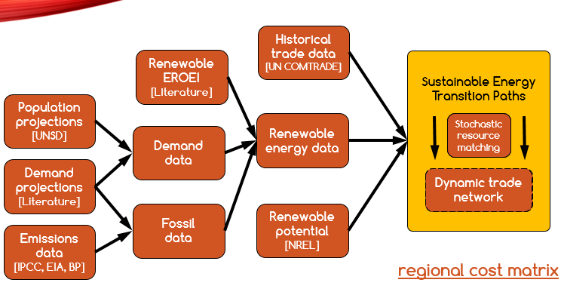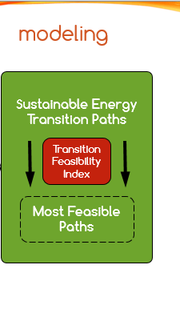

Figure ‎1‑1. Methodological structure for developing sustainable energy transition paths.   
source: own work

First we collect the population history and projections for the rest of the century, for all years and countries, from (UNSD, 2012). Sampling the per capita power demand projections from the literature (Marechal et al., 2005; Schulz et al., 2008; Spreng, 2005), we can convert these into demand projections for all years, for each country.

In parallel, we collect the historical emissions data, averaged over the databases of EIA and BP, for coal, oil and gas (BP, 2014; EIA, 2014). We also collect the historical production data for the same fuels, from the same databases. By dividing the two, we get the characteristic emissions intensities of the three fossil energy carriers, for all historical years, all countries. Using a global carbon cap, we distribute the remaining emissions budgets over fuels proportionally with their emissions intensities. By back-substituting the calculated emission intensity values we get energy production budgets. Using a Hubbert emissions equivalent fossil fuel phase-out (cf. section 2.3.2.2 and (Maggio and Cacciola, 2009a)), we derive global phase-out trajectories for all fossil fuels that collectively fit into the provided carbon budget.

We convert the global fossil fuel phase-out trajectories into national trajectories through a production-based emissions accounting scheme and an extrapolated, quasistationary fossil energy trade network. We distribute the remaining fossil budget over the geographical distribution of fossil producers, based on their production energy intensities, after (McGlade and Ekins, 2015). Then, casting the current energy trade partners into the future of fossil exporter countries and knowing the producers’ fossil trajectories for all producers and all fuels, for all remaining years, we create the fossil fuel consumption profiles of all countries, all years, upon perfect knowledge on the future availability of fossil imports. Finally, we adjust the demand trajectories of countries for fuel-switch, i.e. the replacement of primary energy source with secondary ones, electricity, as per (Jacobson and Delucchi, 2011) and identify the shares of energy generation in the energetic sectors that need to be kept in liquid form.

Knowing the demand trajectories, as well as the fossil fuel availability for all countries, for all years, we calculate the remaining net energy demand gap, and fulfill the rest of the demand will renewable energy. The next step is to estimate the renewable energy investment needed that will allow this deployment. For the planet, we take average EROEI values from the literature and directly estimate the renewable energy investment from the demand gap. As this will imply the deployment of additional, over-the-budget fossil fuels, we decrease the initial budget and iterate until convergence. The country-level renewable energy EROEI’s are based on the multiplication of the global technology EROEI with the normalized marginal resource quality. The marginal resource qualities are calculated as the within country distributions of renewable energy resources, based on their resource class. These are then normalized across all countries by the average resource quality for each resource to compare across resources.

In order to develop the country-level transitions, the available resources must be matched between the exporters and importers. We compute this through a stochastic resource matching algorithm, governed by a cost matrix a and historical country energy trade importance/influence matrix. Each year, countries are allocated their outstanding energy balances in a random order based on the optimal, minimal total energy costs of the deployed energy generation capacity, the global EROEI of renewable technologies, the ancillary energy costs of infrastructural investments (grid extension, if needed, storage requirements of the traded energy resource, losses in conversions to liquids and back to electricity – as per (Bogdanov and Breyer; Breyer et al., 2015a, 2015b; Pleßmann et al., 2014; Schill, 2014; Ueckerdt et al., 2015)) and a country influence factor. We define the country influence factor a normalized metric of ranking the trade partners of a country by importance, based on energy trade histories. Country influence factors are recalculated each year for all country pairs updated with the new trade flows. A particular influence factor is self-influence, defined as the relative importance of building capacity locally as opposed to importing from your most influential trade partner. By controlling the self-influence, we examine scenarios of open energy trade vs. energy security priority.

To understand the behavior of transitions under the variations of renewable EROEI and per capita energy demand, we conduct a sensitivity analysis across a wide range of these parameters values. Then, we create a ranking system for the scenarios, governed by the transition feasibility index, a composite indicator that we designed to reflect on the relative or difficulty of the investigated transitions scenarios.

Finally we compare the total energy investments of resulting from the application of the global model with the outputs of the networked model under open trade and energy security priority scenarios.

Both the global and national SET algorithms are novel contributions to the field and involve original mathematical and simulation modeling methods, constructed around the bases of biophysical economics, system dynamics, agent-based modeling, data mining, network theory, stochastic optimization and data visualization.

For a visual summary and process diagram of the NETSET algorithm, please fast-forward to section ‎4.6.9.

## Dissertation structure

The dissertation is structured into 7 chapters.

We start (Chapter 1) by setting the objective of the research and formulating theresearch question that this dissertation is meant to address. This translates to time-series of optimal global and national SET paths for the countries, under a binding GHG emissions cap and a dynamic energy trade network.

In Chapter 2, we set the background the overarching purpose of the research – i.e. to engineer a sustainable energy transition for the globe and all countries under the existing climate-change constraints – by summarizing the climate change global policy scene and its current burden sharing approaches. In the beginning of the chapter, we introduce and describe the Kaya Identity, one of the accepted methods of societal emissions modeling and examine its factors to identify the possible policy levers to reach the research objective. After examining all four factors, we identify two upon which we can push the most to induce a reduction in emissions and therefore progress towards a successful transition: power per capita and emissions intensity of energy. Consequently, we conclude this chapter with a detailed analysis of future per capita power demand projections, for all countries, and the derivation of Hubbert emissions equivalent fossil fuel phase-out curves.

Having established the possible levers through which societal emission can be constrained within climate change imposed limits, while maintaining a steady power flow to the society, in Chapter 3, we review the existing climate change modeling practices, with a special focus on energy systems and GHG emissions accounting. We point out several flaws of integrated assessment models (IAMs), currently widely accepted to be the reference or “industry standard” for climate change modeling and discuss their shortcomings in their ability to accurately model transitions. This is followed by brief overview of modeling historical technological transitions and an in-depth review of examples from the energy sector, and we present a proposal to adjust the economic engine of most IAMs, the Constant Elasticity of Substitution (CES) curve with Dynamic Elasticity of Substitution (DES), in order include technological transitions. However, even this extended approach can still not address the recursive nature of energy return on energy investment (EROEI[2]) calculations and the qualitative differences between fossil fuel and renewable EROEI (i.e. renewables need most of the energy investment up-front), hence we conclude with the justification and proposition to use numerical, differential equation-based models, rooted in biophysical economics and net-energy analysis to accurately model energy transitions on centennial scales and a finish with brief review of existing such models and hybrid-IAMs.

Chapter 4 presents the methodology for developing such a dynamic model in detail, starting by defining the theoretical framework in which the research objective gains significance and meaning (SET guidelines), defining and outlining the data sources, necessary data mining and processing and coding the dynamic simulation (differential equation) global model. This framework is then extended with the dynamic trade allocation algorithm to reach to the national transitions. For the global SET, we design a sensitivity analysis across a wide range of renewable EROEIs and possible future per capita power consumption profiles. The concept of the Transition Feasibility Index (TFI) is introduced, in order to create a ranking systems of different SET paths, based on technological progress and EROEI values of renewables, economic and energetic feasibility (renewable energy investment ratio, ε), and the population’s long-term efficiency assumptions (subsequently defining the final energy demand, D).

For the regional part, we extend the framework of the global transition to include energy trade, as well as the distribution of the global GHG emissions to national producer quotas. We model individual countries as autonomous agents deciding on their energy options placed in a dynamic global trade network, year-to-year, over the period 2015-2100 and identify a set of necessary assumptions and constraints that lead to the design rules of a dynamic energy trade network that will govern the SETs of each country. We also develop the concept of country influence, the main metric through which energy trade options priorities are governed.

After constructing the theoretical foundations of the global and regional SET, we construct two dynamic simulation models and conduct a numerical analysis on their behavior. In the next two chapters, we present the results of these simulation models. In Chapter 5, we present the set of experiments we designed to for the sensitivity analysis, our key assumptions and finally, the results obtained for the global SET. We explore a wide range of EOREI and per capita power demand options and present the optimal decision frontiers – with their respective renewable energy investment rates – to meet the planetary emissions constraint. The particular feature of renewable energy installations that the upfront energy invested in constructing a renewable energy infrastructure subtracts from the net energy available (1-1/EROEI) for societal energy needs and this energy is needed mostly at time of commissioning of the plant, rather than on an operational basis is a fact typically neglected in future energy projections. We find that the easiest pathway requires installation of renewable energy plants to accelerate at least by a factor of 50 and perhaps more than 90 over current rates, at their peak, to mitigate climate change and sustain the economy and the basic energy demand of the population. As such, this is the first model to transparently represent the dynamics of the energy transition on a physical rather than on an economic basis.

This is followed in Chapter 6 by the summary of the results of NETSET, an adapted version of the global case for regions and countries. Due to high number of degrees of freedom of this model, as well as the sheer number of countries involved, only the aspects that crucially differentiate the NETSET model from the global SET are investigated and presented. In a lot of aspects, the NETSET transitions behave similarly to the global one, but there are two key differences that render NETSET apart: distribution of emissions and renewable energy resources amongst countries and energy accounting of international energy trade – along with the complications these bring, such as storage and power grid expansion. We model countries as agents placed in a dynamic global trade partner and/or geographic network with an iterative, stochastic resource allocation decision framework designed to minimize total energy costs for the globe at the end of the transition. On top of the localized (GIS-based), national distribution of renewable resources, we include the influence of existing trade partnerships, existing grid infrastructure and geographic proximity into the optimization objective. Finally, as the resource allocation problem is computationally very intensive and therefore not optimizable in polynomial time[3] we explore the future possibilities of the exploring, improving and extending the capabilities of the NETSET model through a stochastic optimization[4].

In the concluding Chapter 7, we revisit the objectives of the research questions and set guidelines for future work, potentially developing this into a larger, internationally funded research project. We underline that particular SETs can be defined for each economic sector and with better calibration of the electrification rates, technology EOREIs and per capita consumption rates very accurate, climate-compliant energy policies can be constructed for all countries of the world, while at the same minimizing the total global energy input requirements for this transition and hence minimizing the GHG emissions. In an event of a globally coordinated, climate change-driven energy policy agreement, the results of such a work would be deemed invaluable.

# GLOBAL CLIMATE CHANGE AND EMISSIONS CONTEXT AND REGIONAL CONSIDERATIONS

This chapter presents recent trends in climate change policy and the existing carbon “burden-sharing” approaches. We introduce and describe the concept of *Kaya Identity*, one of the accepted methods of modeling societal emissions accounting and examine its factors to identify the possible policy levers to meet the research objective. We define the topics of *societal per capita power* and *energy return on energy investment* that are critical in developing the SET concept. In the second part of the chapter, after having identified per capita energy consumption and emissions intensity of energy as the main controllable factors of societal emissions, we develop a set of trajectories for the expected evolution of *per capita power demand* for the rest of the 21st century for the world as a whole, as well as separately for individual countries that is used as the target demand baseline in the SET. Finally, we define the concept of *Hubbert emissions equivalency* and provide a set of fossil fuel phase-out curves under three different emissions budget assumptions and two expected phase-out timetables that represent the IPCC-based carbon constraints of the SET.

## Current global climate change policy scene

Just after of the 2015 United Nations (UN) Conference of the Parties (COP) Climate Summit in Paris (COP21), it looks like there is at least some level of consensus among nations that laissez faire (or “zen” in (Rayner and Malone, 1997)) policies are not effective anymore against combatting climate change and a strong combination of mitigation and adaptation techniques will be necessary (Robbins, 2016). These imply a complete reform of the anthropogenic carbon emissions cycle in order to avoid catastrophic, unpredictable effects (Karl and Trenberth, 2003; Roe and Baker, 2007) that could possibly lead to mass extinctions (Hall 2015). The Sustainable Development Goals (SDGs) of the UN make this a top priority for all nations the next two decades and emphasize that climate change has overarching linkages to energy, food and global security (Godfray et al., 2010; Lagi et al., 2015; Wheeler and Braun, 2013), poverty and the global economy as well.

While moderate climate change might carry some positive effects, such as an increased flora in certain climatic belts (Nemani et al., 2003), these effects are dwarfed by the destructive consequences embedded in large planetary delays. (Matthews et al. 2009) have shown that global mean surface temperature varies linearly with the cumulative amount of carbon present in the atmosphere. They estimate the carbon-climate response to be in the range of 1.0-2.1 °C / trillion tons of carbon. Taking into account the already released emissions stock, limiting global warming to 2 °C compared to preindustrial levels would limit the remaining (with reference to 2008) cumulative emissions from all carbon-sources to be under 0.7 TtC = 2556 GtCO2, with a range of 0.4 to 1.5 TtC. The (IPCC 2014) and (Quéré et al., 2015) subsequently, set the fossil carbon dioxide budget for the planet consistent with the likely (66%) 2°C global warming scenario to 990 GtCO2 (cumulative after year 2012, with a confidence range of 510-1505).

Currently, the way UN is trying to address climate change is through intended nationally determined contributions (INDC), an unregulated, non-standardized set of pledges submitted to the United Nations Framework Convention on Climate Change (UNFCCC) in regular intervals, outlining member nation’s strategies on all climate impact aspects, from forest conservation to renewable energy deployment. While these contributions are hard to measure, assess or quantify, attempts at doing so have shown that they will miss 2 °C target by quite a notch (Figure ‎2‑1) a radically different approach is needed in order to address the problem effectively (Stern, 2016).

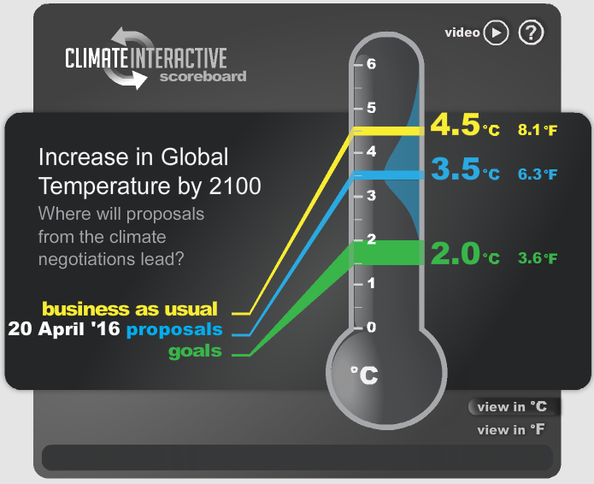

Figure ‎2‑1. Expected global warming based on the INDC pledges submitted to the UNFCCC before the COP21  
source: Climate Interactive, data source: En-ROADS Climate Policy model (Jones et al., 2013), year: 2015

In order to gain an understanding of the possible better approaches towards tackling the problem of climate change, in the following section we discuss the Kaya Identity as one of the prominent conceptual models to assess societal emissions and through a thorough investigation of its factors, we deduce the existing available options for a society to control its emissions – and how it all connects to consumption and energy.

## Societal emissions modeling through the Kaya Identity

One of the widely used standard for emissions accounting in the field of climate change modeling is the Kaya Identity: a chained multiplicative formula to benchmark the GHG emissions rate of a society at any point in time, composed of four factors:

* Population (*N*)
* Economic wealth (*GDP/N*)
* Energy intensity of the economy (*E/GDP*)
* Emissions intensity of energy (*C/E*)

|  |  |
| --- | --- |
| $$C=N\left.\left(\frac{GDP}{N}\right.\right)\left.\left(\frac{E}{GDP}\right.\right)\left.\left(\frac{C}{E}\right.\right)$$ | ( ‎2‑1 ) |

The Kaya Identity ( ‎2‑1 ) is a member of the IPAT (*I = PAT*, where I represents Impact, P population, A is affluence and T is technology) family of identities (Chertow, 2000; Commoner, 1976; Ehrlich and Holdren, 1972; Kates, 2000), which are used to describe human impact on the environment. The Kaya Identity in particular is used to quantify CO2 emissions of a society at any given point time and scale. It is a non-cumulative formula, (i.e. it is used to express rates of the quantities involved) however it can be integrated over *time* to yield cumulative emissions for any given timescale. It received criticism for being overly simplistic by postulating that the different factors are linearly independent, and therefore cannot possibly represent an accurate picture of such a complex system as the carbon emissions (Rosa and Dietz, 2012), however it is still useful to understand and rank the available levers to alter emissions of a society. We present the current status of each of the factors of the product as well their rates of change. The range of the rates of change is a critical consideration for further dynamic analysis in order to compare between their long-term effects (Waggoner and Ausubel, 2002).

In this section (‎2.2) we take a look at the current values and the evolution of each of the Kaya Identity factors, as well as their derivatives and integrals to help us understand the scales involved with each variable.

### Population

The first term of equation ( ‎2‑1 ) is population, *N*. There are various projections about global population, but the consensus is that it is going to increase then stabilize given the inertia of population dynamics (2014). In Figure ‎2‑2, we have plotted the top 12 countries by population size. What we observe is that all large countries (except post-Soviet Russia) have had a positive population growth rate for the past 50 years. Even China, with an extremely strict child control policy still had a net growth rate of 0.5% in 2013. Nigeria, with a population growth rate of nearly 3 percent will double its population every ~24 years at this pace.

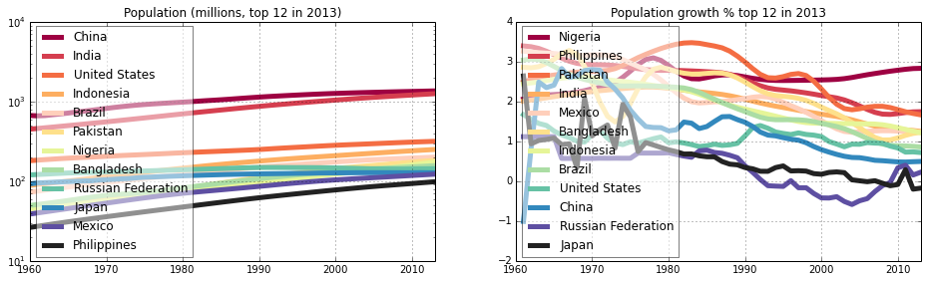

Figure ‎2‑2. Evolution of the population for the 12 most populous countries of the world  
source: own work, data source: WDI, year: 2013

### GDP per capita and per capita power

The next term of the Kaya Identity is *GDP / N*, the per capita gross domestic product This term is used to describe the economic purchasing power of the population, which correlates with its tendency to consume energy (Ayres, 2003, 2016; Ayres and Warr, 2005; Hall and Klitgaard, 2011; Tanzer, 1974). If we plot the evolution over time of the average per capita power consumption (for all countries with available data) compared to their per capita GDP, we get a quasi-stationary picture of a strong linear correlation between the two values (R2 between 0.7 and 0.82).

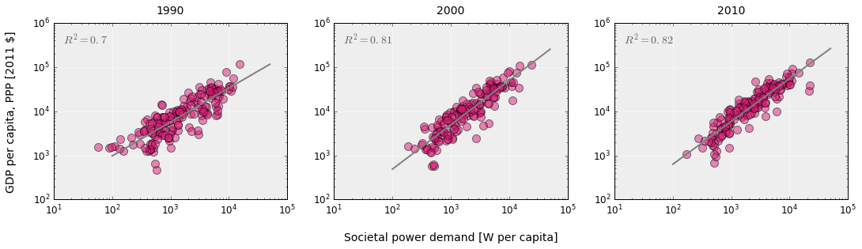

Figure ‎2‑3. Evolution of societal per capita power demand and per capita GDP for 1990, 2000 and 2010, for all countries with available data. Log-log regressions fitted, coefficients of determination shown in the top left corner of each plot.  
source: own work, data source: WDI, years: 1990, 2000, 2010

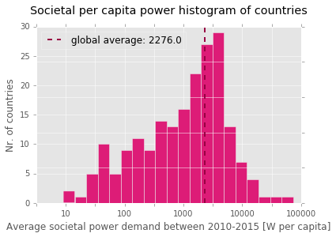

Figure ‎2‑4. Distribution of per capita power demand per countries of the world. Values shown are averaged over the 2010-2015 period. The global average, weighted by population is 2276 W/capita.  
source: own work, data source: WDI, years: 2010-2015

However, from Figure ‎2‑4 we can see that there is considerable inequality in how the global demand is distributed across countries, with some consuming north of 20kW per person, on average, whereas others below 100W.

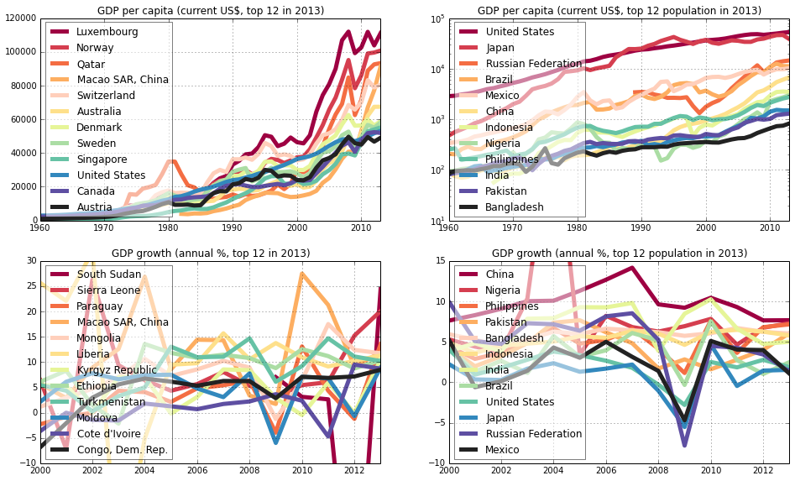

Figure ‎2‑5. Evolution of GDP/capita and GDP growth rate for the top 12 countries and 12 most populous countries of the world  
source: own work, data source: WDI, year: 2013

Looking only at the evolution of GDP per capita (Figure ‎2‑5) we can see that there is little overlap between the top GDP/capita countries and the top population countries, with only the United States showing up on both plots (with Japan almost making the list). This would mean that from only this narrow perspective, the emissions expressed by the Kaya Identity *would not represent* a significant threat. However, the picture that we get form the flows plot is radically different: China has the highest current population, but it also has the highest GDP growth rate - and has had so in the past 30 years. Closely behind are Nigeria, Philippines and Pakistan, all with large populations.

### Energy intensity of the economy & energy return on energy invested

The third factor of the identity is the economic energy intensity term *E / GDP*. This shows how much energy is consumed to yield one dollar of economic output (or in some interpretations, how much energy is produced per one dollar, the inverse of this). This represents a country's capability to consume/produce energy efficiently for supporting economic activity (Figure ‎2‑6).

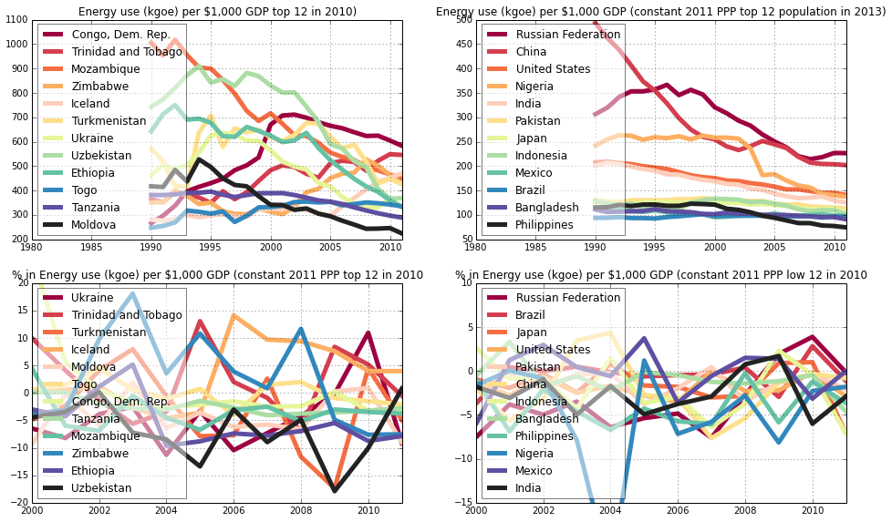

Figure ‎2‑6. Evolution of energy use per 1000$ GDP for the top 12 countries and 12 most populous countries of the world  
source: own work, data source: WDI, year: 2013

Since the Kaya Identity is a product, the percentage improvement of one term on the right-hand side brings equivalent benefits of the same percentage improvement of the left-hand side. Knowing this, consumption reduction practices, i.e. demand side management (DSM), should be prioritized as potentially this term has lower barriers to improve than the others, especially for the first 10-25% of reductions (Pimentel and Pimentel, 2007; Webber, 2012; Weber and Perrels, 2000). After a certain threshold value however, it gets increasingly hard to reduce, without contracting economic output (Alcott, 2005; Polimeni, 2012). Nevertheless, in the current context of the discussion, this would be beneficial for emissions – but probably not so much for human material wealth. It is also worth pointing out is that some of the countries which have the lowest efficiency (highest intensity) have been improving at fast rates, in line with the low-hanging fruit theory for DSM.

If more energy efficient systems become available, E/GDP goes down. If people start consuming less energy while maintaining the same lifestyle (yielding the same economic output), this number will also go down. If cheaper energy production technologies become available, the inverse of this number goes up (leading to decrease of E/GDP). However, at this stage we need to examine the notion *cheaper* not only from the conventional, monetary side, but from the *energy* side as well.

For any energy project, (Murphy et al., 2011) identify four key energy stocks, calculated as the integral of energy flows over their duration:

* $E_{g}=\int_{t_{0}}^{t}{{\dot{E}}_{g}}dt$, the energy generated by the project
* $E_{c}=-\int_{t_{0}}^{t}{{\dot{E}}_{c}}dt$, the energy expended to construct the project
* $E_{op}=-\int_{t_{0}}^{t}{{\dot{E}}_{op}}dt$, the energy expended to operate the project
* $E_{d}=-\int_{t_{0}}^{t}{{\dot{E}}_{d}}dt$, the energy expended to decommision the project

Then, the energy return on energy invested (EROEI) can be defined as the ratio of integrated energy outputs over the integrated energy inputs over the project lifetime (Gupta and Hall, 2011).:

|  |  |
| --- | --- |
| $$EROEI=\frac{E_{g}}{E_{c}+E_{op}+E_{d}}$$ | ( ‎2‑2 ) |

In some cases (energy projects with a constant energy input, such as a fossil fuel plant) it is possible to simplify the definition the EROEI to include only terms of operational flows, such as $EROEI=\frac{E_{g}}{E_{c}+E_{op}+E_{d}}≅\frac{\dot{E_{g}}}{\dot{E_{op}}}$, but due to the changing intensity of the investment during project stages, the *operational EROEI* might be significantly different from the overall *project EROEI*, especially in cases of capital-intensive installations, such as nuclear or renewable power (Figure ‎2‑7). Therefore, when looking at the project EROEI, we add the *construction* and *decommissioning* stages to the project. Unlike the investment energy cost which is upfront, we assume that operations and decommissioning costs are evenly spread over the project lifetime*[5]*.

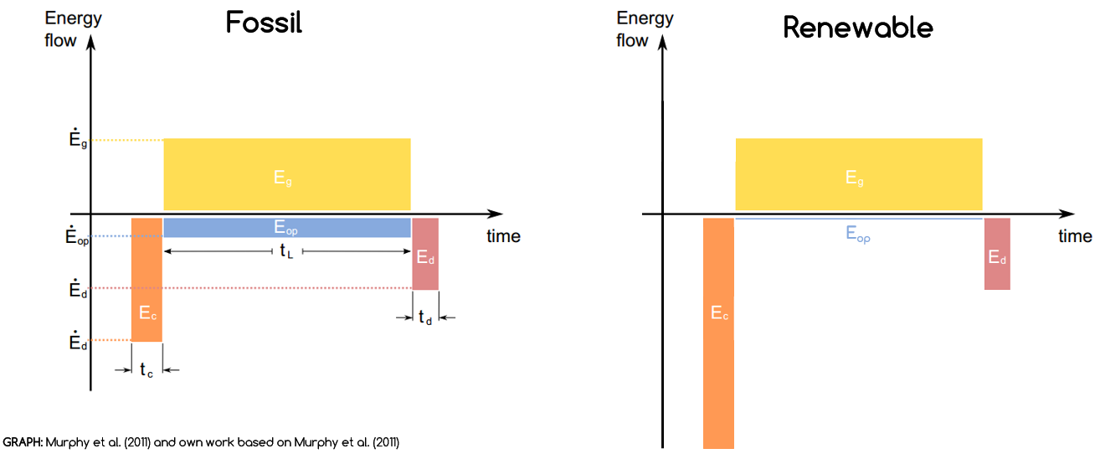

Figure ‎2‑7. Comparing energy flow profiles of different energy types  
Fossil fuels (left), Renewables and other capital intensive fuels, including nuclear and large hydro (right)  
source: left (Murphy et al., 2011), right: own work

Therefore in the context of the E/GDP term of the Kaya identity, if more efficient energy-harvesting technologies become available (meaning that they produce more output energy for the same amount of input energy – energy investment), then E/GDP decreases. However, when framing this in a context of a long-term change (i.e. an energy transition), the time at which this efficiency improvement occurs (i.e. if the investment gets lower over the project lifetime, almost on generational time-scales, or instantly, if it is replaced by an energy capital intensive technology – such as renewables) also becomes critical as there might be significant differences between the spot average values of E/GDP and its value distribution over time.

### Emissions intensity of energy

The last term of the Kaya Identity is the emissions intensity of energy (also called emissions factor) *C/E*. This represents the CO2 (or sometimes expressed in terms of carbon) equivalent emissions of per unit of energy. This is directly tied to the physical properties – the carbon content – of the fuels used, weighted by their share. If the mix of renewable energies – sources with no direct emissions – in the global energy mix increases, then overall weighted emissions intensity will drop. For the globe as a whole, it will also go down if the countries for which the improvement in carbon intensity outweigh those for which is deteriorating.

It is possible to directly control this term of the identity: calculating the energy mix intensities for a number for all possible fuel share combinations, one can set technology performance targets for a given carbon budget (Trancik, 2014).

Currently there is no clear trend (Figure ‎2‑8) in the evolution of this term when looking at individual countries, however, the smaller countries exhibit a higher volatility. As coal has been considered a cost-effective and reliable energy source in the late 20th and early 21st centuries, large developing nations (China, India, Bangladesh, Pakistan) opted for extensive deployment of this fuel for power generation, leading to an increase in their country-level *C/E* terms. This led the global number in the same direction as the rest of the large energy producers/consumers have stagnated (Europe, United States, Mexico), mostly due to capacity replacements of older technology coal plants, offset by the commissioning of some newer ones (Raupach et al., 2007).

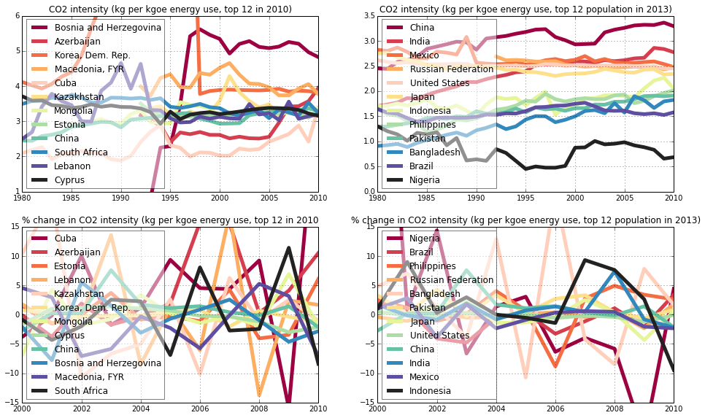

Figure ‎2‑8. Evolution of emissions intensity of energy for the top 12 countries and 12 most populous countries of the world  
source: own work, data source: WDI, year: 2013

### Review of Kaya Identity factors and comparison of rates of change

Now taking all of the recent Kaya Identity component data into account and extrapolate, China *alone* could contribute more than 50% to future CO2 emissions with 1/6th of the global population. China came out in all but one (GDP per capita) factors in the top 3, leading 3 of the 4 factors (Population, GDP growth, Emissions intensity) and coming in second on one (Economic energy intensity). China is followed by India on 3 of the plots.

While the Kaya Identity is a good tool to estimate carbon emissions for a region, country or globe and one of its great features is its simplicity – not only because it facilitates understanding, but also because uses relatively easily available data – this may become drawback as well, since it lacks a dynamic view of its factors. Therefore, it should be used with care for extrapolations and modeling long-term societal changes and transitions of the energy system. Because is a purely multiplicative formula, *errors in estimates* of the individual factors are going to *scale* the end result in a proportional way. Since some of the terms are quite complicated to assess, such as the E/GDP or C/E or have a qualitative touch to them (E/GDP), eventually the results might be off by a significant margin. If there is a consistent 7% bias for all terms, the combined effect might be as high as 28% (although, it could also easily cancel out). Local variations of the identity factors make global predictions increasingly hard.

Table ‎2‑1. Signum of 1st and 2nd derivatives of the Kaya Identity factors  
source: own work, data source: WDI, year: 2013

|  |  |  |  |  |  |  |  |  |
| --- | --- | --- | --- | --- | --- | --- | --- | --- |
| **Country** | $$\dot{N}$$ | $$\ddot{N}$$ | $$\dot{\left(\frac{GDP}{N}\right)}$$ | $$\ddot{\left(\frac{GDP}{N}\right)}$$ | $$\dot{\left(\frac{E}{GDP}\right)}$$ | $$\ddot{\left(\frac{E}{GDP}\right)}$$ | $$\dot{\left(\frac{C}{E}\right)}$$ | $$\ddot{\left(\frac{C}{E}\right)}$$ |
| China | **+** | **–** | **+** | **+** | **–** | **–** | **–** | **–** |
| India | **+** | **–** | **+** | **+** | **–** | **+** | **–** | **–** |
| US | **+** | **–** | **+** | **+** | **–** | **–** | **+** | **+** |
| Indonesia | **+** | **–** | **+** | **–** | **–** | **–** | **–** | **–** |
| Brazil | **+** | **–** | **+** | **+** | **–** | **–** | **+** | **+** |
| Nigeria | **+** | **+** | **+** | **+** | **–** | **+** | **+** | **+** |
| Pakistan | **+** | **–** | **+** | **+** | **–** | **–** | **+** | **+** |
| Bangladesh | **+** | **–** | **+** | **+** | **–** | **–** | **+** | **–** |
| Russia | **+** | **+** | **+** | **–** | **–** | **–** | **+** | **+** |
| Japan | **–** | **–** | **+** | **+** | **–** | **–** | **+** | **+** |
| Mexico | **+** | **–** | **+** | **–** | **+** | **+** | **–** | **–** |
| Philippines | **+** | **+** | **+** | **+** | **–** | **–** | **+** | **–** |

Let us take a brief look at the signum of the derivatives of factors of the Kaya Identity factors in order to illustrate the rates of change. Table ‎2‑1, represents the direction of variation of the factors, as well as the direction of their speed of variation for the 12 largest countries for the last available year. There is a large variation between the rates and quantities across countries, even when looking just at the 12 largest countries by population. There are countries that have been increasing one or more of their parameters at an *increasing* rate. This is alarming, as when rate of change (derivative) of the factors increases (positive second derivative), then end effect on the identity is *exponential*. This leads to the requirement of either *exponential decay* in the other parameters or a very fast linear decrease, followed by the attenuation of the exponential increase – as a condition to maintain a stable emissions level. Given the nature of the parameters – as discussed in the beginning of this section – a natural exponential decrease in either of them is highly unlikely to occur spontaneously, nonetheless necessary to reach net-zero emissions state (York, 2007). Therefore, both climate-change mitigation and adaptation measures must follow active, predestined trajectories towards meeting a planetary emissions constraint, which can then be translated into country-level, recommended variations of the Kaya factors. However, a major element that the Kaya identity lacks is the deeper connection to economy – and hence *endogenous* economic and energy dynamics. New energy technologies are still costly and thus will take time to develop and even more so to diffuse. The energy cost at which these technologies are available will also vary.

On top of that, if we want to fit into a given carbon budget, defined in cumulative terms, then it is not enough to look at the spot-values of C, because the emissions are a path-dependent integral. This means that it is not only crucial to reduce emissions with 20-50-80% and stabilize at that level by the end of the century, it is also very important when (Edwards and Trancik, 2014; Sgouridis et al., 2016a) does the intense reduction start – with earlier action giving more way to the transition. Furthermore, the current state of the economy (taken for some region, country or globally) might or might not support the scale of energetic transition that is needed. The momentary amount of investment needed at any point in time, both in energy and economic terms (Sgouridis et al., 2015) could potentially place a large burden on economy if it occurs too fast and thus can only be achieved through a smooth, pre-planned transition.

(Raupach et al., 2007) argue that nearly constant or increasing emissions intensity of energy has been observed in both developed and developing regions and effectively no region was decarbonizing its energy supply in the 2000-2007 period – largely due to coal power plants. The prospect of sustained sub $50/barrel oil prices definitely doesn’t help (Armstrong et al., 2016; Nemet et al., 2016; Reboredo et al., 2016).

As the combination of all factors, the growth rate in emissions is the strongest in China (by far), India, and other developing economies. In 2004, the developing and the least-developed regions (80% of global population) accounted for 73% of the growth in emissions, but only 41% of the emissions and only 23% of cumulative emissions since industrialization (Raupach et al., 2007).

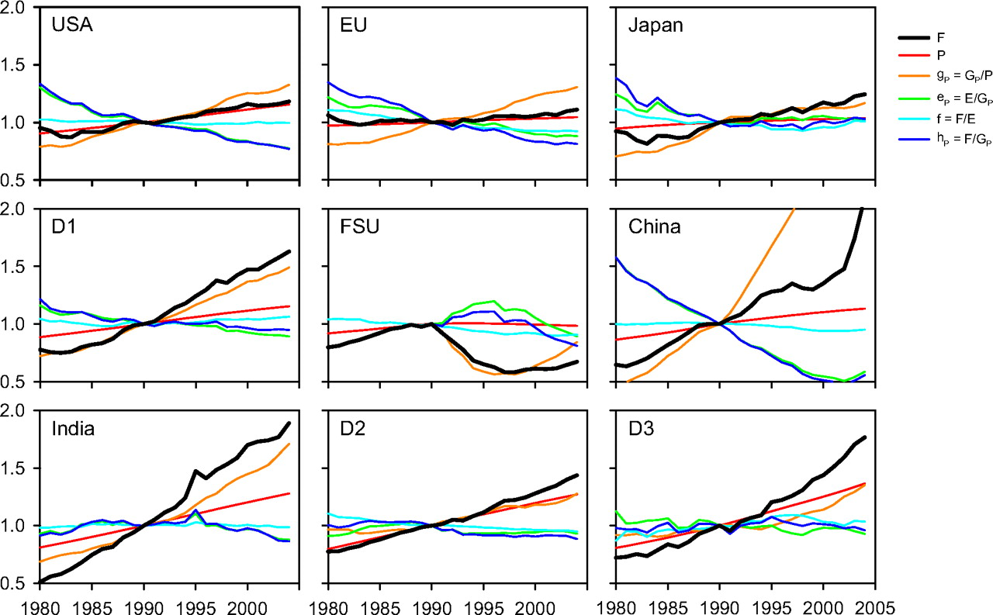

Figure ‎2‑9. Evolution of the components of the IPAT identity for countries and regions   
Legend: FSU – Former Soviet Union, D1 – developed, D2 – developing, D3 – least developed countries  
F – CO2 emissions flux (rate) from fossil fuel combustion and industrial processes, P – Population, gp – GDP per capita PPP   
hp –emissions intensity of the economy, ep – a energy intensity of the economy, f – emissions intensity of energy  
source: (Raupach et al., 2007), data source: EIA

## Climate policy levers to control global and national emissions

Based on the Kaya Identity formulation of societal emissions, we investigate the controllability of each of its 4 factors:

* Population *N*
* Economic wealth (per capita income) *GDP/N*
* Energy intensity of the economy *E/GDP*
* Emissions intensity of energy *C/E*

The population component is difficult and controversial to control because of inertia and complexity on the timescales needed to tackle climate change (decades). While GDP/N is a possible candidate it is difficult to make de-growth politically and culturally acceptable (Kallis, 2011) and furthermore it is difficult to impose artificial consumption limits on a free-market, global economy. This leaves two climate policy levers:

* *Energy intensity of the economy* – often called energy efficiency improvements and used as the “easy-way-out” in climate target policies, often used as filler to make up for unmet emissions targets from adjustments the energy system. However, there is a large uncertainty involved with the feasibility of these projections (Owens and Driffill, 2008), and has its own dynamic problems, such as the rebound effect (Sorrell et al., 2009).
* *Emissions intensity of energy* – this involved greening the energy generation mix – coupled with shift in primary energy from direct fossil use to include more direct electricity generation, and a subsequent transition of industries to be electric, rather than directly fossil powered (Jacobson and Delucchi, 2009; Williams et al., 2012).

As both levers have physical constraints tied to them, a successful policy will aim to maximize utilization of both levers. Let us look into each of the lever in more detail.

### Controlling the energy intensity of the economy through power per capita modeling

In a *biophysical* model – that is translating all measurable quantities, including economic, in terms of physical flows, see sections ‎1.4 and ‎3.6 for more detail –, the energy intensity of the economy would lead to an energy per capita target, assuming an external, desired per capita GDP. Then, assuming an equal distribution over the 8760 hours of the year, this is converted into an average per capita power consumption target.

We have already seen (section ‎2.2.2) that currently[6], the global, population-weighted per capita power consumption is around 2276 W/capita (EIA, 2014) when accounted in primary per capita power terms (see Figure ‎2‑3), however, this is by far not distributed equally among nations, ranging from about 100 to more than 10000 W (see Figure ‎2‑4). And there is a strong correlation between GDP and per capita energy consumption, a trend which has been steady over the past few decades (see Figure ‎2‑3).

By the end of the century, however, the average power demand is expected to change – and there are many mechanisms driving the change. Developing nations desire to get wealthier, therefore increasing their per capita power demand. Advanced economies are expected to reduce their net power demand as a result of increase in process efficiency and DSM. Furthermore, primary energy demand is expected to decrease as more energy efficient - at the conversion stage - carriers are introduced, such as electricity directly – at the expense of less efficient traditional sources, such as internal combustion engines. These phenomena altogether lead to a wide interval estimates for per capita power demand by the end of the century, ranging from 1400W/capita (Jacobson and Delucchi, 2009, 2011), through 4000W (Spreng, 2005) and up to more than 6000W (Pickard et al., 2009). However, Marechal et al. 2005 suggest 2000W as the lower feasible limit of average primary power per capita for maintaining an acceptable quality of life in a technical society (Marechal et al., 2005; Pfeiffer et al., 2005; Schulz et al., 2008). Therefore, based on this we have created a range of possible demand profiles to be studied in further in our analysis, and we will consider the 2000W/capita scenario as the base case. Using this information and the population projection of the UN (UNSD, 2012), we can construct (through the equation in the inset of Figure ‎2‑13) distinct demand profiles for the rest of the century (Figure ‎2‑10). These are used in the global model to assess the relative importance of this parameter in the context of the global SET.

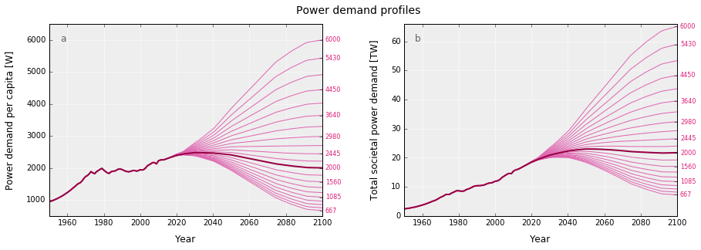

Figure ‎2‑10. Expected per capita and total societal power demand profiles  
source: own work, data source: WDI, EIA, UNSD

For a regional SET, we need to provide a specific net-energy demand forecast for each nation. Since this is a highly subjective value that is not possible to forecast accurately, we propose a transformation as a working hypothesis that introduces a reasonable convergence for high-energy consumers while maintaining country diversity and variation. When converting this global demand to national values, it is unreasonable to expect that all nations will converge to this value by the end of the century, given the wide distribution of the per-capita histogram (see Figure ‎2‑4). The transfer function reduces the energy use of high consumers and allows the increase of the demand in developing countries. Bearing in mind that the per capita power distribution is exponential, we choose a logarithmic transfer function, i.e. countries with a consumption north of 20kW will try to essentially halve their consumption, but countries with just a few tens of Watts might increase it 100-fold. This results to an end-of-the-century population weighted average per capita consumption of 3954W, almost double than today’s value, and a more egalitarian world (Figure ‎2‑11). The function we used for the transformation (*D2100*) is presented in Equation ( ‎2‑3 ). The transfer function has been mathematically constructed to yield a logarithmically asymmetric scaling of the demands of the countries between 0.5 and 20, converging around 3954W by 2100. This behavior is shown for all countries in Figure ‎2‑12.

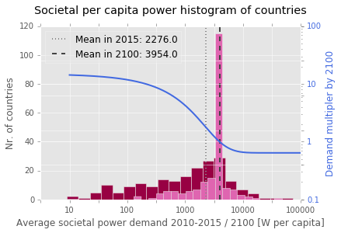

Figure ‎2‑11. Distribution of per capita power demand per countries of the world for 2010-2015 and 2100. Values shown in the darker pink shaded histogram are the current distribution, averaged over the 2010-2015 period. The global average, weighted by population is 2276 W/capita. The light pink histogram is the expected distribution in 2100, after transforming the countries’ current demand through a demand multiplier function. The global average modifies to 3954 W/capita  
source: own work, data source: WDI, years: 2010-2015, own assumptions and calculations for 2100

|  |  |
| --- | --- |
| $${f\left(t\right)=\left\{\left[a-\frac{b}{1+e^{-λ\left[\log_{10}\left(ω^{t}\right)-μ\right]}}\right]\right\}}^{γ}$$ $$D_{2100}\left(d\right)={\left\{8-\frac{7.2}{e^{-0.01\left[\log_{10}\left(5^{d}\right)+30\right]}}\right\}}^{2}$$ | ( ‎2‑3 ) a  b |

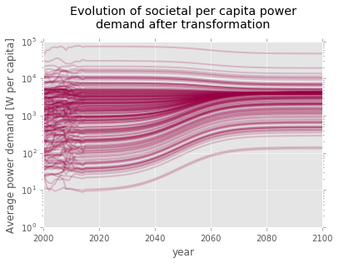

Figure ‎2‑12. Evolution of per capita power demand per countries of the world for 2000-2100,   
after applying the demand transformation *D2100*.   
source: own work, data source: WDI, years: 2000-2015, own assumptions and calculations for 2100

The switch form the 2015 demand values to the 2100 values is done gradually over the trajectory of an S-curve presented in Figure ‎2‑13. This S-curve is simpler than the one defined in Equation ( ‎2‑3 ) , the figure inset includes the exact definition and the parameter values as well.

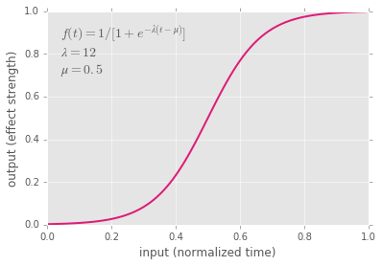

Figure ‎2‑13. Trajectory for applying the demand transformation *D2100* function.   
source: own work

### Controlling emissions intensity of energy through fossil fuel phase-out

Starting from the known cumulative emissions budget (cf. section ‎2.1), we can develop a dynamic demand curve. As the emissions budget is the integral of the yearly emissions, if we use a predefined shape for the trajectory and knowing the value of the budget, we can fully specify (integrate) the trajectory. This trajectory represents a dynamic emissions intensity curve when incorporated in the total energy generation mix. This process is described in detail below.



In order to specify a plausible future phase-out trajectory for fossil fuels we rely on observed historical production and consumption patterns of fossil fuels. It has been empirically observed that the dynamics between the difficulty of extraction/scarcity of a given fossil resource and the availability of alternatives/change reliably create a pattern known as Hubbert curve (Hubbert, 1956), extended by (Cavallo, 2004; Gallagher, 2011; Maggio and Cacciola, 2009a). When multiple resource types are involved (e.g. land-based crude, deep-sea crude, tight oil, tar sands etc.), a composite Hubbert curve can also be created (Maggio and Cacciola, 2009a). This well-established curve provides a useful approximation for the extraction rate of the fossil resources and by implication the development of the demand-side infrastructure simplifying their modeling for our purposes.

While originally developed for representing the production rate of an individual oil reservoir it was later expanded to country and global oil production. Under the assumption of depleting reserves (defined as the ultimately recoverable reserves – *URR*), we can convert the substance reserves into remaining emissions. If these emissions are capped, we can define this cap as *safely recoverable* *reserves*, through the given fuel’s (or the energy mixes’) emissions intensity, defined by , as per ( ‎2‑4 ).

|  |  |
| --- | --- |
| $$SRR=\frac{carbon budget B}{emissions intesity C}$$ | ( ‎2‑4 ) |

Next, by assuming the future proportional contribution of the components of C based on the existing energy mix, we apply the Hubbert logistic curve approximation for all major fossil fuel resources *i* (coal, oil & tight oil, natural gas). The gross fossil energy output *E(t)* can be estimated as a composite of the respective Hubbert curves for each resource as shown in ( ‎2‑5 ) – adapted from (Cavallo, 2004; Maggio and Cacciola, 2009a).

|  |  |
| --- | --- |
| $$E\left(t\right)=\sum_{i}{\left[\frac{{2P}_{peak}}{1+k_{i}∙cosh\left(\frac{{4P}_{peak}}{{SRR}_{i}} \left(t-t_{{peak}_{i}}\right)\right)}\right] }, {SRR}_{i}=\frac{B}{C}∙\frac{c_{i}}{C}=\frac{Bc_{i}}{C^{2}}$$ | ( ‎2‑5 ) |

This will be dependent on the extraction rate at peak production (e.g. peak power *Ppeak*), the time at which production is expected to occur *tpeak*, and the safely recoverable reserves (set by the carbon budget and the relative emissions intensity of fuel *i, ci* compared to the average emissions intensity of the energy mix, *C*) *SRRi* of fuel *i*. Since we are using a multi-Hubbert model of (Maggio and Cacciola, 2009a), *ki* is 1 (for coal and gas) or equal to the mixture (akin to a *timed weight*) parameter of each source *i* within a source group (oil). We call such a trajectory, defined by ( ‎2‑5 ) a *Hubbert emissions equivalent fossil fuel phase-out curve*.

It is also important to note that the amount of energy that can be generated while still meeting a preset carbon cap can also be done through changing the average carbon intensity of the energy mix. This can be accomplished by offsetting energy sources with a high emissions intensity such as coal with those that have a lower emissions intensity, such as natural gas (with *cgas ≈ 0.5· ccoal*) or renewables, with *c* zero.

On Figure ‎2‑14 we have mapped the Hubbert fossil phase-out trajectory for the lower, mean and higher CO2 cap values for RCP2.6 which include all fossil fuel combustion, industry, gas flaring and cement carbon emissions (Table 6.12 (IPCC, 2014)). Given the large variation and implicit uncertainty in the range, we chose not to subtract the flaring and cement emissions from the fossil carbon budget. This means that the lower range, may require an even faster transition than what we present here.

We considered two phase-out timetables:

* An *early* phase-out with fossil emissions peaking and thus retraction start times at years 2015, 2020 and 2025 for the low, mid and high carbon caps, respectively
* A *late* phase-out trajectory with fossils peaking in 2020, 2030, 2040, under the low, mid and high caps, respectively.

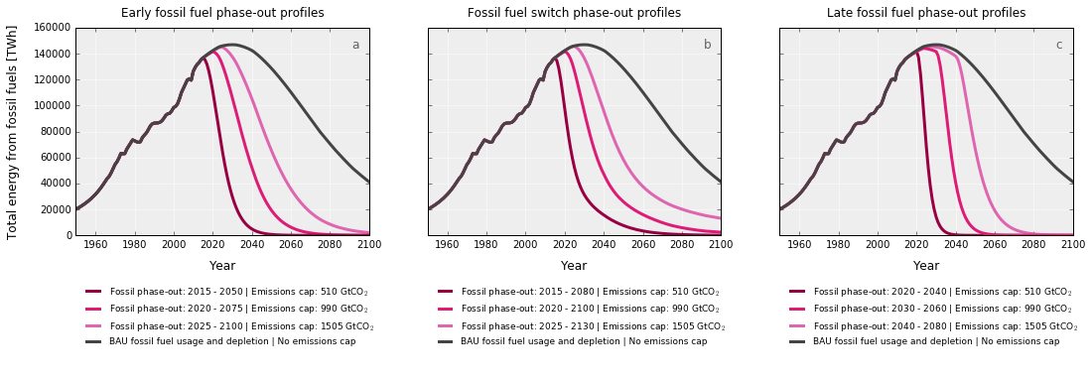

Figure ‎2‑14. Global fossil phase-out trajectories mapped through Hubbert emissions equivaleny for   
early start (2015, 2020, 2025) and late start (2020, 2030, 2040) retraction profiles,   
under 3 different emissions caps: 510, 990 and 1505 GtCO2, respectively, as per the median value and the   
confidence bounds for the IPCC 66% ± 16% RCP2.6 scenario, approximately corresponding to 2 °C.   
The business-as-usual, proven reserves-based fossil depletion Hubbert curves are also shown for reference.  
source: own work. Last available emissions value is average of EIA and BP data

We can see that given the current IPCC emission budget and its confidence bounds, the recommended Hubbert emissions equivalent fossil fuel phase-out trajectories require a complete cessation of fossil energy consumption by 2080 (2100 if on the higher end of the confidence interval) conditional upon early action and the start of curbing emission within a decade. Postponing another decade brings the total consumption phase-out limit forward by 20 years, to 2060.

In this chapter we presented the ongoing discussion on climate change, current global policies and the expectations of the almost inexistent global response, followed by an analysis to identify the most effective policy levers to combat climate change, Through the Kaya Identity, we highlighted that population, wealth, energy consumption as well as the types of energy we use are all linked to emissions and therefore the solution to climate change and a deep reform of the global energy system are intertwined. Through the decomposition and analysis of the components of the Kaya Identity, we identified two key policy levers that are worth focusing on: energy intensity of the economy and emissions intensity of energy. We concluded the chapter with providing the possible evolution paths for both.

# OVERVIEW OF CLIMATE-ENERGY-ECONOMY MODELS AND HISTORICAL ENERGY TRANSITIONS

In the previous chapter we identified two possible policy levers through which we can affect societal emissions and the constraints shaping the form of SET and hence meet the climate change targets put forward by IPCC. This chapter maps the past and current efforts of modeling the interactions within the climate-energy-economy system which is the core systemic context around SET and studies the practical implications of historic energy transitions.

We start with a review and critique of economics-driven *integrated assessment models* (IAMs). Such IAMs are mainstay tools of climate economists used to assess the long-term impacts of climate on the economy and to derive optimal policy responses usually in the form of estimates of (exponential) carbon prices. IAMs have been criticized for controversial discount rate assumptions, arbitrary climate damage functions, and the inadequate handling of potentially catastrophic climate outcomes. We review these external shortcomings for prominent IAMs before turning our focus on an internal modeling fallacy: the widespread misapplication of the *constant elasticity of substitution* (CES) function for the technology transitions modeled by IAMs. Applying CES, an economic modeling approach, on technical factor inputs over long periods where an entire factor (the greenhouse gas emitting fossil fuel inputs) must be substituted creates artifacts that fail to match the consistent S-curve patterns observed in past technological transitions. A policy critical result, the monotonically increasing marginal substitution cost of carbon, a universal feature of IAMs, is called into question by showing that it is unrealistic as it is an artifact of the modeling approach and not representative of the technical substitutability potential nor of the expected cost of the technologies.

We demonstrate this first through a simple but representative example of CES application on the energy system and with a sectoral deconstruction of the actual fossil substitution costs. We propose a methodological modification using dynamically varying elasticity of substitution as a plausible alternative to model the energy transition in line with the historical observations and technical realities within the existing modeling systems, leading to non-exponential carbon-prices, but preserving the high parameter sensitivity of the function by design. We conclude that a fundamentally different approach based on physical energy balances would be more appropriate to model energy transitions and the interactions between society energy and climate throughout. We close the chapter with a review of the latest advancements and available system dynamics and biophysical climate-energy models. The part on integrated assessment models of this chapter has been submitted for publication in (Sgouridis et al., 2016b).

## Overview of the integrated assessment modeling mindset and review of example models

IAMs are climate economy models that are widely used for tying the evolution of the climate system to the economic system. They are state-of-the-art attempts to map the dynamic effects of climate change on the economy and vice versa, projecting them several decades into the future. Doing so allows the comparison of the costs of climate change against the costs of preventative actions, thus providing information to decision makers to inform policy development. One consistent output of the models is that in order to combat climate change, carbon prices should continue to increase throughout this century reaching to very high levels towards the end. We investigate the underlying economic model that leads to this result and discuss why the commonly applied formulation CES is unrealistic in the context of long-term technical substitution processes theoretically and practically as it does not account for the physical and technical replacement potential of alternative technologies (Stern, 2016). We aim first to provide a comprehensive review of the current critiques towards IAMs along several fronts before focusing on exploring the problems and resulting artifacts from using CES in technology substitutions an area that has not been previously discussed in detail.

As a starting point, in Table ‎3‑1, we present an indicative collection of IAMs from different years and the identifying equations for two critical aspects: the economic engine, how they model economic output, and the climate damage function, how they relate climate change to economic disruption.

Table ‎3‑1. IAM models and functional formulations used for economic growth and climate damages

|  |  |  |
| --- | --- | --- |
| Model  (Reference) | Economic Engine[7] | Climate Damage Function |
| DICE[8] (Nordhaus, 1992) | Cobb-Douglas/CES $$Q\left(t\right)=\left[1-Λ\left(t\right)\right]A\left(t\right){K\left(t\right)}^{γ}{L\left(t\right)}^{1-γ}/[1+Ω\left(t\right)]$$ | Quadratic function of temperature $Ω\left(t\right)=ψ_{1}T_{AT}\left(t\right)+ψ_{2}{[T_{AT}\left(t\right)]}^{2}$ |
| ENTICE  (Popp, 2004) | DICE with technological change $$Q_{t}=A_{t}K_{t}^{γ}L_{t}^{1-γ-β}E_{t}^{β}-p_{F,t}F_{t}$$ | DICE |
| ENTICE-BR  (Popp, 2006) | ENTICE with backstop technology $$Q_{t}=A_{t}K_{t}^{γ}L_{t}^{1-γ-β}E_{t}^{β}-p_{F,t}F_{t}-p_{B,t}B_{t}$$ | DICE |
| WITCH  (Bosetti et al., 2006) | $$Q(n,t)={TFP(n,t){\left[α\left(n\right)∙{\left(K_{C}^{1-β\left(n\right)}\left(n,t\right)L^{β\left(n\right)}(n,t)\right)}^{ρ}+(1-α\left(n\right))∙ES{\left(n,t\right)}^{ρ}\right]}^{1/ρ}}_{}$$ | DICE |
| MARKAL  (Loulou et al., 2004) | $$X_{s}=A_{0}{(B_{K}∙K_{s}^{ρ}+B_{L}∙L_{s}^{ρ}+B_{E}∙E_{S}^{ρ})}^{1/ρ}$$ | $$DAM\left(EM\right)=α∙{EM}^{β}$$ |
| MERGE  (Manne and Richels, 2005; Manne et al., 1995) | $$Y={\left[a∙{\left(K_{}^{α}L^{1-α}\right)}^{γ}+b∙{\left(E_{}^{β}N^{1-β}\right)}^{γ}\right]}^{1/γ}$$ | $$D_{t,reg}=α_{reg}∙{∆T}_{t,reg}^{β,reg}∙{GDP}_{t,reg}$$ $$W_{t,reg}=\frac{t_{reg}∙{∆T}_{t,reg}^{δ,reg}}{1+100exp⁡\left(-\frac{0.23{GDP}_{t,reg}}{{POP}_{t,reg}}\right)}$$ |
| MIND  (Edenhofer et al., 2005) | MARKAL | no direct climate effect,  only based on fossil fuel scarcity |
| GCAM[9] (Edmonds et al., 1994) | Not explicit | MERGE |
| MIT EPPA  (Paltsev et al., 2005) | Sectoral nested CES | Not explicit |
| FUND (Tol, 2002a, 2002b; Waldhoff et al.) | Sectoral CES | Sectoral effects, e.g for agriculture: $$a_{t,r}^{r}=a{\left(\frac{∆T_{t}}{0.04}\right)}^{β}+ρa_{t-1,r}^{r}$$ |
| REMIND-R (Leimbach et al., 2009) | MERGE & WITCH with detailed energy trade $$B^{i}\left(r\right)=\sum_{t}{\sum_{j}{\left(p_{j}^{i}\left(t\right)∙\left[X_{j}^{i}(t,r)-M_{j}^{i}(t,r)\right]\right)}}$$ | Not explicit |
| PAGE  (Plambeck and Hope, 1996) | Not explicit | $${GDP}_{i,r}={GDP}_{i-1,r}∙{\left(1+\frac{{GRW}_{i,r}}{100}\right)}^{Y_{i}-Y_{i-1}}$$ $$DD=\sum_{i,r}{(AD_{i,r})}∙\prod_{k=1}^{i}{{\left(1+{dr}_{k,r}∙\frac{ric}{100}\right)}^{-(Y_{k}-Y_{k-1})}}$$ |
| (Hyman et al., 2003) | CES analog for each gas type | Not explicit |
| (Cai et al., 2015) | CRESH function $$\sum_{i}{{\left(\frac{Q_{i}}{X}\right)}^{d_{i}}∙\frac{D_{i}}{d_{i}}}=k$$ | DICE |
| (Baker and Shittu, 2008) | Y= ${[{\left(e_{c}^{ρ}+e_{nc}^{ρ}\right)}^{\frac{ρ}{ρ_{e}}}+H^{ρ_{e}}]}^{1/ρ_{e}}$ | DICE |

A non-comprehensive list of other (important) models not included here would be REMIND (Leimbach et al., 2009), IMAGE, MESSAGE (Sullivan et al., 2013), ICAM (Dowlatabadi, 2007; Dowlatabadi and Morgan, 1993), DEMETER (Palmer et al., 2004) , POLES (Després et al.), GEM-E3 (Russ et al., 2009)AIM (Kemp, 2011), RECIPE (Luderer et al., 2013).

### IAM structure and criticisms

In order to fulfill their stated objective, IAMs must: (i) represent the economic system over decades, (ii) translate economic activity into greenhouse-gas (GHG) emissions, (iii) estimate the impact of GHG emissions on the climate usually summarized in the degrees of change of average temperature from the pre-industrial baseline, (iv) calculate how climate change impacts economic activity. Comparing the net present value of the climate damages in a baseline, business-as-usual (BAU) case against the reduction in damages but increased costs of taking mitigating actions provides an indication on the level of action that is preferable. The results are usually summarized in the form of the carbon price; a tariff that if levied on GHG emissions would provide sufficient incentives for adjustments to be made in an economically neutral way. This should not be confused with the social cost of carbon (SCC) which is the cost of GHG emissions derived through the climate damage function (step iv) represented in their current net present value. In other words the recommended carbon price should force only economically efficient adjustments to be made so that their current cost does not exceed the future costs from climate damages.

The prevailing economic view of climate change mitigation revolves around the idea that countries should deploy measures with a marginal cost that is equal to the global marginal benefit from avoiding climate change. Individual countries though have the incentive to simply reach their own marginal benefits (Aldy et al., 2003). Such a view assumes that countries can have clearly separable impacts – given that the level of interconnection of both natural and social systems is vast, this is not a tenable position. Immigration (see the ongoing 2015 immigration crisis), loss of trade (in terms of losing export and import markets because the trading partners are severely impacted), ecosystem collapse leading to cross-border pollution (see Indonesian forest fires) are just some indicative examples of such interconnections. The presumption that countries can estimate individual costs is therefore unsupportable.

At a fundamental level, IAMs focus on economic output with the implicit assumption that it is equivalent to social welfare. Even after recognizing non-monetized impacts, e.g.(Nordhaus and Sztorc, 2013), they address it by adjusting the monetized impacts. By adopting GDP as the fundamental measure of the economy they inherit its limitations leading to counterintuitive results. Since GDP only traces the monetary value of consumption and investment and is agnostic to their true social value on the basis that the two should coincide. When they do not, then distortions are inevitable. For example, remediating a disaster adds to the GDP, the infamous broken window effect. Of more direct relevance, in GDP terms a reduction in the consumption of fossil fuels and mineral stocks is counted as a negative, increases in agricultural output that depletes soil fertility even if some rot in pantry shelves are counted as positive, and an investment of a given magnitude is an equal positive no matter if it is used to build an RE plant (a facility collecting a *renewable* resource) or a gas-well (a facility extracting a *depleting* resource). There are several measures proposed as alternatives but the ones that would register a difference are at least ones that account for natural capital depletion.

Even after accepting that GDP is a sufficient measure, if only because its use is desired by the models’ users, i.e. policy makers, it is observed that existing IAMs generate a wide range for the marginal price of carbon. A key reason driving this variation in the results is related to some basic assumptions driving the valuation process itself. (Pindyck, 2013) focuses on three of these: the choice of the discount rate, the formulation of the damage function, and the assessment of the probability of catastrophic events.

The choice of the discount rate for events far into the future plays a critical role and even identical models with a fraction of a percentage point of variation will give vastly different results. The theoretical foundation of discounting is based on individual time preferences but in climate change settings it is a question of intergenerational distribution where it can be argued that society itself has continuity not bounded by time and therefore would not have a time preference (Howarth, 1998). As a result, for the distant future only very low constant discounting rates make sense (Gollier, 2002). Variable discounting that allows the distant discount rate to drop close to zero while being higher for near-term accounting, like the hyperbolic discounting function, may be preferable (Karp, 2005). Fundamentally, the discount rate choice should be a decision stemming from a political process on how to valuate intergenerational welfare. While the choice of discount rate is a clear-cut case of political bias inserted by the modeler in the assumptions, the two other areas also demonstrate unstated biases from the side of the modelers.

To begin with, in most IAMs, economic output is assumed to be growing at an exogenous background rate. For example the (Paltsev et al., 2005) CGE formulation results in a consistent global GDP growth that starts from around 4% in 2005 and is reduced to 2% per year by 2100. Interestingly, in an attempt to become more inclusive, a Delphi survey of experts gave the average result of 2.3% global per capita growth for 2010-2100 (Gillingham et al., 2015). In practical terms these rates mean that the average Chinese in 2100 would be able to consume three times more than the average American in 2000 in *real* terms while the 2100 American would be consuming nine times more than her 2000 ancestor. Attaining such consumption levels let alone sustaining them in a finite world is highly unlikely in physical terms considering that the average American in 2002 had an operational ecological footprint that was already four times greater than the global per capital available biocapacity of all Earth’s ecosystem’s (Kitzes et al., 2008). While the financial system and mainstream economics are founded on the premise that an economy is a closed system with infinite capacity for growth the real economy is an open thermodynamic system that relies on environmental inputs for its sustenance (Sgouridis, 2014). As such, when faced with resource and pollution limits the economic system will inevitably contract[10] (R. U. Ayres, 1996), (Bardi, 2011). The ad hoc presumption of future economic growth may in paper relieve the potential economic catastrophe of climate impacts but it is no more than wishful thinking.

Within this frame of practically predestined economic growth, the climate damage function (CDF) is intended to estimate the impact of climate change on economic output. To start with, climate damage functions depend on climate sensitivity – a measure that ties GHG concentrations and temperature change. The upper bounds of climate sensitivity are difficult to deduce from historical data and a fat-tail climate response, where the likelihood of high temperature changes remains substantial even for moderate GHG concentrations, cannot be precluded (Allen & Frame, 2007). Now climate damage functions tie these quite uncertain estimates of climate sensitivity to how the economic system would respond. CDFs are usually presented as a percentage of the GDP that is “lost” to climate impacts but in most cases this loss does not impact the GDP background growth rate. In addition, they are estimated on speculative assumptions and tend to err on the side of low impacts. As a case in point, the climate damage function in the early DICE (see Table 1) is a quadratic function that even at 8C change will only reduce the economic output by less than 10%. These levels of temperature difference are much higher than the difference between average glacial and interglacial temperatures. When even 4C change is described as incompatible with organized society (Anderson & Bows, 2010) and imply conditions beyond breaking point (Jorge Mario Bergoglio, 2015) where the descriptor “hell on earth” would not be inappropriate (McIntosh, 2012), yet DICE and variants assume that the economy would still hum along at 90% of the level it would have had without climate change. Notably, in its latest iteration, DICE-2013R (Nordhaus & Sztorc, 2013) reverted to a quadratic damage function “fitted”[11] on a review by Tol for the range of 0-3C warming (Tol, 2009). The accompanying disclaimer acknowledges the limitation that since any climate data we have are limited to the lower warming scale, the higher warming estimates are speculative. This disclaimer does not prevent the modelers from examining significantly higher warming scenarios later on. Weitzman notes that the insistence on the quadratic function is likely induced by economists’ familiarity with it. More importantly though, he shows that the inherent disregard of climate damage functions to the fat-tail distribution properties of catastrophic climate change with essentially unlimited downside exposure is inappropriate and misleading (Weitzman, 2009).

Tol’s (Tol, 2009) argument that the damage estimates are reliable since they were generated by different methods: enumerative sectoral disaggregation using physical models, statistical observations using historical country data, and Delphi surveys without substantial divergence does not address Weitzman’s critique. Since the estimates refer only to a limited temperature change range they are effectively useless for assessing potentially catastrophic outcomes. More importantly, the detailed “enumerative” damage function, e.g. in the FUND model (Tol, 2002) do not necessarily offer a more precise view of impacts. Firstly there are methodological problems, like functions with highly sensitive parametric behavior due to division with values close to zero (Ackerman & Munitz, 2012). More importantly, providing a detailed breakdown gives a false sense of confidence that hides a few defining assumptions. First, that interactions and feedbacks between sectors are ignored – if for example, Bangladeshi agricultural land is inundated by sea level rise, agricultural output would only by impacted by temperature alone unaffected by sea level rise. Second, the implications of catastrophic events, like drastic crop failures from droughts or floods or fire, hurricanes, a monsoon failure along with the loss of glacial melt in India are not accounted for. Third, the level of impacts rely on extrapolation of moderate data points and past trends with the ultimate effect of having curves with preset growth factors similar to the economic output ones. For example change in agriculture production is based on a quadratic equation (see Table 1 2nd row) that incorporates a preset growth factor (alpha) while higher temperatures are actually increasing that “predestined” growth and is not in line with current research (Ackerman & Munitz, 2012). In the longer term, this assumption is based on the availability of fertile land in the landmasses of the northern hemisphere which would be extremely costly to develop agriculturally resource-wise due to the need for fertilization and infrastructure development. Fourth, the issues of monetizing effects like the loss of ecosystem functions, in which case the cost of losing an ecosystem can be counterbalanced by everyone in the OECD skipping a $30 dollar meal, or the costs of human life are present but not discussed. Finally, the game of positive and negative effects in the end obscures the sectoral and distributional effects. As an example, the savings from the reduction in heating costs are estimated to be more or less equal to the costs of the loss of land from sea level rise. Aside from the absurdity of this equation, the fact remains that those affected by the loss of land are not the same as those who gain from having to heat their homes less.

Such unequal distribution of “benefits” and losses is further underlined by another implication of the cost-benefit analysis (CBA) approach employed in the estimates of climate-damage functions. Since a large part of damages are related to human health and mortality, the assumed value of human life influences these results. CBA ties these valuations to economic output with the ethically disturbing result of valuing lives in developed countries as much as a factor of 15 higher than a life in the developing countries (van den Bergh, 2004).

The problems identified so far highlight a number of very significant shortcomings that by themselves should caution any use of IAMs for assessing climate and energy policy. Nevertheless, these issues are related to exogenous factors, external inputs and assumptions that could, in theory, be improved to better reflect reality. The next section focuses on a potentially more insidious problem as it lies at the heart of the modeling method itself and would not be fixed by a better choice of the discount rate and more accurate estimates of the climate damage function.

## Economic production functions as the engines of IAMs

The theoretical underpinnings and the assumptions needed for using a general equilibrium approach, e.g. market participants act independently or that markets clear instantaneously, have been questioned with regard to their applicability (c.f. (Kirman, 1989), (Varoufakis, Halevi, & Theocarakis, 2012)). Nevertheless, the flaw we present here is more specific and influences even models that do not use a general equilibrium approach. This flaw, inherent in the modeling approach of most sophisticated IAMs, is the application of constant elasticity of substitution (CES) functions and its variants for modeling long-term technological transitions. This fundamental flaw diminishes their policy relevance as it leads to a systematic yet unrealistic overestimation of the costs imposed by a transition to a zero-carbon energy system. We provide a simple implementation and then demonstrate how the same modeling artifacts are present in the results of mainstream models used for energy policy.

### Constant elasticity of substitution functions (CES)

CES functions were introduced as a general production function form for capital and labor substitution (Arrow et al., 1961; Solow, 1956)that could provide flexibility increasing the options between a Leontief function (Leontieff, 1965) (where the elasticity of substitution is zero) and a Cobb-Douglas (Cobb and Douglas, 1928) function (where the elasticity of substitution is unitary). In the form shown in Equation ( ‎3‑1 ), (α) is the share of factor of production (F) and ρ defines the elasticity of substitution (σ) as $σ=1/(1+ρ)$. While the two-input form can be easily expanded into multi parameter general form, there are limitations in solving them especially if the elasticities are not equal so in practice CGE models use nested CES functions to model multiple factors of production with different elasticities of substitution.

|  |  |
| --- | --- |
| $$Y={\left[α∙F^{-ρ}+\left(1-α\right)∙R^{-ρ}\right]}^{-1/ρ}$$ | ( ‎3‑1 ) |

A CES function describes the amount of change required in one input in response to a certain amount of change in other input(s) to maintain a given utility level. An initial, perhaps trivial, observation is that CES functions are limited by the original structure of the inputs of the production function. If an input is not initially utilized and therefore not designed-in, then they obviously will not be used by the model without an intervention. I.e. if no RE is used at the time of model specification, then its share will remain zero.

A more important characteristic, is that in a CES function, the marginal rate of technical substitution (MRTS) of one factor with respect to another (i.e. ΔR/ΔF) depends on the factor proportional value (R/F) as shown in Equation ( ‎3‑2 ).

|  |  |
| --- | --- |
| *MRTSR, F =* | ( ‎3‑2 ) |

While the initial substitution requirements are less than unity, for a large initial share (α) and a positive ρ, by its mathematical definition, CES requires exponentially increasing amounts of input from one factor to replace the other in order to maintain a constant output. CES functions are, by design, *share-preserving***.** The greater the original share (αi) of a factor other factors would need to be utilized exponentially more to replace a marginal reduction of i while maintaining the output (Y) constant as the substitution progresses.

Initially the CES function was intended for modeling the economic output of sectors using two factor inputs labor and capital. In this setting, neither labor nor capital would be reasonably expected to completely dominate and where the range of possible substitution between them would be limited. Bounded this way, the use of CES was perhaps justifiable and fairly representative. Nevertheless, mathematical convenience and ubiquitous use in general or partial equilibrium models of what became a conventional and commonplace approach have led to extending the use of CES functions to model processes with technical factor inputs. This extension though fails empirically because technical processes can fully substitute each other and in fact the substitution tends to become easier as the penetration of an alternative technology increases, thus changing the elasticity of the substitution. Technological substitution often takes an S-curve form that has been historically observed across economic sectors and readily identifiable in the energy domain. Had economists tried to model the transition from steam to diesel locomotives using a CES function, they would find, counterfactually that the world would still be using a large share of steam locomotives. Just substitute the factor input names in the example presented in the following section.

### Example of a CES application for technological transition

This example demonstrates in detail how a typical CES operates emulating the way that is applied in IAMs using computable general or partial equilibrium methods and explains why some policy-critical results are artifacts of the equation and not dictated by any real-world rationale. It is based on calculating the Equation ( ‎3‑1 ) values for modeling the substitution of a portfolio of fossil sources (*F*) by a portfolio of renewable energy (*R*) sources in order to reduce overall system emissions. These technical options are used to generate the energy (*Y*) required for the economic processes of a given region. The demonstration is designed to highlight the sensitivity of the function to the initial shares and the choice of the elasticity of substitution parameter. To do so, we initialize and solve the CES function assuming the cost of the fossil resources (*cF*) as constant acting as the base unit of comparison. We calculate the amount of *R* needed to substitute *F* at any point and the corresponding price of fossil resources (*pF*) that needs to be levied externally in order to force the transition using Equation ( ‎3‑2 ). This result of the Lagrangian[12] function solution of the CES with the assumption of a perfectly competitive two-goods market for energy and unrestricted income is derived in Appendix 1.

In research practice, the preferred metric for measuring the forced replacement of *F* is the carbon price (not to be confused with the social cost of carbon) implemented either as a carbon tax or as a result of a cap and trade system. In this model, the difference between the fossil fuel price and marginal cost provides the level of the carbon price or tax (*C*) necessary to achieve this substitution ( ‎3‑4 ).

|  |  |
| --- | --- |
| $$\frac{P_{F}}{P_{R}}=\frac{α}{1-α}∙{\left(\frac{F}{R}\right)}^{-ρ-1}$$ | ( ‎3‑3 ) |
| $$C= p_{F}- c_{F}= c_{R}∙ \frac{α}{1-α}∙{\left(\frac{F}{R}\right)}^{-ρ-1}-c_{F}$$ | ( ‎3‑4 ) |

Figure ‎3‑1 graphs the values of the input resources and resulting carbon tax for different initial shares (α) and elasticity of substitution (σ) values in line with the range of values used in IAMs. We make four key observations: (i) as anticipated, the substitution curve F-R shows an exponentially increasing input from R to substitute for F, (ii) the substitution rate saturates at different levels depending on the share (α) but very far from a complete substitution, (iii) the carbon price level is small in the beginning and increases exponentially as the substitution saturates, and (iv) the carbon price is *very* sensitive to the choice of the elasticity of substitution parameter.

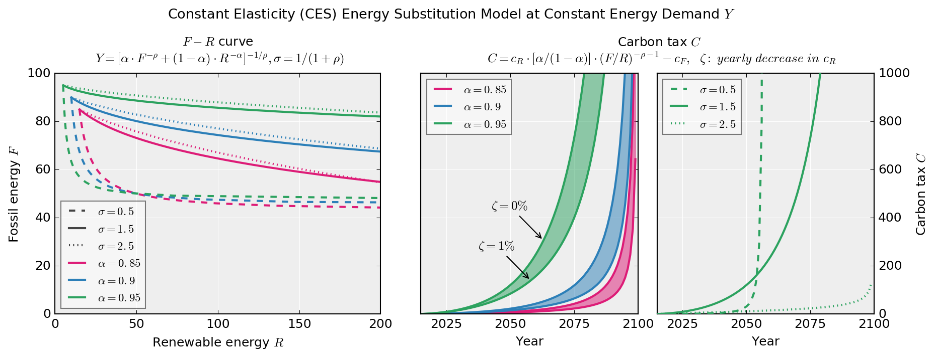

Figure ‎3‑1. Substitution quantities of fossil (F) and RE (R) and corresponding carbon tax levels modeled using CES function for a constant output and variable: initial shares (a), elasticities of substitution (σ), and rates of decrease of RE cost (ζ).  
source: own work

The absolute factor input values, i.e. F-R curve, is virtually never revealed in practice in the IAM results. Nevertheless, it is an important and tangible indicator that can be used to examine how aligned model forecasts are with historical experience. In this setting, it contradicts any reasonably expected technical substitution behavior. In our examples, when the global average F share is 85%, in order to reduce it down to 55%, it requires RE sources to be increased 13 times (for σ=1.5). This occurs progressively as for every unit of fossils that is substituted, it requires more and more RE to replace the same amount of fossils due to the decreasing marginal rate of technical substitution of RE with respect to them. We highlight the fact that this result is contrived as it is estimated with absolutely no reference to the technical capabilities and specifications of the two resources.

By transforming physical inputs to prices ( ‎3‑2 ), economists and modelers manage to move away from the shakier technical areas to the familiar realm of prices. It is much harder to argue with prices although their exponentially increasing behavior is as much a baseless artifact of the CES application. The carbon tax trajectory shows that it becomes exponentially harder to switch from fossils to renewables. This is not even a 100% substitution but barely a 50% one, yet carbon taxes reach 1000 times the unit cost of the fossil energy resource. The exponential rise in the price of F needed in order to force its replacement by RE corresponds to the exponential increase in the quantities of RE “needed” to replace a unit of F. Essentially, the use of prices veils the CES-driven behavior of the physical quantities. Of course, no assumption of increases in the prices of fossil resources would compensate for such radical increase in the tax levels even considering depletion or other market effects.

Since projected future energy demand has an increasing total output, we also include a model with a constant growth rate in the energy demand in Figure ‎3‑2. The effects discussed above are now exaggerated on both the quantities and the prices side as the fossil output needs to keep increasing marginalizing the effect of the RE and making it that much more difficult to reach a high substitution level.

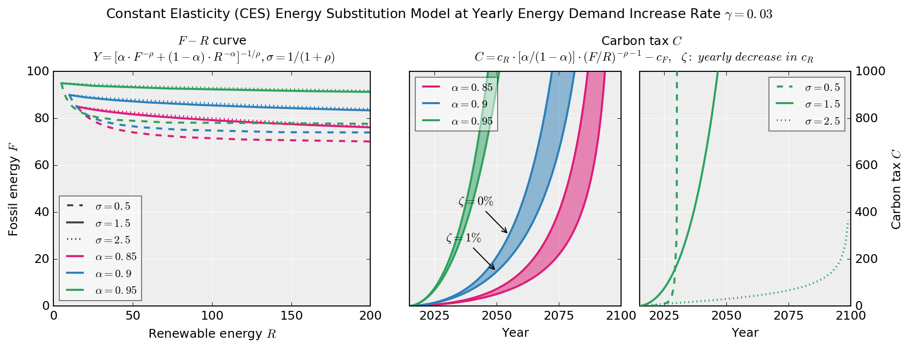

Figure ‎3‑2. Substitution quantities of fossil (F) and RE (R) and corresponding carbon tax levels modeled using CES function for increasing output at rate (γ)=3% and variable: initial shares (a), elasticities of substitution (σ), and rates of decrease of RE cost (ζ).  
source: own work

This example of a CES application demonstrates the fundamental characteristics and sensitivity of CES and highlights the fact that the modeled behaviors, e.g. the exponentially increasing carbon price, are artifacts not based on the characteristics and dynamics of technological substitutions. Yet these artifacts are featured as primary results in the IAMs as discussed next.

## CES energy technology transition fallacy

(Cai, Newth, Finnigan, & Gunasekera, 2015) developed a hybrid CGE model to study global carbon tax and the pathways to mitigate carbon emissions. Their state-of-the-art, hybrid model, called GTEM-C, was designed to combine the top-down (CGE) model with the bottom-up engineering details of energy production and consumption based on a previous the version of Global Trade and Environment Model (GTEM). The improved version uses a technology bundle approach in addition to the classical CES. For electricity generation, the bundle includes nuclear, hydro, wind, solar, biomass, waste, and other renewables in addition to fossil fuels. GTEM-C uses different variants of the CES function in several calculation stages, including switching among factor productions for the total economic output but also among different technologies of energy generation. As shown in, Figure ‎3‑3, GTEM-C utilizes a combination of Leontief functions, constant return of elasticities homothetic (CRESH) functions – a CES variant (Hanoch, 1971), and typical CES to create a nested structure for industrial output. So despite the bottom-up claims, the entire edifice is structured using the CES method.

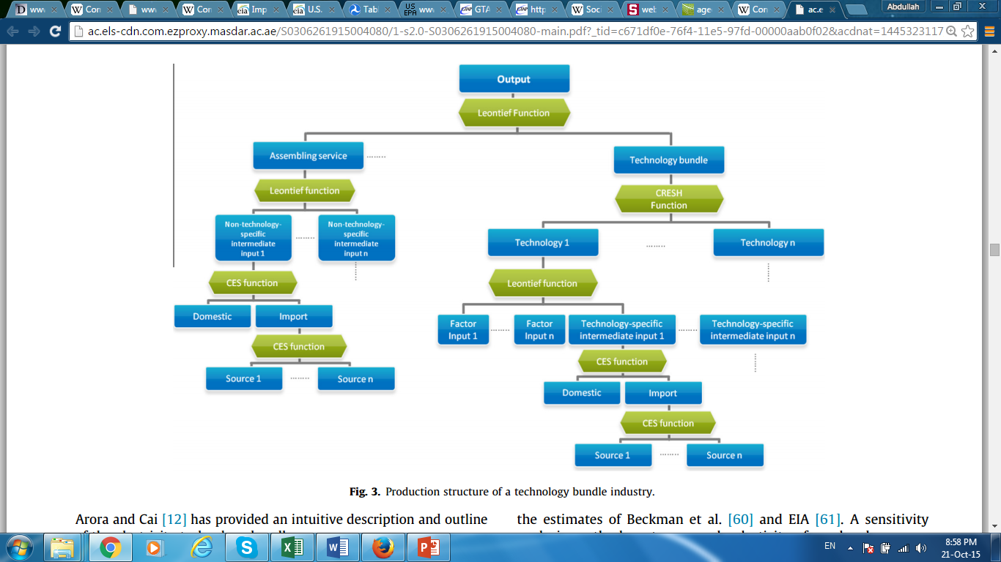

Figure ‎3‑3. Industrial Production Structure in GTECM-C utilizing technology bundles  
source: : (Cai et al., 2015)

Another well-regarded model that exhibits the same artifacts is the MIT Emissions Predictions and Policy Analysis (EPPA) v4 (Paltsev et al., 2005). EPPA is a recursive-dynamic multi-regional CGE model built with the aim to incorporate global economy, trade and GHGs abatement dynamics under a carbon or general tax. It is the economic engine for a broader IAM (the IGSM). The model has been updated so that it includes “*a wider range of advanced energy supply technologies, improved capability to represent a variety of different and more realistic climate policies, and enhanced treatment of physical stocks and flows of energy”.* Nevertheless, it is constructed using the CES function and its variants (Leontief and Cobb-Douglas) for all type of production output, including energy, and final consumption. The treatment of RE by Paltsev et al. is “*as imperfect substitutes represent[ing] the unique aspects of these renewable technologies. While they can be well-suited to some remote locations, they also suffer from intermittency that can add to their cost if they were to provide a large share of electricity production*.” The elasticity of substitution chosen permits gradual but limited adoption only as prices of other technologies rises. Recognizing a limitation in the treatment they refer to work by (Cheng, 2005) on integrating intermittent sources like wind in CGE modeling. The approach proposed by Cheng may have merit but the entirely counterintuitive result from its application is edifying. Cheng’s assumption that all intermittent sources require fossil back-up, i.e. ignoring non-fossil storage options, leads to the elimination of all such sources in a high carbon price scenario by the end of the century relying solely on nuclear, hydro and carbon-capture fossil options!

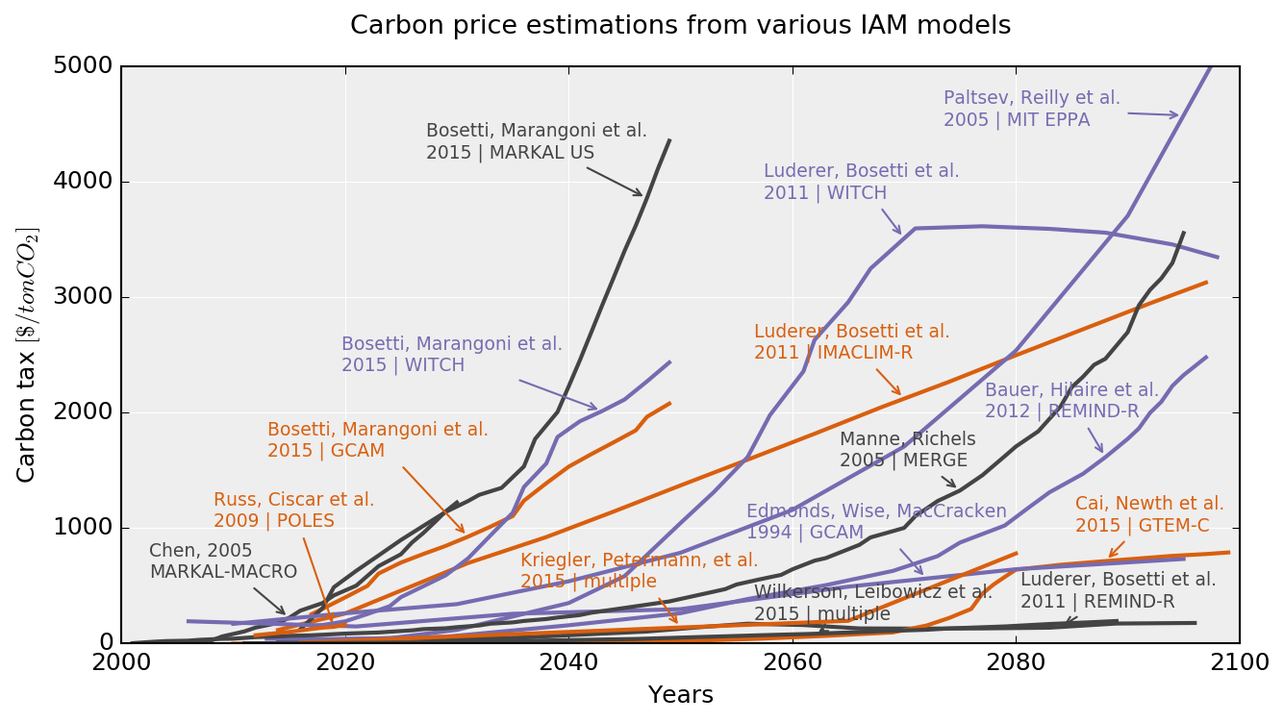

Figure ‎3‑4. Carbon price estimations from various IAM models[13]  
source: own work, data sources: see graph annotations, data is presented as processed, after unit conversions

As intuited from its structure, EPPA results follow the expected pattern. Required carbon prices need to rise exponentially to very high levels (5500 $/tCO2 or about seven times higher than in previous paper as shown in Figure ‎3‑4) in order to bring carbon emissions back to 1990 levels by 2100 and allegedly stabilize CO2 concentration at 550 ppm.

Recently efforts are under way to compare the sensitivity across IAMs in a consistent way. They do find differences but not substantial ones and fail to question the fundamental, technical validity of the results. In these studies the carbon price becomes exogenously set and the resulting behavior of the technical inputs is monitored. (Wilkerson et al., 2015) contrasted three major models (GCAM, MERGE and EPPA) and their results are similar. Using either a quadratic increase in carbon tax or a carbon shock all three models show that the primary energy input in the future remain fossil fuels albeit with CCS. This study is notable in that it shows extreme rate changes of technical solutions seemingly without recognizing the physical impossibility of the task; GCAM shows a quadrupling of nuclear energy within 5 years, while MERGE deals with the shock by increasing biomass with CCS ten-fold within a decade. Along similar lines, (Kriegler et al., 2015), compared a larger number of models but the relevant results remain similar. Using the metric of transformation index (with 0 no change and 2 total change) the final energy mix scores values from 0.3 to 1.1 and primary energy mix from 0.9 to 1.6 with GCAM scoring the highest value with carbon prices reaching to more than 1700$/tonne. While the detailed technology mix is not clearly disclosed in this setting, by comparing the GCAM projections of the Wilkerson et al. paper we can assume that the bulk of this “transformation” is based on the growth of nuclear and biomass with CCS. The fact that biomass is considered by IAMs as much more costly to replace than RE is reinforced in a recent model survey (Luderer et al., 2013).

## Policy implications of the CES fallacy

The IAMs we have discussed in the previous section are very consistent in finding the need to exponentially increase the carbon tax reaching several thousand constant dollars per tonne towards the end of the century. The policy interpretation of these fallacious results can come from the modelers themselves: early on, Nordhaus found that essentially doing nothing is an optimal policy and then proceeding to expand on entirely unsubstantiated claims of the low cost option of climate engineering (Nordhaus, 1992). Since then researchers refrain from making explicit recommendations letting their carbon price findings to speak for themselves. We identify three main problems resulting from relying on these flawed IAM results for energy policy: *price diversion, sticker shock, and technological myopia*.

Price diversion refers to the tendency to leave all physical planning aside in favor of price setting. Since all economic models dealing with technological projections divert the discussion towards the question of pricing as a policy mechanism it is natural for the policy makers to adopt this thinking. While the social cost of carbon may be an interesting if highly indeterminate number (Allen & Frame, 2007), using it to guide policy decisions in a very dynamic technological transition environment where the new technology costs drop faster than any technology forecast and the price of the commodities fluctuate randomly is counterproductive. This is so because it creates the false impression that setting a price (perhaps even a large increase in the future cf. (Wilkerson et al., 2015)) would be sufficient to meet the targets. When what is needed is physical system planning relying on setting energy availability targets and phase-out strategies that inform the business sector, instill trust in the transition reality, and fuel reinforcing economies of learning and scale.

Sticker shock is the reaction to the exponentially increasing requirement of carbon prices and the estimated “costs” of mitigations. Policy making stakeholders instinctively perceive that raising carbon taxes to the thousands when it is barely possible to pass legislation for such a rate in the low teens is politically futile. When humans are faced with what seems an impossible task subconsciously take refuge to resignation. Sisifus’ optimal strategy is to stop pushing the rock up, same as for average students graded on a curve. Admittedly speculative, resignation is the least helpful psychological attitude when dealing with what is a civilizational crisis. More practically, a high carbon price is directly related to a perception of a high cost of alternatives. This prevents policy stakeholders from undertaking long-term technology-based planning.

This reinforces the effects of technology myopia. In IAMs that improperly use the CES function, the costs of incorporating new technologies (i.e. adding a non share-preserving possibility) becomes prohibitive and they revert to the technology shares that already exist: fossil with CCS, nuclear, or biomass. This becomes facilitated not because nuclear, CCS, or biomass are viable technologies or competitive or able to scale in the necessary time frame but simply because such technologies are already included in the original formulations of the production mix and it is easy to model them with a known increase in cost. This dynamic is responsible for the ubiquitous but spurious finding that CCS including biomass with CCS (i.e. negative emissions) is a significant part of any viable technology mix for achieving a low concentration pathway, but also the RCP2.6 scenario in (van Vuuren et al., 2011). When policy makers review the results they are likely to inherit the models’ technology myopia.

## Alternative approaches to CES-based IAM modeling

To start correcting this flawed approach, a review of empirical findings should be a critical first step. Energy and economy support each other in a reinforcing relationship (R. U. Ayres & Warr, 2005). If the economics of IAMs were correct, when looking at past transitions, the costs of substituting the last steam locomotive or whale-oil lamp would have been tremendous but, of course, they were not. In fact the more substitution progressed, the transition accelerated becoming easier and faster until when close to saturation it started slowing down again. The slow-down was not price induced, i.e. the incumbent technology was not becoming cheaper in response, but a reflection of dynamics of niche markets and social inertia. This S-curve (defined in the simplest form by the logistic function) behavior of technological transitions is well established across economic sectors (Christensen, 1997; Schumpeter, 1943) but also in energy system transitions (R. U. Ayres, Ayres, & Warr, 2003), (Fouquet, 2010), (Grubler, Nakicenovic, & Victor, 1999) and as shown in Figure ‎3‑5. In the widest documented sampling of technology deployment trajectories, the pattern of exponential deployment rate and exponential cost reduction in technology diffusion was consistently observed (Nagy et al., 2013).

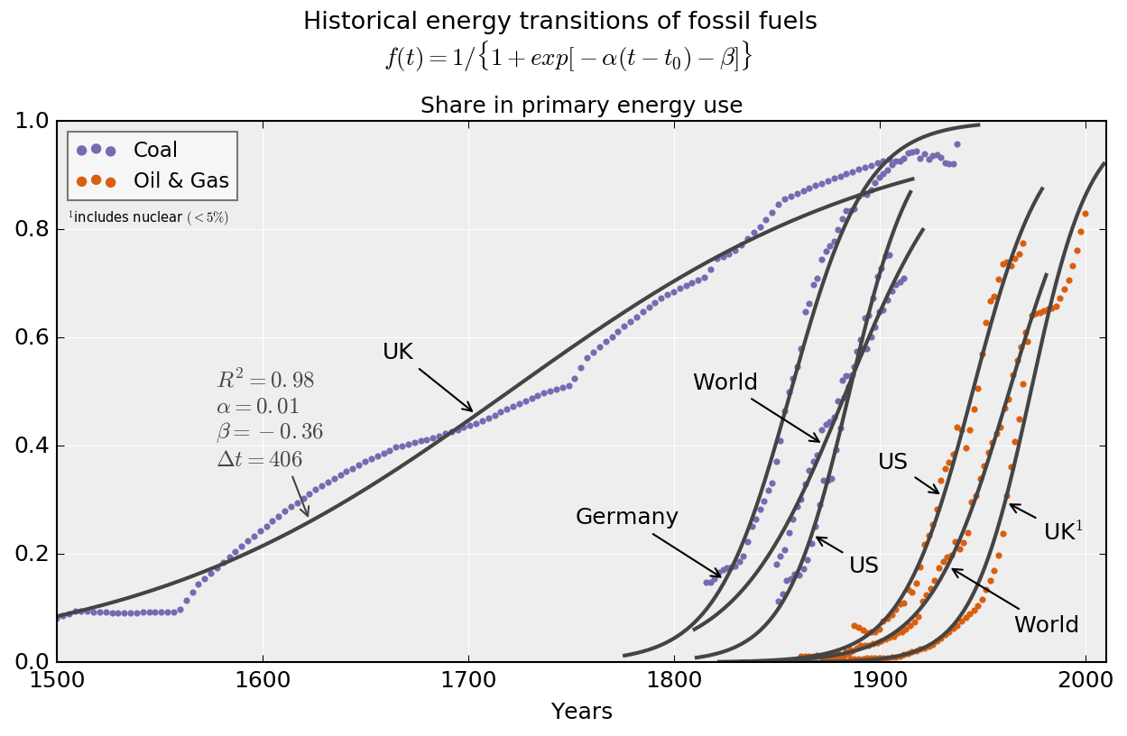

Figure ‎3‑5. Historical Energy Transitions Data and S-curve fits   
source: own work, data sources:

The recognition of such dynamics is not foreign to economists – in fact it was explored early on using the logistic function and its variants (e.g. (Mansfield, 1961)). The logistic function has been used successfully to describe with excellent fits historical energy transitions (Marchetti & Nakićenović, 1979) on a technological/social basis but also on a physical depletion basis with the well-known Hubbert curve (Hubbert, 1956; Maggio & Cacciola, 2009). Other approaches include: The Gompertz-curve,a generalized version of logistic function with asymmetric early diffusion and saturation slopes – commonly used in biology (Kozusko and Bajzer, 2003), technological forecasting (Martino, 2003) and for growth in general (Turner et al., 1976), and differential equation-based model, of which the most well-known is the Bass Diffusion (Norton and Bass, 1987) model (a Ricatti differential equation with constant coefficients), originally developed for single product adoption in a fixed-population market – an analogue of which would be the energy system and competing technologies. The solutions of the Bass equation contain both the logistic function and the Gompertz-curve as special cases.

Perhaps the key characteristic of an S-curve transition with the CES function is that it cannot be modeled by one as it fundamentally presents a relationship with a *dynamically* evolving elasticity. Taking this as a starting point, we find that it is possible to better approach S-curve transition dynamics in the existing modeling formulations by exogenously adjusting the elasticity of substitution. Using the sample formulation in section 3.2.2, we demonstrate this effect using both linearly and exponentially decreasing elasticities (see Figure ‎3‑6 for the constant energy demand case and Figure ‎3‑7 for the increasing demand). We believe that developing this approach and calibrating it against the expected evolution of the technical profiles of the substitutes offers a viable compromise that can maintain the relevance of the existing models.

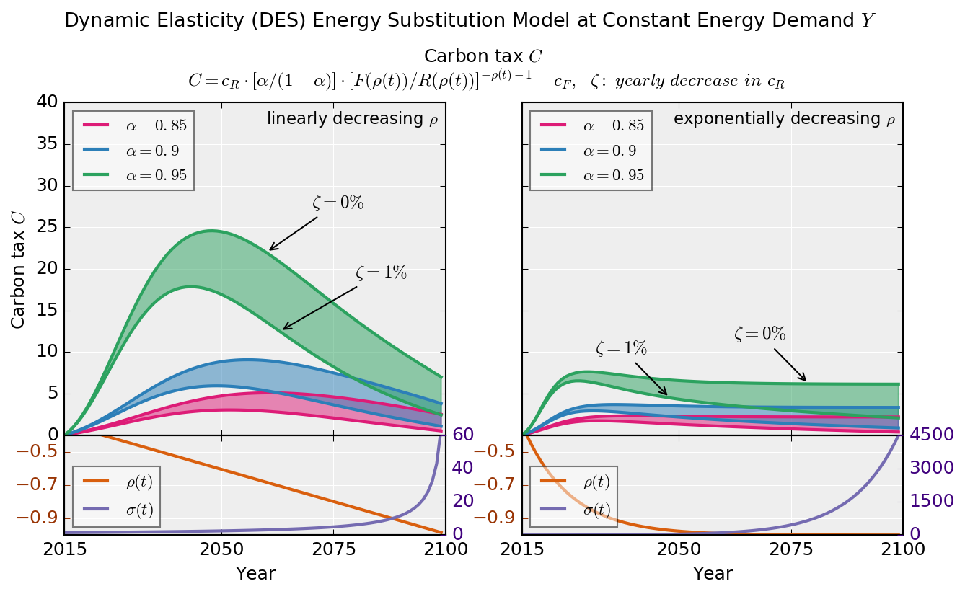

Figure ‎3‑6 Using a Dynamic Elasticity Energy Model with linear and exponential decrease of the elasticity (ρ) for constant output  
source: own work

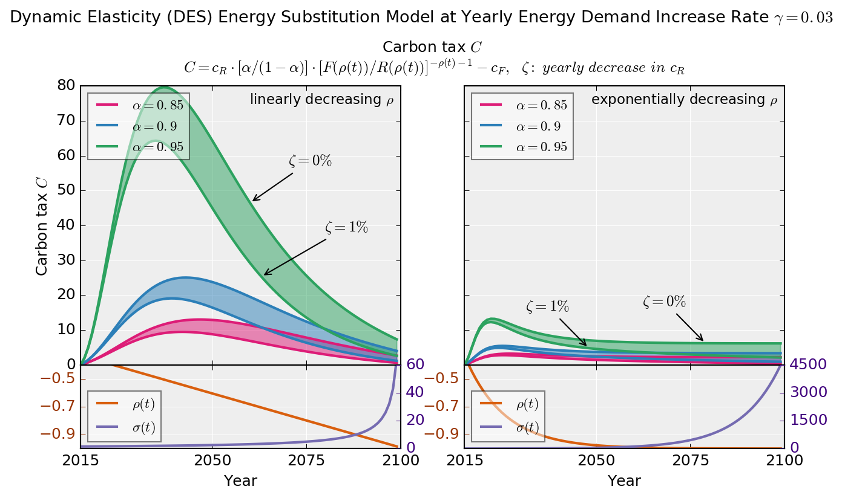

Figure ‎3‑7 Using a Dynamic Elasticity Energy Model with linear and exponential decrease of the elasticity (ρ) for increasing output  
source: own work

While a carbon price peak may be counterintuitive to economists’ marginalist thinking, in practice, it is what should be expected based on the dynamics of technical diffusion. Economies of scale, scope, learning, and the initial adopters pull of followers form parts of the technology diffusion process. At the absolute worst case, the carbon price would be capped by the cost of the substitute technology even if it *is* inferior and therefore would have no reason to become exponential. Even today the back-stop alternative technologies have either reached or are within reach of direct competition with fossil fuels on several fronts while maintaining a strong momentum towards cost reductions.

Change is inherent in an energy system that is undergoing a transition. Efficiency and demand shifting are already happening and opportunities to reduce waste are actively sought. In key sectors like transportation, changes like a modal shift from air travel to high-speed rail provide important avenues to utilize the renewable energy supply (Sgouridis et al., 2011) competing directly and even entirely subsuming the air service once the rail connections become operational for distances less than 500km. For automobiles and residential energy storage battery technologies are well on their way to become directly competitive (Rockström et al., 2009). On the supply side, the levelized cost of energy (LCOE) trajectories for wind and even more for solar photovoltaic have been consistently declining becoming directly competitive with wholesale electricity prices in several regions. While it is correctly pointed out that LCOE of RE does not account for the full cost of renewables integration (Joskow, 2011), it is insufficient to rely on the estimated costs from ramping up the fossil-fuel back-ups as cost indicators. This approach takes as a given assumption that storage is expensive but is missing the point that for a sustainable energy system under transition, the combined LCOE of RE plus short and long-term storage including power to liquids are fully representing the system operation costs and there are no additional “integration” costs. Studies that take this physical reality into consideration confirm the existence of manageable upper bound at a global (Pleßmann et al., 2014), or country level analyses e.g. Germany (Schill, 2014), Finland (Aslani et al., 2014; Zakeri et al., 2015) and Japan (Komiyama et al., 2013). In the first study that disadvantaged renewables by not considering long-distance transmission options and the use of hydro resources, the costs of 100% RE-based do not exceed double current retail cost of electricity for the majority of the world population. For the critical long-term, large-scale storage where the proven solutions like pumped-hydro is not possible, the available options include grid-batteries, and power to liquids. These would use electrolysis to hydrogen and then hydrogen to liquids processes. The latter provide avenues for creating drop-in alternatives for applications that require energy dense fuels in addition to acting as grid support.

Expecting the carbon price to grow by several factors higher than this back-stop cost has no physical basis. Of course, as these technologies diffuse their cost would go down. Even if they do so at slower rate than the RE supply technologies have exhibited recently, their downward sloping costs imply the same for any carbon price. In this section we presented a modification to dynamic elasticity of substitution models that could be a useful way for bridging the development of physics-driven, high-resolution energy models.

## Dynamic climate-energy-economy models

The inability of CES-based IAMs to accurately model energy transitions could be overcome by the proposed adaptation of the cost function to be dynamic, but in this approach we would also not overcome the inherent fallacies embedded in the treatment of GDP (external growth in many cases, hard to conceive a climate damage function). Therefore we take the alternative approach of building a model from the ground up, purely based on physical energy stocks and flows, handling costs through the EROEI of different energy types.

There is only one existing implementation of a net-energy (e.g. one that includes EROEI) based dynamic model (Dale et al., 2012a, 2012b), however, there is a set of examples of dynamic climate-energy-economy models, going back to the 70s.

Forrester’s originating *World* (Forrester, 1971) model Meadows’ update to it *World3* (1972), revised (2004), were the first global system dynamics models to address the limitations of the exponential growth paradigm and forecast overshoot and collapse behavior of global attributes such as consumption and population. While comprehensive and innovative, all resources were aggregated into one variable. Naill’s natural gas model *GAS1* was the first to disaggregate (1971), but it was mainly focused on natural gas and was limited to the US. This work was also capable of capturing Hubbert “peak”theory (1956).

Starting with 1972, the Resource Policy Group at Darthmouth College and the System Dynamics Group at MIT have developed a series of national energy models for the US, after a winning a grant aimed at reducing dependence on domestic gas and oil: Nail and Meadows extended the natural gas model to include all major energy sources, but no specific renewables yet (*GAS2*) (1972). A major addition for the next iteration of the model (*COAL1*) (1974) was the endogenous incorporation of demand. Further development of this work yielded COAL2 (1977) and FOSSIL1 (1976), which showed that the energy problem of the US is not resolvable in the short term, neither demand nor regulatory policies alone are capable of handling it and demand needed to stabilize, along with the increase of alternatives. This work was one of the most comprehensive energy dynamics models up to date, but it was still limited to US and it was not too specific regarding alternative energies. Naill extended his work after moving to the Department of Energy, resulting the development of *FOSSIL2* and *IDEAS* models (1992), which represents the basis for today’s national energy planning model (Naill, 1992), updating Forrester’s *national model* (1976).

Sterman added economy to *FOSSIL1* which was the first model to capture energy-economy dynamics, as energy was being modeled in isolation from the economy in all previous models. He found that his model’s major behaviors modes were remarkably robust (1982) – which he later used for his model in economy dynamics (1986), A more generic energy dynamics model was developed by Wang et al. (1983).

Also on energy-economy interactions, Richardson and Sterman extended Naill’s natural gas model to account for endogenous technological change and created the *exploration-discovery-production* resource chain. Then, later, collaborating with Davidsen and using a synthetic data experimental technique, they have developed the petroleum lifecycle model (1990) which stood as one of the major supporting bases for the Hubbert theory.

Fiddaman (1995, 1998) extensively studied and added climate interactions to Sterman’s model, inspired from Norhaus’ *DICE* model (1992). His *FREE* model also endogenously accounted for technological change and bounded rational decision making. Fiddaman continued his work on climate-energy interactions, resulting in model updates focusing on global climate policy in (2002a) and (2007).

The collaboration of Sterman, Fiddaman, Jones and others’ at Climate Interactive lead to the development of the *C-ROADS* model (2012), which monitored the effect of national greenhouse gas emissions on climate and temperature. The very recent update of this, dubbed *En-ROADS* (2013) also accounts for the effects of changes in energy and public policy and economy on climate – however, it is not open source for others to access.

FELIX (IIASA, 2014) is a more recent system dynamics model that includes social, economic, and environmental earth systems and their interdependencies, similar to EnROADS, implemented in Vensim, but its active development seems to have stopped.

The first true biophysical, net-energy model of the global economic and energy system was GEMBA (Dale et al., 2012a, 2012b). It has been used mainly to investigate the energy transfer from the industry sector of an economy towards renewables on the event of a large scale-up, as well as the increase in energy investment with the declining EROEIs[14]. It did not include climate constraints in its first implementation. What it did include though was a first image of a potential sustainable energy transition (Figure ‎3‑8) and a Monte-Carlo sensitivity analysis across an array fuel EROI values and potential “reserves” (ultimately recoverable reserves URR for fossil fuels and total energy potential TP for renewables) and their peak production rates – a la Hubbert-shaped production.

The energy sector in GEMBA is modeled as competing and complementary duopolistic market (Figure ‎3‑9 & Figure ‎3‑10), where industrial output depends on the available energy to fuel it, which in turn depends on continuous energy investment, coming at a well-defined cost by EROI and reserves.

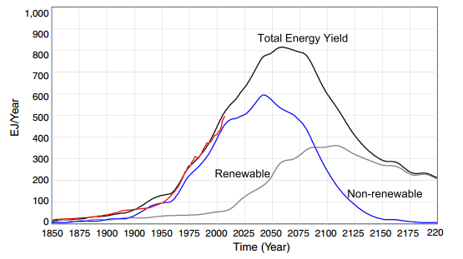

Figure ‎3‑8 A sustainable energy transition trajectory resulting from GEMBA  
source: (Dale et al., 2012b)

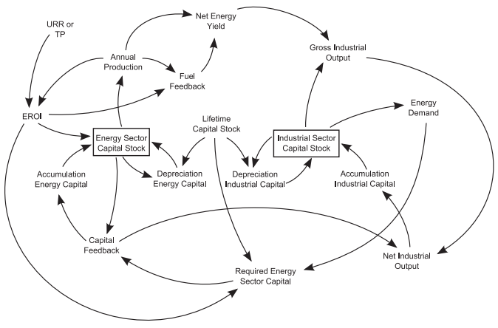

Figure ‎3‑9 Causal loop diagram of the global energy-economy system implementation in GEMBA  
source: (Dale et al., 2012b)

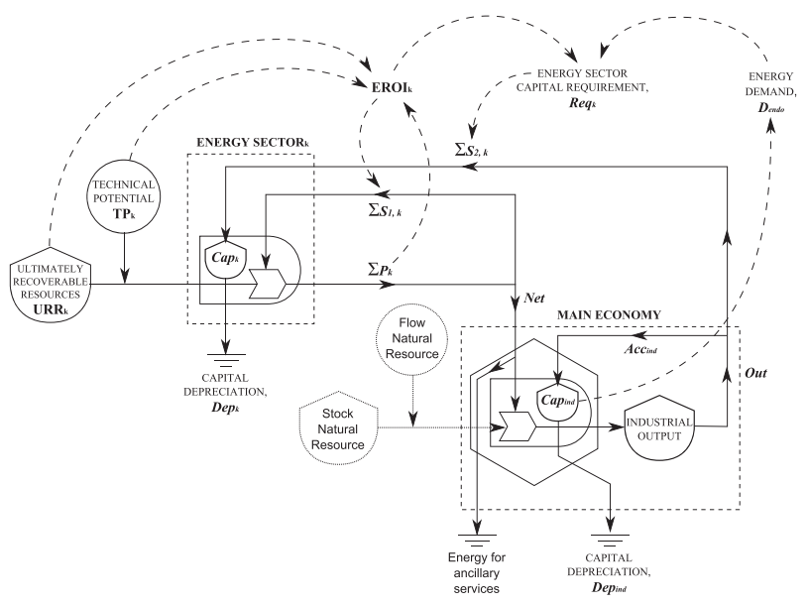

Figure ‎3‑10 Energy-economy system interactions as a circuit diagram (analogous to a stock and flow model) in GEMBA  
source: (Dale et al., 2012b)

Since GEMBA’s last publication was in 2011, a considerable amount of new data has surfaced – especially on renewable installation rates, EROEI and global GIS data on resource potentials – allowing a recalibration of it. In our sustainable energy transitions analysis presented in chapter 4, while we will reconstruct a dynamic biophysical model from the ground up based on the theoretical foundations of the transition – also to be defined in the next chapter – we follow GEMBA’s approach as a broad guideline.

System dynamics models – including GEMBA and EnROADS – however, also have their disadvantages, as their structure is rigid. In order to be able to model a global energy market and the corresponding energy trade network, we will have to turn to an alternative mindset and construct a hybrid system-dynamics agent-based model in which countries, having energy systems governed by a set of system dynamics rules, can make discrete decisions in time about energy trade. This will eventually be the NETSET model, presented in detail in section ‎4.6.

When talking about model of global energy trade, there is one particular initiative that needs to be mentioned, the GTAP project (Hertel and Hertel, 1997; Peters et al., 2011; Smith and White, 1992). GTAP is a widely used economic input—output model to create social future and it has an extensive breakdown of economic sectors and their respective energy intensities. Since at its core is based on GDP and models climate change in a manner similar to IAMs, it is currently not used in this dissertation and the SET and NETSET models. However, because of its very detailed sectorial breakdown of the economy, in the future it could be very useful to create sectoral SETs for countries.

In this chapter we have conducted a critical overview on the main methodology used today to model climate change and the global energy system: IAMs. We have pointed out that IAMs require a paradigm shift in order to begin providing policy-relevant results that reflect the practical implications of finite resource pools in economic systems that are accustomed to exponential growth. We have seen that in physical terms, our ability to model future economic dynamics and its interactions are very limited if we rely on the underlying “growth mentality” as it inherently prevents us from seeing pivot points. The use of CES functions to model physio-technical transitions that are by definition following a process with dynamic elasticity of substitution is a paradigmatic manifestation of such a mentality, as it reinforces the fiction that changing the current energy mix becomes exponentially harder as we proceed. This can only be associated with vertiginous increases in the carbon price. An alternative approach, should recognize that policy making is beyond simply setting a high price. By this we do not imply that the energy transition can occur unassisted in the timeframe dictated by risk-averse climate change mitigation. On the contrary, recognizing that there are institutional, political, and infrastructural barriers, governance and policy making should act by setting appropriate deployment target of RE and storage alternatives thus accelerating the dynamics of energy transitions historically observed.

After the IAM analysis we concluded the chapter with a brief overview of system dynamics models, an alternative and more physics-based approach to model climate change and energy dynamics.

# MODELING GLOBAL AND REGIONAL SUSTAINABLE ENERGY TRANSITIONS: PRINCIPLES, THEORY AND DYNAMICS

This chapter defines the concept of a sustainable energy transition (SET). We develop a set of guidelines that unequivocally defines a sustainable energy transition. We continue with formulating our net-energy model equations for each of these guidelines, leading to a unified equation for the transition. Parts of this chapter have been published in (Sgouridis and Csala, 2014). We derived a detailed methodology of applying the SET to the global case, followed by a step-by-step conversion guideline for translating the global SET into regional implementations for individual countries. We discuss the implications of displacing primary energy resources with secondary ones in a country energy mix throughout an energy transition, broken down by sectors of the economy. This is followed by the discussion of the impacts of intermittency of renewables on national grids, therefore introducing the need for storage and trade. Frist, we analyze residual load duration curves to estimate the trade-offs between energy investment scale-up and subsequent curtailment versus building and maintaining expensive energy storage. We conclude the chapter through the incorporation of energy trade into regional sustainable energy transitions – including the geographically specific renewable resource potentials, fossil extraction energy intensities, existing trade networks, and historical country cross-influence in energy trade – thereby arriving to the definition of the country-level, networked SET model, NETSET.

## Theoretical considerations on energy investment during SET

Fossil fuel extraction is currently affordable, due to the maturity of the industry. However, the effects of reaching the limit of resources has been encountered already, as shown by the increases in real fossil fuel prices (Hamilton, 2008), especially that of oil (regardless of the latest price-drop, largely due to oversupply, but also more complex geopolitical phenomena (Xiao, 2015)). This is due to the fact that fossil resources are increasingly harder to detect and extract, leading to an increase in the energy investment and subsequent financial investment in the process.



Figure ‎4‑1. Energy transition inflexion point: where the declining share of fossil fuels is matched by that of renewables   
source: own work, data source: concept

This can be formulated by stating that non-renewable fossil reserves must inevitably reach a state of decreasing EROEI. Technological efficiency is increasing with increased research and development (Wright, 1936), which is increasing also proportionally with the scale of deployment but also the potential benefits the technology offers. Hence, as more of a certain technology is deployed, its EROEI can rise until scaling or technology limits are reached. Dale et al. (2011) suggest that EROEI can be represented as a function of two components (Figure ‎4‑2), each depending on the cumulative production:

* A technology component: more efficient technology leading to a net increase in EROEI
* A physical component: lesser resources leading to a net decrease in EROEI



i.e. exhaustion of sites with good generation potential

Figure ‎4‑2. EROEI = *f* (cumulative production)   
source: own work

For a sustainable energy consumption-generation parity it is desirable to have all global energy provided by technologies with an increasing or stable EROEI for the scale of deployment. Likewise an energy mix dominated by renewable energy technologies. Fossil energy generation can only part of the energy mix at an extraction rate lower than *both* the regeneration rate of fossil resources and the emissions assimilation capacity of the planet.

The global and national energy systems will have a transition point when the renewable resources overtake the fossil ones due to the emissions constraints, decreasing EROEI and increasing cost of fossil technologies and the increasing EROEI and decreasing cost of renewable energy technologies. We investigate in depth the timing and dynamics of such transitions. An energetically and economically successful transition from a fossil energy based energy society to a renewable energy based one is what we call a *sustainable energy transition*, and we tie this concept to three well-defined guidelines in section 4.3*.*

There is no experience for such transition on a large scale and modern society has yet to undertake one. Past energy transitions were never absolute in primary energy resource terms. For example, while it is commonly perceived that the fossil fuel era has supplanted the use of biomass, traditional biomass remains a significant primary energy resource exceeding nuclear primary energy (EIA, 2014). The same is true for the transitions from coal to petroleum and natural gas. In other words, the transitions occurred in certain economic sectors (e.g. there are no commercial coal steam ships or rail locomotives – see Figure ‎3‑5) but the resource remained in use in other sectors (electricity) due to price and availability. Even this partial transition needed 100 years of innovation and more than 50 years of diffusion to scale sufficiently (Fouquet, 2010). The study of historical energy transitions is a fairly nascent field. (Grubler, 2012) identifies three key insights:

1. Energy end-use capacity, as a rule, is much larger than generation capacity. This means that transitions in energy services are able to lead the energy supply transitions. Without identifying it as such, it also means that the energy using equipment stock may create lock-in for energy supply.
2. Energy transition rates vary across nations – they are usually slower in large, developed economies but faster in smaller ones - which by implication have a smaller, less extensive infrastructure.
3. The patterns of energy transitions are similar to generic s-curve technology diffusion processes (cf. (Christensen, 1997), (Wilson and Grubler, 2011)): a long experimentation phase with limited uptake, emergence of dominant design(s) that slowly move upward from niche to general adoption, a parallel move down the cost curve through standardization, scale and network economies, and eventual spreading from the lead innovation adopter countries to the periphery countries (see section 3.3).

## Components of the SET energy-economy system and its endogenous dynamics

As we discussed extensively in chapter 3, conventional economists do not readily recognize the tight coupling between energy and the economy primarily because of the perceived abundance of fossil fuels that has allowed energy to be considered a necessary economic factor of production but in sufficient reserve quantities, that, like oxygen, can be accessed as necessary. This fallacious perception has been showcased before (Fiddaman, 2002b; Georgescu-Roegen, 1976; Hall and Klitgaard, 2011; Tainter, 2004). These approaches place energy flows at the foundation for the operations of open, thermodynamic systems like the economic system – giving birth to the field also referred to as *biophysical economics*.

Following this view, in (Sgouridis and Csala, 2014) we adopt an energy-oriented framework that captures the dynamics of energy flows of an economic system in a simple but comprehensive approach, broadly built upon (Dale et al., 2012b). While the emergy concept provides similar perspectives (Brown and Herendeen, 1996; Brown and Ulgiati, 1997; Hau and Bakshi, 2004) it uses a more complicated accounting structure basing fossil energy on solar flux making the representation of the energy economy system unnecessarily complex for our purposes. We identify three main subsystems critical for modeling the transition: fossil energy extraction, renewable energy capacity, and the energy demand system, and use system dynamics causal loop notation for visually presenting them (Sterman, 2000). Initially, the framework represents a closed economy (i.e. one with no imports/exports) which represents the state of the global energy system.

### Fossil energy sub-system

Fossil energy is energy stored underground and, for all types of fossil fuels, (coal, petroleum, natural gas) is characterized, in its broader form, by three stocks: the undiscovered reserves, the discovered reserves, and the total resource extracted (Figure ‎4‑3). Once discovered and prior to peaking, its rate of extraction (power) is demand-driven – i.e. it is more limited by the amount and utilization of existing demand-side capital infrastructure that can use/combust it (i.e. boilers, internal combustion engines, and turbines) than by the availability of extraction capacity (i.e. oil and gas rigs and coal mining equipment). As demand expands lower-quality resources are accessed and as a result the marginal amount of energy required for extraction of the same quantity of energy increases as measured by EROEI (Brecha, 2013; Murphy et al., 2011). In a market system, this becomes the base “energy price” of the energy resource (e.g. the price of internationally traded crude oil cannot be lower than the production cost of the marginal producers like heavy oil and tar sand extraction in the current energy system) and balances the demand for the resource when compared to alternatives.



Figure ‎4‑3. Causal loop diagram of the fossil energy sub-system  
source: (Sgouridis and Csala, 2014)

It is important to note, that the rate of the demand-side capital investment turnover and systemic inertia (primarily because of the financial system) can significantly delay the adoption of alternative resources even if they offer a lower marginal EROEI.

### Renewable energy sub-system

Renewable energy (with the exception of biomass) acts as an energy extender – it allows an upfront energy investment to provide energy returns (equal to the EROEI times the initial investment) over the lifetime of the installation (Figure ‎4‑4).



Figure ‎4‑4. Causal loop diagram of the renewable energy sub-system  
source: (Sgouridis and Csala, 2014)

Renewable energy generation is dependent on the cumulative capacity that has been built since the time that the first renewable energy infrastructure was installed minus the capacity that has been decommissioned at the end of its lifetime. Every time period *t* approximately 1/lifetime of capacity is decommissioned**[15]**. The renewable energy EROEI is subject to a reinforcing feedback due to economies of scale and learning and a balancing feedback due to the installation of renewable resources in the prime locations – those with the highest resource quality – first. Since the absolute maximum renewable energy potential is several orders of magnitude larger than the installed capacity on a global scale (de Vries et al., 2007) we can ignore the renewable saturation loop and assume an exponentially increasing EROEI due to a learning curve with elasticity to installation volume. Unlike fossil fuels that need a continuous energy investment stream but also provide immediate energy return, most renewable energy options introduce a significant delay between the time of the investment and its return (Dale and Benson, 2013). In addition, output variability and the cost of energy storage make renewable energy harder to integrate as a dominant resource in a demand-driven energy paradigm. As a result, substantial demand-side infrastructure investment is required to transition to the supply-constrained energy paradigm of SET.

### Energy economy sub-system

The energy provided by the energy subsystems is made available to the economy. This energy can be either (i) invested in further energy recovery – i.e. building new energy generation infrastructure renewable and non-renewable, or (ii) used for societal needs – e.g. agriculture, non-energy manufacturing, and services (net social surplus). Surplus energy is the key flow that allows a civilization to thrive – it is what permits recreation, experimentation, development and entrepreneurship. In an energy economy representation, we can also identify the portion of the societal surplus that is invested in building or replacing energy-consuming capital - the infrastructure and equipment that transforms secondary energy into desirable energy.

Viewed from the demand-side, energy consumption depends on the size and utilization of the energy consuming capital stock (i.e infrastructure like roads, railways, buildings, etc. as well as equipment -e.g. vehicles, appliances, chillers etc.). The size and vintage of the energy consuming stock is dependent on the past investment and the associated final energy services capacity of the constructed energy-consuming capital – a measure of the final energy capacity that is added per unit of investment. The vintage of the energy consuming capital stock impacts primary energy demand as it changes the technologically dependent conversion efficiency of primary energy to final energy services **[16]**. The cumulative active installed capacity on the demand side can then be described as the difference between the cumulative installed capacities minus the cumulative depreciated capacity.

In the next sub-chapter we connect these systems through 3 SET *principles* – a set of equations that unequivocally define and describe the properties of a successful SET.

## Formal definition of SET and its 3 principles

Currently, fossil resources are not regenerating in any timeframe meaningful for human societies (Princen et al., 2013). Since fossil energy is a limited resource, a substantial uptake of renewable energy is required so that society maintains the available energy needed for its operation and concomitantly, mitigate emission of greenhouse gases. This, albeit with a substantial delay, is expected to lead to a slow-down and subsequent stop or turn-around of global warming sparing the worst negative climate effects on society. The resultant energy gap needs to be addressed through new energy-generating techniques which preferably are emissions-free or they have limited emissions or replacement of the energy consuming stock – both of which require a substantial energy investment. Moreover, the deployment rate of these installations must be in sync or higher than the fossil phase-out rate, so that the global energy demand is met at all times (Sgouridis et al., 2013).

In (Sgouridis and Csala, 2014), (S. Sgouridis et al., 2015) and (Sgouridis et al., 2016a) we have defined SET as: *a controlled process that leads an advanced, technical society to replace all major fossil fuel primary energy inputs with sustainably renewable resources while maintaining a sufficient final energy service level per capita*. Under this framing, a return to a hunter-gatherer society in a massively depopulated planet cannot be considered as a SET; a SET requires a coordinated transformation of both the energy supply and the energy demand side (economy) while the per capita energy service levels (equity) are sufficiently maintained for the duration and the environmental constraints are met (environment).

We have formalized 3 principles to yield the mathematical definition of a sustainable energy transition.

### SET principle I – system carrying capacity constraint

**First***, the impacts from energy use during SET should not exceed the long-run ecosystem carrying and assimilation capacity.* This constraint limits the energy system’s impacts to the planetary boundaries with greenhouse gas (GHG) emissions being critical (Rockström et al., 2009). The fossil CO2 budget for the remaining 21st century is estimated to be between 510 and 1,505 Gt CO2 with a mean of 990 Gt CO2 for a reasonable probability range of staying below the 2°C warming from pre-industrial levels target (IPCC, 2014). Carbon capture and storage (CCS) could potentially be used to relax the constraints on fossil fuels it may not have the capability to scale sufficiently fast. On the RE side, the impact of installations, e.g. in terms of occupied area, should not be environmentally damaging. This appears possible for the scalable RE technologies (primarily solar, wind), whereas bio-derived fuels, nuclear and hydro do not appear able to offer similar scalability because of physical and political constraints (Jacobson and Delucchi, 2011; Moriarty and Honnery, 2012).

### SET principle II – smooth net energy availability constraint

**Second***, per capita net available energy should remain above a level that satisfies societal needs at any point during SET and without disruptive discontinuities in its rate of change.* Energy use per capita is correlated with economic development with high-income countries (extensively discussed in section 2.3.2.1) using on average a per person power (*Dnet*) of 6000W compared to a world average of 2267W on average over 2010-2015 (Figure ‎2‑10). To translate this into the global net power demand (*PSnet*), shown in ( ‎4‑1 ), we multiply by population. For a detailed analysis of expected per capita power demand curves for the globe, as well as individual countries throughout the 21st century, recap section 2.3.2.1 and Equation ( ‎2‑3 ) .

|  |  |
| --- | --- |
| $${PS}_{net}\left(t\right)=D_{net}\left(t\right)∙N(t)$$ | ( ‎4‑1 ) |

### SET principle III – energy investment planning constraint

The **third** SET guideline indicates that *the rate of investment in building renewable energy harvesting and utilization capital stock should be sufficient to create a sustainable energy supply basis without exhausting the non-renewable safely recoverable resources.* Since RE installation rates represent the investment of the energy supply side, the fraction of its available energy society chooses to expend in building renewable energy capital over the total energy - the renewable energy investment ratio – is a critical determinant of future energy availability and an indicator of the effort incurred. The magnitude of upfront energy investment for a given expectation of future energy availability depends on the composite EROEI of the renewable energy portfolio.

Of course, energy is not the only physical input for RE, material utilization of common and rare metals can be significant. Prior work indicates that to a degree there is sufficiency (Hertwich et al., 2015) but higher levels of cumulative installed capacity may be untenable which we reflect in the *transition feasibility index* in chapter 5, but a full material analysis is outside the scope of this dissertation.

## Classification of energy sources considered in this analysis

In order to best capture the dynamics SET and make the problem tractable, we need to define and classify the considered energy sources in the analysis. In we present such a breakdown and classification. We structure energy source into 3 large categories: fossil fuels (see more in section ‎4.5.1.1)‎4.5.3, scalable (4.5.3) and non-scalable (‎4.5.4) resources. We also included regenerated electricity in the form of batteries and power-to-liquids.

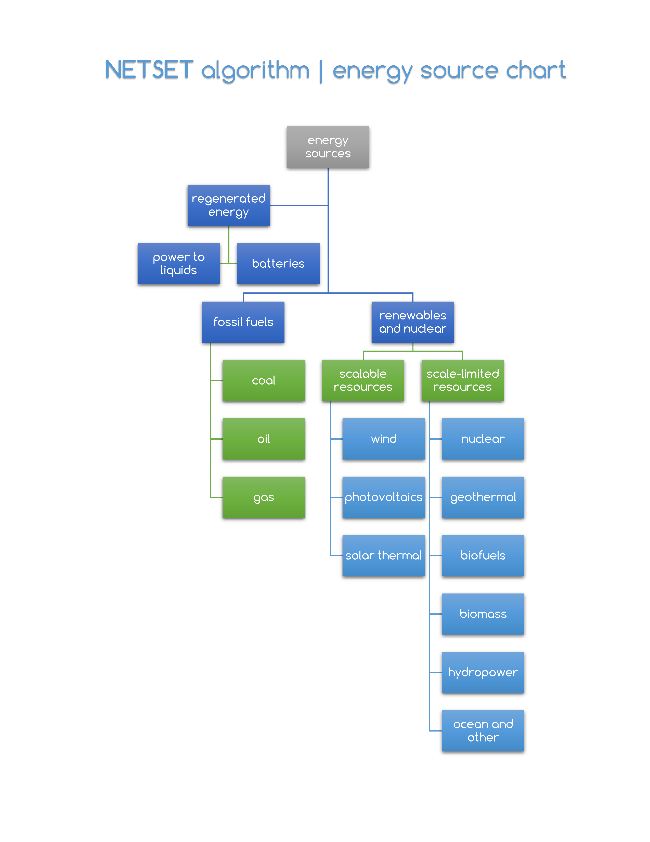

Figure ‎4‑5. Classification of energy sources used in SET (without the regenerated energy part) and NETSET  
source: own work

## Development of the SET unified dynamic equation

In this section, we derive the formal equations governing a global SET. The next section (‎4.6) describes the additional steps needed to convert this into a regional model.

### Societal energy demand and EROEI under SET

Having defined the desired future net primary power (*PSnet*) for non-energy related societal needs, we can establish the capacity deployment profiles of all energy sources in order to meet *PSnet* across the projection timeframe by calculating the capacity installation rates $\frac{d}{dt}P_{i}(t)$, where $P_{i}(t)$ denotes the installed capacity of energy source *i*. Generically, for any resource, the installation rate can be broken down into 3 qualitatively distinct subcomponents ( ‎4‑2 ).

|  |  |
| --- | --- |
| $$\frac{d}{dt}P\left(t\right)=\frac{d}{dt}{PS}_{net}\left(t\right)+\frac{d}{dt}P(t-L)+\frac{1}{τ}\int_{1}^{τ}{I\left(t+k\right)}dk$$ | ( ‎4‑2 ) |

where $\frac{d}{dt}{PS}_{net}\left(t\right)$ represents the change in societal power demand, $\frac{d}{dt}P(t-L)$ is the replacement of the capacity with lifetime *L*, deployed *L* years ago and $I\left(t\right)$ is the energy investment needed in time t to meet the societal power demand required at time *τ* in the future –distributed over the deployment time *τ*.

In order to unequivocally define the SET pathways, we need to formulate   
( ‎4‑2 ) for all energy sources *i*. Based on their different behavior, we can split the energy sources into two main groups: *scale-limited* sources with a *deployment capacity limit* (including coal, natural gas, oil, biomass and biofuels, nuclear and hydropower), and *scalable* including wind, geothermal, solar photovoltaic (PV) and concentrated solar power (CSP). Scale-limited resources are fossil fuel sources (coal, natural gas, oil) that are limited by reserves or emissions and potential renewable sources (biomass, biofuels, nuclear and hydropower) limited by land constraints and/or by low political and public acceptance.

Additionally, to estimate the net energy output, we need to distinguish between *capital-intensive* (wind, geothermal, solar photovoltaic, concentrated solar, nuclear and hydropower) and *operational-intensive* energy sources (coal, natural gas, biomass and biofuels) – recap from section ‎2.2.3. We adjust for the EROEI (*R*) defined as the ratio of gross energy output (*Eout*) over energy invested (*Ein*) shown in equation ( ‎4‑3 ). The main difference between the energy sources is the timeframe of the investment power, dependent on the investment effort duration (*Lin*). If we note the power out of the project, available spread over its lifetime with *L*, for operational-intensive energy sources, we can assume that *L*≈*Lin*(the two are approximately concurrent), while for capital intensive energy sources, most of the investment has to come before *Eout* is accessible – potentially spread over a deployment time *τ*. In our simulations, For all capital intensive resources, we assume an energy deployment time τ = 3, meaning that *Ec(t)* is equally distributed in the years *t-3*, *t-2* and *t-1*.

|  |  |
| --- | --- |
| $$R=\frac{E_{out}}{E_{in}}=\frac{P_{out}∙L}{P_{in}∙L_{in}}$$ | ( ‎4‑3 ) |

#### RE EROEI

The EROEI range reported for RE is large, ranging from less than 5 (e.g. biofuels) to over 200 for hydro (Gagnon 2008) with the scalable technologies, solar and wind from less than 10 to over 40 (Raugei *et al* 2012), (Carbajales-Dale *et al* 2015), (Hall *et al* 2014), (Bhandari *et al* 2015) although even lower system values are reported (Prieto and Hall 2013), (Weißbach *et al* 2013) necessitating the exploration of a wide EROEI range.

The RE EROEI is dependent on two factors: the local quality of the resource and the technology that is used to harvest it (Dale *et al* 2011). The EROEI of a PV module can be very high if deployed in a location with a high insolation or zero if indefinitely stored in a warehouse. This location dependence is partially why there is a large diversity of estimates and need for normalization. We distinguish between the two components by identifying technical EROEI *(RT)* to indicate the RE installation performance under standardized conditions (e.g. insolation, wind speed etc.) that is subject to the learning effect from cumulative installations and a resource quality adjustment factor that is dependent on the weighted average resource quality at the locations that RE is installed (θ). Section ‎4.6.4.4 presents in more detail the calculation of the value of the quality factor θ. The learning curve is approximated by a typical Wright learning curve for the technical EROEI of RE technologies (Neij 2008) assuming a learning factor *γ* for each technology and depending on the cumulative capacity installed *PR(t)*.

Finally, we consider that in order to utilize variable RE some combination of storage and curtailment will be necessary (Barnhart *et al* 2013). Barnhart et al. assuming optimal storage deployment, derive the adjusted EROEI using the stored fraction (*φ*) energy that would have been curtailed without storage, the efficiency of the storage system (*η*) and the embedded energy intensity of the storage technology measured by the parameter of energy stored on invested (*ESOI* or *S*) dependent on the storage technology. We assume that the time to deploy storage is equal to the time to deploy the RE system.

Combining the components of technical EROEI, resource quality, learning effect and storage infrastructure deployment we derive Equation ( ‎4‑4 ) for the system EROEI for RE technology *k*.

|  |  |
| --- | --- |
| | ( ‎4‑4 ) |

The values used for the simulations by technology and resource are shown in Table ‎5‑1, Table ‎5‑2 and Table ‎5‑3.

#### Fossil fuel EROEI

While the EROEI of RE tends to increase due to the learning-curve effect that of fossil fuels declines as a result of depletion (Guilford *et al* 2011). We assume a constant exponential decay rate, specific to each fuel, calibrated from the available EROEI measurements following (Dale *et al* 2011) and subject to $R_{f}\left(t\right)=j+(R_{f}(0)-j)e^{-αt}$. The EROEI values of fossil fuels in 1950 R*f* (0) were 40, 30 and 80, for oil, gas and coal respectively. These are subjected to the historically calibrated 3% time decay (*α*), and stabilizing around value (*j*) 8, 10 and 20 by 2100 consolidating reported data from Fig. 4 and 11 in (Hall *et al* 2014), Table 2 in (Murphy and Hall 2010), Tables 2 and 3 in (Raugei *et al* 2012), Fig. 2 in (Cleveland 1992). While this is a time-based factor rather than the more appropriate capacity-based one, it is calibrated to incorporate the learning and resource depletion effects historically (before 2014) based on the quoted sources. The values post 2015 do not have a substantial effect on the energy time series output, because the fossil fuel phase-out is very steep and controlled by the carbon cap so even if the average EROEI did improve towards the end of the phase-out, the amounts extracted at that time are insignificant.

### Dynamics of fossil fuels under SET

In order to satisfy the constraint put forward by SET guideline I, fossil fuels under SET will follow a trajectory that fits into predefined emissions limits. In section 2.3.2.2, we have extensively discussed the creation of such curves for a given planetary carbon budget, defined as per Equation ( ‎2‑5 )( ‎2‑2 ).

In the initial transition years the energy input for achieving the desired RE installation rates may exceed the energy delivered from the capacity installed (Dale and Benson, 2013). In this case, additional fossil resources are included upfront reducing the availability of the fossil resource later and then subtracted from the latter part of the fossil curves.

### Dynamics of renewables under SET

From ( ‎4‑2 ), any change in demand and the (external) trajectory of the fossil and scale-limited sources *PXnet(t)* define the addition of net renewable power needed *dPRnet* ( ‎4‑5 )

|  |  |
| --- | --- |
| $$\frac{d}{dt}{PR}_{net}\left(t\right)=\frac{d}{dt}\left\{{PS}_{net}\left(t\right)-\left[{PF}_{net}\left(t\right)+{PX}_{net}(t)\right]\right\}+\frac{d}{dt}{PR}_{net}\left(t-L\right)$$ | ( ‎4‑5 ) |

Recognizing that capacity retirement patterns do not form a perfect pipeline delay due to stochasticity over the lifetime *L*, we substitute the term $\frac{d}{dt}{PR}_{net+}\left(t-L\right)$ in ( ‎4‑5 ) with a first-order delay $\frac{{PR}_{net}(t)}{L}$.

Equation ( ‎4‑6 ) defines the power investment needed to make available the renewable energy capacity addition at time t+τ for all renewable energy types *k*, individually.

|  |  |
| --- | --- |
| $$I_{k}\left(t\right)=\frac{d}{dt}{PR}_{{net}_{k}}\left(t+τ\right)∙\frac{L_{k}}{R_{k}}$$ | ( ‎4‑6 ) |

For completeness, we incorporate a Wright learning curve for the EROEI of RE technologies (Neij, 2008). Assuming a learning factor *γk* for each of the renewables,   
equation ( ‎4‑6 ) modifies to:

|  |  |
| --- | --- |
| $$I_{k}\left(t\right)=\frac{d}{dt}{PR}_{{net}_{k}}\left(t+τ\right)∙\frac{L_{k}}{R_{k}∙a_{k}(t)}, a_{k}(t)={\left[\frac{PR(t)}{PR(t_{0})}\right]}^{1+γ}$$ | ( ‎4‑7 ) |

We spread the investment burden proportionally to the share of the sources in the net power mix for each year. If more renewable investment is needed than the power available to meet the desired demand, additional fossil-fuels are extracted (the “seed”) to cover the deficit, yielding the investment shares *μi.*

We define the *renewable energy investment ratio* for each of the renewable energy types present in the system, as per equation ( ‎4‑8 ):

|  |  |
| --- | --- |
| $$ε_{k}\left(t\right)=\frac{I_{k}\left(t\right)}{\sum_{k}{I_{k}\left(t\right)}+{PS}_{net}(t)}$$ | ( ‎4‑8 ) |

### Scale-limited low-carbon energy resource options

#### Carbon Capture and Storage Feasibility and Scaling Limitations

Carbon capture and storage (CCS) systems offer a possible way for extending the fossil fuel usage beyond the carbon cap limits if GHG emissions is captured and directed into long-term storage in geologic formations or the deep ocean. We chose to exclude technical CCS as an option in this analysis for the following reasons:

1. Slow to scale. Until now, there are very few CCS plants that are commercially operating and their large-scale adoption is unlikely before 2035 based on the deployment timescales for large engineering technologies (Haszeldine 2009). At that point SET would need to be well advanced and the contribution of CCS would be marginal at best.
2. Operational energy penalties. The operational energy penalty for a complete CCS cycle (including capture, capture medium regeneration, compression for transport, and compression for formation injection) is significant. From applying first principles, a 40% system penalty is considered achievable and 29% is a good target for post-combustion capture systems (House *et al* 2009).
3. Lifecycle energy penalties. In addition to operational energy penalty, significant capital investment is needed in terms of capture systems (doubling the cost of the power plant) and the pipeline and pump network that is needed to transfer the CO2 to appropriate geological formations. Combined, they approximately halve the EROEI of the fuels to which capture is applied while around 10% of the produced CO2 would still be emitted.
4. Opportunity cost. Operational and capital energy penalties translate to additional financial costs per unit of energy produced that are close to *current* RE levelized cost of energy making the future large-scale deployment of CCS for energy generation uneconomical and therefore unlikely.

Nevertheless CCS infrastructure could be useful for sequestration of carbon from the organic cycle if applied to biomass combustion. Also, this discussion does not apply to organic or mineral capture processes, e.g. oceanic fertilization in which the existing atmospheric carbon is captured by biological or physical processes but which should have no impact on the use of fossil fuels for energy.

#### Scale-limited Non-fossil Options (nuclear, hydro, bio-energy, geothermal, ocean)

In principle, the methodology described in the previous section (‎4.5.3) can be applied for any other RE and nuclear resources aside from solar and wind. Nevertheless, because of their limited scalability, we deploy these resources with pre-determined trajectories at levels that fall within the considered constraint forming the “base” above which the scalable RE builds. Non-scalable resources are otherwise accounted as a normal resource with their own EROEI. Resources are considered non-scalable because of reserve constraints (geothermal, hydro, uranium for nuclear), technical constraints keeping them still in pilot scale (tidal, engineered geothermal, thorium reactors) or conflict with other needs (e.g. food for bioenergy, security for nuclear, and ecosystem and community preservation for hydro). We forecast these resources by extrapolating from historical values and saturating at a level that we consider reasonably sustainable. Figure 1, in the main article, also shows the default pathways of scale-limited energy resources that we have assumed while the text below explains our rationale. It should be highlighted than the methodology described in Section 2 can accommodate any number of resources so the addition of these options is methodologically simple and can be done later if practical applications show better potential than expected taking a portion of the other scalable RE contributions. Since the EROEI of a competitive new resource would be higher but still close to the one it displaces, the generality of our findings is not impacted.

*Nuclear* expansion is controversial (Pearce 2012) and has been minimal in high-income countries due to cost overruns, seeming lack of cost-competitiveness, difficulties with waste storage, and the high-risk perception by the general public. In fact the trend is one of de-nuclearization in countries like Germany and Switzerland. Developing countries are picking up the slack with reactor construction but the growth trend is slow and does not seem likely to grow faster especially given the fact that total costs are non-competitive with RE resources and construction rate peaked in 1976. Additional constraints are the fossil-fuel reliance of the industry (Sovacool 2008) and the availability of low-cost Uranium, which according to careful estimates is nearing its peak (Dittmar 2013) putting under question the economical operations of existing and further deployment nuclear plants. The current operable nuclear capacity is 384GW with 68GW under construction and 561GW planned or considered by 2030 (WNA 2016). Given delays, cancellations, and accelerated closures, for our SET maps we assume that nuclear energy’s contributions will peak in 2055 doubling the current capacity (100% increase) and will slowly scale down by 20% afterwards until 2100 as decommissioning rate is higher than new installations.

*Large hydro* is a very significant complementary resource to variable RE as it provides a reliable mode that can quickly load-follow and be used as a storage option in case of excess production (Farahmand *et al* 2014). Nevertheless, hydro faces a similar scaling challenge since much of the resource potential has been tapped in Europe and N. America and future deployment is controversial in several regions especially in light of less disruptive RE (Kahn *et al* 2014). The dependence of hydro on precipitation make it vulnerable to climatic variability (Gaudard *et al* 2016) and several countries that face persistent droughts have seen their hydro output drop precipitously as a result. While this has created havoc in energy systems in Africa, it is arguably a regional issue and in the long-term it is not expected to significantly impact hydropower output even when accounting for climate change (Cole *et al* 2014), (Hamududu and Killingtveit 2012).Finally, the flooding of forested areas does increase GHG fluxes, such an increase can be managed and therefore, we don’t think this would be a significant impediment (Demarty and Bastien 2011). Smaller hydro, with run-of-the-river and small dam installations does have significant potential to grow but from a fairly small base and without the dispatchability advantages of large-installations. Given the projected boom in planned construction (Zarfl *et al* 2015) and the synergies of hydro and variable RE, we assume that hydropower expansion will peak in 2055 at 180% of current capacity and slowly scale down by 10% in 2100.

*Bioenergy* growth should be studied at high-resolution, regional, and technical scales and would be constrained by the extent that it conflicts with food needs and land availability (Harvey and Pilgrim 2011) raising concerns of indirect land use change (Havlik *et al* 2011) (Searchinger *et al* 2008), that is as areas are converted from food to bioenergy other areas will be transformed to make food. The apparently exaggerated estimates of biomass contributions in IAMs largely derives from the failure to account for these issues and the conflicting policy requirements with regard to agriculture and conservation (Creutzig *et al* 2012). While there are benign options to address the food-energy-environmental trilemma (Tilman *et al* 2009) their scalability in the face of the constraints above is inevitably limited. While some resources like woody biomass have high theoretical potential, economic and ecological constraints suggest that they would only really be able to offer minimal usable surplus (Smeets and Faaij 2006). The conversion of the large (but not accurately estimated) current uses of primary/traditional biomass into higher conversion efficiency processes could increase the contribution of biomass in the secondary/final energy services domain but not affect its primary energy representation. In our scenarios, biomass and waste-to-energy are assumed to continue their historical growth rate before plateauing at a level 50% greater than today by 2100. Biofuels are assumed to triple by 2055 and stabilize at that level until the end of the century.

*Geothermal* energy has high capacity factors and a long history of deployment in high quality areas. Alas, such areas are limited giving an estimated maximum potential of 2TW. Lower grade heat can still be utilized for thermal applications adding another 4-5TWth (Stefansson 2005) We use these numbers for bounding the geothermal energy contribution considering that engineered or enhanced geothermal resources EGS that have a significant potential (Tester *et al* 2006) are unlikely to scale up significantly in the next decades given that no project is yet to be successfully piloted.

*Other RE* energy types may have potential. Tidal energy is predictable and consistent but with the penalties of working in corrosive marine environments. While tidal barrages have been deployed for decades, the costs and environmental impacts of building the barrage have stalled expansion. Currently less than 500MW are installed so far (with a stated potential of >60TW). Standalone tidal turbines are still at pilot level and theoretically viable but significantly more expensive than alternatives (Rourke *et al* 2010) (Allan *et al* 2011). These facts make the plausible contributions of marine technologies in the next 30 years quite small due to delays in scaling so we do not consider them separately. We also do not consider ocean thermal as it has never been piloted and the thermodynamics (temperature differential) imply very low EROEI.

Table ‎5‑4 at the end of the results section presents the assumptions on capacity deployment of the scale-limited resources used in the global SET simulations. For NETSET, latest available (2014 or 2015) values have been preserved and carried forward until 2100.

### 

The simulations we conduct are designed to highlight the evolution of SET under various assumptions (for demand, EROEI, phase-out strategy, etc.). In order to be able to compare between the advantages of each of the resulting trajectories, we need to develop a metric that combines the strengths of all paths into a composite indicator.

Figure ‎4‑6 Figure ‎4‑7

|  |  |
| --- | --- |
|  | ( ‎4‑9 ) |

Figure ‎4‑6 In section ‎5.3.8, we include two alternative TFI trajectories and present the resulting changes in simulations.

Figure ‎4‑6. Weighting distributions for the relative feasibility of: RE EROEI *f(x)*, net energy demand *g(x)*, peak renewable energy investment ratio *h(x)*, and average renewable energy investment ratio *k(x)*.  
source: own work for (S. Sgouridis et al., 2015)

### Illustrative global SET example

provides an illustrative example for a successfully implemented SET. We used the medium IPCC carbon budget (990 GtCO2), the medium UN population projection, a 2000W/capita final power demand and fossil fuels were set to peak in 2020, and were retracted on an automatic Hubbert-curve. Wind, solar PV and solar CSP share were arbitrarily set to 2:4:1 – please see section ‎4.6.4.5 for the detailed description of the more advanced approach of defining technology shares based on resource utilization. The starting composite EROEI of renewables was 20, with a breakdown and evolution shown in the inset of the bottom left plot (b).

At the peak of the transition, in ~2030, renewable capacity installation rates hit 6TWp/year, a 55-fold increase from today’s deployment values (Sgouridis et al., 2016a), with sustained equilibrium installation rates of 4TWp/year. The total cumulative installed renewable capacity by 2100 is 100TWp.

Notice the “hump” in the fossil fuels at the early phase of the transitions – accounting for the seed renewable energy investment to enable the transition. Depending on the uncertainty around the values of renewable EROEI, this hump can grow to be so big that it violates SET principle III. In section ‎5.3.8, we present an alternative transition path that it designed to meet more stringent constraints, therefore it exhibits a larger investment seed hump.

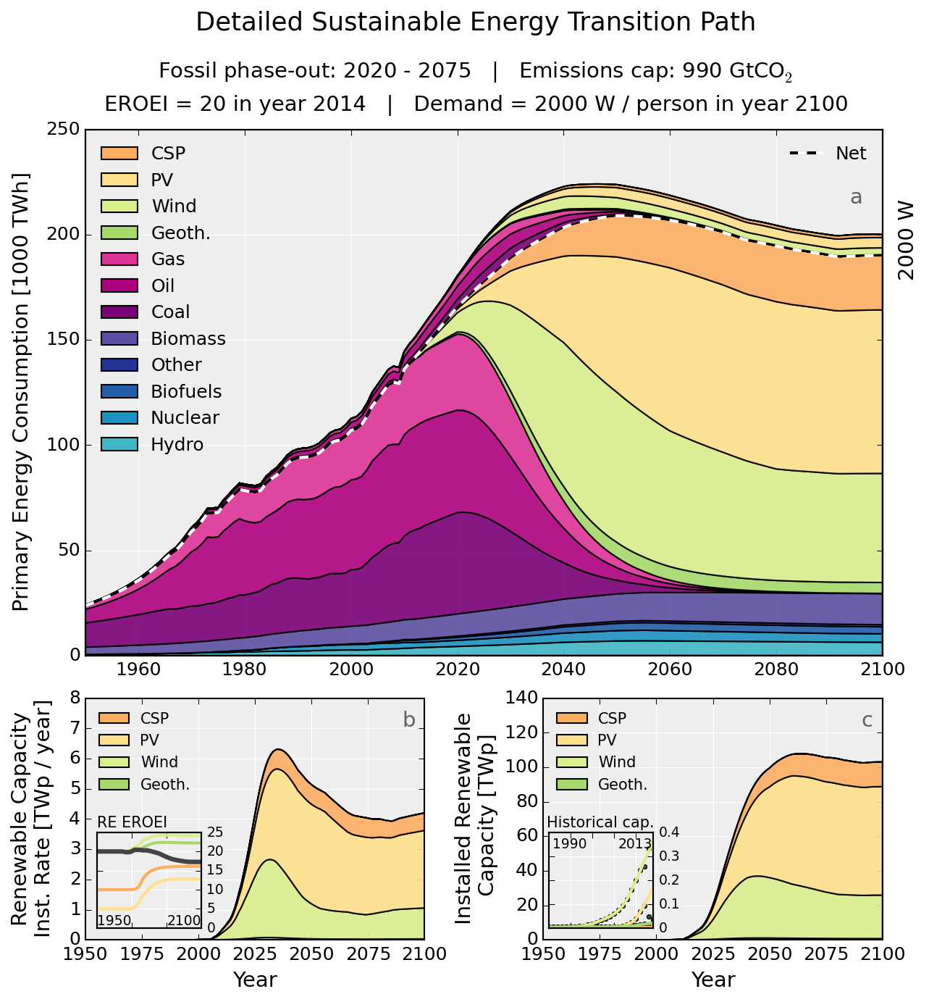

Figure ‎4‑7. Example of a successful sustainable energy transition  
source: own work for (S. Sgouridis et al., 2015), data source: EIA, BP, UNSD, WDI

## Converting the global SET into the networked, regional NETSET

### Theoretical foundations and overview of the conversion process

In this section we extend the theoretical foundations of the global sustainable energy transition (SET) mathematical model to define SET paths for *regions*: countries or regional geographic entities that include aggregations of countries, territories or sub-areas of large countries, such as individual states of the federal republics of the United States, Russia or India. We call the resulting framework *networked regional sustainable energy transition* model (NETSET). It is intended to provide a framework and an algorithm for constructing viable SET pathways for all regions in the context of a globally connected energy system. In principle, the global SET lays out all the mathematics that define any transition, for the regional case only the inputs would change – except for trade. For this reason there is no substantial mathematical modeling in this section, but rather only particularizations of the global equations of section ‎4.5. While most of the description is aimed to be self-explanatory, where deemed necessary, we do provide the mathematical definitions of the concepts.

In this dissertation, *regions* are almost equivalent *countries*. 189 regions have been included in the analysis and we will use the two terms interchangeably:

Afghanistan

Albania

Algeria

Angola

Antigua & Barbuda

Argentina

Armenia

Aruba

Australia

Austria

Azerbaijan

Bahamas

Bahrain

Bangladesh

Barbados

Belarus

Belgium

Belize

Benin

Bhutan

Bolivia

Bosnia & Herzegovina

Botswana

Brazil

Brunei

Bulgaria

Burkina Faso

Burundi

Cambodia

Cameroon

Canada

Cape Verde

CAR

Chad

Chile

China

Hong Kong

Macao

Colombia

Comoros

Congo

Costa Rica

Croatia

Cuba

Cyprus

Czech Republic

Ivory Coast

DRC

Denmark

Djibouti

Dominican Republic

Ecuador

Egypt

El Salvador

Eritrea

Estonia

Ethiopia

Fiji

Finland

France

French Guiana

French Polynesia

Gabon

Gambia

Georgia

Germany

Ghana

Greece

Grenada

Guadeloupe

Guatemala

Guinea

Guinea-Bissau

Guyana

Haiti

Honduras

Hungary

Iceland

India

Indonesia

Iran

Iraq

Ireland

Israel

Italy

Jamaica

Japan

Jordan

Kazakhstan

Kenya

Kiribati

Kuwait

Kyrgyzstan

Laos

Latvia

Lebanon

Lesotho

Liberia

Libya

Lithuania

Luxembourg

Madagascar

Malawi

Malaysia

Maldives

Mali

Malta

Martinique

Mauritania

Mauritius

Mexico

Mongolia

Montenegro

Morocco

Mozambique

Myanmar

Namibia

Nepal

Netherlands

New Caledonia

New Zealand

Nicaragua

Niger

Nigeria

Norway

Oman

Pakistan

Panama

Papua New Guinea

Paraguay

Peru

Philippines

Poland

Portugal

Qatar

South Korea

Moldova

Romania

Russia

Rwanda

Réunion

Saint Lucia

St. Vincent & the Grn.

Samoa

Sao Tome & Principe

Saudi Arabia

Senegal

Serbia

Seychelles

Sierra Leone

Singapore

Slovakia

Slovenia

Solomon Islands

Somalia

South Africa

Spain

Sri Lanka

Palestine

Sudan

Suriname

Swaziland

Sweden

Switzerland

Syria

Tajikistan

Thailand

Macedonia

East Timor

Togo

Tonga

Trinidad and Tobago

Tunisia

Turkey

Turkmenistan

Uganda

Ukraine

UAE

United Kingdom

Tanzania

US VI

USA

Uruguay

Vanuatu

Venezuela

Vietnam

Yemen

Zambia

Zimbabwe

NETSET, like SET, follows a net-energy-driven approach. From this point forward, whenever using the term *local* or *regional* or *in-country*, we will refer to in-region values of a particular quantity. The process broadly follows the global SET approach (cf. Section 4.4):

* define the regional net demand – see sections ‎2.3.1 and ‎0.
* estimate the net availability of both domestic and imported fossil fuels, and
* calculate the RE installation trajectory that meets the net demand at the lowest energetic costs through an iterative optimization process constrained by domestic resources, energy security, scalability, diversification, country influence and existing trade networks

Please see section ‎4.6.9 for a visual overview of the entire NETSET algorithm.

First, we adjust the definition of global energy and power demand to the regional level. In addition to the global case, here we include a detailed transition from energy to electric power, by splitting the total energy demand into primary consuming sectors[17] (electric power generation, buildings, transportation, industry and other) – necessary to account for varying electrification rate dynamics among sectors.

Next we define the fossil fuel phase-out profile at a given region in a way that is consistent with the global SET. The underlying principles are: (i) fossil producers will cumulatively match the global “limit” phasing-out the lower EROEI fuels first including the “seed” fuel, (ii) the extracted fuels form a globally available “pool” which fossil importers can access proportionally to their historic trade network. While this may be penalizing countries that have worse resource potential but limited access to the historic trade network compared to countries that have relatively better potentials and a historically higher proportional access to the fossil fuels trade. Nevertheless, it provide a good first approximation for bounding this indefinite problem. Fossil fuel distribution follows a policy of minimizing the total cumulative retrieval energy expenditure and therefore a regional distribution as per different energetic costs (based on localized, fuel-specific EROEI) associated with each producer (McGlade and Ekins, 2015). When placed into the existing global fossil energy trade network and after setting a fossil distribution trade policy for countries (could be as simple as maintaining the current trade status quo), this results in the maximum available fossil fuel consumption curves for each region, that can be estimated for any global emissions constraints.

The third step is the estimation of the maximum local renewable deployment potential and its associated energy investment based on the geographic properties of the region, through maximum year-to-year generation change rates for each technology.

In NETSET, we need to account for the variability and dispatchability of renewables *and* the variability of demand. Any mismatches where demand cannot be met solely through direct generation by renewables is identified by estimating residual load duration curves (RLDC) and calculating the size and energy requirements of any (local, in-region) storage needed, as well as the scale of oversizing (and any eventual resulting curtailment) on the original system to accommodate for this storage. This effectively changes[18] the peak power requirement as energy from storage becomes available or energy for charging storage is required. A simple but sufficient approach to address this variability is by using the resource-characteristic demand RLDC scale-up factors for the different energy generation technologies estimated by (Ueckerdt et al., 2015), and the resource-characteristic storage scale-up factors estimated by (Bogdanov and Breyer; Breyer et al., 2015a, 2015b; Pleßmann et al., 2014) – see section ‎0 and Figure ‎4‑32.. Building this storage capacity will incur more energy investment, but we can internalize these investments into the EROEI of renewables, following an *energy stored per energy invested* metric (ESOI) after (J. Barnhart et al., 2013).

We internalize energy trade by creating an implicit energy market where imported energy competes with locally-generated and stored energy for their energy costs. Knowing the geographic characteristics of the regions and their renewable potential (including the storage scale-up factor as discussed above) we can trace the curve of the marginal energy costs (energy investment cost of adding an additional unit of energy generation capacity[19] at different stages of cumulative installed capacity). Maintaining the accepted economic naming convention, we will refer to energy provider regions as *exporters* and energy receivers as *importers*, with the energy exchanged as *exported* or *imported* or simply *traded* energy.

By estimating and ranking the marginal energy cost functions of all regions and all non-fossil[20] energy carriers that can be traded (electricity through the power grid and different types of *regenerated electricity* after various ways of storage through the usual transport channels of the global trade network) we apply an optimization algorithm to decide between various types of energy imports rather than increasing energy generation capacity locally. The systemic objective function of such an algorithm is to minimize the global cumulative energy costs.

Under regional NETSET, we control the dynamics of trade through a trade influence matrix and its two defining factors: a *self- influence factor*, defined as the relative of the importance of trade local energy compared to the one coming from the most important trade partner and a *power-factor*, defining how spread out are the values of trade influence between the most important and least important trade partners. We later see in section ‎4.6.6 that these two levers fully define the governing rules of global energy trade and thus we can easily create various trade policies.

The distribution of energy in the trade network represents a generalized assignment problem that cannot be solved though combinatorial optimization algorithms such as “the Hungarian method” in polynomial time. Therefore, we develop a stochastic resource allocation algorithm with simulated annealing. Since the marginal energy costs of exporter regions also vary with the exported amount (due to changing intra-region energy costs at which these exports can be made available), this leads to the elements of the trade costs being defined as functions, therefore rendering the optimization under these circumstances impossible. However, it is possible to overcome this limitation by introducing a tiered system by binning the energy trade flows into buckets with preset sizes. Now each of these tiers will have a well-defined cost for the amount of traded electricity. The optimization of the trade network can then be solved tier-by-tier, country-by-country, year-to-year, allocating the energy available for trade and updating the energy costs at each tier.

The completed regional model includes the components of the global model, but adds a significant extension in the form of energy trade, therefore becoming the networked SET. Given the significant amount of complexity that a global trade network brings to any model, usually this is omitted and only global transitions are investigated – or countries with very well-known, isolated data universes (Lund and Mathiesen, 2009) – a however, the energetic interconnection of countries – such as the significant, two-way energy trade between Denmark and Germany renders such analyses oftentimes erroneous (Cochran et al., 2014).

However, while for the global modeling case, trade is a non-issue, for regional models, the link between energy production and consumption requires the large-scale transport of energy and embodied energy in goods through trade networks. Within this energy flow, there is a virtual circulation of carbon emissions (Kang et al., 2012). (Jarvis et al., 2015) argue that it is precisely these networks, constructed on easily accessible, abundant, cheap, fossil energy within the past one-and-a-half century that allowed the global distribution of resources – and formed the basis of the exponential economic expansion of societies.

### Transitioning from primary energy demand to electricity

In order to get an accurate estimation of the per capita energy consumption for each region, we must take into account the expected fuel switches in consumption from primary to secondary, cleaner energy types, an increasing share (almost 100%) of electricity. For industries operating on irreplaceable fossil fuels (shipping, air transportation, chemical industry, etc.) must be substituted either with biofuels or electricity-driven, non-warming fossil alternatives – *power-to-liquid* substitute liquids, such as syngas or ammonia.

We create a relative sectorial energy scalar variable and separate the total net regional power demand into *s* sectors (electric power, transportation, industrial, buildings and other[21], as per the definitions of US EIA) each having a share  in the final energy mix[22]. Let us note the share of electricity in the sectorial power demands of the non-power sectors with , the share of biofuels and biomass-derived fuels as , the share of fossil fuels as and the share of synthesized fossil replacement (power-to-liquid: PTL) fuels with as , for each non-power sector *s*.

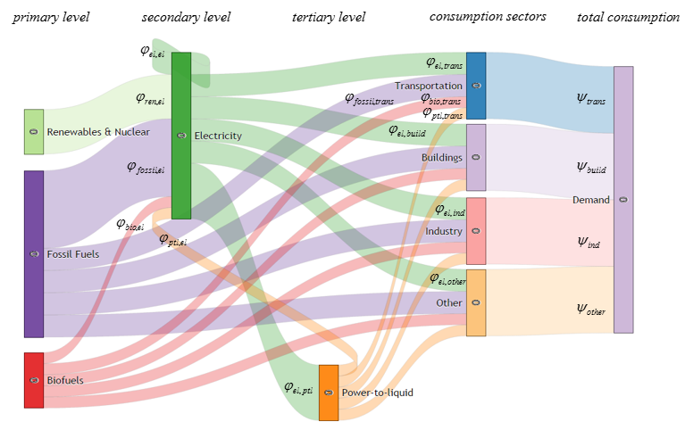

Figure ‎4‑8. Illustrative Sankey-diagram of primary and secondary and tertiary energy flows and consumption sectors  
source: own work

We can identify three distinct energy supply levels: the primary level, represented by the fossil fuels, biofuels and direct-to-electricity sources[23], the secondary level, represented by electricity and finally, the tertiary level, represented by power-to-liquids. We define the input shares of fuel source *xi* on level *i* into fuel source *xj* on level *j* as . The Sankey-diagram[24] of Figure ‎4‑8 is meant to conceptually illustrate this. When defining the mathematical relationships, on top of energy shares we must also explicitly include the conversion efficiencies between fuels *a* and *b*, where applicable. Subsequently, equation ( ‎2‑1 ) in the sectoral from can be written as:

|  |  |  |  |
| --- | --- | --- | --- |
|  | | | ( ‎4‑10 ) |
| where: |  | net societal sectoral power demand at time *t*, in region *c*, in sector *s* | |
|  |  | normalized sectoral energy intensity of the economy at time *t*, in region *c*, in sector *s*, relative to the 2015 values of the *energy share/economic share* ratio of sector *s* | |
|  |  | energy share of sector *s* in the energy mix, at time *t*, in region *c*, | |
|  | *s* | sector: {transportation, buildings, industry, other} | |

Which, after including the fuel types *xi* from levels *i =* {1,2,3}, their sectoral shares *φ* and process conversion efficiencies *η* converts to:

|  |  |  |  |
| --- | --- | --- | --- |
|  | | | ( ‎4‑11 ) |
| where: |  | energy share of fuel *x* in sector *s*, in region *c*, at time *t* | |
|  |  | conversion efficiency (including transport, leakage) of fuel *x* in sector *s*, at time *t* | |
|  | *x* | fuel types, with their respective levels *x1*: {renewables & nuclear, fossil fuels, biofuels } *x2*: {electricity} *x3*: {power-to-liquid} | |
|  | *i* | level of fuel type *x*: {primary: 1, secondary: 2, tertiary: 3} | |

Keeping in mind that because PTL fuels might be converted back to electricity (e.g. after shipping), as well as the reconversion of electricity itself after storage[25], we must keep track of that by creating a virtual quaternary level that includes regenerated electricity (Figure ‎4‑9).

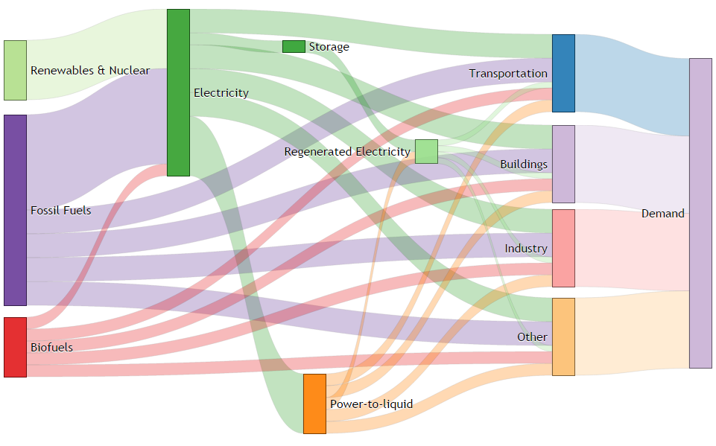

Figure ‎4‑9. Sankey-diagram with 4 energy generation levels, with Regenerated Electricity explicitly depicted  
source: own work

(Jacobson and Delucchi, 2009, 2011) provide an estimate of the aggregate percentage reduction reductions in primary energy under a 100% renewable world, estimated based on GTAP-type methodology of each economic sector. When averaged over all countries, we see a 3% reduction of primary energy demand in Agriculture, 15% in Transportation, 40% in Industry, 12% in Commercial, and 25% in Residential by 2050, leading to a weighted average overall reduction of 31% for a 100% renewable energy system.

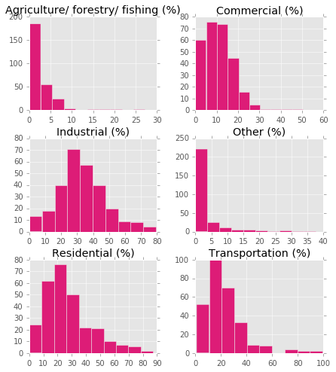

Figure ‎4‑10. Percentage reduction in primary energy requirements as a result of fuel switching, for the globe  
source: own work, data: (Jacobson and Delucchi, 2009), year: 2050

On top of shifting from primary to secondary energy demand, there is a fraction of energy in each sector that cannot be provided via electricity due to mobility constraints (such as shipping or air transportation, fertilizers, etc.). (Jacobson and Delucchi, 2009, 2011) and the broader Solutions Project they lead at Stanford also provides an estimate of the total energy generation capacity that must be dedicated to hydrogen generation in order to meet the energy needs of each sector that cannot be fueled directly through electricity. While not fully equivalent, we have taken these numbers as the best available indicators of the share of total energy that must be coming from liquid fuels throughout the energy transitions, in each country (Figure ‎4‑11).

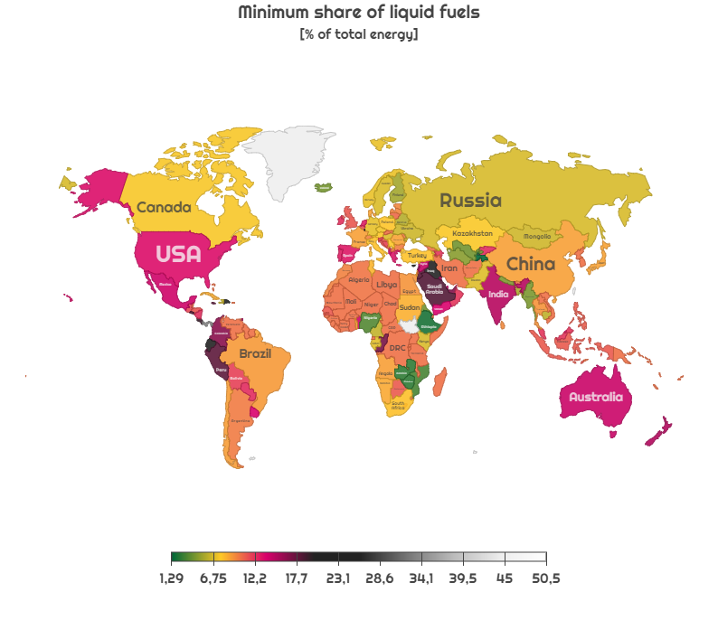

Figure ‎4‑11. Minimum share of liquid fuels based on the maximum electrification rate of sectors in each country  
source: own work, data: (Jacobson and Delucchi, 2009), year: 2050

### Emissions distribution and subsequent regional fossil consumption

#### Emissions history of countries

An important aspect of the regional discussion in climate change is “burden-sharing”: i.e. how to distribute the global emissions budget over nations. In order to understand the ongoing narratives first we need to look at the historical emissions (Figure ‎4‑12) by country. We can see that there is clearly an asymmetric distribution among countries. Currently, the largest emitter is China, followed by the United States, while in the per capita statistics the Middle Eastern and the Caribbean nations top the list (and the territory of Gibraltar, an all-import-based economy). However, when looking at the historical rates, we can see that most of the growth in the recent two decades has come from developing countries – those not listed under Annex B of the Kyoto Protocol, and China especially. Oil and gas emissions have been steady, but coal emissions increased dramatically due to massive coal-driven electrification of large economies in transition (Le Quéré et al., 2009), especially China, and the massive increase of the transportation sector in India.

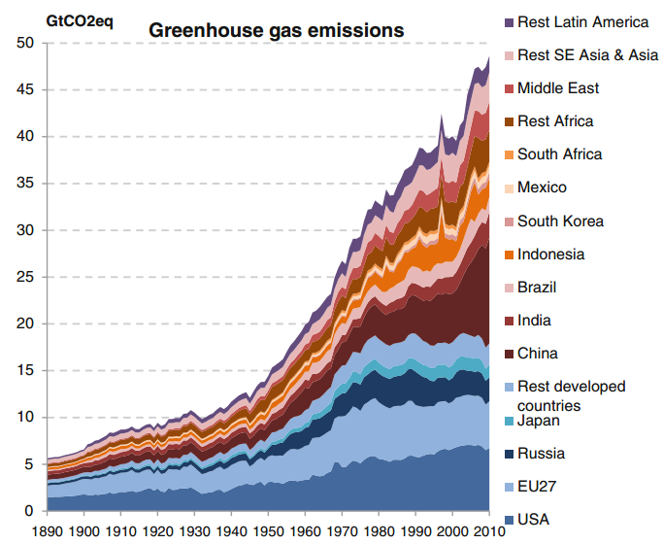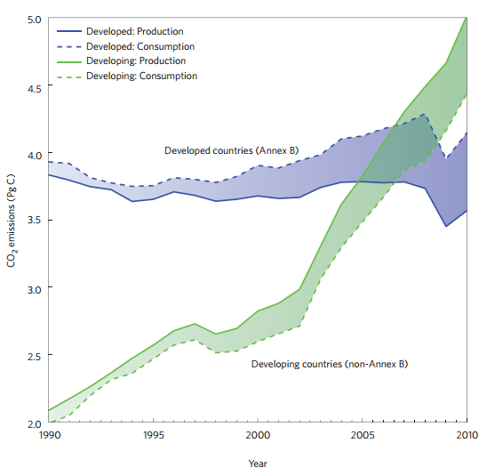

Figure ‎4‑12. Left: Evolution Global GHG emissions distributed by country and regions   
source:(Elzen et al., 2013), data source: EDGAR 4.2 FT2010   
Right: Global historical GHG emissions of countries grouped by the Kyoto protocol (1997)  
source: (Peters et al., 2012), data source: EIA

Looking at the EIA forecasts, while there is large uncertainty, total Chinese emission rates are expected to increase by a further 50% by 2050, while Indian emissions are expected to more than double, compared to today’s (2015) values (c.f Figure ‎4‑13).

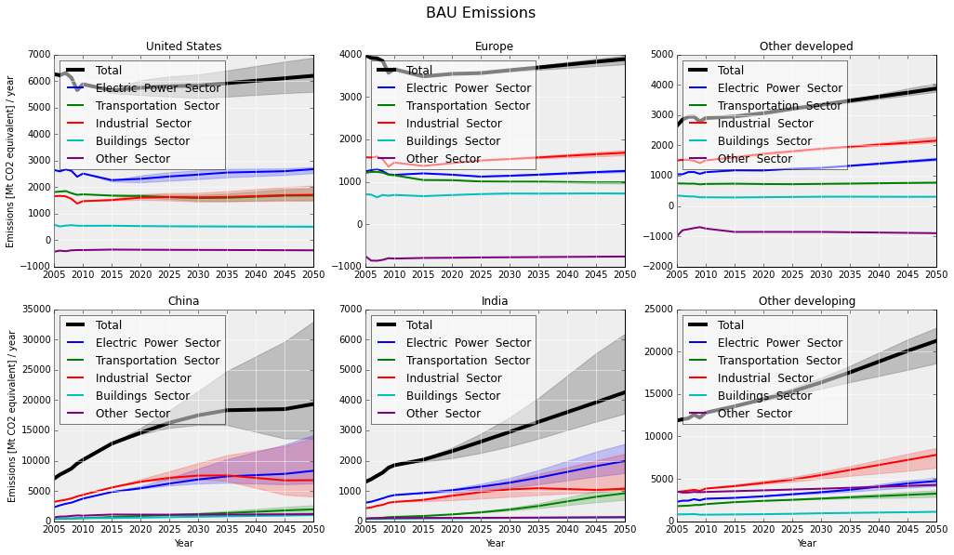

Figure ‎4‑13. Global GHG emissions predictions by sector, for countries and regions, under business as usual (BAU)  
Legend: Other developed – OECD sans OECD Europe and US, Other developing – Non-OECD sans India and China  
source: (Csala, 2015), data source: EIA International Energy Outlook, year: 2013

#### Climate change burden sharing: emissions distribution

In order to meet the global carbon caps outlined by the IPCC’s RCP2.6 scenario to limit global warming to 2 degrees (with a 66% confidence), country-level emissions quotas must be determined and agreed upon by nations. As the largest cumulative emitters and the largest per capita emitters are vastly different, this is a complex geopolitical issue. When distributing global emissions among nations, there are a few possible paths to take.

1. Laissez-faire policy

Currently, the furthest progress on GHG emissions burden sharing is the COP21 agreement. Every nation “pledges” a voluntary GHG reduction plan called the nationally-determined contributions (NDCs) that is non-binding and therefore carries significant uncertainty. Since these NDCs were produced independently and in a non-coordinated fashion, it is unsurprising that they collectively fail to meet the targets. The existing NDCs do not reach to IPCC’s RCP2.6 scenario leading to 2.7-3.7 degrees according to (Burns, 2016), 3.5 according to (Kintisch, 2015) “half-way between BAU and 2 degrees according” to (Boyd et al., 2015), and leaving “significant gap” (2015a). Therefore this approach at its current state is highly likely to exhaust the global carbon budget before the century runs out (Iyer et al., 2015; Lane, 2016; Manolas, 2016), thus leading a global warming over 2 degrees, or a scenario which economic discontinuities make physically infeasible. Some argue that non-national contributions are even more important, for higher enforceability (Ottinger, 2015) and there is vast difference between the in-country accountabilities (Michaelowa and Michaelowa, 2015). Nevertheless, the major problem with the INDC’s is not that they are not binding, but they are not standardized and often unmeasurable or unquantifiable or a “mess” (King, 2015). (Aldy et al., 2016) provide a framework to compare NDCs, but they point out that even relatively well-defined pledges are hard to convert into emissions-reductions numbers.

1. Physical emissions quotas

If an international authority can be established that monitors physical, non-monetary emissions of countries and enforces a hard limit on their quantity, then countries of the world could, in theory, be allocated well-defined, physical emissions quotas. The way in which these quotas would be determined is also subject to controversy, but, in principle, they could be distributed based on consumption or production of fossil fuels and hence, source of GHG emissions.

1. Consumption-based quota

A consumption-based quota would be rooted in a country’s Population (called “equity”), Emissions Rate (called “inertia”), GDP, Fossil Reserves – or a combination of these, resulting in a set of “High Emitters” and “Low Emitters” (Peters et al., 2015). There are two competing arguments on distributing emissions: flow-based and stock-based. Flow-based distribution reflects the current situation and operationally current emissions. Alternatively, a stock-based distributions relies on summing historical emissions since a certain, well-defined time in the past, usually taken as either the start of industrialization in 1850, or 1990 (Davis and Caldeira, 2010), or a similar date in the late 20th century – essentially controlling the burden of historical emissions for developed countries. Developed and wealthy countries of today lean towards the first option, arguing that the Kaya Identity should be followed when implementing an emissions distribution scheme – hence emissions are mostly driven by population and per capita consumption of energy and the energy intensity of the economy of a nation, while developing countries and emerging economies favor the second argument, pointing out that current wealthy nations that enjoyed lengthy periods of economic development and expansion, reached where they are today exactly because of unrestricted consumption of fossil fuels (Elzen et al., 2005; Reif and Schenker, 2015).

Figure ‎4‑14 Left, provides an illustration of the existing EU, US and Chinese NDC pledges (with targets set for 2030 or 2050), (Peters et al., 2015) and shows the extremely steep trajectory to be followed to fit into 2°C carbon budget. On the same figure, Right, we can see the massive differences in the fossil retraction path that the US hypothetically would have to follow under an *inertia*, or an *equity* emissions distribution scheme.

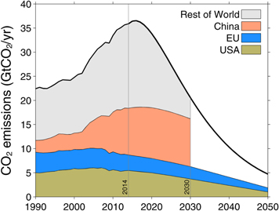 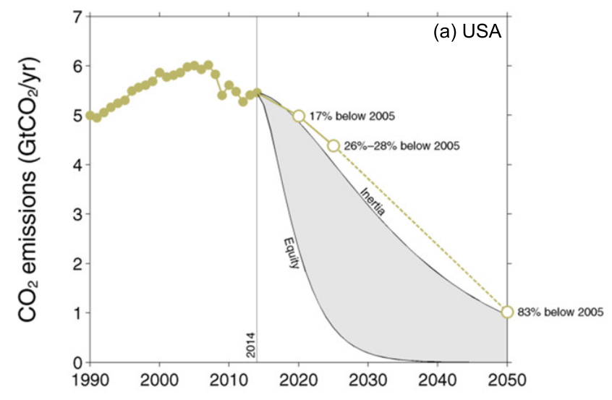

Figure ‎4‑14. Left: Global GHG emissions paths of EU, US and China, and the rest of the world represented to fit into 2°C,   
Right: The US trajectory under a population based (“Equity”) and a present-day emissions rate-based (“Inertia”)  
 national carbon cap – “Inertia” included on the Left, source:(Peters et al., 2015), data source: UNFCCC INDCs, year: 2015

A blended, consumption-based emissions distribution scheme was proposed by (Raupach et al., 2014), that was based both on equity and inertia, governed by mixture weight parameter *w*, initially set to *0.5* (Figure ‎4‑15).

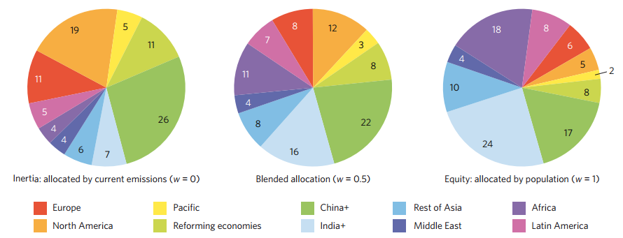

Figure ‎4‑15. The share of carbon quotas of countries allocated under different weights (*0,0.5,1*) to fit into 2°C,   
source: (Raupach et al., 2014)

(Caldeira and Davis, 2011; Davis and Caldeira, 2010) suggest that the emissions should be based on population in general, but also based on accumulated GDP, taking account of the GDP growth of countries since t0 = 1990 and – an important innovation – taking into account the emissions embedded in trade flows.

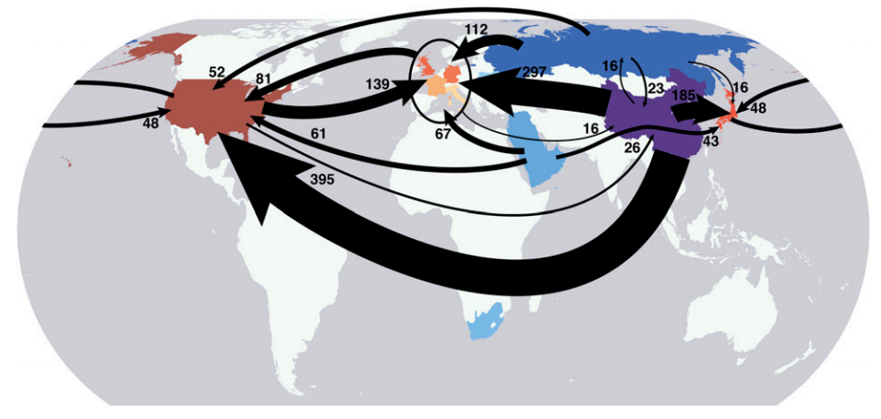

Figure ‎4‑16. Largest interregional fluxes of GHG emissions embedded in trade   
source:(Davis and Caldeira, 2010), data source: Global Trade Analysis Project (GTAP)

As such, in their global carbon accounting model, they attribute a large portion of China’s emissions to the US and Europe, transferring the emissions from the place where the goods are manufactured to where the good are finally consumed, effectively adjusting the energy intensity of the receiver economy in the country-level IPAT models. Of course to be fair, this requires an energy input-output lifecycle analysis (EIO-LCA) to determine what is the energy fraction of each product that goes into manufacturing and for energy-intensive goods, such as aluminum, this may represent a significant share but it is difficult to assess without controversy.

Other mechanisms to foster or enable consumption-based distribution would be Emissions Trading Schemes (ETS), or global binding agreements (albeit with modifications e.g. a modified, binding COP21 or other, individual-based binding approach by (Chakravarty et al., 2009), engaging and persuading the high-income emitters to adopt reduction measures.

1. Production-based quota

GHG emissions could be also limited as production source. By employing a prioritization scheme that minimizes total energy expended, e.g. extracting the easiest extractable – and thus carrying the lowest economic (but not necessarily energy) costs – reserves first, until the carbon budget is depleted, as suggested by (McGlade and Ekins, 2015).

Table ‎4‑1. Regional distribution of reserves unburnable before 2050 for the 2 °C scenarios with and without CCS  
source:(McGlade and Ekins, 2015), data source: TIAM-UCL Integrated Assessment Model

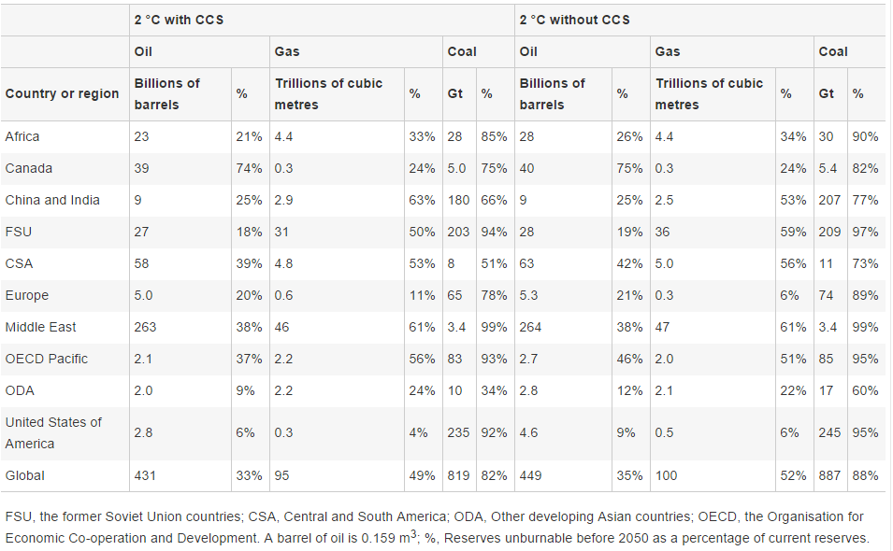

In NETSET we chose to use a production based emissions distribution, because of two reasons:

* First, NETSET is engineered to fit into a global carbon cap, but it also affected by energy trade. By limiting the emissions and hence fossil energy generation ant the source – e.g. the producer countries, the complex step of conversion between energy intensities of source and target economies can be avoided.
* The investment energy of the SET process depends heavily on fossil energy seed. By deciding on available fossil energy at the producer level, we do not allow for the complex process of countries to taking “energy loans” from a common pool of now-limited energy production of their trading partner.

Therefore, after establishing the trade-history and existing trade-partnerships between countries, the remaining emissions would be controlled at the source, by limiting the physical flow of the production. Since our approach is based on net-energy flows, this approach is more appropriate. In the following, we incorporate the production-based emission distribution into the SET framework.

#### Extending the global SET framework to include regional distribution of fossil fuel production and trade

In sections ‎2.3.2 and ‎4.2.1, we describe how the global fossil-fuel phase-out curves are driven by Hubbert multi-variant curves (Maggio and Cacciola, 2009b), based on the underlying estimates assumptions for peak production capacities, peak years and extractable reserves. For the global SET, we converted the extractable reserves into *safely* extractable reserves, by design fully compliant with the chosen planetary carbon budget. For nations or regions, this is effectively replaced by the carbon budget of the country, resulting from the distribution mechanism chosen. Here we show the development of a *production-based* emissions distribution of a global carbon budget, over all countries, under a Hubbert emissions equivalent fossil phase-out and a status quo fossil fuel trade network.

For the global SET, the required additional energy capacity additions by year were defined as: $\frac{d}{dt}P\left(t\right)=\frac{d}{dt}{PS}_{net}\left(t\right)+\frac{d}{dt}P\left(t-L\right)+\frac{1}{τ}\int_{1}^{τ}{I\left(t+k\right)}dk$, where *PSnet* represents the net societal power demand and *I* represents the energy investment into building renewable capacity.

For the regional case, *PSnet* needs to be converted into:

|  |  |
| --- | --- |
| $${PS}_{net}^{*}\left(t\right)={PS}_{net}\left(t\right)+ {PS}_{trade}\left(t\right)$$ | ( ‎4‑12 ) |

where *PStrade*, represents the additional energy in the trade flows between countries and it is defined as the imported energy minus the exported energy. Since the trade data (e.g. UN COMTRADE database) is usually reported in monetary terms, using dynamic prices of energy carriers (e.g. World Bank Commodity database), we need convert these monetary flows into material trade volumes. Then, using the specific energy content of each energy carrier, we get the embedded energy in the trade flow. Since in the SET framework, we convert all energy flows to over-the-year evenly distributed power flows by convention, we do the same for the embedded energy values. Likewise, ( ‎4‑13 ) fully defines *PStrade*.

|  |  |
| --- | --- |
|  | ( ‎4‑13 ) |

where $V_{{import}_{i}}\left(t\right)$ is the value of imported energy carrier *i* at time *t*, for all energy carriers *i* in *ec*; $p_{i}\left(t\right)$ is the unit price of energy carrier *i* at time *t*; $ω_{i}$ is the unit energy content of energy carrier *i* (expected to be constant over *T*). To illustrate what is contained in these trade flows, in Figure ‎4‑17 we have shown the coal trade (imports: left, exports: right) of the United States (top) and Germany (bottom) averaged over 2010-2015.

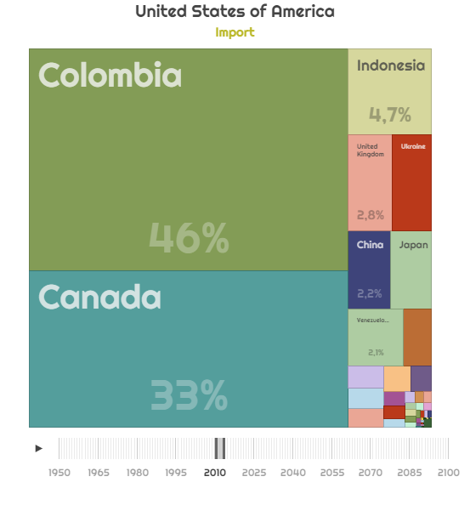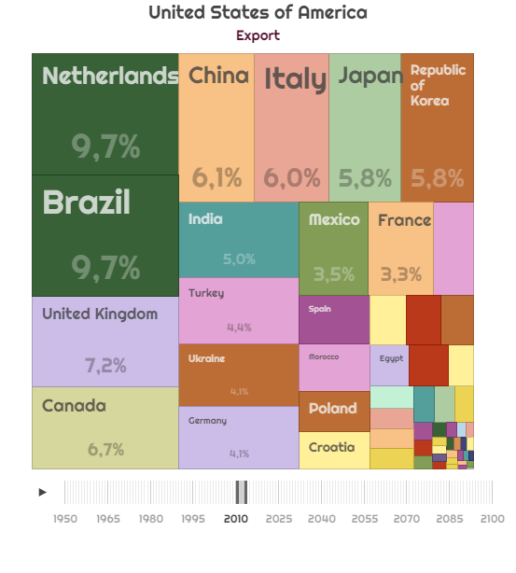  
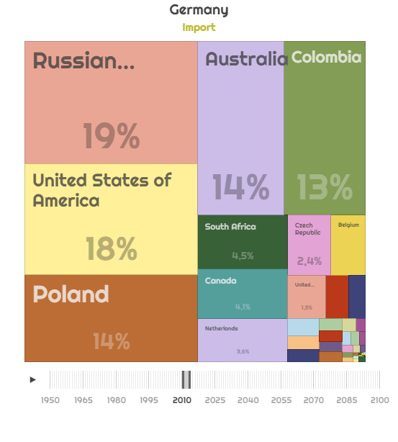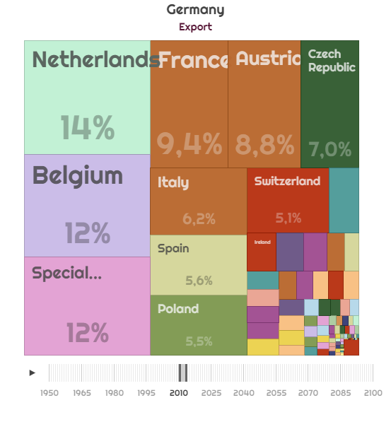

Figure ‎4‑17.Coal trade (imports: left, exports: right) of the United States (top) and Germany (bottom),   
averaged over the years 2010-2015  
source: own work, data: UN COMTRADE, year: 2010-2015

Based on the unrecoverable reserves suggested by (McGlade and Ekins, 2015) presented Table ‎4‑1, we can construct the fossil phase-out curves of fossil fuel producer countries cf. section ‎4.2.1, using the resource values from EIA and 2020 as their peak time, and an extrapolation of the 2005-2015 trends into 2020 as their peak production, using the original definition of the Hubbert curve ( ‎2‑5 )[26], for all fuel types, for all producing countries. Knowing the trade history network of countries, for all energy carriers and assuming a status quo energy trade until the full retraction is completed, we can construct the fossil fuel profiles of all countries. In Figure ‎4‑18 we have shown the remaining oil imports (top) of the United States (left) and Germany (right) and the remaining (only sown until 2050) oil exports (bottom) of Canada (left) and Saudi Arabia (right). The asymmetric phase-out pattern is clearly visible, with low-EROEI resources (such as Canadian tar sands) being phased out first.

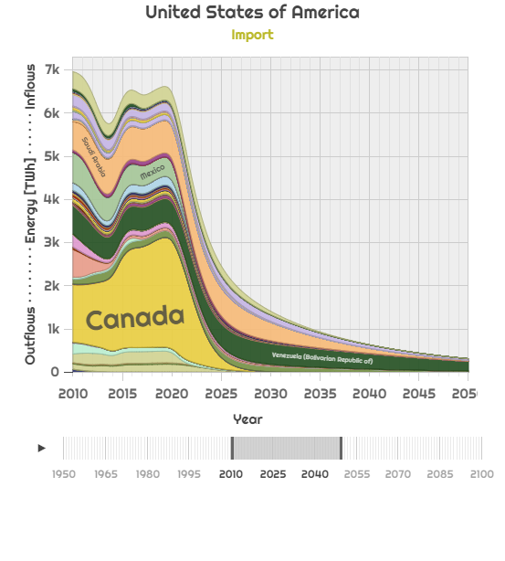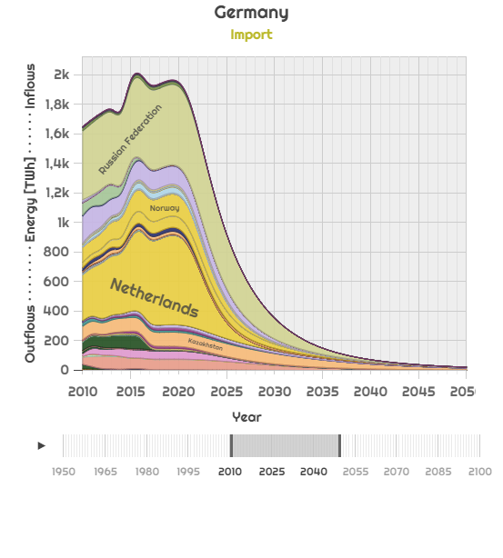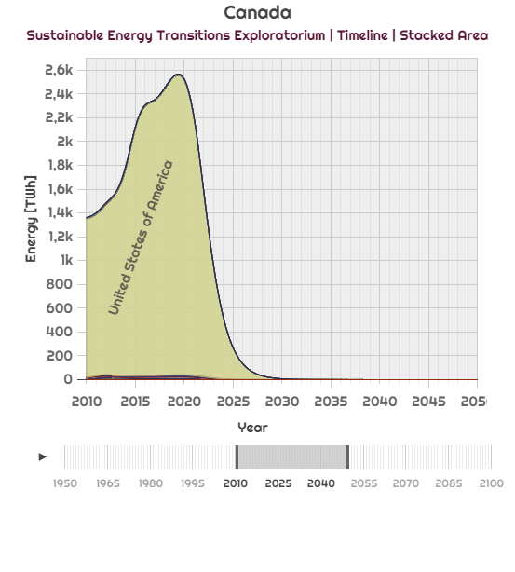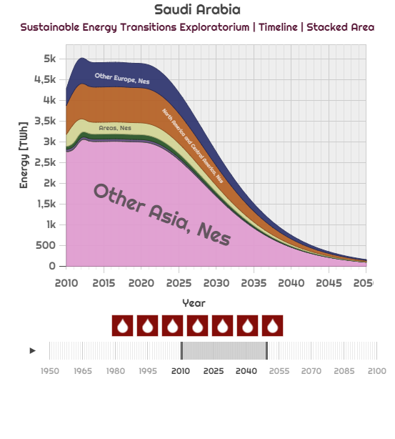

Figure ‎4‑18.Oil trade under a Hubbert retraction governed by EROEI and stationary fossil energy trade   
(imports: top) of the United States (left) and Germany (right) and exports (bottom) of Canada (left) and Saudi Arabia (right)  
 source: own work, data: UN COMTRADE until 2015, forecasted until 2020, Hubbert until 2050, year: 2000-2050

Taking into account the updated energy demand and fossil availability, equation ( ‎4‑5 ) becomes:

|  |  |
| --- | --- |
| $$\frac{d}{dt}{PR}_{net}^{*}\left(t\right)=\frac{d}{dt}\left\{{PS}_{net}^{*}\left(t\right)-\left[{PF}_{net}^{*}\left(t\right)+{PX}_{net}(t)\right]\right\}+\frac{d}{dt}{PR}_{net}^{*}\left(t-L\right)$$ | ( ‎4‑14 ) |

Equation 4-13 essentially modifies the total renewable deployment rate. However, before we can redefine the renewable capacity deployment rate, we must account for the renewable EROEI that will depend on geography and therefore will be particular to each of countries. Moreover, the choice of country-partners will greatly affect the total global renewable energy investment, based on the EROEIs of the trade-partner choices of individual countries.

### Regional renewable EROEIs and geographic resource distribution

#### Mapping global renewable resource power density (i.e. quality) distribution through resource classes

For integrating regional EROEIs into the global NETSET equations, we must consider the substantial differences in countries’ energy costs of renewable energy generation. This is directly related to the resource quality of each renewable energy type. A common measure, used by the NREL to classify resources based on the energy return per unit area is the *resource class*. Resource classes are nominal scales between 0 and 10 (for CSP, 0-9 for wind and 3-14 for PV), tied to the per unit area power return of each energy resource through a linear scale. Therefore, in essence, the difference between the resource class and the EROEI is only a multiplier and should also account for portfolio resource diversity. Resource classes are normalized across different resources, by varying the EROEI multipliers by resource.

Based on the global GIS data for GHI, DNI and wind speeds, and the resource characteristic power densities (provided by NREL) we calculate the available yearly energy production from each resource, distributed over the resource classes Figure ‎4‑19 provides a histogram of the class distribution for all countries for PV (top), CSP (middle), Wind (bottom).

After intersecting the GIS data with a dataset of country borders, we can construct the resource availability histograms for each country. On Figure ‎4‑20 we show for comparative purposes the resource availability of Iceland (left) and Jordan (right), two countries with a similar area, but situated at very different latitudes and having different climates.

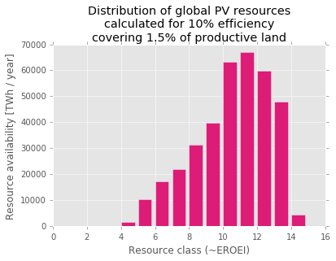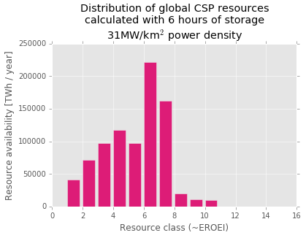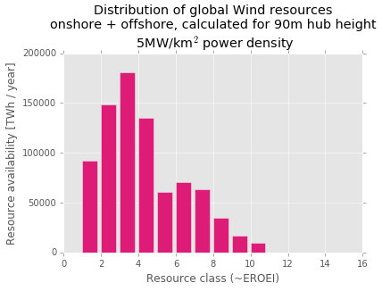

Figure ‎4‑19.Global distribution of PV (top), CSP (middle) and Wind (bottom) resources   
by resource class and resource availability in each class  
source: own work, data: NREL

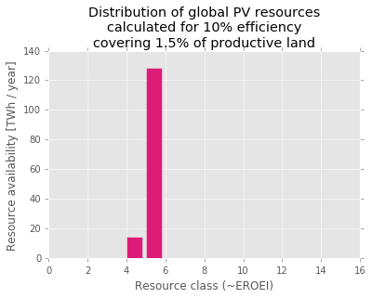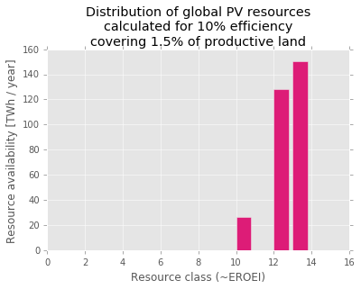

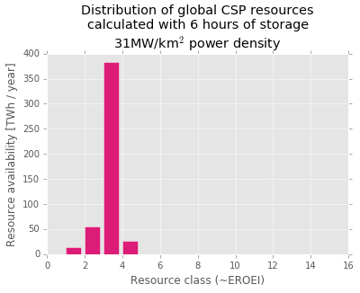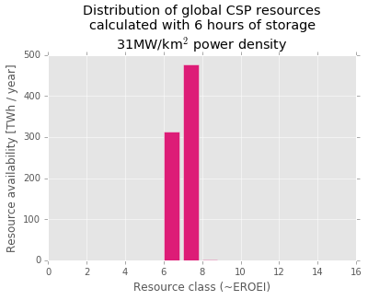

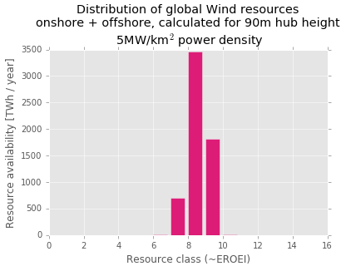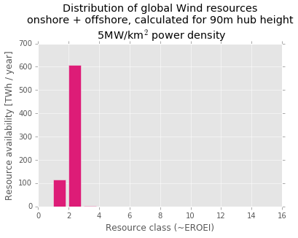

Figure ‎4‑20. Distribution of PV (top), CSP (middle) and Wind (bottom) resources   
by resource class and resource availability in each class for Iceland (left) and Jordan (right)  
source: own work, data: NREL

In order to be used in the global regional models, renewable resource distributions must be normalized and benchmarked against each other. Therefore, we developed a unified system of 10 classes for each resource (equivalent to resource class *deciles*), which normalizes the distributions across resources. We then plot the existing generation from installed capacity evenly distributed over the classes of the countries where the generation is coming from. The deviation between the resource-weighted average classes of these two distribution will define the resource utilization on a global level or in a country. The next sub-section explains this process in detail. Then, Figure ‎4‑19 converts to Figure ‎4‑21, Figure ‎4‑22 and Figure ‎4‑23.

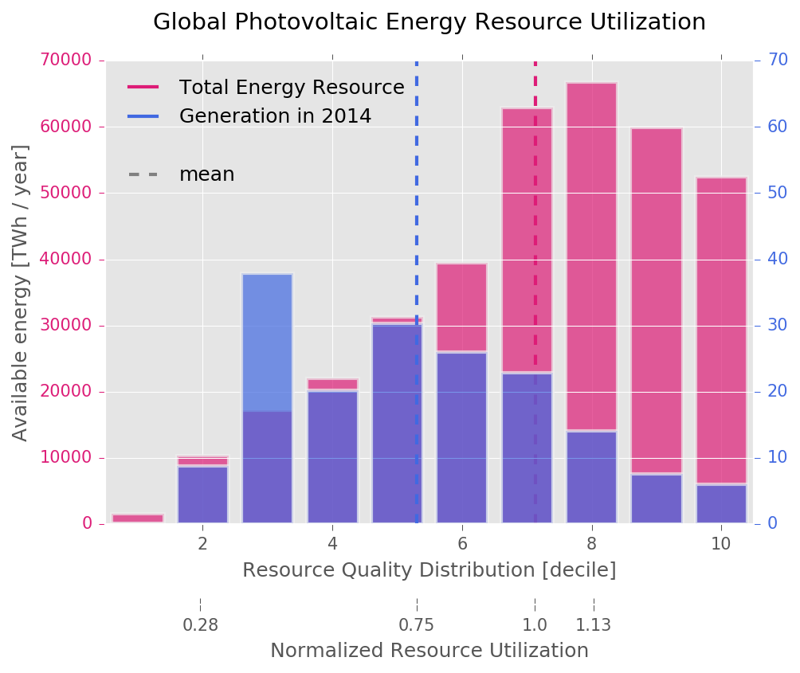

Figure ‎4‑21. Distributions of global, yearly available photovoltaic energy (pink, left axis) and energy generated by existing installations (blue, right axis) binned into different NREL power classes. A secondary horizontal axis shows the corresponding insolation values of each class. The energy resource potential data is calculated based on available GIS GHI insolation data from NREL while the generation data is the average of the BP and EIA databases for 2014. Both datasets are cross-sectioned into countries and then summarized again by class. The dashed lines represent mean values for the two distributions. The energy values have been calculated assuming a 10% overall plant efficiency and covering 1.5% of productive land in each country.  
source: own work, data: NREL

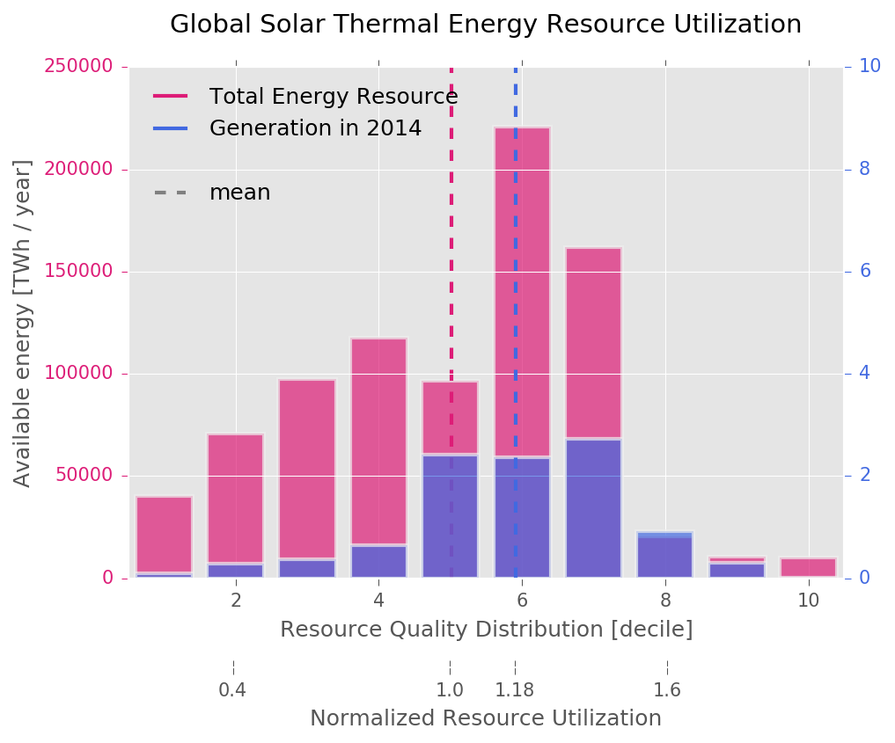

Figure ‎4‑22. Distributions of global, yearly available solar thermal energy (pink, left axis) and energy generated by existing installations (blue, right axis) binned into different NREL power classes. A secondary horizontal axis shows the corresponding insolation values of each class. The energy resource potential data is calculated based on available GIS DNI insolation data from NREL while the generation data is the average of the BP and EIA databases for 2014. Both datasets are cross-sectioned into countries and then summarized again by class. The dashed lines represent mean values for the two distributions. The energy values have been calculated using 6 hours of storage with a 31MW/km2plant power density.  
source: own work, data: NREL

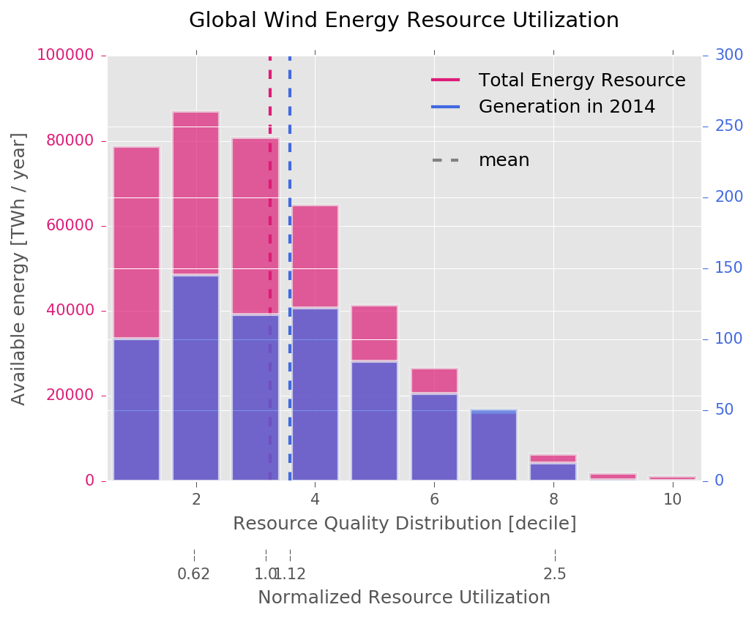

Figure ‎4‑23. Distributions of global, yearly available wind energy (pink, left axis) and energy generated by existing installations (blue, right axis) binned into different power classes. The energy resource potential data is calculated based on available GIS wind power density data from NREL while the generation data is the average of the BP and EIA databases for 2014. Both datasets are cross-sectioned into countries and then summarized again by class. The dashed lines represent mean values for the two distributions. The energy values represent the totals for onshore and off-shore wind power and have been obtained from the GIS data using a 5MW/km2 turbine power density, a 90m hub height, taking into account all available resources located at 0-100 miles from available infrastructure and roads on the onshore and 5-50 nautical miles out on the sea, for shallow and transitional waters.  
source: own work, data: NREL

#### Country-level resource distribution maps

The actual deployment shares of RE resources is a local problem dependent on local resource quality, relative technological advantage (i.e. higher technical EROEI), demand patterns and location of the load centers, and the relative value of energy security vs trade. We are developing a regional model that takes these into account in detail. Nevertheless, for the purposes of the global transition pathway derivation we need a simpler approach and assume that the contribution of the scalable renewable resources depends much more on the relative availability of locations to deploy rather than the relative EROEI of the technology and that a portfolio of resources will always be necessary (i.e. no resource will dominate) given the geographical diversity. This approach assumes that the resource shares in SET depend on: (i) the quality distribution of each resource globally, and (ii) the relative actual utilization of each resource compared to the global quality distribution.

We benchmark the existing EROEI estimates to the individual technical *RT* values, with regard to the resource qualities of the sites that they are reported in order to calculate a *global normalized technical EROEI* *RTk*for each technology *k*, using the NREL Renewable Resource Data Center power density datasets. For each technology, this creates distributions of available power density binned into resource quality tiers, defined by NREL as power density *classes* dependent on the physical location *sites* where RE plants can be installed.

Figure ‎4‑21, Figure ‎4‑22 and Figure ‎4‑23 present the distributions of resources binned by energy classes for wind, PV, and CSP respectively along with the current RE deployment. The classes are defined by power density for wind (see <http://rredc.nrel.gov/wind/pubs/atlas/appendix_A.html>), global horizontal irradiance GHI for PV, and direct normal irradiance DNI for CSP.

Let us start this sub-section by presenting the global resource distribution and generation distribution over classes by making the countries explicit on the graph. First, let us look at the resources in Figure ‎4‑24, Figure ‎4‑25 and Figure ‎4‑26.

We can see from these figures that the globe possesses a lot of good solar (both DNI and GHI) resources, located in the deserts, followed by the equatorial belt, with a large amount of high class resources in Australia, Brazil and China. Russia leads by the sheer amount, but all of these resources are in the bottom 60% percentile. Wind energy is concentrated around the lowest classes, but the global distribution of wind power classes nicely relays the well-known Weibull distribution of wind speeds.

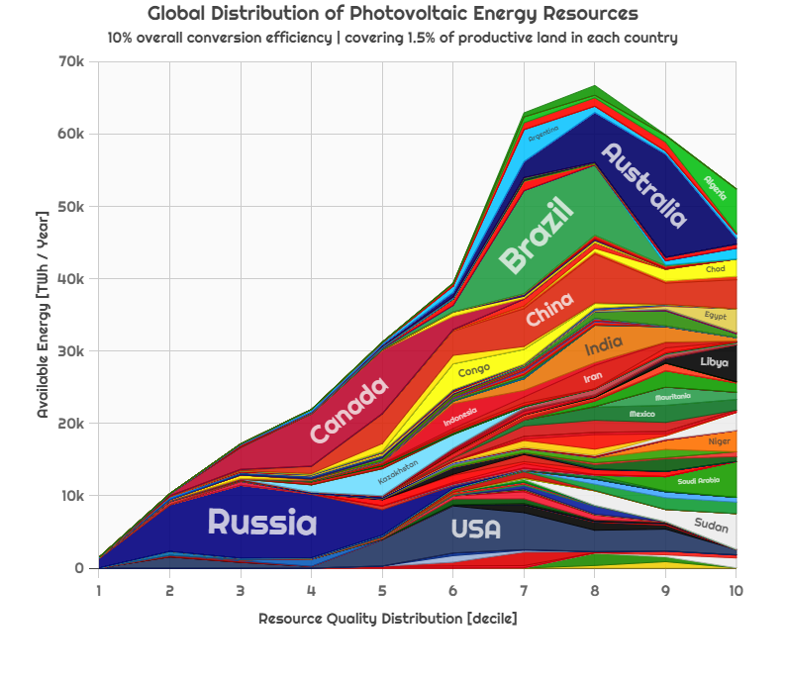

Figure ‎4‑24. Global distribution of photovoltaic energy resources into to resource quality deciles (as in Figure ‎4‑21) with countries made explicit. source: own work, data: NREL

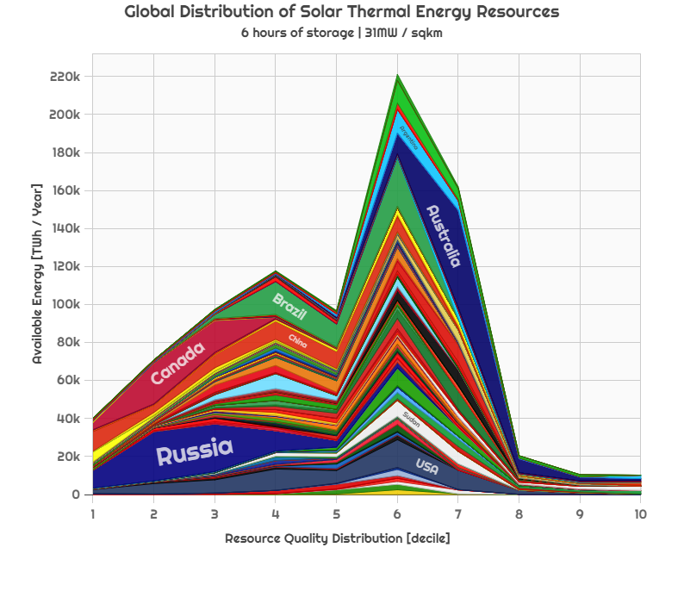

Figure ‎4‑25. Global distribution of solar thermal energy resources into to resource quality deciles (as in Figure ‎4‑22) with countries made explicit. source: own work, data: NREL

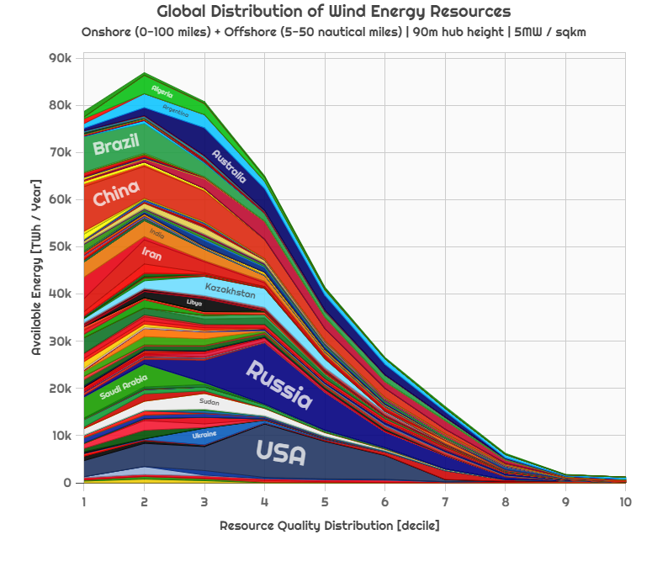

Figure ‎4‑26. Global distribution of wind energy resources into to resource quality deciles (as in Figure ‎4‑23) with countries made explicit. source: own work, data: NREL

We then look at the evolution of renewable energy generation by geographic location, by distributing the reported generation values evenly across a the resources classes of countries. We take two snapshots, in years 2014 and 2000.

We can see that Germany has the most solar energy generated, closely followed by Italy, Japan and China. But is also very significant to note that Germany solar resources are among the *worst on the planet*. Solar thermal power has three major players, UAE, USA and Spain, all with resources on the better end of the class spectrum. Wind power generation is dominated by the USA and China and it is important to note the presence of the UK, with a significant amount of wind energy generated from very good resources. The situation changed a lot since 2000, when there was no industrial CSP, less than 1 TWh of PV energy (compared to more than 50 TWh in Germany in 2014) generated in Japan and the USA, while Denmark was a major player in wind.

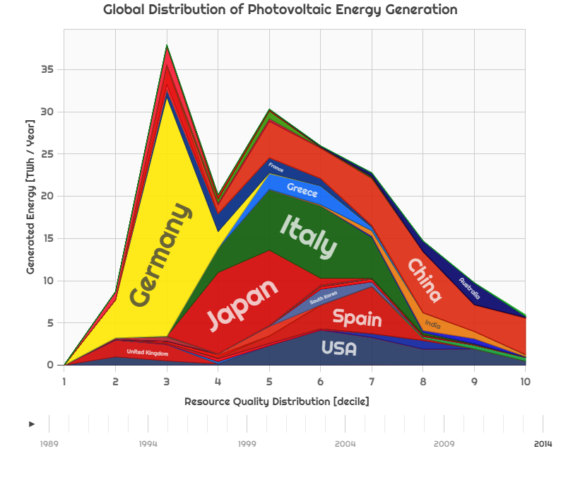

Figure ‎4‑27. Global distribution of photovoltaic energy resources into to resource quality deciles (as in Figure ‎4‑21) with countries made explicit. source: own work, data: NREL, year: 2014

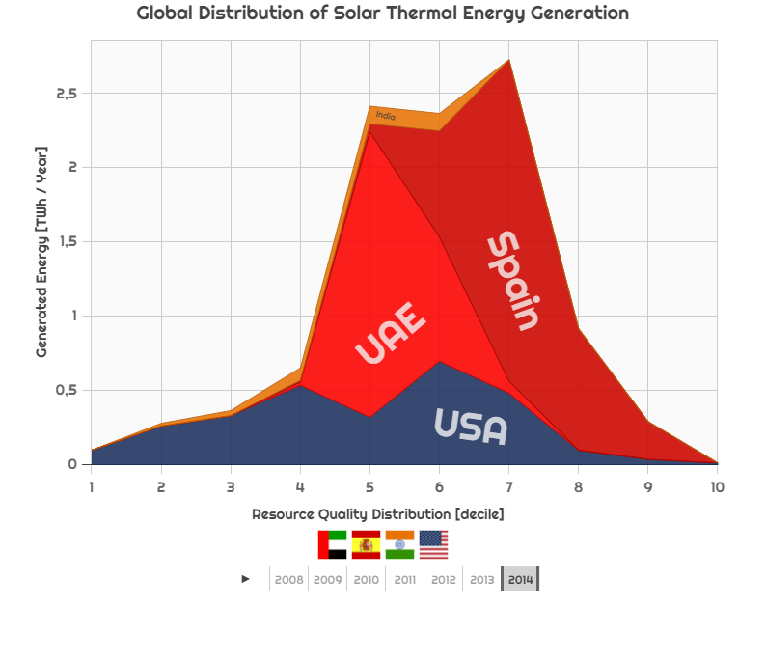

Figure ‎4‑28. Global distribution of solar thermal energy resources into to resource quality deciles (as in Figure ‎4‑22) with countries made explicit. source: own work, data: NREL, year: 2014

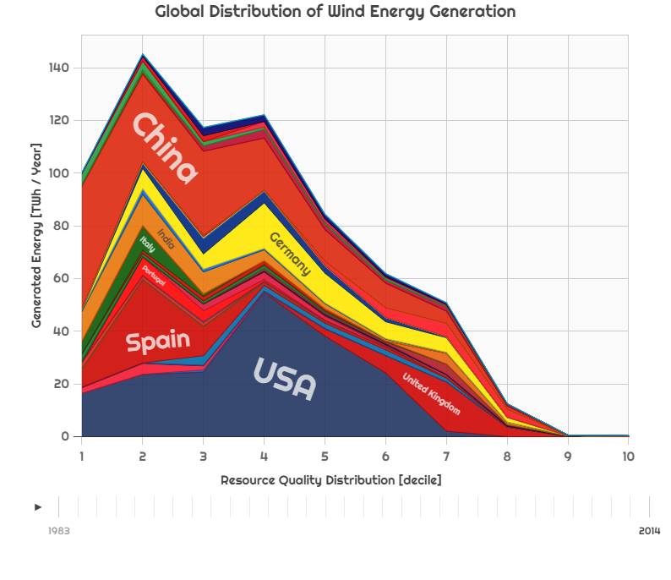

Figure ‎4‑29. Global distribution of wind energy resources into to resource quality deciles (as in Figure ‎4‑23) with countries made explicit. source: own work, data: NREL, year: 2014

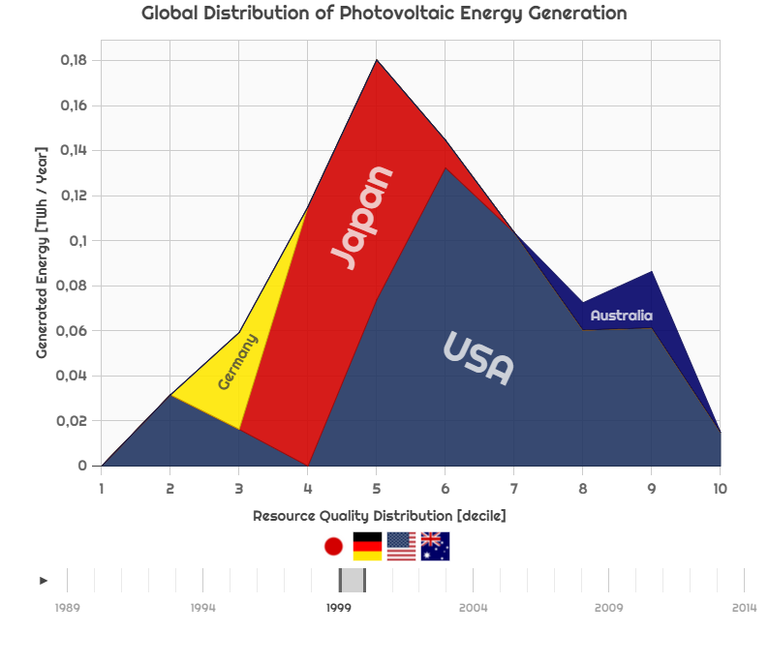

Figure ‎4‑30. Global distribution of photovoltaic energy resources into to resource quality deciles (as in Figure ‎4‑21) with countries made explicit. source: own work, data: NREL, year: 2000

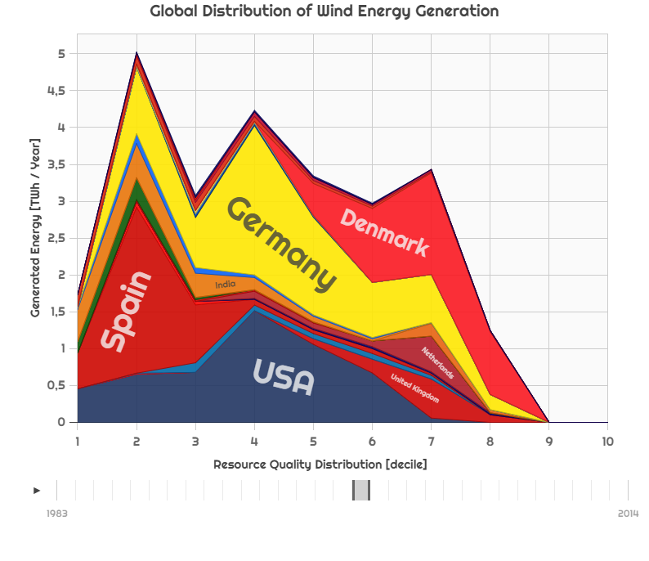

Figure ‎4‑31. Global distribution of wind energy resources into to resource quality deciles   
with countries made explicit. source: own work, data: NREL, year: 2000

In the following subsection, we present the theoretic background of prioritizing resources geographically and between the three sources. We use a global approach, but the theory holds for countries as well, by switching global resources and generation to in-country values.

#### Updating the renewable EROEI learning and deriving capacity installation rates through capacity factors

Having modified one of the main factors of renewable energy investment, we must update, equation ( ‎4‑6 ) to reflect the regional dependence.

|  |  |
| --- | --- |
| $$I_{k}^{*}\left(t\right)=\frac{d}{dt}{PR}_{{net}_{k}}^{*}\left(t+τ\right)∙\frac{L_{k}}{\left.R_{k}∙a_{k}^{*} (t\right)}$$ | ( ‎4‑15 ) |

The learning rate of renewable EROI αk in regional case will be defined by the country learning rate, representing in-country Wright learning, multiplied by the global learning rate, representing global learning in the technology as a whole and multiplied by an exponentially declining transfer function – empirically observed from the behavior of fossil fuels and representing the cumulative usage of prime quality renewable energy installation sites, for each country. Therefore αk modifies to:

|  |  |
| --- | --- |
| $$a_{k}^{*}\left(t\right)={\left[\frac{\sum_{countries}{\left.PR(t\right)}}{\sum_{countries}{\left.PR(t_{0}\right)}}\right]}^{1+γ_{weighted average}}∙{\left[\frac{\left.PR(t\right)}{\left.PR(t_{0}\right)}\right]}^{1+γ}∙e^{-ζ\frac{\int_{t-L}^{t}{PR(t)}dt }{{PR}_{max}}}$$ | ( ‎4‑16 ) |

In Equation 4-15, *PRmax* is the maximum renewable energy potential of each country for each renewable energy source, $\int_{t-L}^{t}{PR(t)}dt$ is the total renewable energy installed *in situ* (and not total *cumulative* installed, since replacements of existing plants do not account for site depletion) for each source, and $ζ$ is the renewable site usage coefficient. Taking into account the regional renewable energy investment defined as per Eq. ( ‎4‑15 ), with the new $a_{k}^{*}$ a situation might arise in which the renewable energy investment needed is higher than the amount of available energy in a country – triggering the need for trade.

We allocate the power investment for deploying the RE systems proportionally to the share of the resources in the net power mix for each time step (year). If more renewable investment is needed than the power available to meet the desired demand, additional fossil-fuels are used (the “seed”) to cover the deficit and then subtracted from the budget of later years, yielding the investment shares *μi*. Essentially, we take the fuel that would have been available towards the end of the transition and front-load it in order to build the RE infrastructure effectively changing the fossil phase-out profile, we need to iterate the simulation until convergence to ensure that the cap requirements are met as described in section ‎4.5.3.

We can now convert from average power investment to deployed plant nominal peak capacity *C* through the capacity factor (CF or ψ) under standard conditions for each technology *k* ( ‎4‑17 ). The capacity factors *ψ* are connected to the EROEI dependent on the nameplate capacity *C* as per $R=\frac{C∙ψ∙L}{E_{in}}$ (Kessides and Wade 2011). As the EROEI adjusts for locational variation through *θ*, the capacity factor is also linearly and correspondingly adjusted by this factor as estimated later in Equation ( ‎4‑20 ).

For PV, while the 2014 capacity factor is reported around 12%, for utility-scale plants, (Bolinger *et al* 2016) report a minimum CF of 14.8% and a maximum of 34.9%, This variation is dependent of course on the GHI, but also factors like tracking (single-axis can improve the CF by 15-20%) and the inverter loading ratio. Under this light, our modeling assumption that the 2100 CF for PV would be slightly less than 20% is justified.

|  |  |
| --- | --- |
| | ( ‎4‑17 ) |

#### Defining resource utilization and the mechanism for prioritizing resources geographically and between each other

Using the information learnt about the global distribution of resources, we can use a set of measures to compare within them and between them. All of the definitions following in this section are valid both for the globe, as well as for countries.

The first measure we use to compare between resources is the weighted average resource class. If we define the *total energy available* from class *j* as *Wjk*, for resource *k*, then, the energy-weighted average class of resource k can be defined as per ( ‎4‑18 ).

|  |  |
| --- | --- |
| | ( ‎4‑18 ) |

Similarly we can estimate the weighted average class of the currently deployed energy harvesting plant with their location-dependent classes by creating a similar distribution and weighted mean for the existing generation $W_{ji}^{*}$, for each resource *k*, as shown in ( ‎4‑19 ). We create the distribution of the global existing capacity by adding the countries’ reported capacity values into the global pool, distributed proportionally with their in-country resource class distributions.

|  |  |
| --- | --- |
| | ( ‎4‑19 ) |

The ratio of the two distribution averages the available and the deployed   
( ‎4‑20 ) defines the EROEI quality adjustment factor *θi.* if we assume that the standardized class is the weighted average of the available resources. In other words, an adjustment factor *θ* implies that the weighted average distribution of the installed capacity resource quality is exactly equal to the weighted average resource quality distribution of the planet.

|  |  |
| --- | --- |
| | ( ‎4‑20 ) |

#### Estimating the relative share of renewable resources in the global SET

The final step is to distribute the new renewable energy investment amongst the different technologies, based on their resource utilization. The a priori assumption in each time-step is that the new installations are given the same priority of getting installed – i.e. 1/3 for the three scalable resources. Then, we modify this based on the relative impact of two factors: the resource utilization and the average class of each resource.

The first factor gives the improvement potential of the deployed distribution compared to the global resource distribution of a certain resource – presented in detail in sections ‎4.6.4.1 and ‎4.6.4.2. Wind installations across the globe have been deployed in classes with an average that is slightly higher than the global resource class distribution which is also the case for CSP. For the case of PV, however, the situation is very different, as the majority have been deployed in locations with classes significantly below the global average resource class. In the future, we expect the actual mean to drift closer to the resource mean, or above considering that there is always an energetic incentive to utilize the location with the better class. However it might not considerably exceed the mean, as the good quality resources are not always adjacent to places with infrastructure and/or population centers.

The second factor decides how to choose between technologies: solar resources have an almost normal distribution, whereas wind-resources are heavier on the low-class side – this means that, on average, the global solar resources have a higher power density and therefore, if all resources are utilized at their average class (*θk* = 1), are likelier to be installed with a fixed energy investment budget.

Therefore we can define the change in the shares of renewable technologies ($\dot{ω_{k}}$) as a product of three terms:

* an unbiased, proportional distribution 1/K, where K is the number of renewable resources,
* a factor that is inversely proportional to their resource utilization, and will converge towards 1+*xk* (e.g. to the mean or *xk*% away from the mean) by the end of the simulation,
* a normalized factor corresponding to the average resource class of a certain resource compared to that of other resources.

The relative strength of the two effects is controlled by parameters *s* and *z* and the transition rate from today’s shares to these future optimums is controlled by the share transition parameter *w*, as defined as per Equation ( ‎4‑21 ).

|  |  |
| --- | --- |
| | ( ‎4‑21 ) |

The parameter values we used for the global energy transition simulations are shown in section ‎5.4. The early NETSET model years (t0 is 2000) were calibrated to match the historical installed capacity to 2014 as shown in section ‎5.3.8 for all trajectories.

### Estimating storage requirements under NETSET

Wind and photovoltaic solar power yield variable power generation curves and therefore need a very large[27], interconnected grid, or storage that must be accounted for when designing regional transition trajectories. There are three competing principles affecting the size and type of the storage: the grid connection the availability of traded electricity, and the local generation potential and its distribution over time. Apart from trade, the storage vs. local size problem is analogous to deciding where to place the red line on Figure ‎4‑32: above that is storage charging, below is discharging. This identifies the tradeoff between oversizing generation and undersizing storage, at the cost of curtailing the excess power instead – or, correspondingly increasing the storage size with a smaller generation capacity.

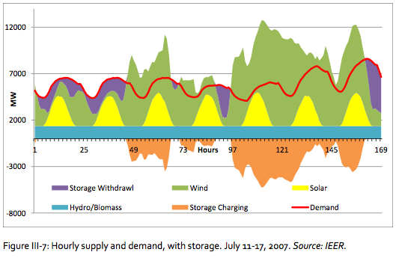

Figure ‎4‑32. Example of an intermittent, renewable energy-based system with storage charging and discharging cycles  
source: (Makhijani et al.)

We address this trade-off by applying the residual load duration curves (RLDC) (Ueckerdt et al., 2015) method, based on flexibility coefficients (Sullivan et al., 2013). The RLDCs are developed based on the consumption profile and energy mix of a country, and indicate the power and duration which can be used for storage charging. Since the timescales investigated in this analysis are years and not minutes, we have considered sufficient to include this effect in the NETSET only through a linear scalar, derived from the detailed analysis presented for the energy mix and consumption profile of Germany in (Schill, 2014; Ueckerdt et al., 2015).

If we take the energy generation profile Figure ‎4‑32 and extend the time slices to include a whole year, then sort the slices according to height, the resulting image is similar to the one presented in Figure ‎4‑33. Every country’s energy generation profile can be converted into this curve, called the *load duration curve*. This can be dissected into a base load box (energy generation by sources whose rates are hard to change quickly, such as nuclear power), a minimum load box (energy generation sources that need to be always on in order to maintain the electricity system) and an intermediate triangle (sources that can be turned on or off easily and fast). Intermittent resources add to the load duration curve through a trapezoid on top of the intermediate load, based on their availability. When not used for minimum load, base load or intermittent load, excess energy coming from renewables can be either curtailed or stored – counted as negative generation. This negative generation is conceptually equivalent to storage load. The resulting curve is called a residual load duration curve.

The storage requirements based on RLDC can be expressed as a percentage of total renewable energy generation, for each renewable energy type, depending on the properties of the energy systems of each country as well as their available storage options. In our NETSET analysis, we use the storage requirements as estimated by (Bogdanov and Breyer; Breyer et al., 2015b; Pleßmann et al., 2014)

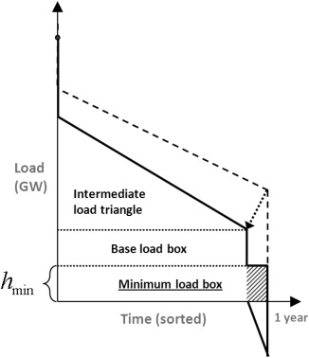

Figure ‎4‑33. Conceptual definition of the residual load duration curve  
source: (Ueckerdt et al., 2015)

### Incorporating energy trade into NETSET

#### Defining trade cost and its factors

This section presents the mechanism through which energy trade is handles in NETSET. It also presents the definition of the country influence index, the main energy trade prioritization metric.

Throughout this section we will refer to the importer country, as the receiver, or simply A or country, and the exporter country, as the sender, or simply B or partner.

We model the energy trade between countries through a trade cost vector. The trade cost vector is constructed for all countries trading with all other countries, for all resources over all tradeways. The resources considered are PV, CSP and wind energy and the available tradeways are electric grid and power-to-liquids. The cost of a trading of resource *k* over tradeway *q* between country *A* and *B*, *TCABkq* will be defined as the product of 5 normalized (around 1.0) factors: the reciprocal of country influence *CIAB*, the transaction cost *XCABq* and the reciprocal of the normalized adjusted EROEI *NRk*, in turn composed of reciprocal of resource utilization *RUBk* (local version of factor 2 of Equation ( ‎4‑21 )), the resource quality advantage *QAk* (local version of factor 3 of Equation ( ‎4‑21 ))and the normalized technical EROEI *RTk*.

|  |  |
| --- | --- |
|  | ( ‎4‑22 ) |



The transaction cost *XCABq* is the normalized transport cost of transporting one unit of electric energy from country to partner, over tradeway *q*. *XC* gets calculated through a tiered cost system dependent on whether:

* A and B have traded electricity before – they are grid partners!
* A, B geographic neighbors but haven’t traded electricity in the past, need to build local grid
* A,B, not neighbors haven’t traded electricity through any means, need to build supergrid
* A,B trade through 2 power-to-liquids conversions, at source and at target.

All of these metrics are distance-based and are calculated using the geographic centroid of countries and the past electricity trade networks. Figure ‎4‑34 provides an illustrative example of the process: Latvia (LT) and Poland (PL) are not grid partners, but they are in the same region. Therefore the *XC* of energy trade between Latvia can be either through a local grid that needs to be built, whose costs are shared equally by both parties, from the centroid of Latvia to the centroid of Poland, or trough PTL conversion, over the same distance. The chosen tradeway eventually will be the one that carries the lower costs of the two. Grid and PTL costs used are as per (Bogdanov and Breyer, 2016). Local grid expansion is set to cost twice as much as a grid expansion to a neighbor, and a supergrid (transcontinental) costs 5 times as much.

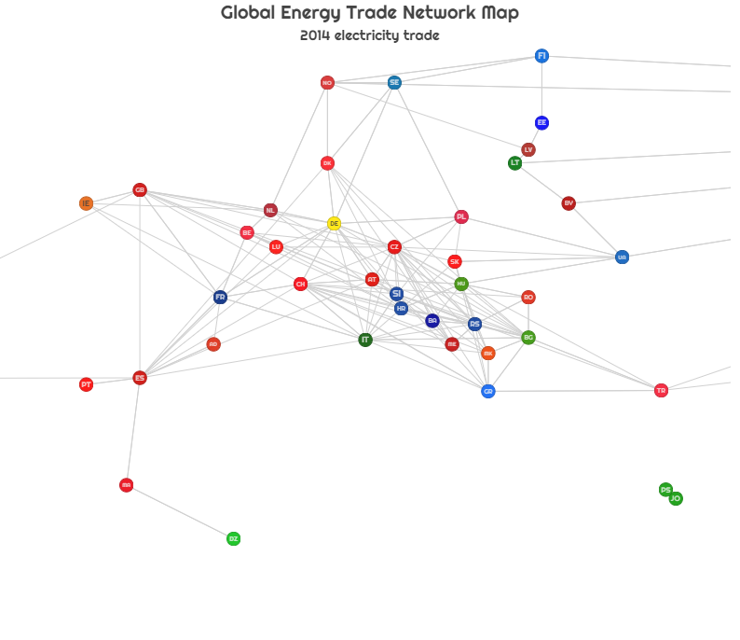

Figure ‎4‑34. Electricity trade network of Europe  
source: own work, data: UN COMTRADE, year: 2014

#### Country importance and influence

The other important metric deciding on the cost of energy trade is the *country influence*. Country influence is a measure developed from the energy trade histories of countries that is proportional to the “ease of trading” between parties: e.g. two countries that have traded 50% of their total energy trade volumes with each other are likely to trade with a much lower costs involved that two other countries who have just traded one percent of their energy in only one year ever before. Moreover if a 90% country A’s energy imports are coming from country B, whereas country B exports only 5% of its total energy exports to country A, country B will be most likely a very important trade partner for A, while A for B, not so much. This will mean that the country *importance* of B for A is very high, or, conversely, the *influence* of country B on A in very high. In the next paragraph we formally define this relationship.

Let us define the *IMABi* as the trade flow of importing energy source *i* (we have historical data for fossil fuels and electricity) by country A from country B, and *IMAB* as the sum over all energy sources *i*. By mapping all trade flows between all country pairs, we call the resulting matrix *IM* the import-matrix. We can conduct a similar exercise to map export flows, resulting in the export-matrix *EX*. We can easily see that these matrices are both asymmetric square matrices, with zeros on the diagonals (self-trade) Conversely, as a safety- measure to shield our analysis against any data inconsistencies, we can also create the reverse matrices *RIM* and *REX*. *RIMAB* will be defined as *EXBA* and *REXAB* will be defined and *IMBA* – bearing in mind that in online trade databases the import flows reported are not always matching 100% the export flows of the reversal of partners.

We then normalize all four trade matrices to create *NIM*, *NEX*, *NRIM* and *NREX*. The normalized matrices will contain the trade values relative to the average trade value of a certain country:

|  |  |
| --- | --- |
| | ( ‎4‑23 ) |

The resulting matrices all have rows normalized against 1, corresponding to the average trade value of that row.

Country importance is then defined as a weighted mix of the normalized trade matrices, taking import as the one carrying the most powerful weight, followed by export and the reverse matrices. Both trade directions are taken into account: e.g. if A is an important import partner for B, then for B, A is also an important export partner – and therefore both countries will likely use all of their political and economic influence to keep the trade flow between them in the future.

Because of the vast differences in the trade volumes of countries with their partners (energy trade volumes tend to be exponentially distributed – empirical observation from UN COMTRADE), we need to control the extent at which the relative importance of the most important trade partner exceeds that of the average trade partner. We do this through the introduction of an exponent, the country importance *power factor* *p*. Higher power factors will lead to a denser distribution of importance values, while lower power factor values will emphasize differences more.

We must also define the importance of self-trade (equivalent to building energy capacity in-country) and assign a unified value *q* to all countries’ self-trade.

Then, we can formalize the definition of country importance CM as follows:

|  |  |
| --- | --- |
| | ( ‎4‑24 ) |

|  |  |
| --- | --- |
|  | ( ‎4‑25 ) |

The country influence matrix CI will be then the transpose of the country importance matrix CM. The logic behind this definition is that if a trade partner is very important for a country then that trade partner has a high trade influence on this country. Because of the incorporation of both A to B and B to A flows in the definition of CM, but with different weights (as per ( ‎4‑25 )), as well as due to the potential differences in database for direct and reverse flows, the differences between CM and CI will be present but subtle.

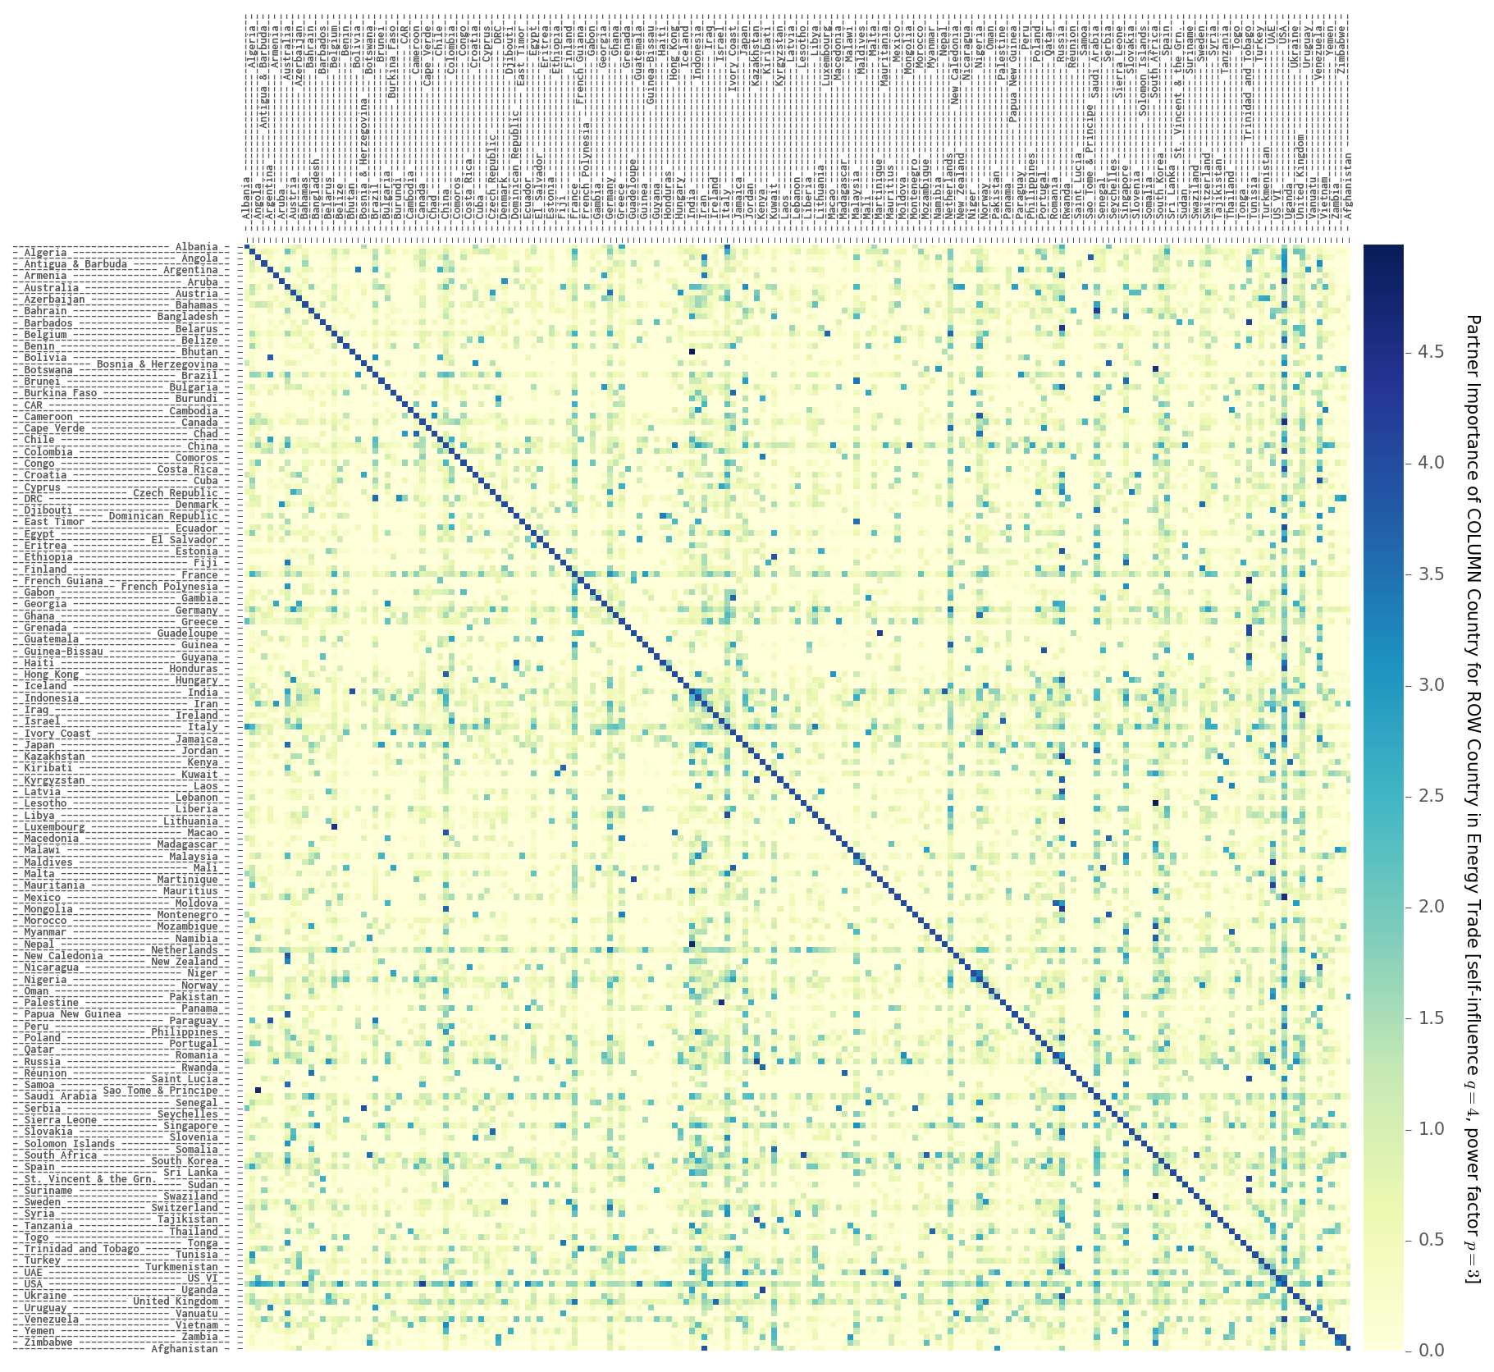

Figure ‎4‑35. Country importance/influence matrix calculated for 189 countries with q=4 and p=3  
source: own work, data: UN COMTRADE, years: 1962-2014

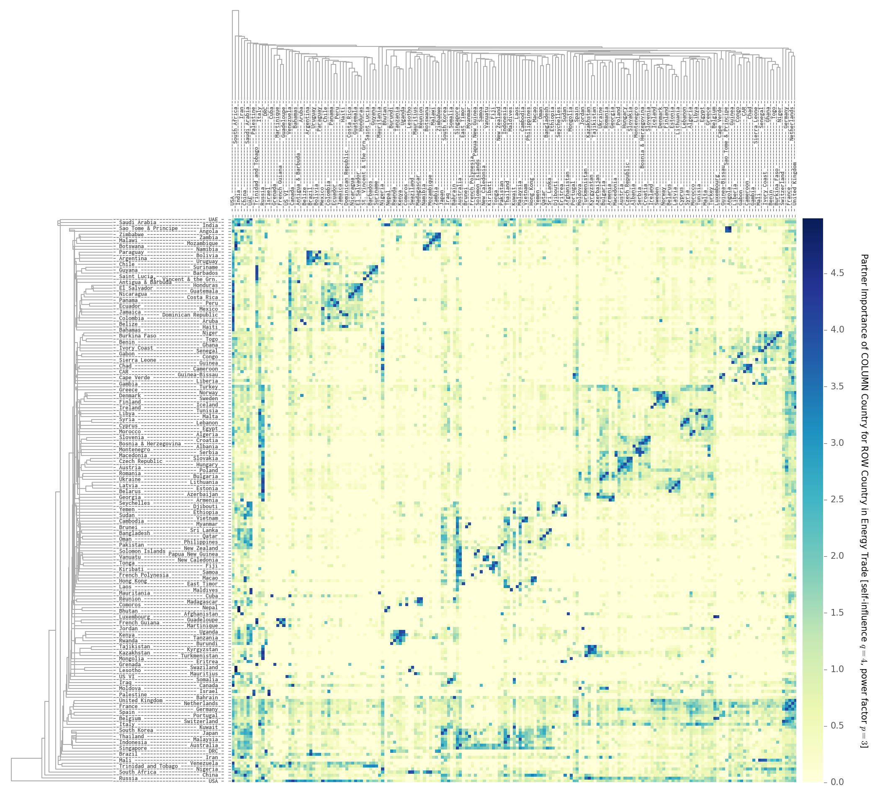

Figure ‎4‑36. Clustered country importance/influence matrix calculated for 189 countries with q=4 and p=3  
source: own work, data: UN COMTRADE, years: 1962-2014

Figure ‎4‑35 presents the country importance/influence matrix calculated for 189 countries of NETSET with self-influence q=4 and power-factor p=3. Figure ‎4‑36 presents the same matrix after a reordering of rows and columns based on hierarchical clustering to easily reveal the trade clusters and the most influential countries.

In the presented matrix a stronger blue box indicated a stronger influence of COLUMN country on ROW country. We can see from Figure ‎4‑36 that the USA is the most influential, as the first row is almost all dark blue – meaning that USA has medium to high level of influence on all countries. However, the bottom row is also almost all bleu, meaning that the USA is also very dependent on energy trade from its partners. It is also interesting to notice the heavy influence of Russia (11th column) on the countries of former Soviet bloc, but the reverse of this is not true (2nd row from bottom). Through clustering, we can also visually identify the large energy trading clusters of the world: the Latin American cluster in the top left, with a South American mini-cluster and a large Central American component, the Southeastern African cluster in the top middle the very large North and Eastern European cluster in the middle center, slightly to the right, with clear Baltic, Balkan, Non-EU and Scandinavian sub-clusters, just slightly to the top right from the European cluster the West-African one, the Southeast Asia-Oceania cluster in the middle. We can also identify the energy-dependence of Western Europe (bottom 20, stronger blue rows) as well as the strong influence of a few (UK, Netherlands, France, Germany, rightmost columns).

Benchmarking the desired country influence has to do with setting the universal rules governing global energy trade. This sets the power balance in the network between importers and exporters, i.e. the trade demand of importers or exporters will prevail upon conflicting results – and the openness of trade, i.e. how important is locally-produced energy compared to traded energy.

Let us start by defining the *country influence vector* as the vector of countries sorted by their average influence (e.g. the mean of all values in their column in the country importance matrix or the mean of all values in their row of the country influence matrix)

#### Power balance

An importer-driven structure results in a top-down hierarchy, where the importers “demand” and “force” the producers into supplying their products, leading a lock-in of partners – with the most influential countries in the trade influence vector taking the best resources first. This world has the structure of a multiplayer prisoner’s dilemma game.

An exporter-driven, bottom-up structure resembles a free market (as exporter’s cannot really “force” their products on importers but rather they list them on the open energy market, with prices ultimately deciding the flows), or a public goods game. In this case, in the event of conflicting demand for the same resource, the exporters partition the resource proportionally to the country influence factors of the aspiring importers.

#### Openness of trade

Both of these worlds can exist in “cooperate” or “defect” modes, analogous to countries maximizing the total system benefits or their own. In our particular case the system benefit is the total energy investment needed to complete the SETs of all countries.

In both cases, the way in which the country influence is calculated becomes crucial. The openness of trade will be decided by the self-influence factor, i.e. how much countries value trading with themselves – expanding energy generation in-country – compared to the importance of their average trade partner. This will be diagonal of the country-influence matrix. The power balance will be decided based on the influence power factor, deciding on the spread of country influence, i.e. how much more influence does the most important trade partner of a particular country have compared to that the average trade partner. See stage F in section ‎4.6.9.

### NETSET resource allocation algorithm

When trying to engineer a coordinated, networked sustainable energy transition for all countries, one single factor has paramount importance: the renewable energy investment ratio. Fossil producer and especially large exporter countries will have to decide how much are they willing to ramp up production in the immediate period before and in the early years of the transition – in essence, bringing forward future energy emissions reserves in time, that enables to build up the renewable energy generation capacity, acting as energy seed for the transition. This, of course, curtails their remaining emissions budgets, but it is unavoidable for a successful transition – as we see from the global SET TFI results.

We have already used the most feasible values of the renewable energy investment rates from the global SET to benchmark the fossil energy production budgets in step C2. This leaves us with well-defined trajectories of demand and fossil fuel availability, along with exogenous profiles of scale-limited resources. This decision, at first glance, seems to lie solely with the exporters, to decide whether they want to alter their business-as-usual production profiles and ramp up production in the near future. However, as saw in stage F, importers can also govern exporter production rates – but the renewable energy investment eventually might not happen at the same pace in all countries. At first run of the model, we use indicative values of global set. In a manner similar to the global SET process, we then alter the initial fossil investment budget and run NETSET again until we have a conversion towards the emissions cap (after 3-4 iterations the deviation is <1%).

After this, we need to determine (guided by the global SET TFI values) the maximum yearly growth rates (“ramp-up speed”) of renewable energy production for each technology – putting a constraint on the maximum extractable >= tradeable amount of energy year-to-year. In theory, resource renting would also exist, where countries would invest into building generation capacity from their own energy budgets, for export back home in other countries with good resource quality (such as DESERTEC). In this case both energy investment and the energy consumption would be in the consuming country, therefore in essence “altering” the resource distribution of that particular country. However, because of the geopolitical uncertainties of such solutions, currently we rule them out.

The NETSET model will be solved year by year, by allocating the energy amounts needed by countries to match the gap between fossil fuel availability (plus the non-scalable energy production) and energy demand. Then energy trade flow directions and the traded resources will be determined by country influence and the transaction cost picked by countries in the order or the country influence vector. The global systemic goal of NETSET is set to minimize energy investment, therefore the adjusted EROEIs (based on resource utilization, resource advantage and ESOI) will also be deciding factors in the trade flows, as well as a diversification factor *ωmin* (a minimum share in energy consumption for each resource within a country – for energy security and grid stability reasons).

Following the order set by the influence vector, importer countries will pick their best trade partners until they have matched all of their demand. In-country production is considered trade with self and does not behave differently from trade with other countries. In the event that a country’s increase in demand cannot be matched in a certain year (for very large consumers with rapid growth – limited by the production growth-rates of all other trade partners), the in-country limit on growth-rate is lifted and demand is matched by expanding in-country renewable production, regardless. At this stage country’s trade pick is not implemented as a trade flow, but rather recorded as a bid. The actual trade flow amount will be decided by the exporters, based on the global trade rules set in F, after all countries have recorded their bids.

After all countries in the influence vector have places their trade bids, there will be overlapping requests recorded for the same resources. This conflict is possible to solve through one of the following two relaxation methods:

* + Trade volumes are divided amongst bidders based on their country influence (therefore not matching their entire demand) and the bidding process is recursively repeated until all demand has been matched. After z iterations, when the trade bid amounts have decreased significantly, trade bids are set as binding all trade volume is allocated to the bidder.
  + Total volumes are tiered into smaller amounts, and a tier trade is considered immediately binding after the bid has been placed. As long as the country bidding order is decided by the trade influence vector (therefore preserving the distribution by influence proportionality), this process is discrete equivalent to the other, with a predefined number of recursive z iterations resulting in z tiers.

After all trade bids have been fulfilled, a situation might arise, where country A imports all of the energy production of country B, which in turn imports all of its energy from country C, purely due to the differences in trade influence. We call this a trade chain. Depending on the difference in country influences of AC (influence of A on C) and AB + BC, we can choose to relax the trade chains. In particular, the amounts of energy traded in the chain will be distributed as follows:

* + An amount proportional to AB + BC – AC, i.e. the influence advantage of B on C over A, will be kept as a trade chain, while the rest will be shifted on the direct trade route AC.

Trade chains can exist several levels deep (A to B to C to D …), at this stage because of significant computational complexity, we will only consider level 0 – no trade chains – or level 1.

Finally, while the bidding order of the country influence vector might reflect the geopolitical realities of energy trade, it might not necessarily lead to the overall lowest energy investment and thus not the lowest overall energy transition cost. In order to find the optimal energy investment cost, we do a simulated annealing on the country influence vector: we switch two countries at random in the country influence vector and repeat the entire trade allocation process. If the resulting total energy investment cost of the transition is lower than before, we keep the two countries switched in the order. We repeat the switching process until the energy investment cost starts to converge.

The deciding metric of a trade flows will be the trade cost vector. At each trading step (e.g one trading tier) the importer country will create and maintain a trade cost vector, which will include the costs of trading with partners, over various tradeways (as in E4). This will be the product of 5 normalized (around 1.0) factors: the reciprocal of country influence, the transaction cost and the reciprocal of the normalized adjusted EROEI, in turn composed of reciprocal of resource utilization, the resource quality advantage and the normalized technical EROEI. The chosen trade partner and tradeway will be the one carrying the lowest cost. Once implemented, a trade flow will be in effect for Lcontract (contract lifetime) number of years.

### NETSET energy cost estimation and sensitivity analysis

In order to test the NETSET model for robustness against the uncertainties in the assumptions, at the final stage of the NETSET algorithm, we have incorporated a set of sensitivity tests.

The main sources of uncertainty in the networked part of SET are stemming from the parameter values defining the universal governing rules of global energy trade. We conduct all 4 combinations of a high and low values of self-influence and power factor.

The maximum yearly growth rates of renewable energy production also play an important role when choosing the trade partners, therefore we try two different values, as well as for the diversification factor ωmin, as these two parameters play a crucial role in eliminating potential trade flows not satisfying the constraints set by these parameters within a particular trading tier.

Lastly, to check for the consistency of the simulated annealing, we execute the process with 3 different random seeds.

### Visual NETSET algorithm overview

In this section we have summarized the NETSET algorithm as a nine-stage process. Here we give a visual walkthrough of the process and its stages. All steps at all stages are executed for *each country, each year* and *each energy source*, unless explicitly stated otherwise.

1. A 6-step process to collect and curate population, energy, emissions, reserves and GDP data
2. A 6-step process to generate primary and secondary energy demand profiles
   * After this stage, the global SET can be run in its entirety
3. A 9-step process to generate fossil-fuel phase-out curves for countries under various climate change scenarios and emission caps
4. An 8-step process to benchmark renewable energy resource potentials and resource utilization
5. A 9-step process to derive the country influence matrix and the transaction cost matrix
6. A 3-step process setting the universal governing rules of energy trade through varying the parameters of the country influence matrix
7. A single step to benchmark the energy investment costs and energy availability
8. A 9-step, recursive process to implement the global energy trade mechanism and develop the NETSET dynamics
9. A 5-step iterative process to conduct a sensitivity analysis on NETSET

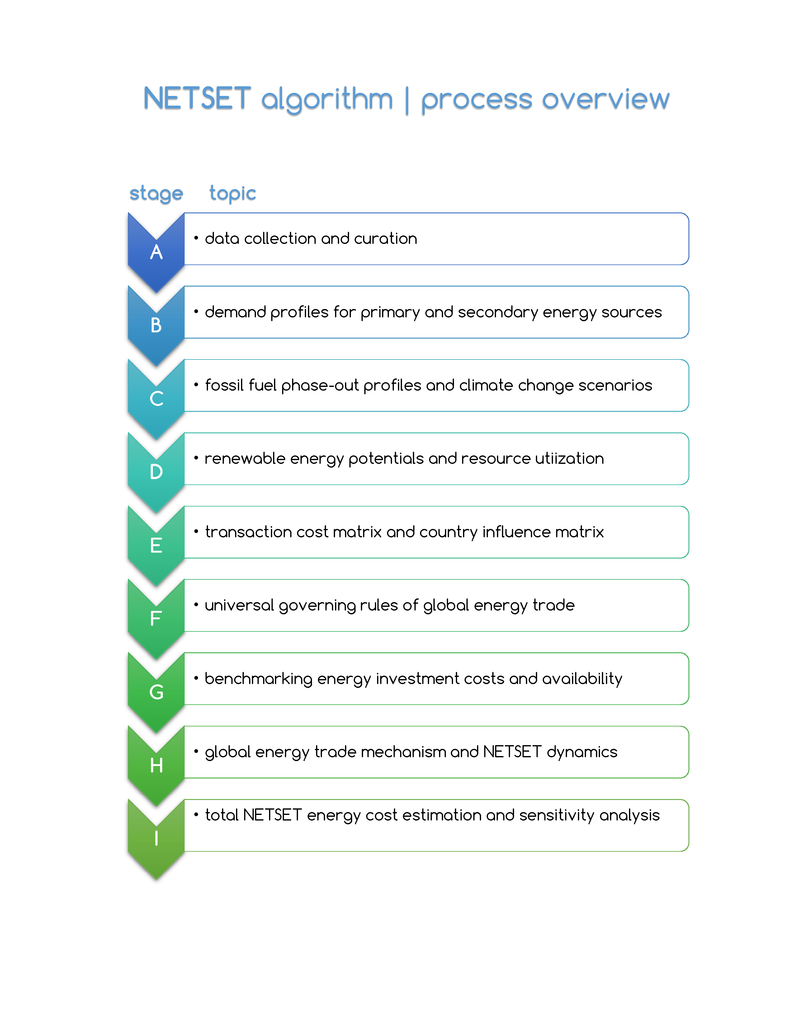

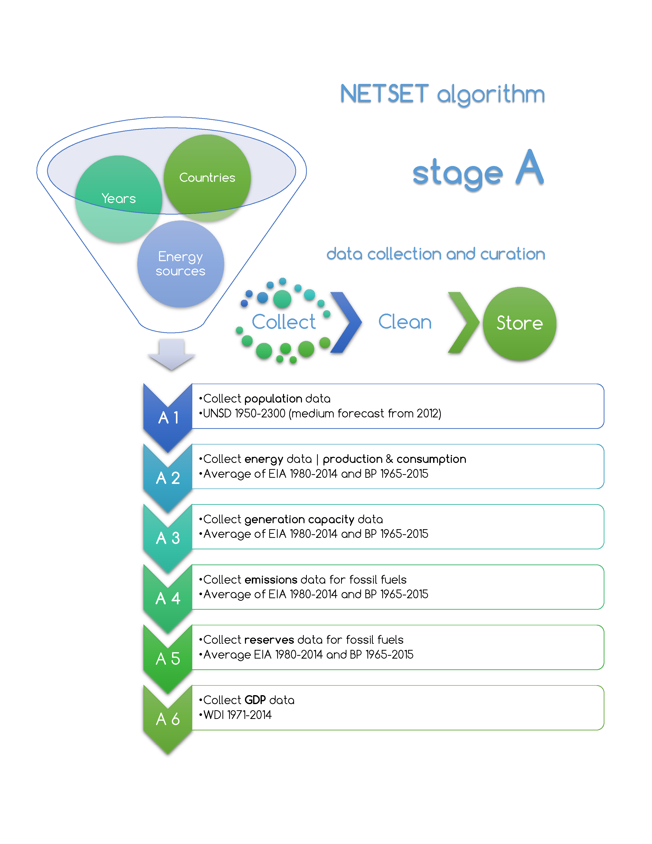

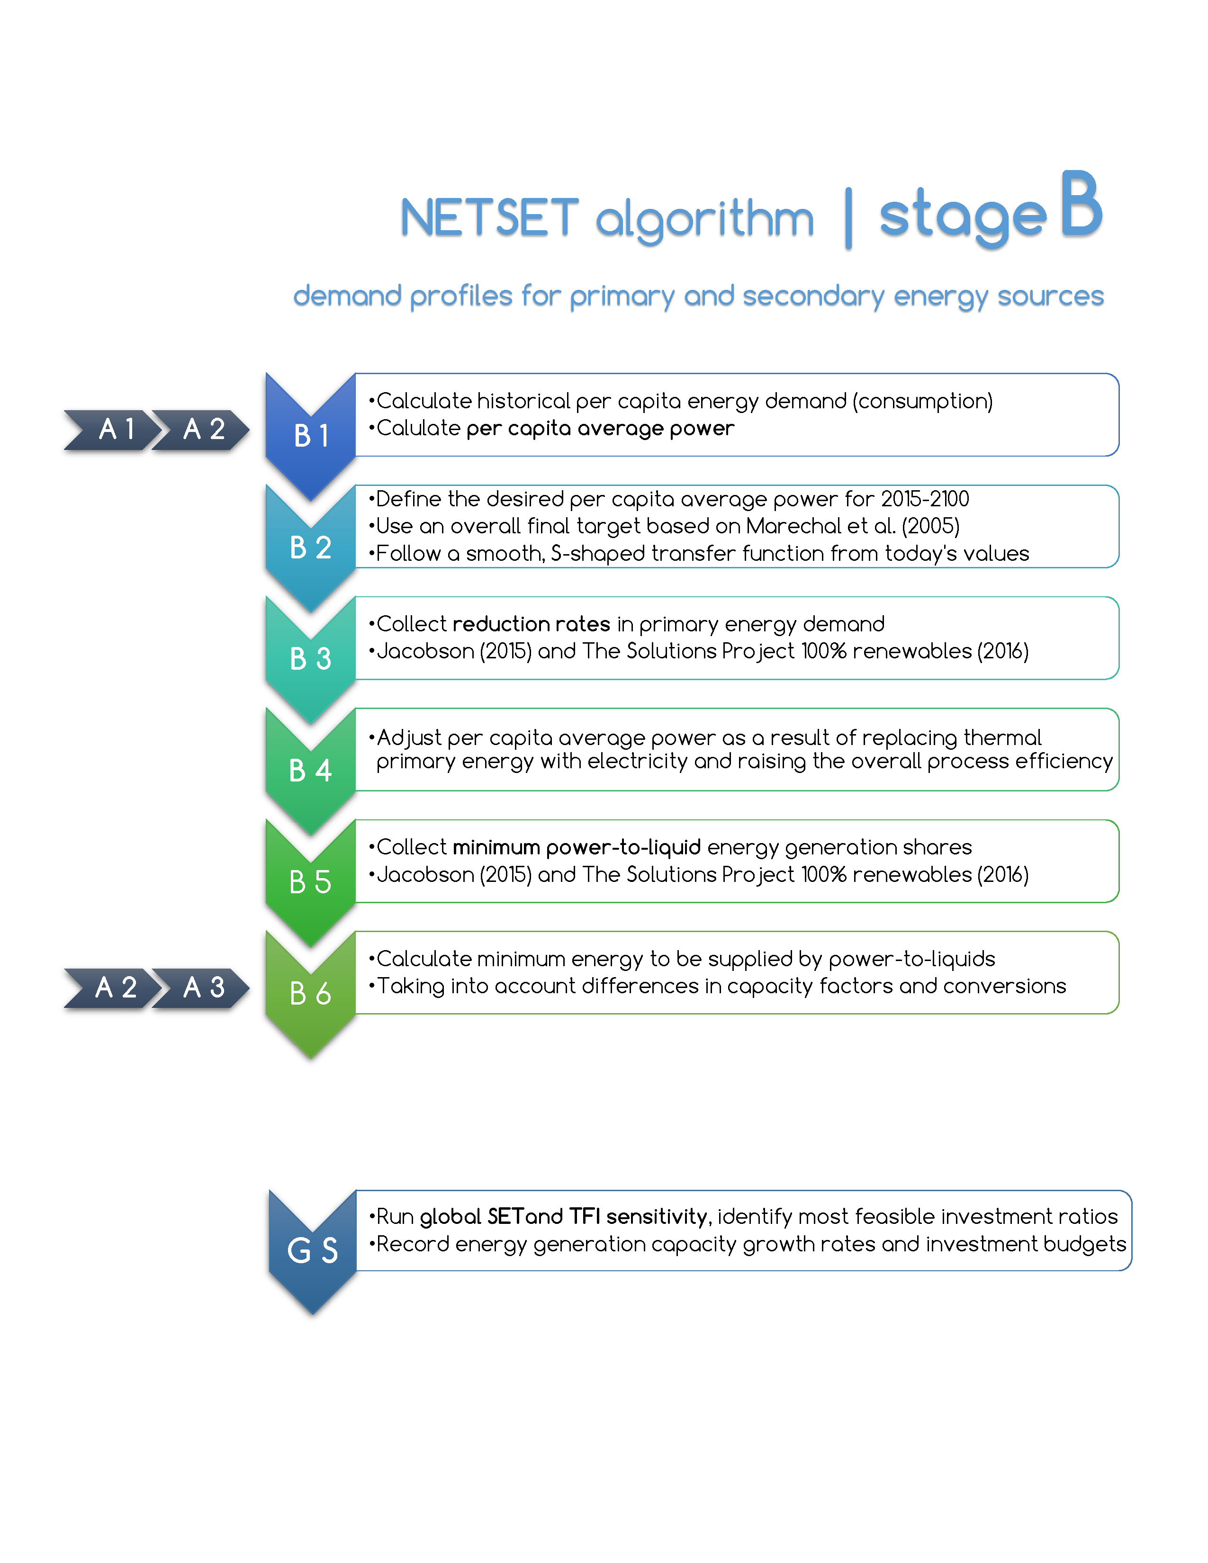

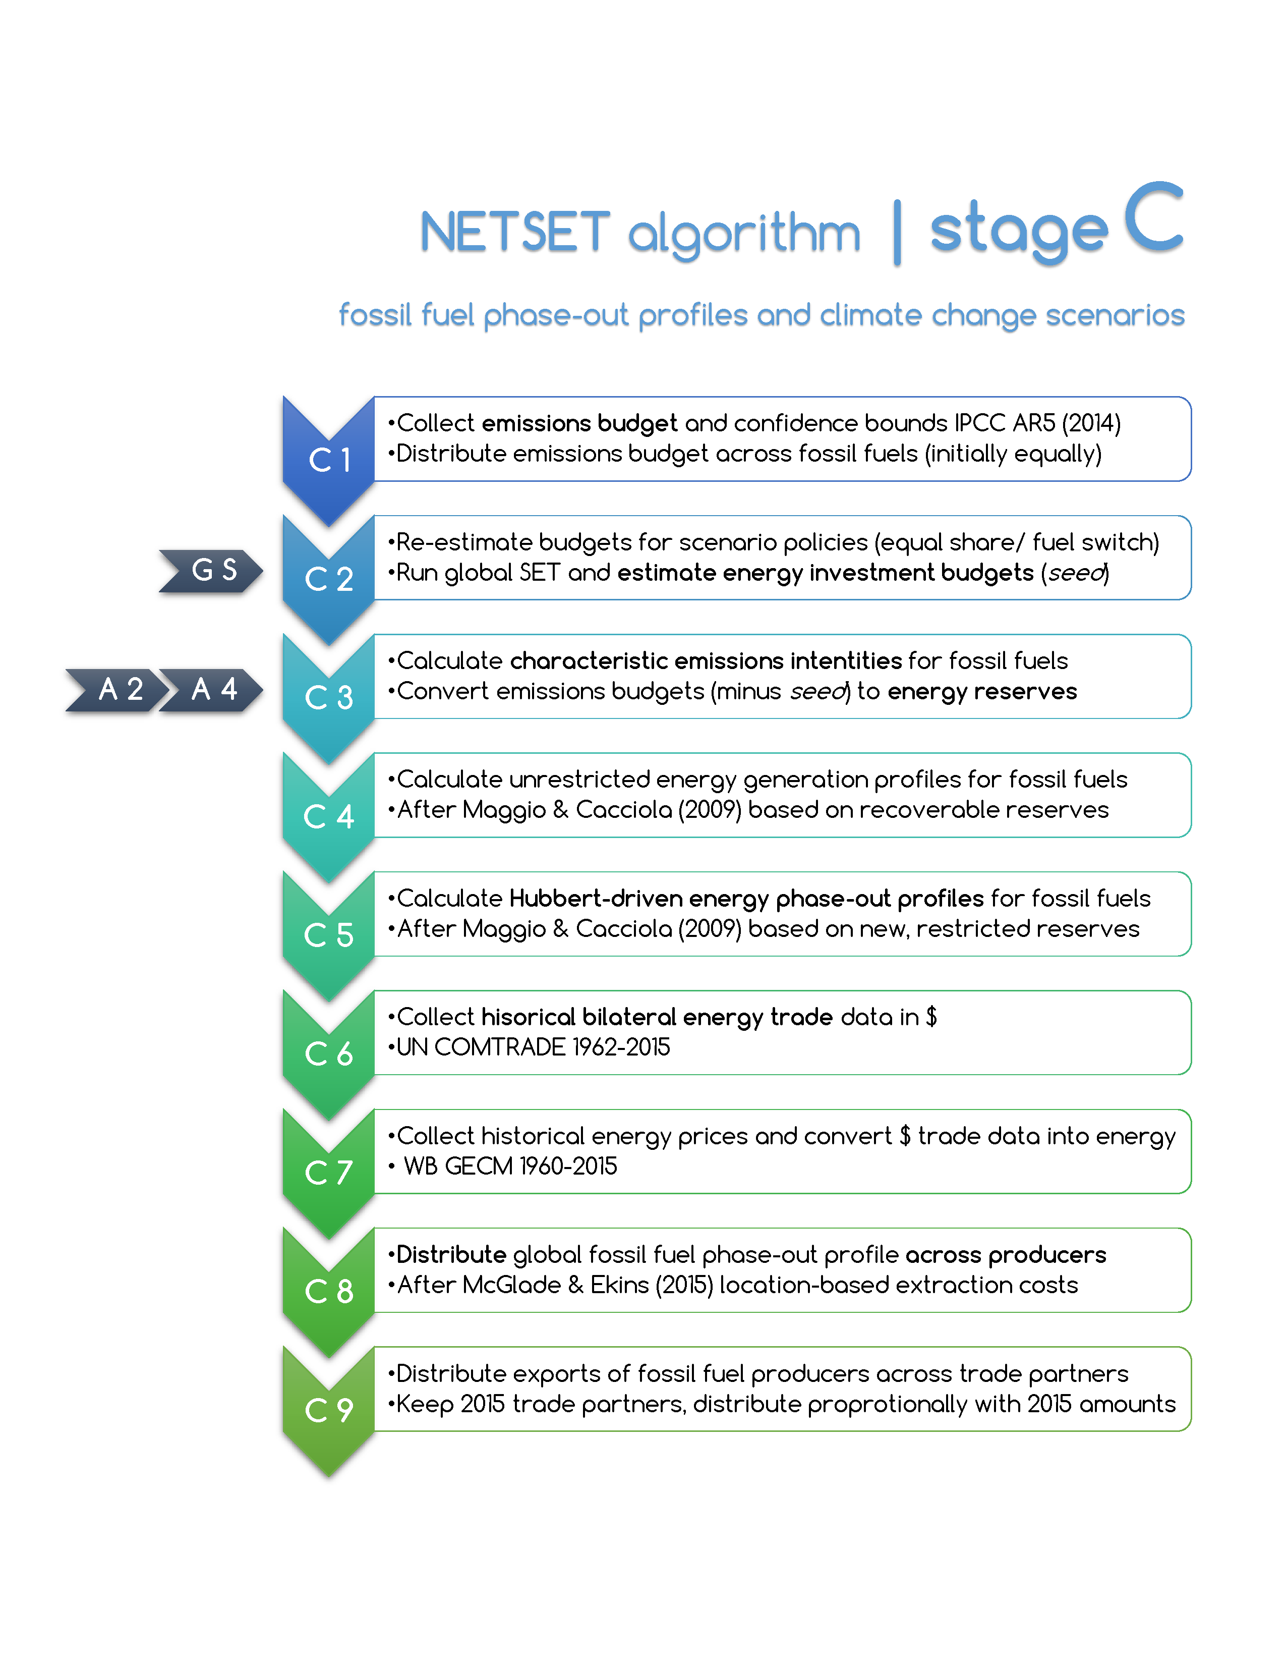

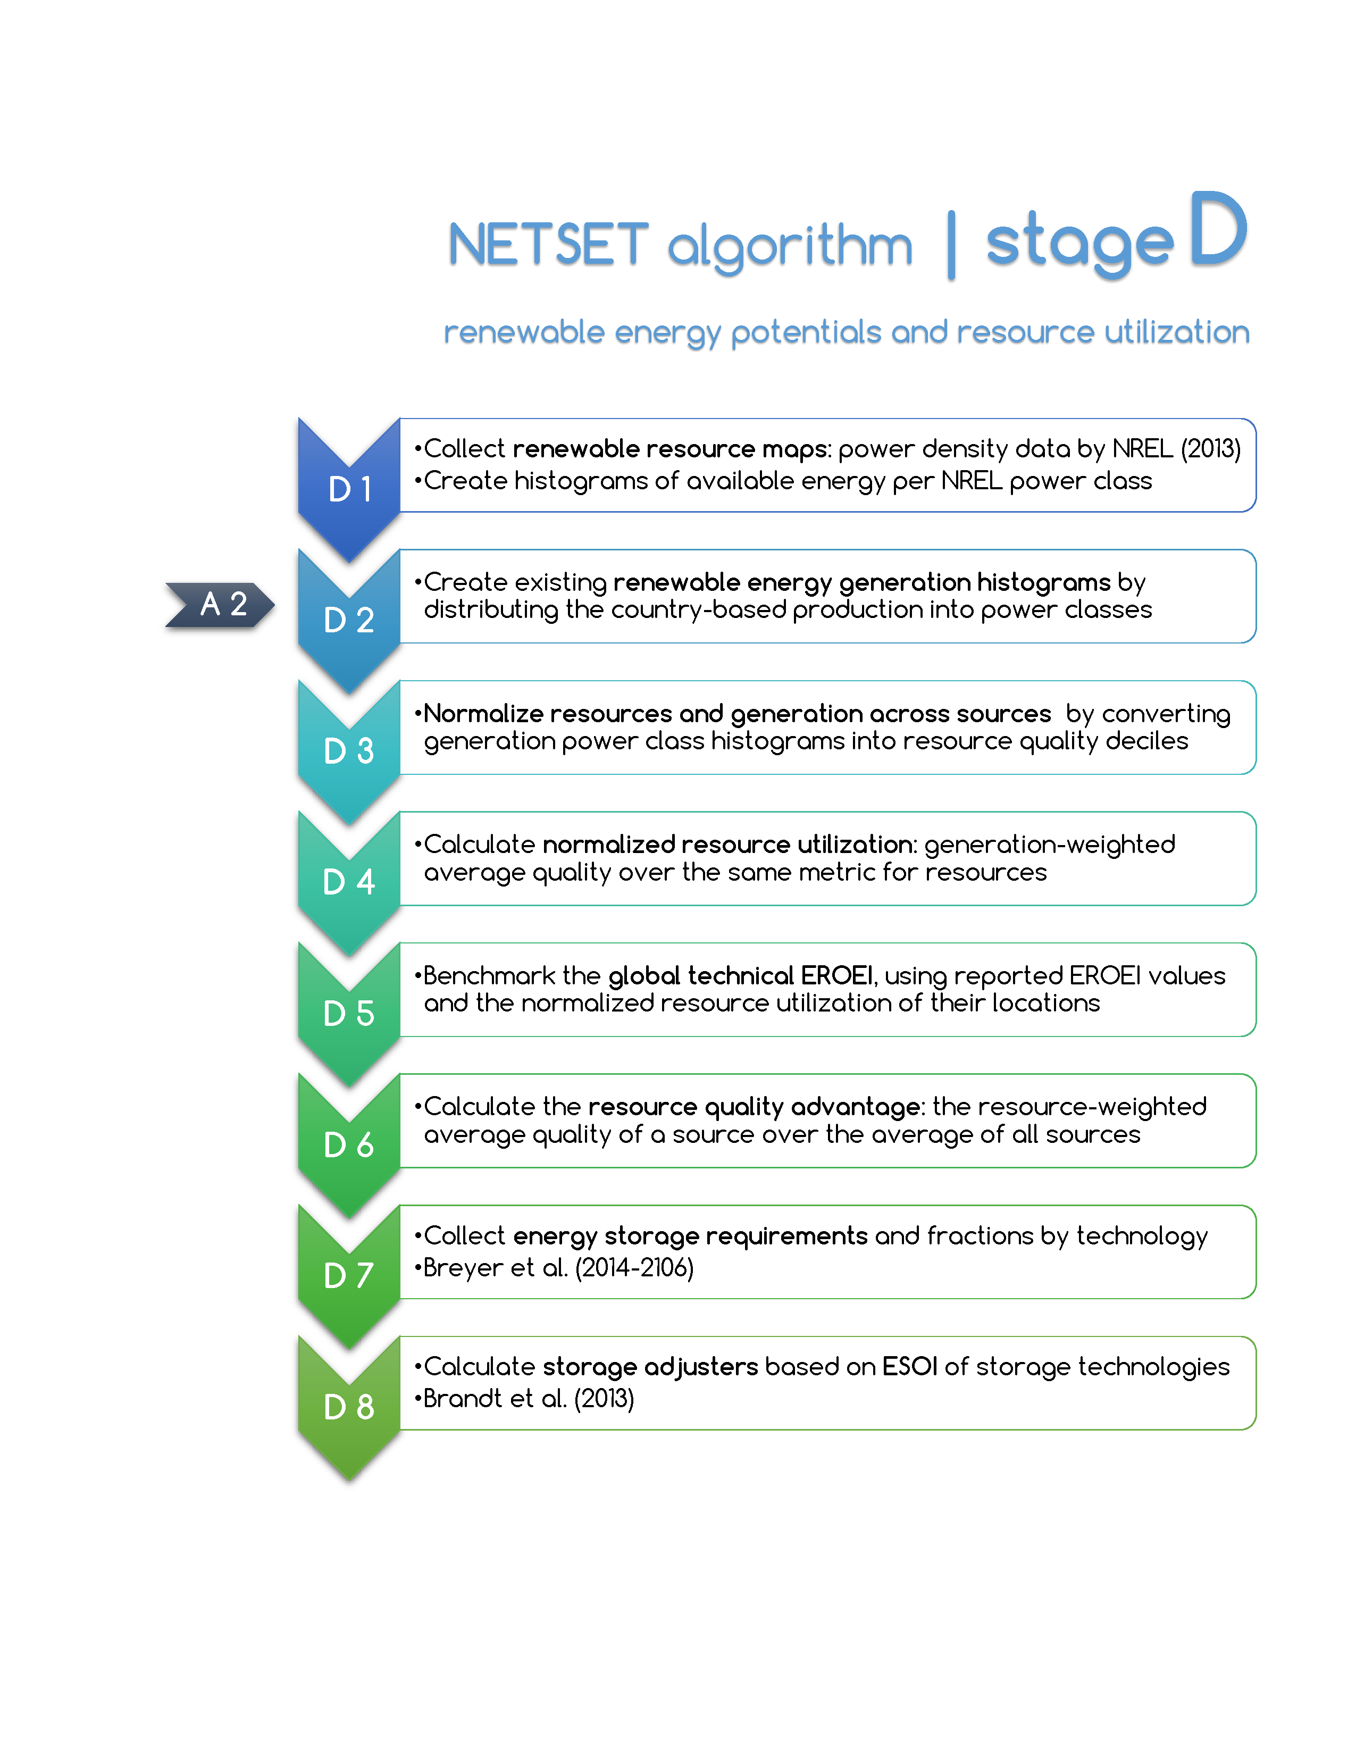

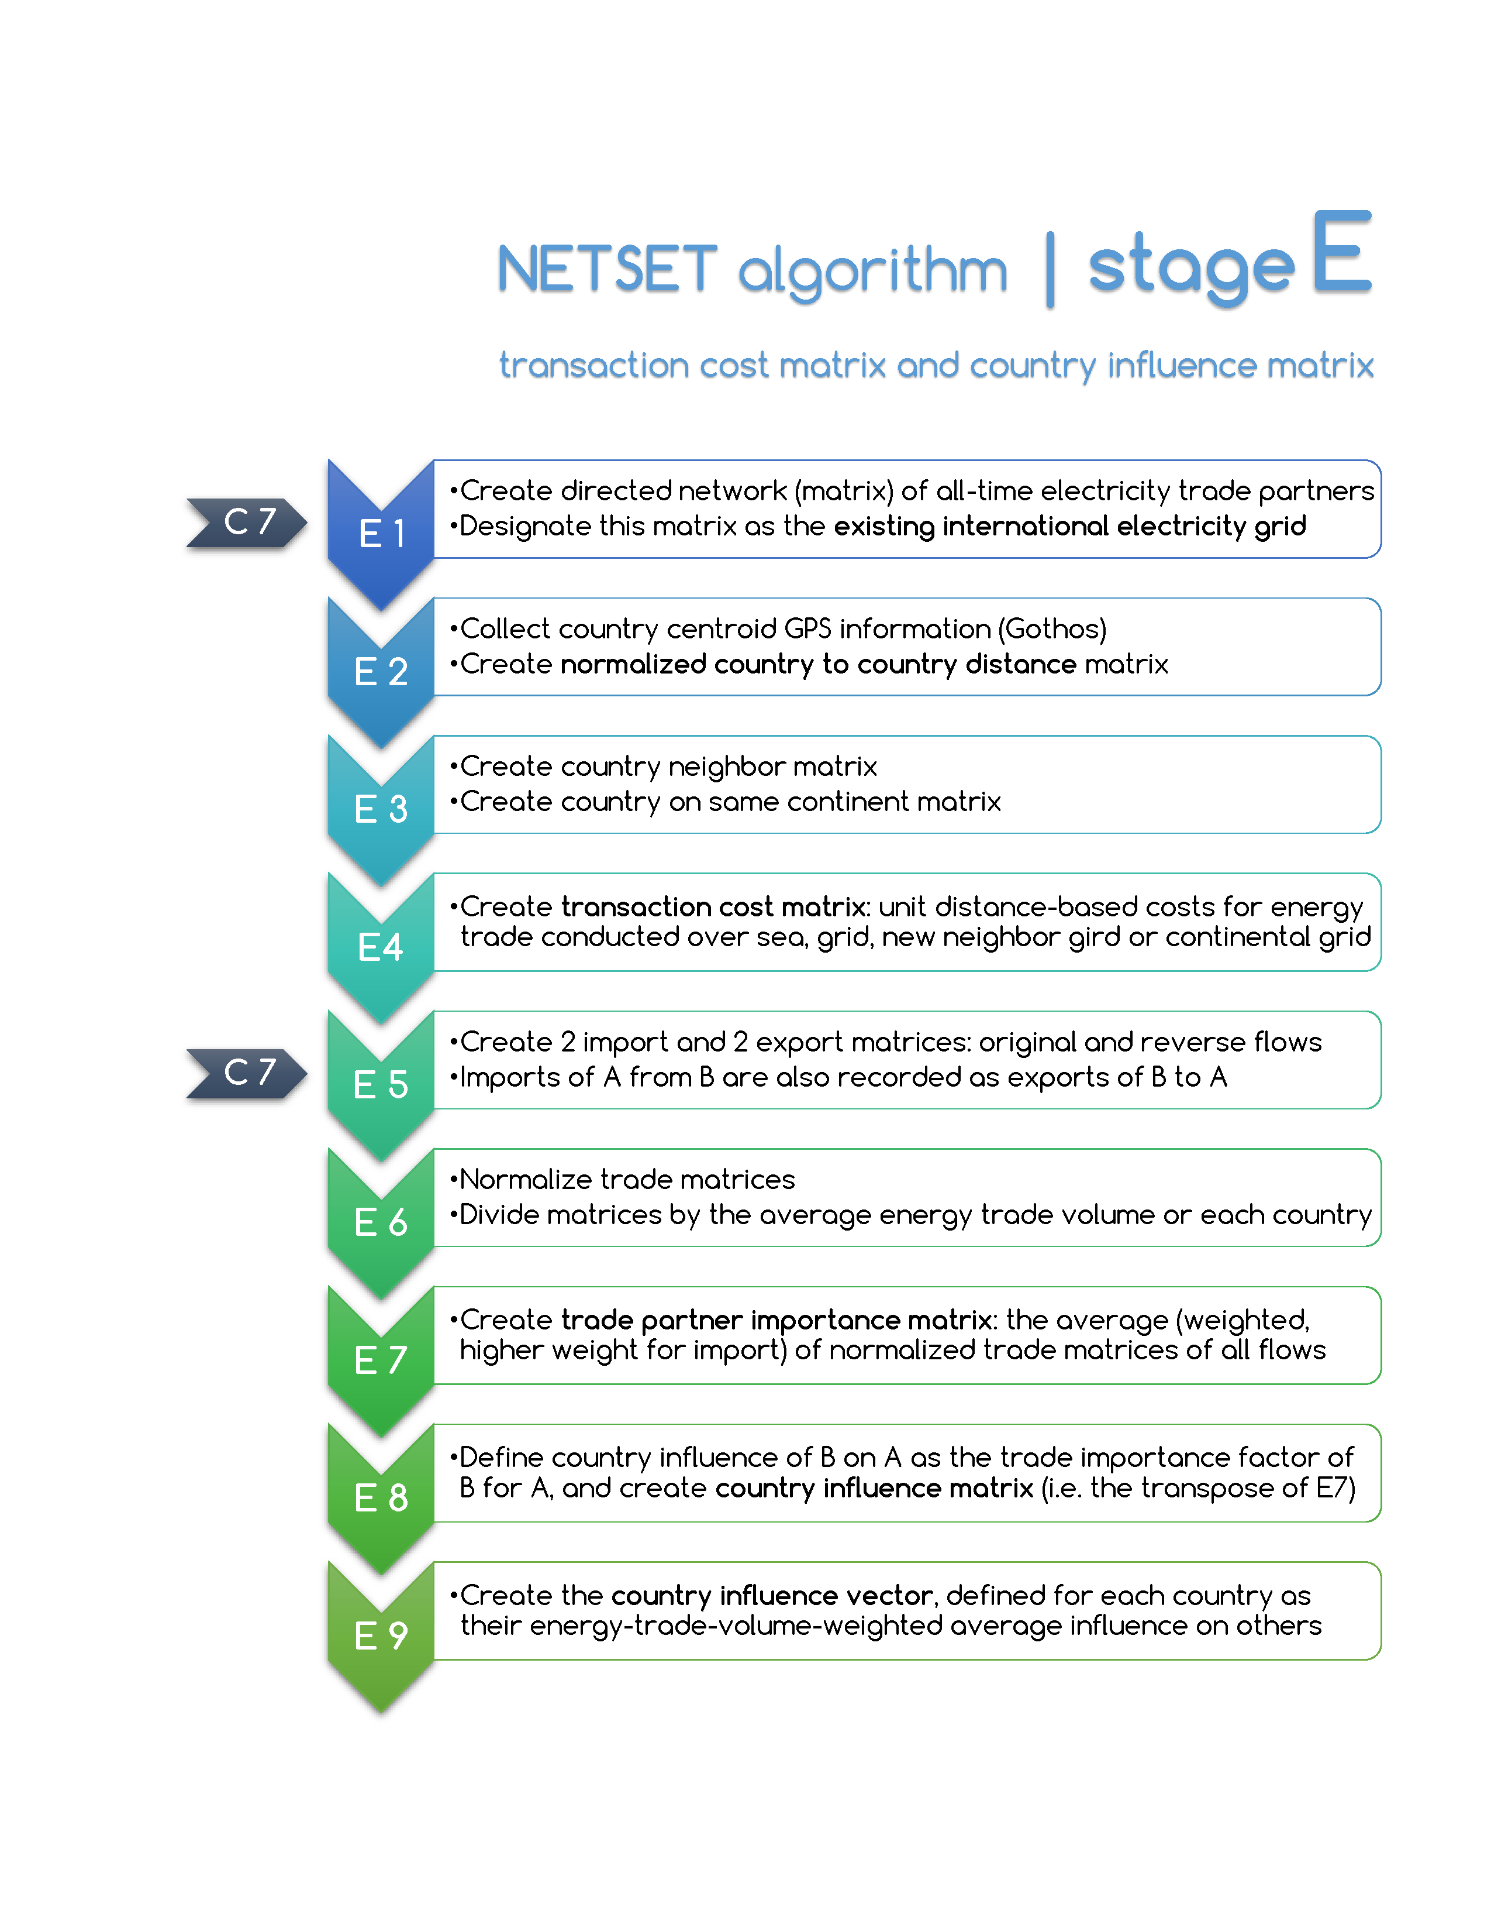



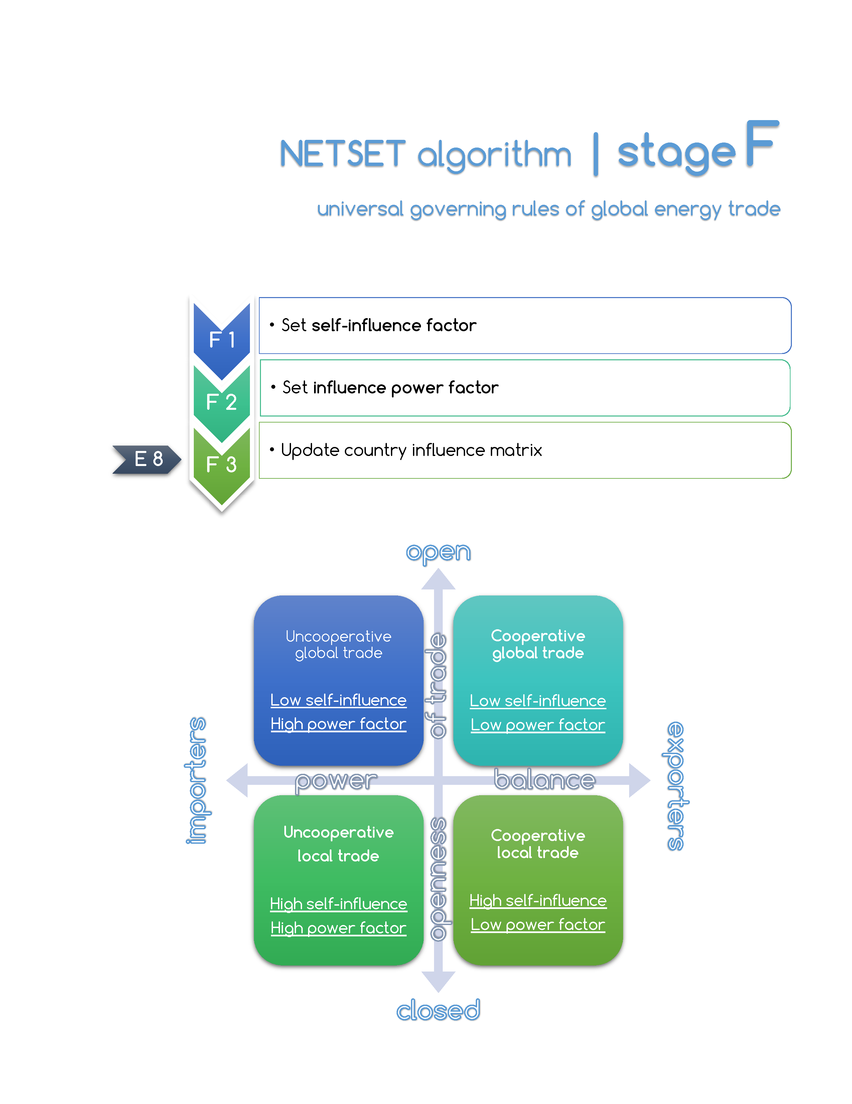

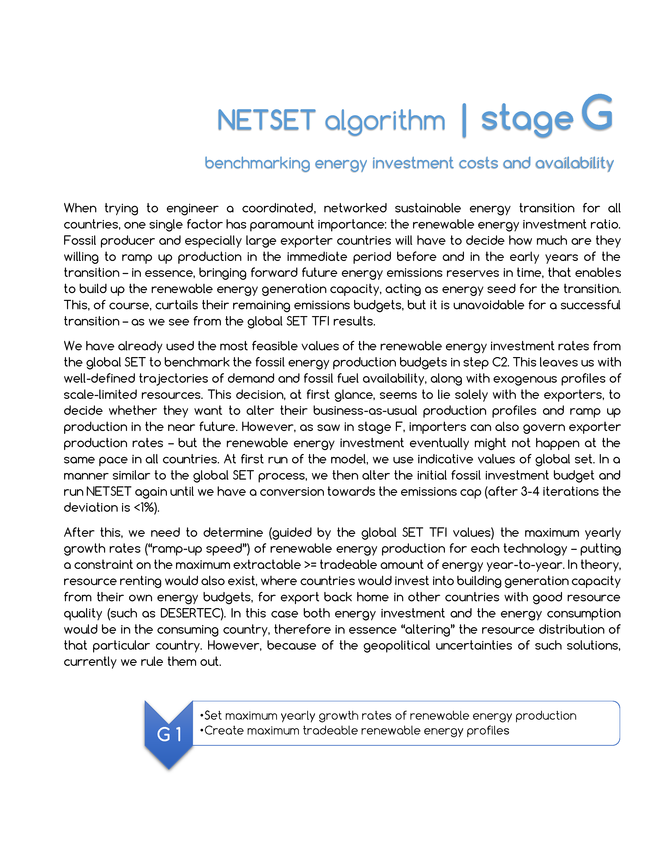

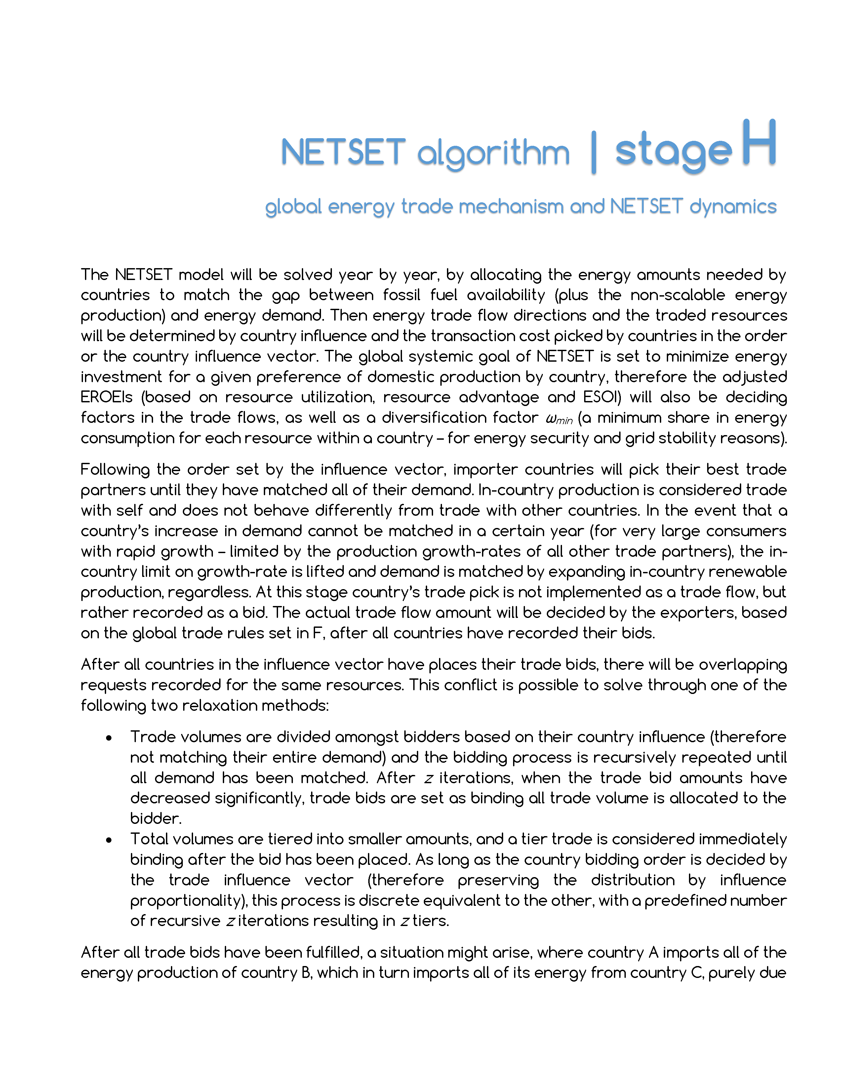

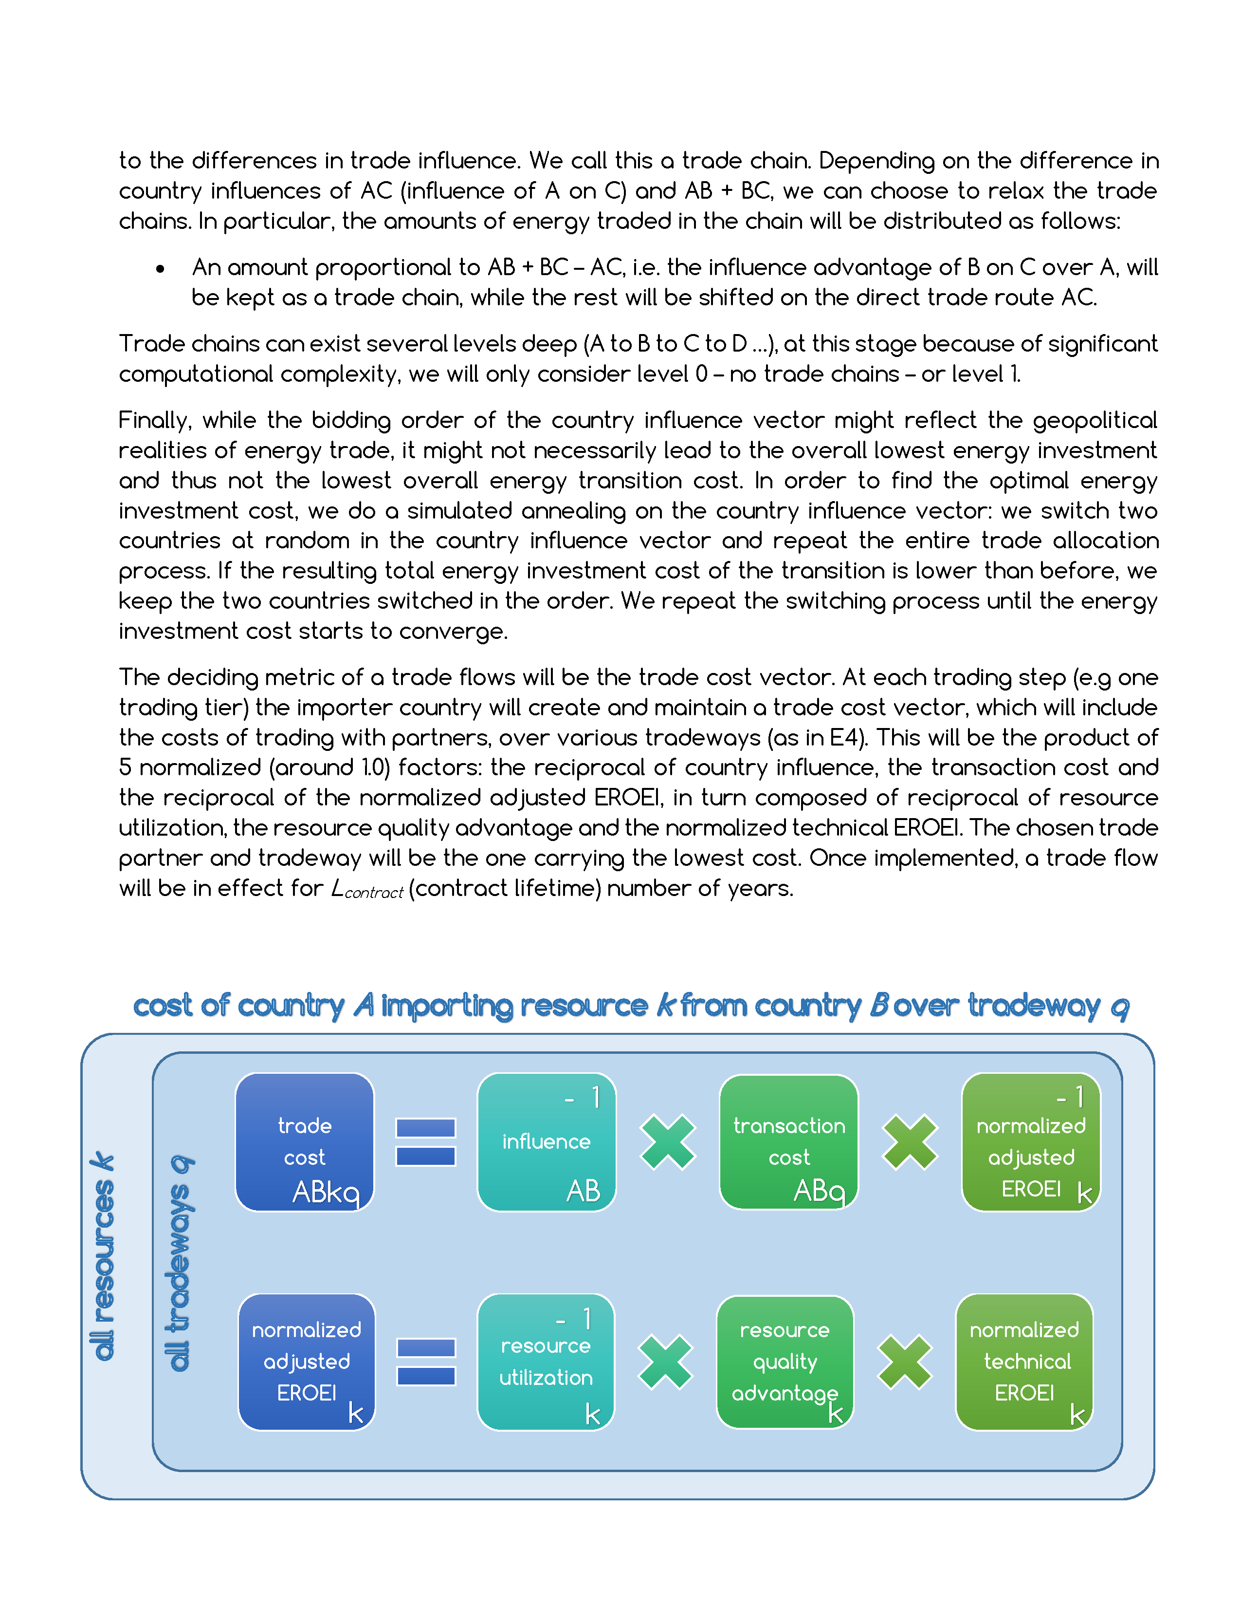

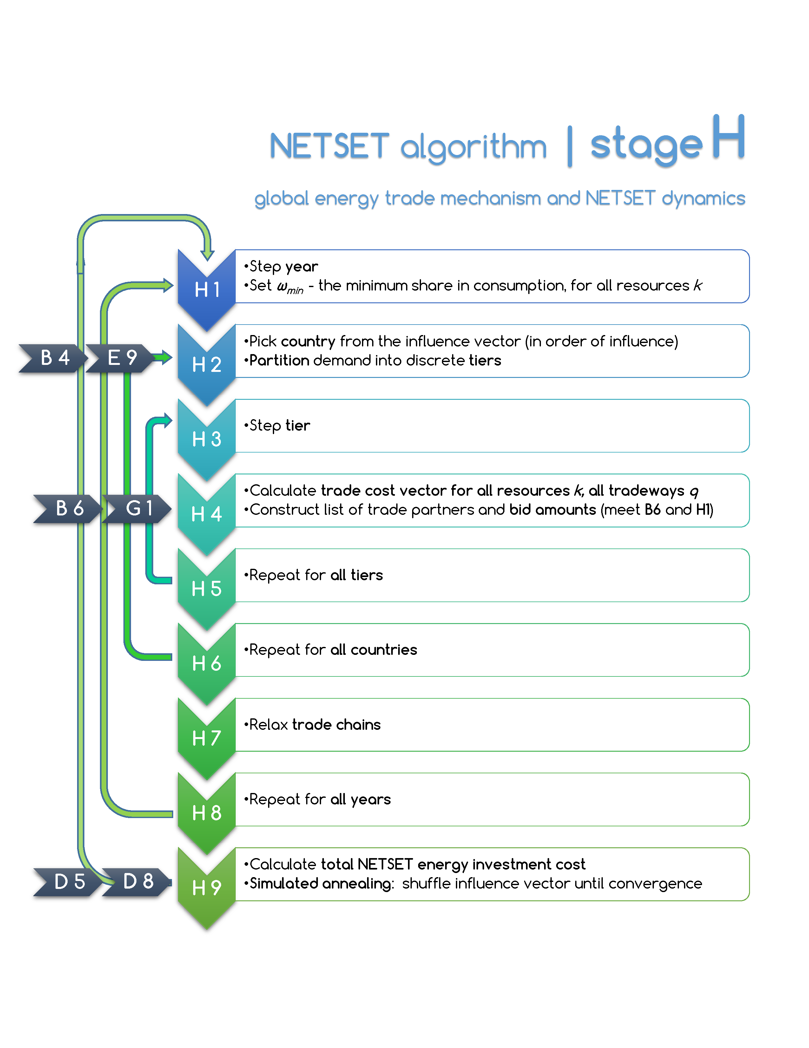

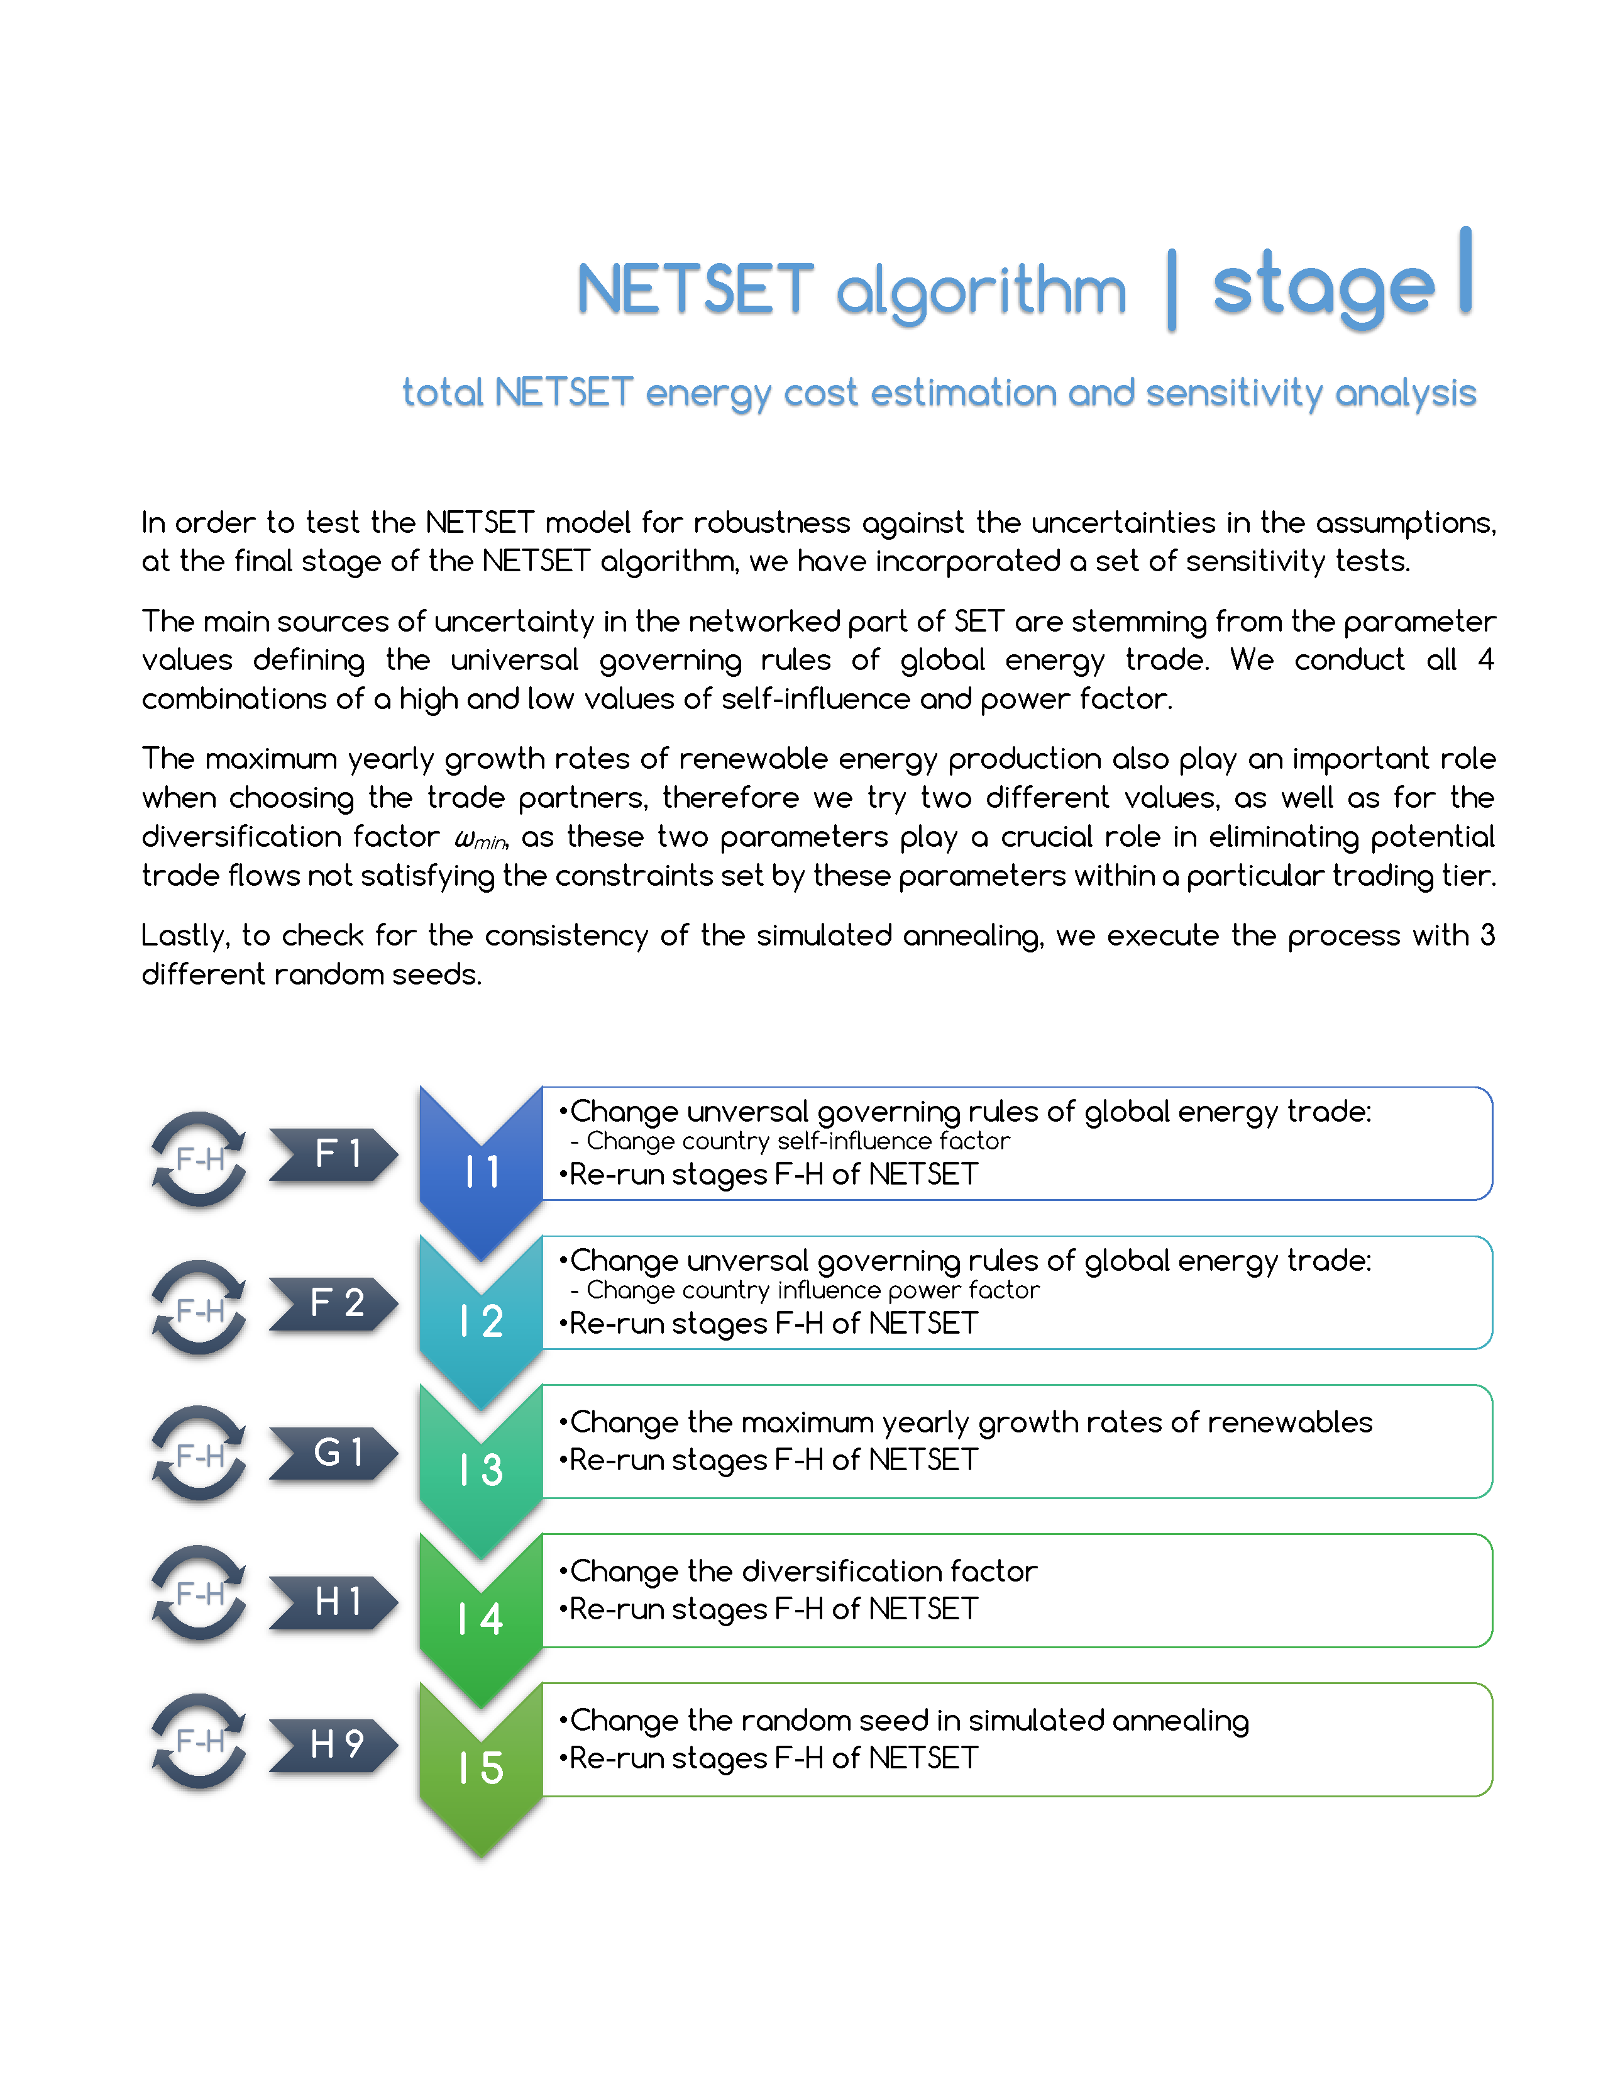

# ENGINEERING A GLOBAL SET: APPLIED ANALYSIS & RESULTS

In this chapter we present and analyze the result of a set of simulations and sensitivity analysis we conducted on the global SET model over a wide range of values for the following input parameters:

* Final per capita power demand
* Composite renewable technology EROEI
* Fossil phase-out start
* Fossil fuel switch
* Emissions cap
* Transition feasibility index components

The chapter starts with description of the experiment design, then continues to present the results of the sensitivity analysis. Using the defined quantitative index, the transition feasibility index (TFI), we rank between different transition paths and identify the best candidates for completing a successful SET. Parts of this chapter have been submitted for publication in (Sgouridis, Bardi, Csala, 2015, in preparation).

## Global SET experiment design

As outlined in sections 2.3.1 and ‎2.3.2‎2.3.1, we have simulated global transitions under 3 different greenhouse gas emissions caps:

* IPCC RCP2.6 median: 990 GtCO2 equivalent budget
* IPCC RCP2.6 low: 510 GtCO2 equivalent budget
* IPCC RCP2.6 high: 1505 GtCO2 equivalent budget

For a median demand of 2000W/capita in year 2100, we have taken a logarithmic scale of 10 steps below the value (down to 667) and 10 step above the value (up to 6000).

For an average renewable energy technology EROEI median values of 20 we have taken a similar approach to that of the demand, taking a logarithmically distributed 10 values below, until 6.67, and 10 above, until 60.

Using this sensitivity envelope, we have generated the sustainable energy transition morphology of the world under different greenhouse gas emissions budget constraints, different demands and different renewable technology EROEIs, all of which have some uncertainty attached to them in the literature.

We also conduct all analysis under 3 fossil fuel retraction policies. There is an obvious trade-off between delaying the start of the transition and the transition speed – the slope of the phase-out curve. This becomes important when all this fossil energy generation capacity need to be replaced by renewable energy![28]

## Global SET results discussion

Figure ‎5‑1 shows an example of a possible SET trajectory that presents the details of all constitutive energy resources for a 2000W net energy per capita demand by 2100 and an initial weighted-average RE EROEI of 20.

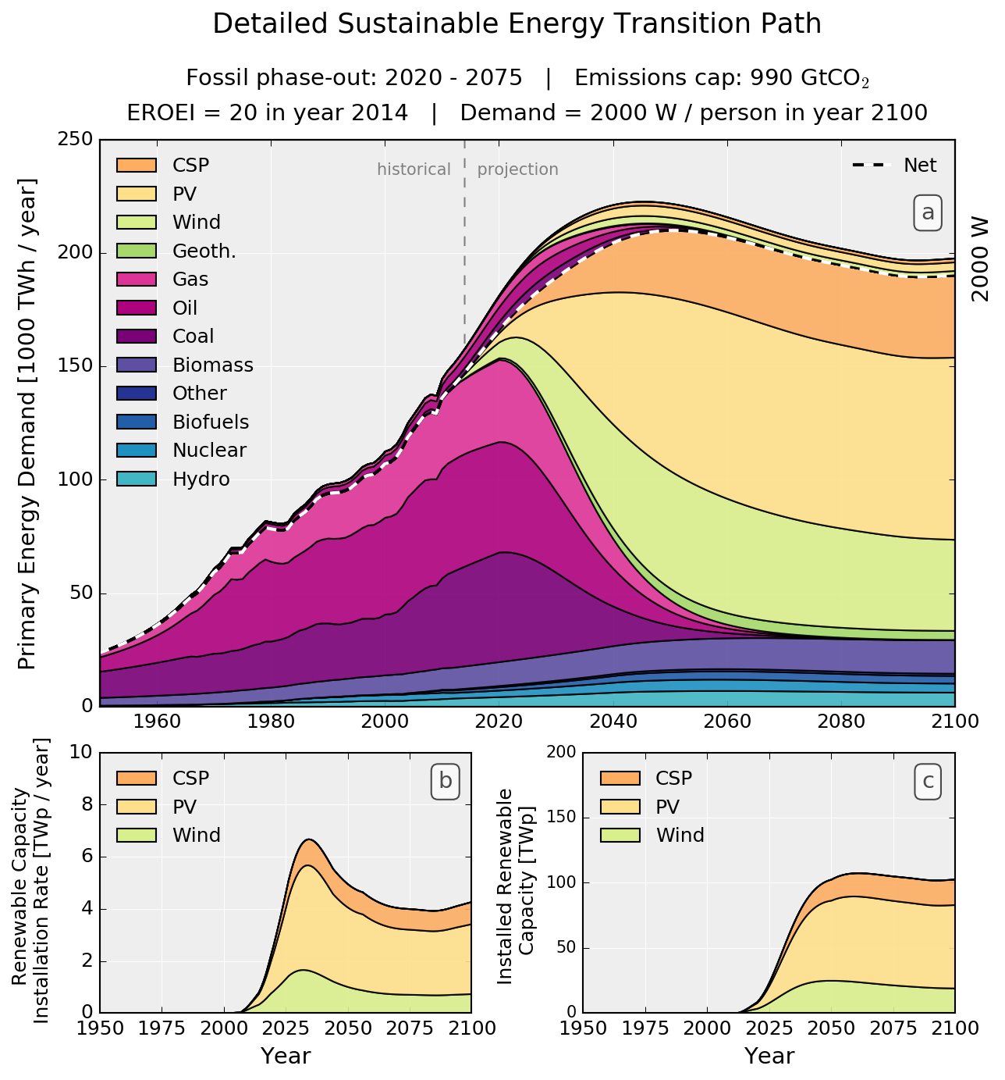

Figure ‎5‑1. (a) SET-compliant primary energy supply evolution (in PWh) for providing 2000W average net power per capita by 2100 to a population of 10.8 billion. Fossil fuel emissions comply with a 990 Gt CO2 cap peaking in 2020 and phased-out by 2075. The dashed line represents the net available energy while the values above it the energy investment in building and operating the energy system (“seed”). (b) RE portfolio installation rate profile (in TWp/year). (c) Installed RE Capacity (in TWp).

The RE energy investment magnitude (the principal component of the difference between gross and net energy) is evident as the notable hump above the net energy demand shown as the dashed line in Figure ‎5‑1a during the transition acceleration phase (2020-2060), highlighting the role of fossil fuels as “seed” of the transition. Figure ‎5‑1b and Figure ‎5‑1c respectively show the RE installed capacity and installation rate. Section ‎5.3.8 provides a close-up comparison of the historical capacity additions compared to the model results and the change of the composite EROEI for this scenario and also shows another trajectory that is more constrained and less smooth forced by lower initial EROEI assumptions (10) and the lowest carbon cap.

Given the wide possible range in both the EROEI of the RE supply and the net demand for energy, we compile the SET-compliant trajectories of RE installation rates and capacity into contour maps to illustrate the impact of these parameters on the RE trajectories. The isolines of **Error! Reference source not found.** and Figure ‎5‑4 show the required RE installed capacity for the range of power demand profiles in Figure ‎2‑10 and a wide range for scalable RE EROEI (6.7-60) respectively under the three fossil fuel caps and the three fossil phase-out schemes. Each horizontal cross-section represents the RE installed capacity in a SET-compliant RE trajectory and the slope of the contours represents the net capacity addition rate. The actual installation rate, mapped in Figure ‎5‑5 and Figure ‎5‑6, is larger as it accounts for the replacement of decommissioned RE installations. In terms of year to year capacity expansion rates, this implies that the historic peak growth rates of cumulative installed capacity (at >40%) should continue until 2020 (see Figure ‎5‑7 and Figure ‎5‑8) independent of trajectory and then, as the installed base grows, slow down differentially but not substantially remaining >10% until after 2030.

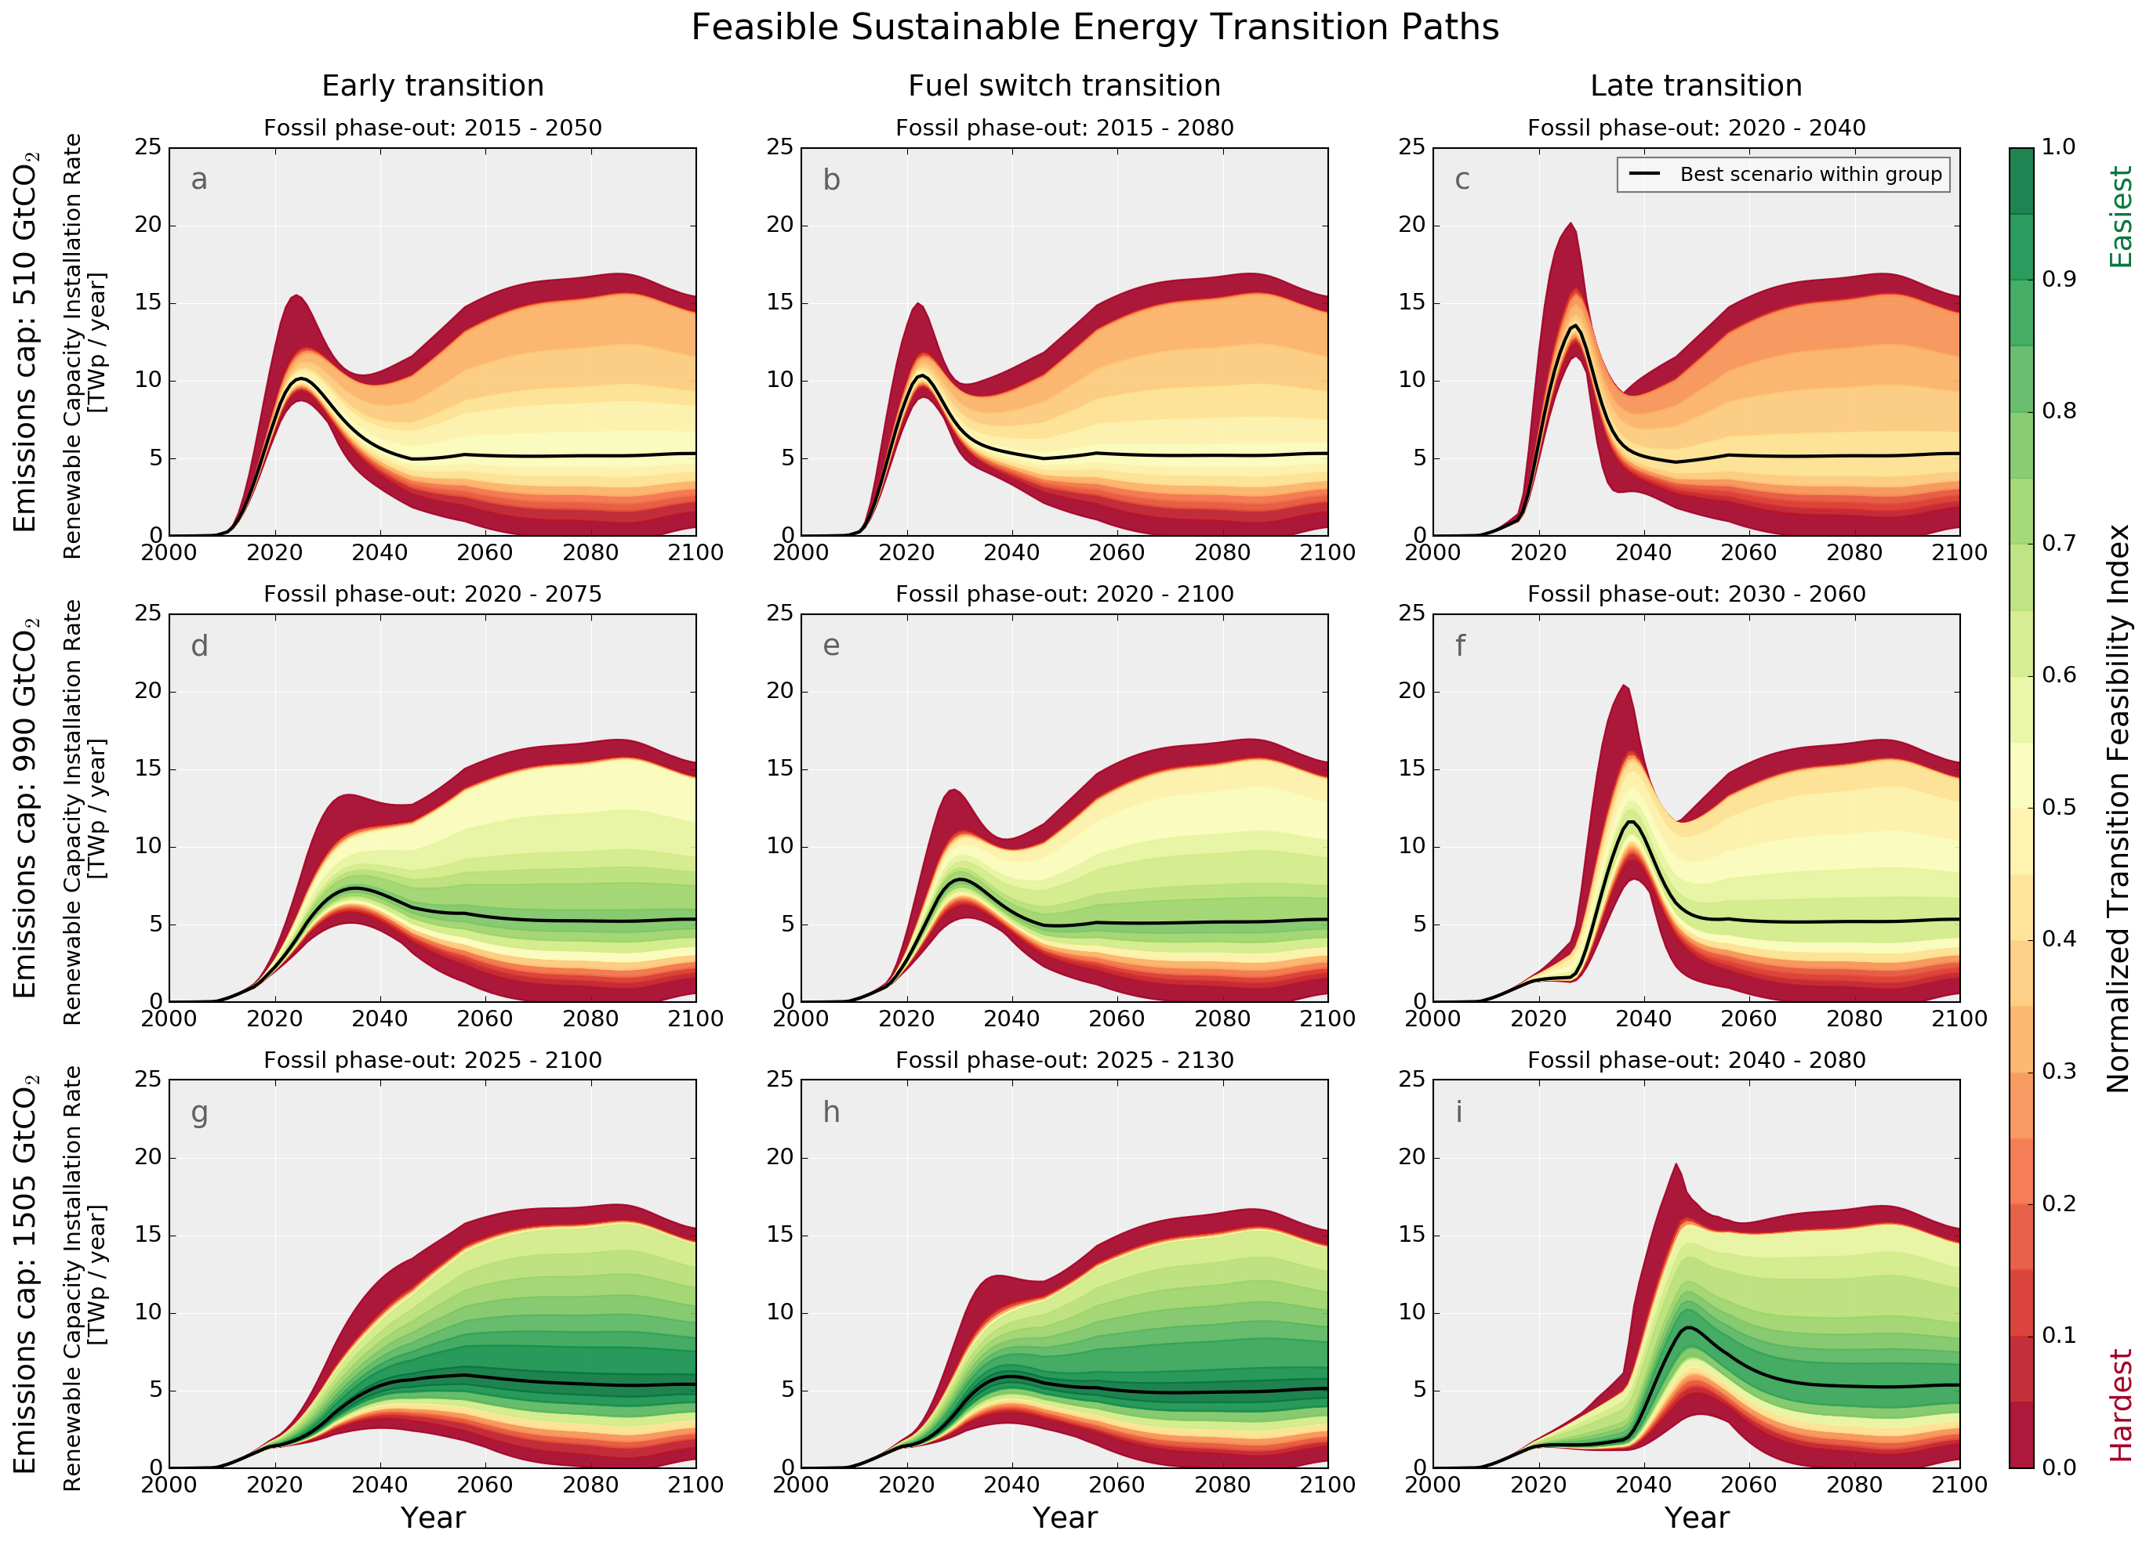

Figure ‎5‑2. Envelopes of SET-compliant RE installation rates over the RE composite EROEI range of 6.67 to 60 (in 2014) and a per capita net power demand range of 667-6000 W/person (in 2100), under early, early/partial and late fossil fuel phase-out strategies and for three fossil emission caps: 510 (a,b,c), 990 (d,e,f), and 1505 (g,h,i) Gt CO2. The Transition Feasibility Index is a normalized composite measure of the relative difficulty of each trajectory. The solid lines draw the highest TFI (most feasible) trajectory in each group.

When adjusted for TFI, the fairly wide distribution of transition trajectories narrows significantly as the more feasible SETs form a thin band that gets narrower and harder as the fossil-fuel phase-out is delayed. The five-year delay in initiating the transition reduces the TFI of the Figure ‎5‑1 trajectory by 22% while the 50% cut in the emissions cap by 43%. To make relative evaluation easier, Figure ‎5‑2 plots in profile the SET-compliant RE installation rates in TWp/year for all combinations of EROEI and final demand trajectory colored by their relative TFI value. A lower EROEI pushes higher installation rates earlier by several years in response to the increased upfront investment. Nevertheless, in the critical initial acceleration phase, capacity additions are more influenced by the emissions cap and fossil phase-out. Looking at the highest TFI trajectory for the 990Gt CO2 cap, the choice of an early fossil fuel phase-out halves the installation rates with corresponding peak at 6.6 in 2020 versus 11.4 TW/year for the late one in 2030 (comparing the bold lines in Figure ‎5‑2d and f). In either case, this implies an increase from the 2013 RE installations that were around 0.12TW/year by a factor ranging from 55 to 95. The early and fuel-switch phase out profiles offer a wider range of easier paths than the delayed transitions primarily because of their lower investment peaks. Crucially, the lower 510Gt CO2 cap leaves little slack creating a very narrow and difficult SET trajectory range penalized by the consistently high peak installation rate of around 10TWp although *if* these peaks can be reached then the rest of the trajectory becomes achievable.

In every case, the trajectory of a successful SET consists of a sustained acceleration in the rate of investment in renewable energy of more than one order of magnitude within the next three decades. A peak in installation rates, but not cumulative capacity, forms at the point where the rate of energy demand growth starts to slow down. Transition trajectories that have a lower peak are harder as they assume an economy that can operate at the lowest energy per capita or very high EROEI values for RE. A fuel switch strategy helps in the second half of the century as it lowers the capacity installed but not so much at the acceleration phase from 2015-2035 (compare Figure ‎5‑2b,e,h against a, g, h). Importantly, further delays in the rise of RE investments cannot be compensated by subsequent additional acceleration because the decline in net energy from the carbon-constrained fossil fuels would be insufficient to power the transition without energetically impoverishing society or exceeding the carbon cap if the carbon cap is the average expected or lower as indicated by the very low TFI throughout the entire range in Figure ‎5‑2c,f).

While these transition patterns may seem aggressive, they are in line with the time progression of past energy transitions. Although those transitions were partial, they typically were completed within several decades (Fouquet 2010). However, a SET should encompass the entire energy system while providing sufficient *net* energy to sustain the global economy. Of course, attaining SET depends not only on RE installation but also on replacing a large part of the present energy-utilizing infrastructure (from industrial machines and vehicles to buildings and roads) to match the new energy resources.

While present infrastructure systems are adapted to specific energy carriers, for instance liquid fuels for transportation, the technologies available for SET provide electricity, a high quality energy carrier. The relatively low fossil fuel final energy conversion efficiency might imply that an RE-based, electrified economy would require lower levels of per capita primary energy for the same economic output and since our methodology so far has focused on primary energy supply an objection can be raised that lower levels of primary energy are realistically needed. We address this argument first by mapping the SET trajectories for a wide range of primary energy demand per capita that includes values lower than even the most optimistic estimate (see discussion in the Background section) and second by noting the need for oversizing an RE energy system as discussed below.

In SET, societies can adapt by means of restructuring their productive infrastructure and, if not possible, to use electricity to produce synthetic fuels. For instance, modern agriculture relies on fossil resources for mechanization and for the production of critical fertilizers. Nevertheless, it is technically possible to transform the agricultural infrastructure from one using liquid fuels to one that uses electricity (Bardi *et al* 2013). In other cases, e.g. in aviation, synthetic drop-in fuels can be produced, but with large associated conversion losses. Results from network analysis indicate that future societal energy intensity is likely to be higher if expected urbanization trends materialize (Jarvis *et al* 2015). As a result, done on a global scale, an RE-based energy system will deploy (i) overcapacity (ii) mechanical, electro-chemical and chemical storage (Lewis and Nocera 2006) for grid stability, daily and seasonal variability, and synthetic fuels, and (iii) replacement, modification and expansion of infrastructure systems to support rising incomes in the developing world and in order to make them compatible with renewable energy supply – e.g. electrification of transportation systems and long-distance electricity transmission. While we have provisioned an EROEI derating to account for storage needs as detailed in section ‎4.5.3, our estimates still rely on average annual power and they are most likely conservative for a given trajectory as actual installed RE power would need to be higher to capture demand peaks and especially seasonal variations reducing system efficiency and adding to the energy investment required.

On the question of policy, given that there are significant lead times and many infrastructure investment decisions taken today have useful lives and impacts of several decades(Davis *et al* 2010), their construction needs to account for SET already. Policy mechanisms should be in place to commit to appropriate RE targets and prioritize the allocation of economic resources from other activities to meet them. Such long-term planning requires government direction towards specific but technology-agnostic RE deployment targets. A critical aspect aiding such decisions is that the targets themselves become a factor in driving the economic competitiveness of the alternatives.

Markets though are useful in deciding on the allocation between technologies. Since economic activities require energy to provide material wealth, real economic growth is reliant on a corresponding increase in the quality-adjusted energy supply (Ayres *et al* 2003). This has implications for a financial system in which debt is extended relying on the expectation that future growth will permit its repayment; it cannot stay solvent without securing an adequate energy supply to support the expected future economic energy intensity. We therefore propose a corollary, normative economic statement for SET on par with the physical ones: *financial commitments of future consumption (debt) should be limited by future energy availability*. Tying debt extension to RE investment itself could provide a self-regulating incentive to the financial system to actively pursue the energy transition.

## Global SET simulation graphs

### Global cumulative installed renewable capacity

#### Demand sensitivity

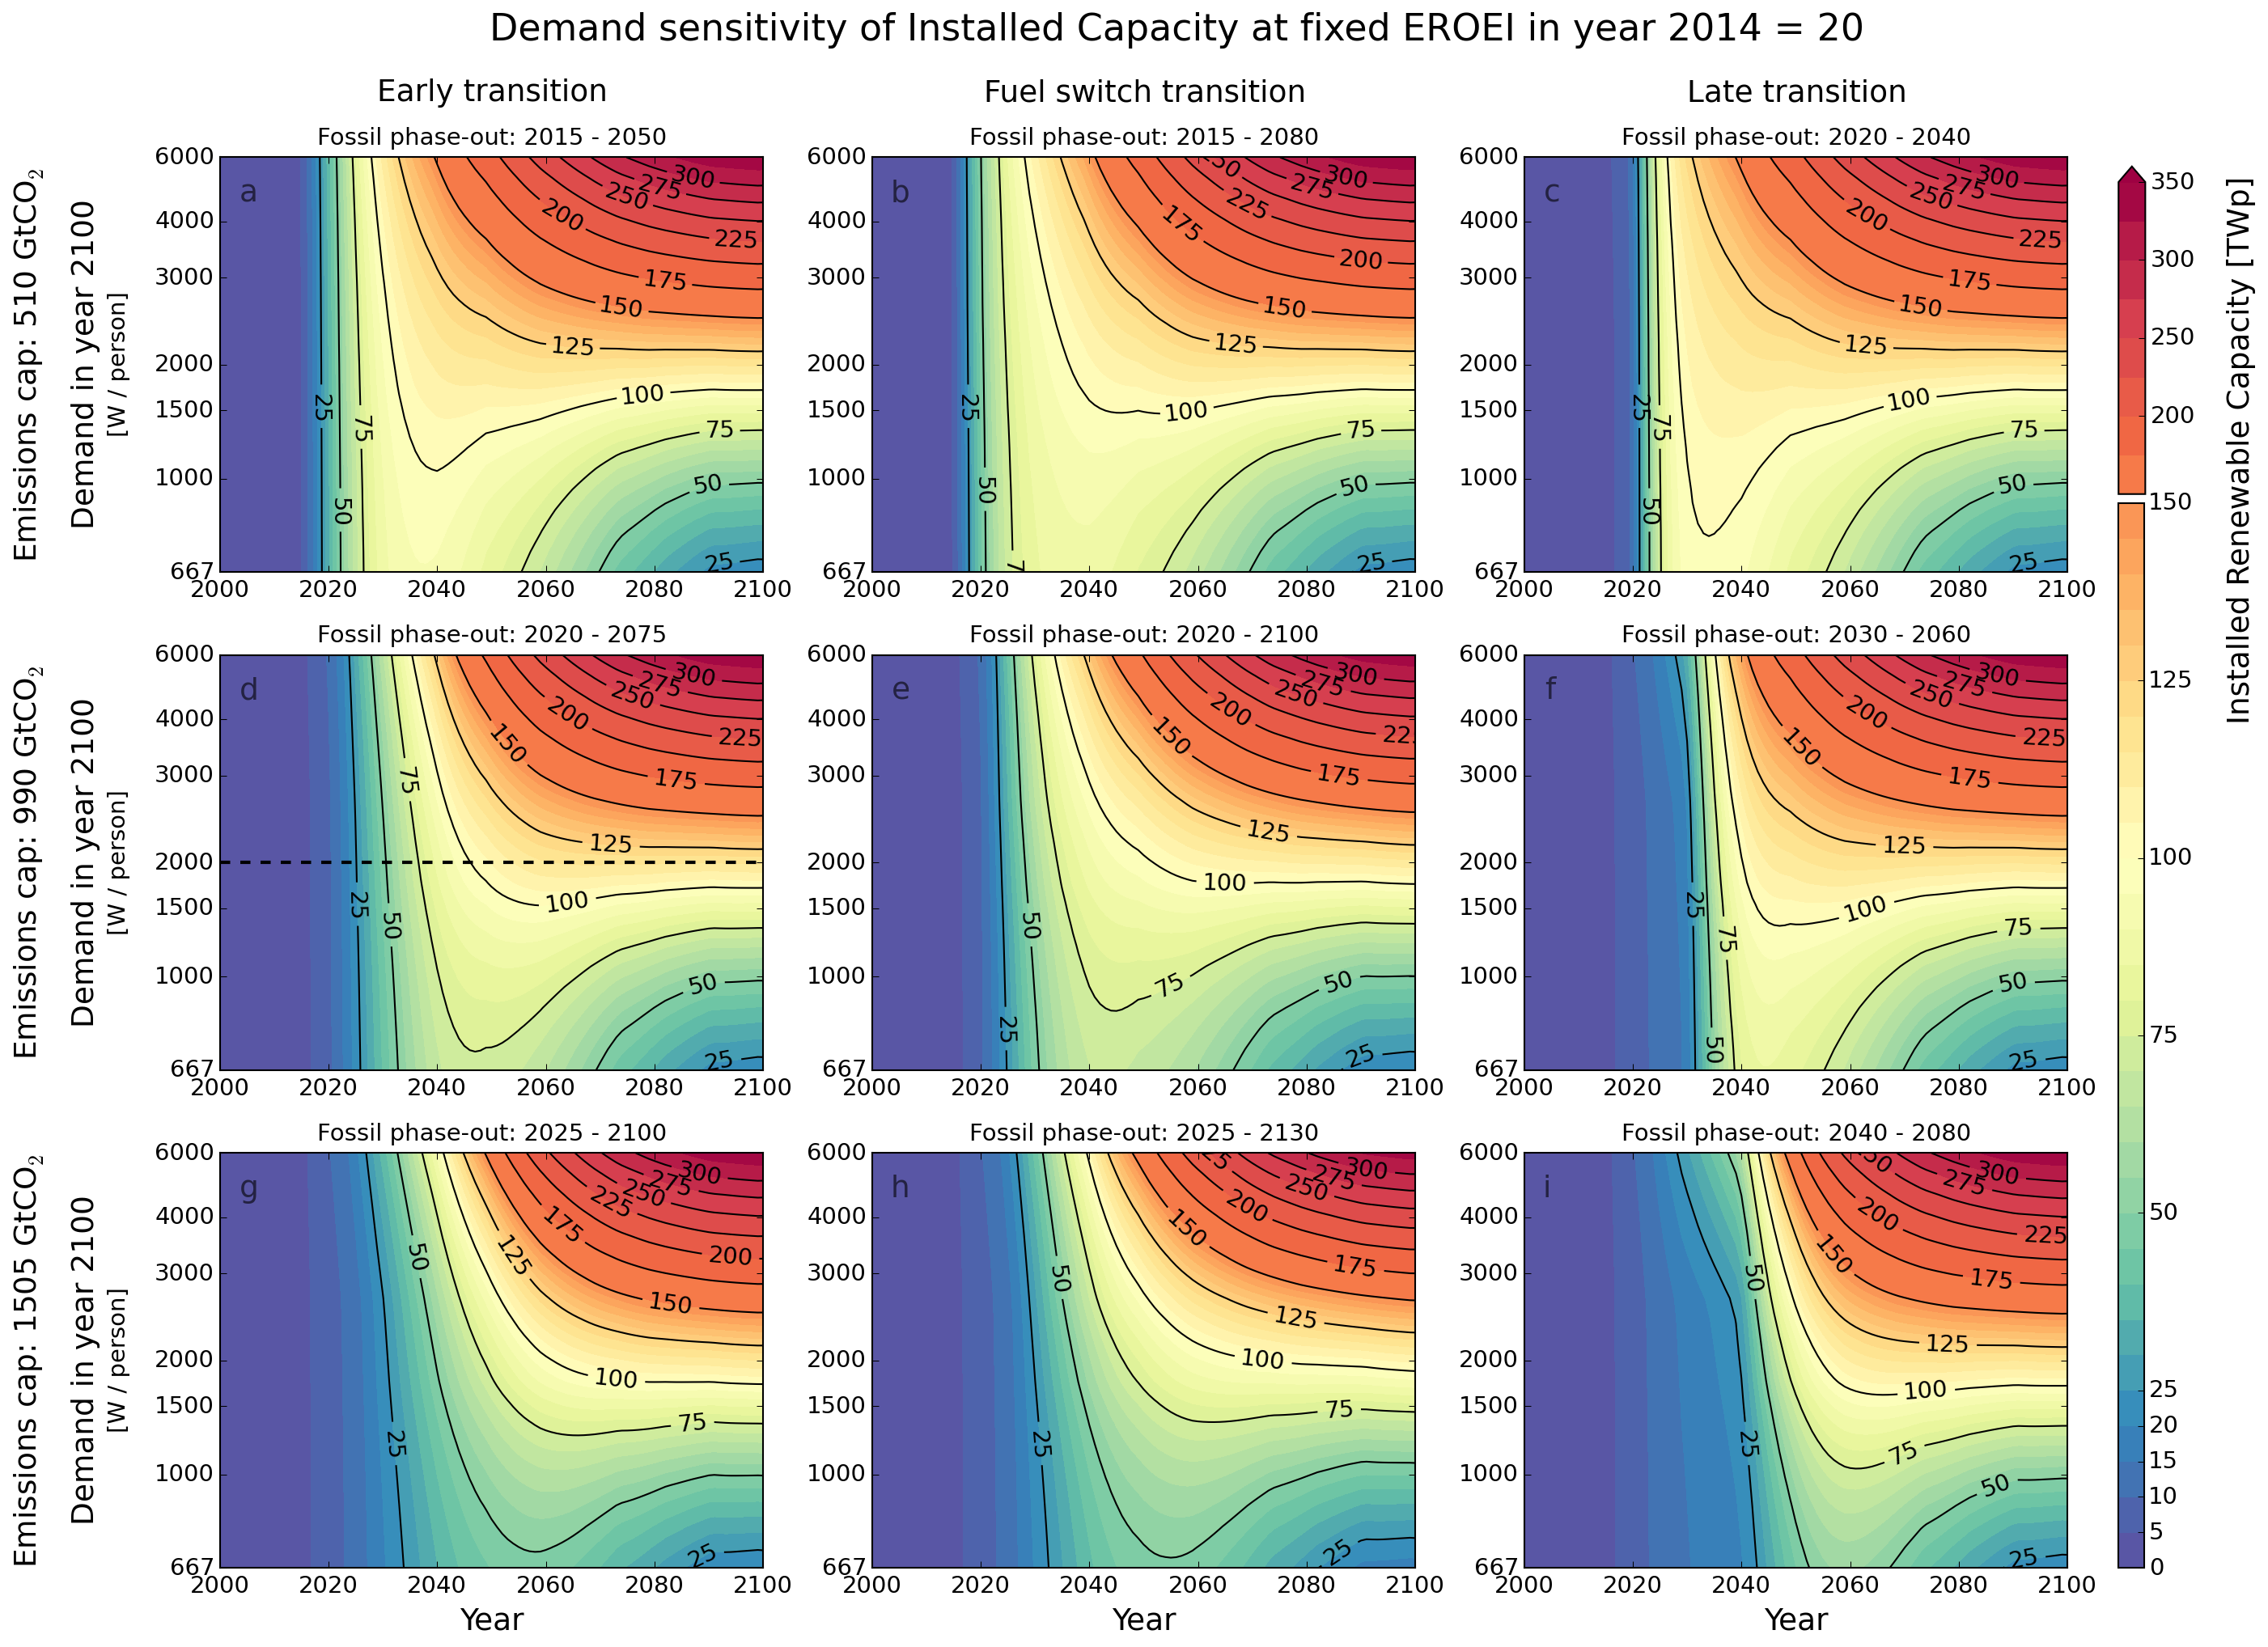

Figure ‎5‑3. Contour maps of SET-compliant installed RE capacity (in TWp) until 2100 for different trajectories of net primary power demand (shown in Figure ‎2‑10) assuming a composite initial RE EROEI of 20. The trajectories are identified by the net desired supply in year 2100. Each map depicts a combination of a fossil fuel phase-out strategy (early, fuel switch and late) and a fossil emission cap: 510 (a-c), 990 (d-f), 1505 (g-i) Gt CO2 as shown in Figure ‎2‑14. The cross-section indicated by the dashed line corresponds to Figure ‎5‑1c. source: own work

#### EROEI sensitivity

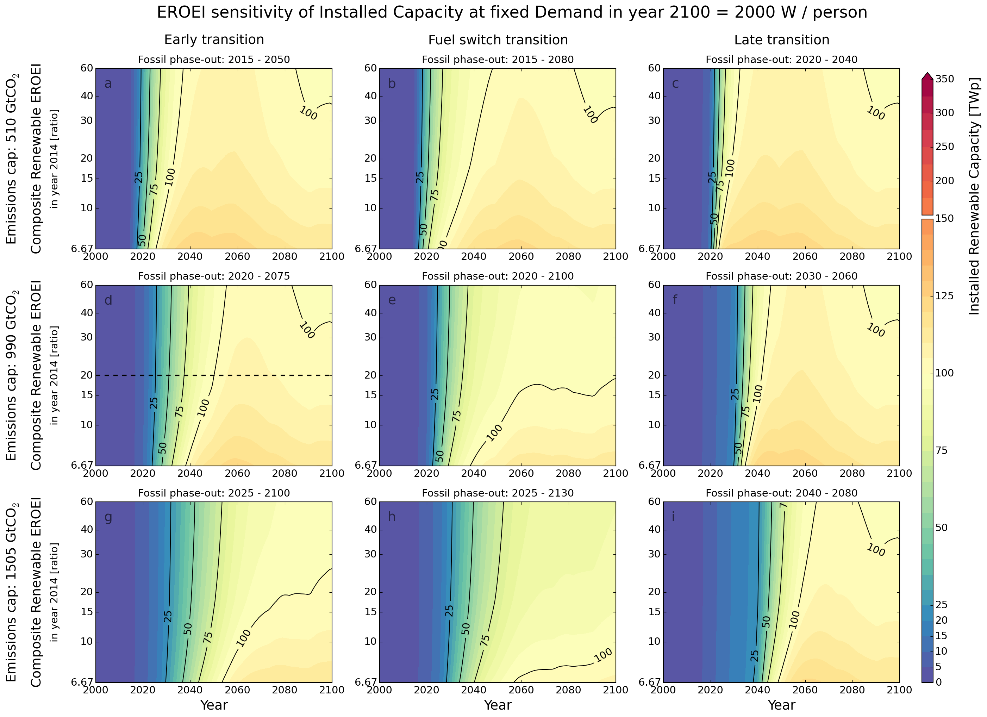

Figure ‎5‑4. Contour maps of SET-compliant RE capacity (in TWp) until 2100 for a range of composite RE EROEI values assuming the 2000W/capita energy demand trajectory. Each map depicts a combination of a fossil fuel phase-out strategy (early, fuel switch and late) and a fossil emission cap: 510 (a-c), 990 (d-f), 1505 (g-i) Gt CO2 as Figure ‎2‑14. The cross-section indicated by the dashed line corresponds to Figure ‎5‑1c. source: own work

### Global renewable energy installation rates

#### Demand sensitivity

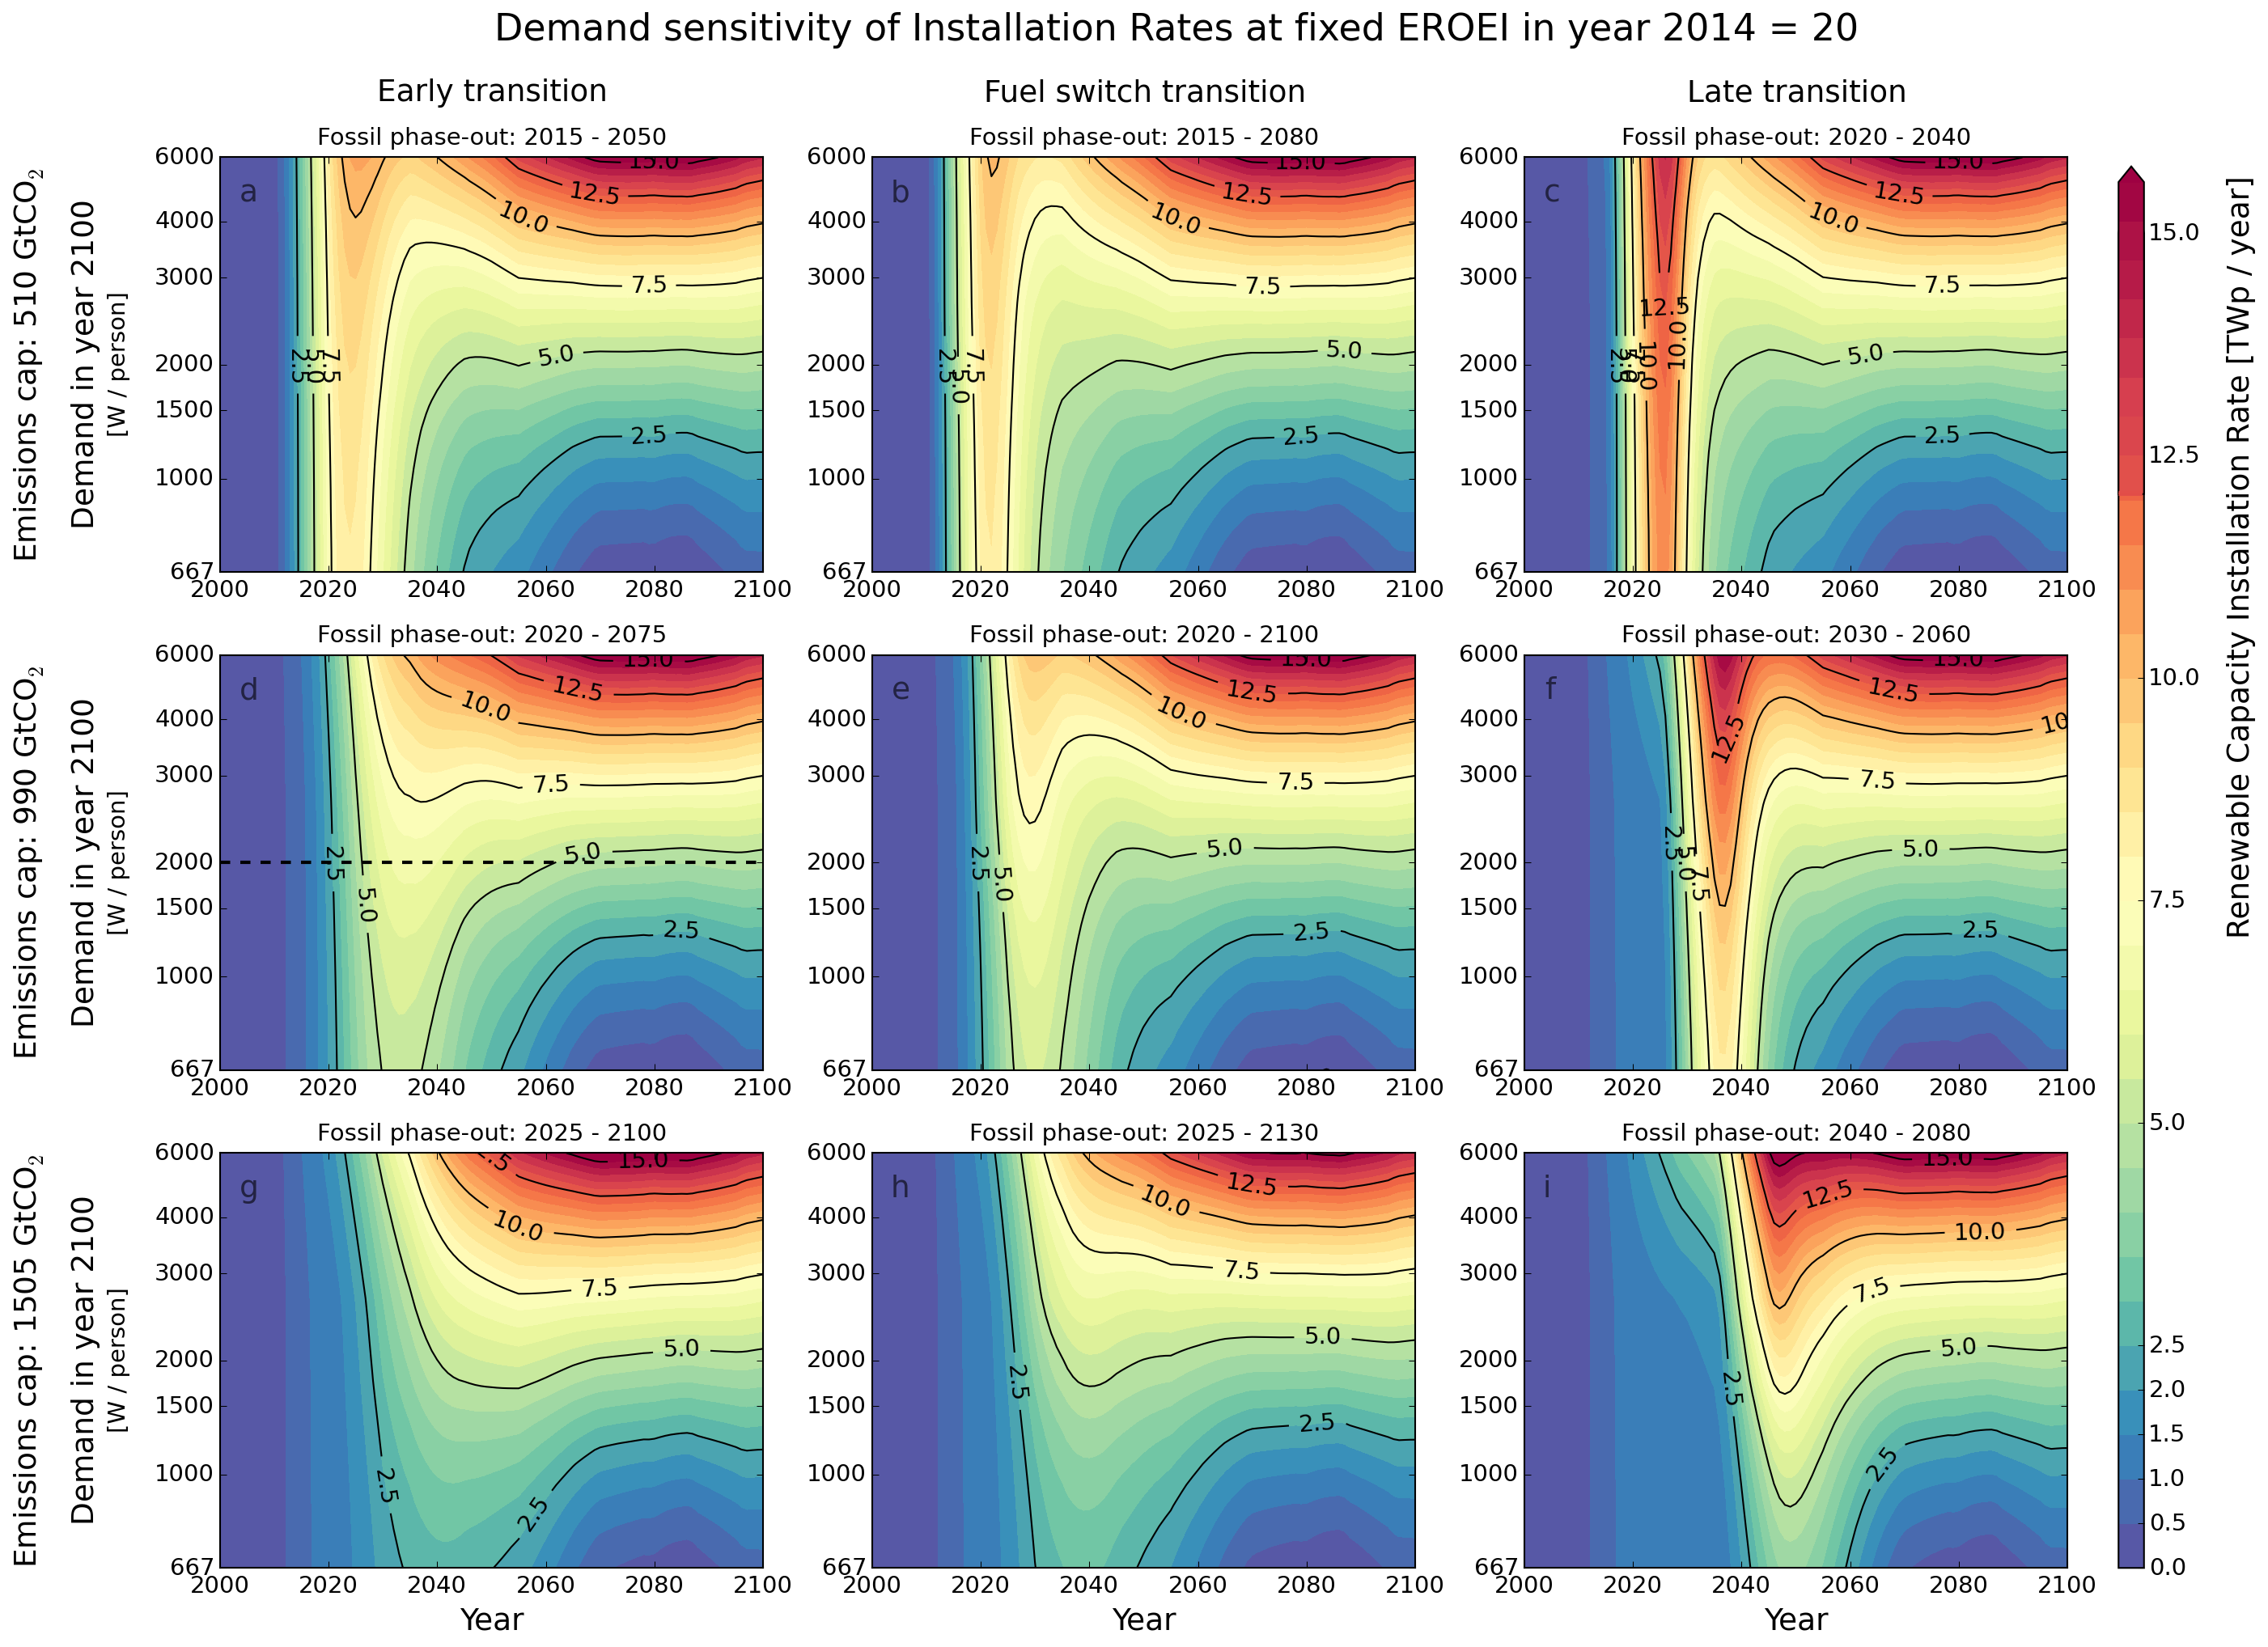

Figure ‎5‑5. Contour maps of SET-compliant RE capacity installation rate (in TWp/year) until 2100 for different trajectories of net primary power demand (shown in Figure ‎2‑10) assuming a composite initial RE EROEI of 20. The trajectories are identified by the net desired supply in year 2100. Each map depicts a combination of a fossil fuel phase-out strategy (early, fuel switch and late) and a fossil emissions cap: 510 (a-c), 990 (d-f), 1505 (g-h) Gt CO2) Figure ‎2‑14. The cross-section indicated by the dashed line corresponds to Figure ‎5‑1b. source: own work

#### EROEI sensitivity

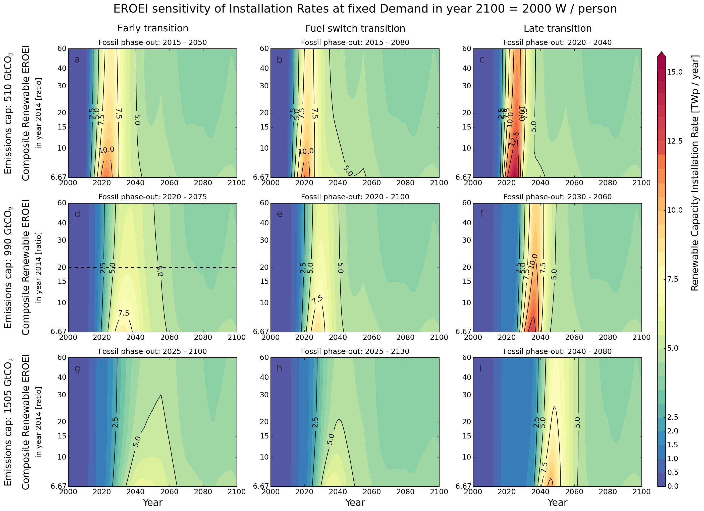

Figure ‎5‑6. Contour maps of SET-compliant RE capacity installation rate (in TWp/year) until 2100 for a range of composite RE EROEI values assuming the 2000W/capita energy demand trajectory. Each map depicts a combination of a fossil fuel phase-out strategy (early, fuel switch and late) and a fossil emission cap: 510 (a-c), 990 (d-f), 1505 (g-i) Gt CO2 as shown in Figure ‎2‑14. The cross-section indicated by the dashed line corresponds to Figure ‎5‑1b. source: own work

### Global renewable energy installation rates (% of total)

#### Demand sensitivity

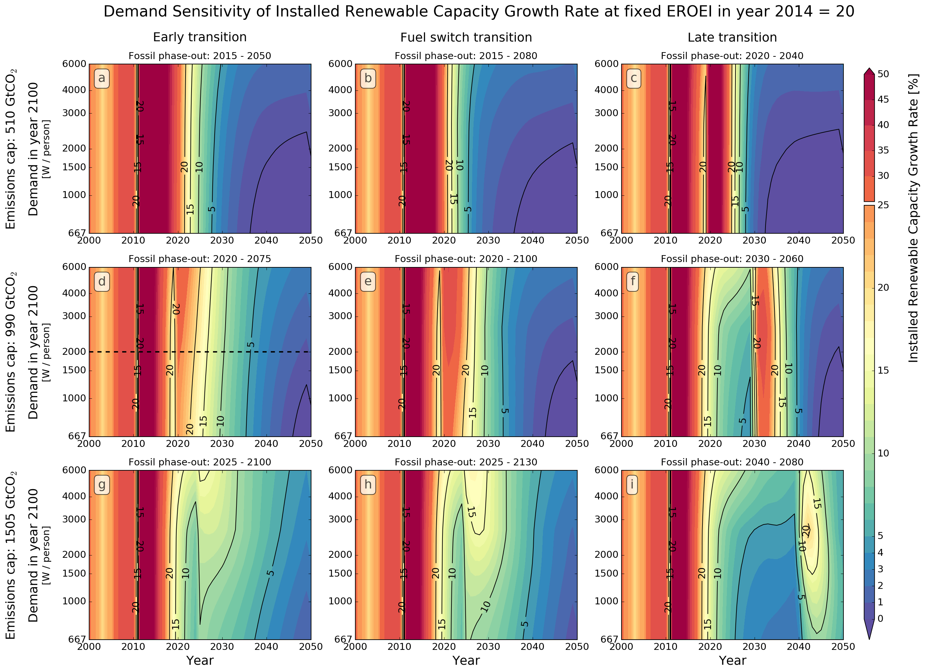

Figure ‎5‑7. The year-to-year rate of change of the RE capacity installations (growth rate) for SET-compliant RE trajectories until 2050 for different net power demand levels (667-6000) by 2100 under early, early/partial and late fossil fuel phase-out strategies and for three fossil emission caps: 510 (a-c), 990 (d-f), 1505 (g-i) Gt CO2 from Figure ‎2‑14.

#### EROEI sensitivity

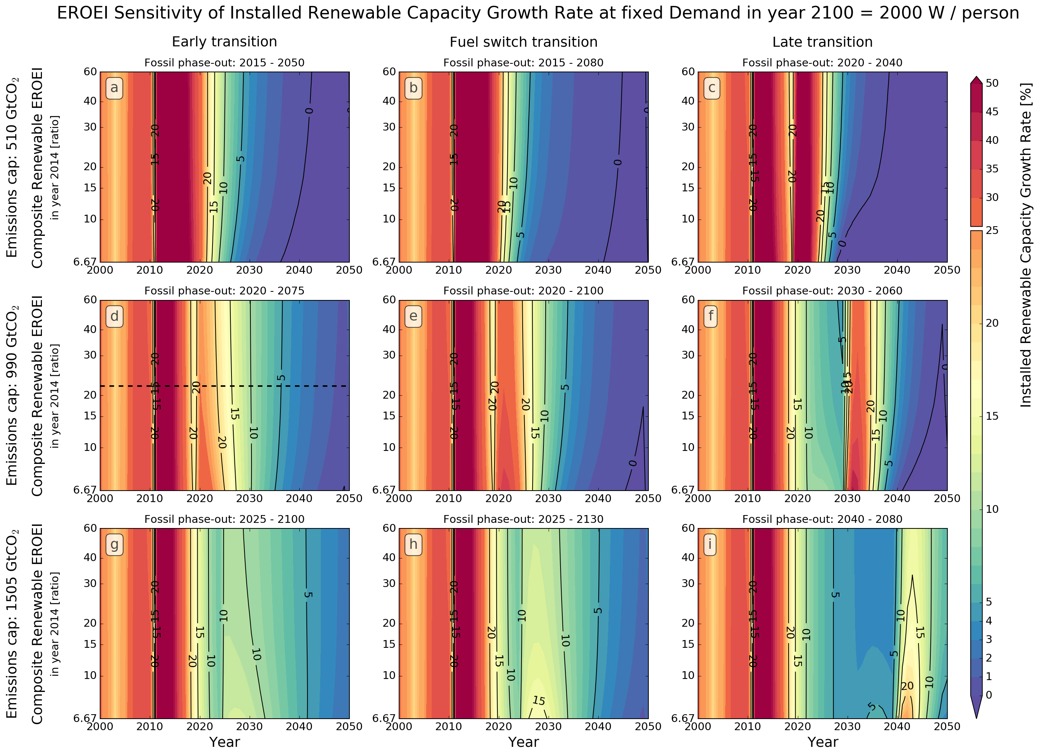

Figure ‎5‑8. The year-to-year rate of change of the RE capacity installation rate (growth rate) for SET-compliant RE trajectories until 2050 for different composite EROEIs (6.67-60) for 2000 W/person net primary power demand by 2100 under early, early/partial and late fossil fuel phase-out strategies and for three fossil emission caps: 510 (a-c), 990 (d-f), 1505 (g-i) Gt CO2 from Figure ‎2‑14.

### Global renewable energy investment rate (ɛ)

#### Demand sensitivity

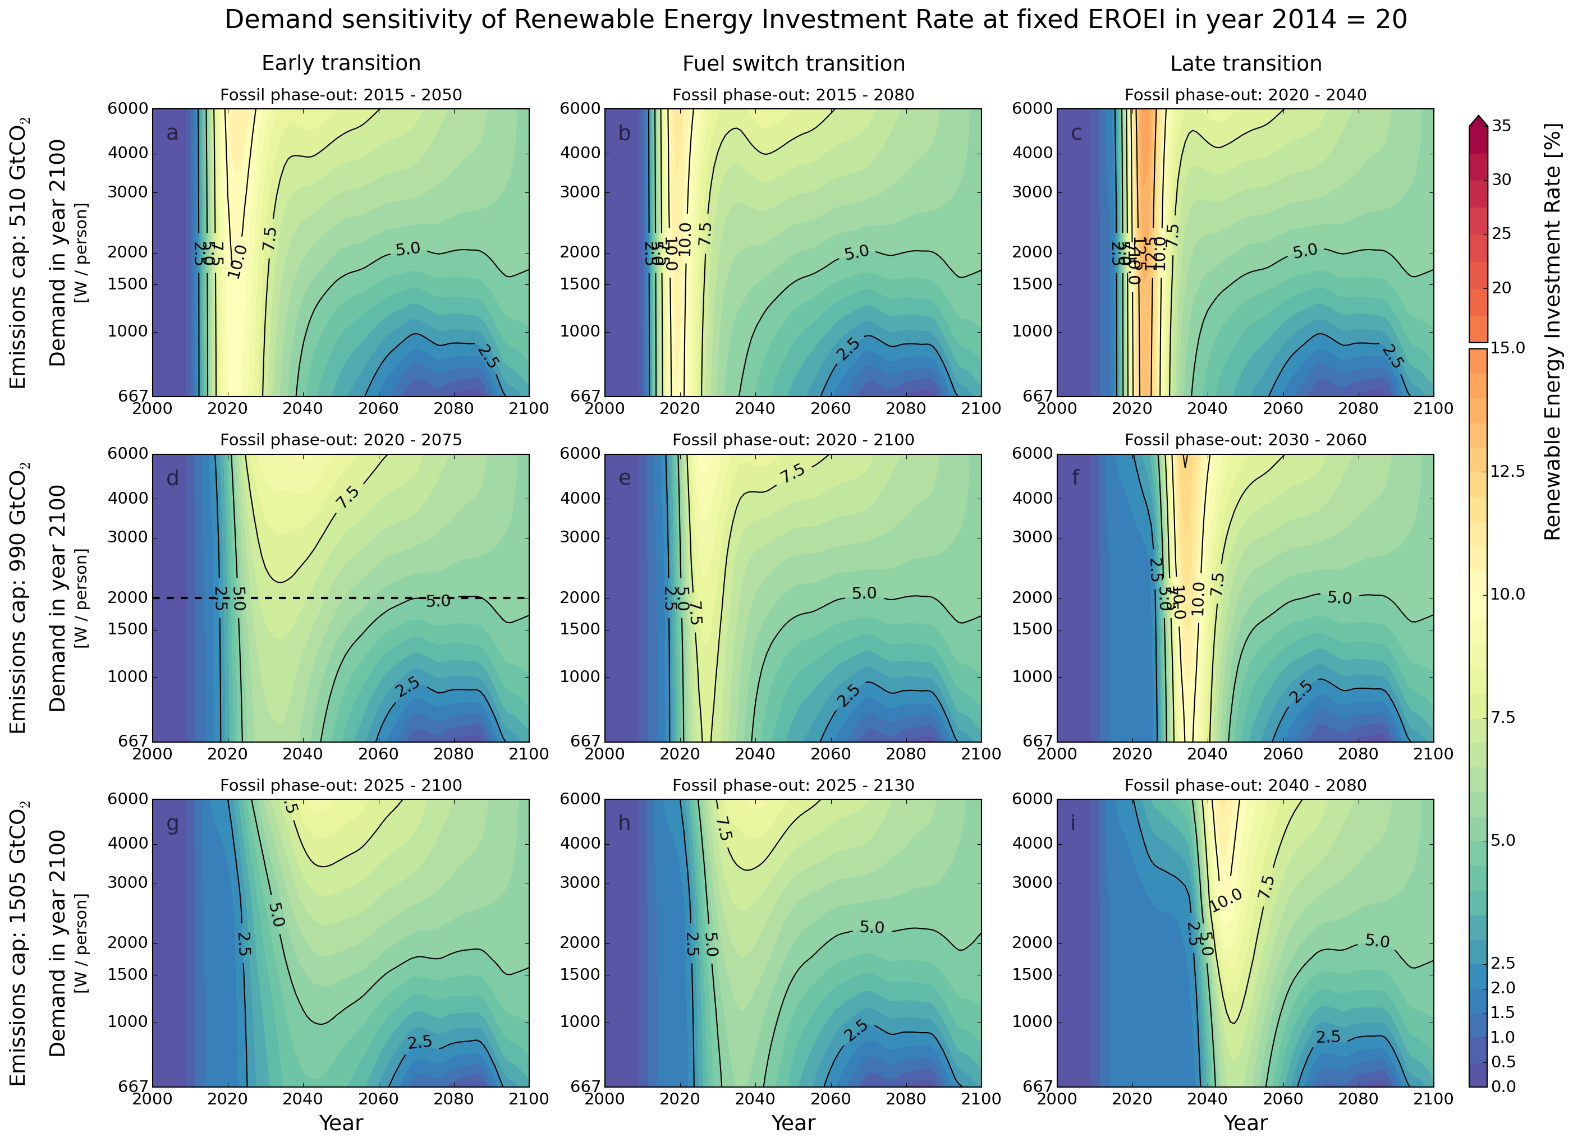

Figure ‎5‑9. Contour maps of SET-compliant RE investment rate (in %p/year) until 2100 for different trajectories of net primary power demand (shown in Figure ‎2‑10) assuming a composite initial RE EROEI of 20. The trajectories are identified by the net desired supply in year 2100. Each map depicts a combination of a fossil fuel phase-out strategy (early, fuel switch and late) and a fossil emissions cap: 510 (a-c), 990 (d-f), 1505 (g-h) Gt CO2) from Figure ‎2‑14, calculated as per ( ‎4‑8 ).   
source: own work

When looking at the renewable energy investment rates (ε) – that is the amount of energy that has to be diverted from gross energy generation towards building renewable energy generation capacity (i.e. the ratio of seed energy to total) – we can see that while ε is not very sensitive to demand, even for the medium carbon cap, sustained investment rates of 5% are necessary. Delaying the transition raises the peak investment rate to at least 10%.

#### EROEI sensitivity

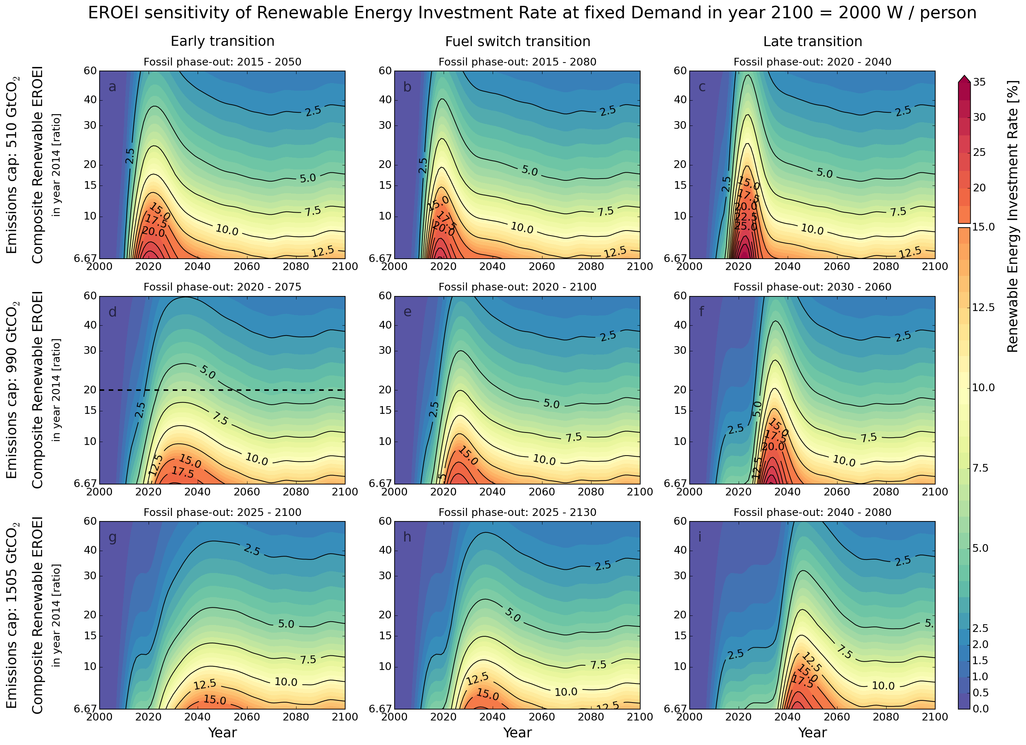

Figure ‎5‑10. Contour maps of SET-compliant RE investment rate (in %/year) until 2100 for a range of composite RE EROEI values assuming the 2000W/capita energy demand trajectory. Each map depicts a combination of a fossil fuel phase-out strategy (early, fuel switch and late) and a fossil emission cap: 510 (a-c), 990 (d-f), 1505 (g-i) Gt CO2 as shown in Figure ‎2‑14, calculated as per ( ‎4‑8 ). source: own work

When looking at the sensitivity of ε with regard to EROEI – as expected, the changes are much more accented. Low, but still possible composite EROEI values of <10, for the early transition with medium carbon cap, lead to a peak ε of almost 20%, and a sustained ε of 10%. That is, on tenth of all the energy generation capacity at all times must be diverted towards building and replacing generation capacity.

### Global SET simulation envelopes

#### Renewable capacity installation rates

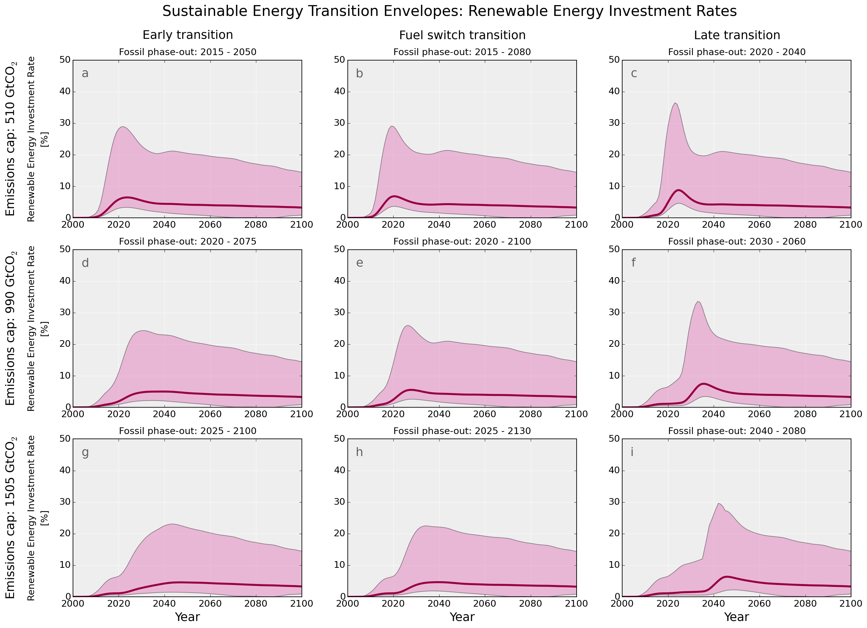

Figure ‎5‑11. Full envelope of renewable capacity installation rates encountered in the simulation exercise. Each map depicts a combination of a fossil fuel phase-out strategy (early, fuel switch and late) and a fossil emission cap: 510 (a-c), 990 (d-f), 1505 (g-i) Gt CO2 as shown in Figure ‎2‑14. source: own work

Figure ‎5‑12. Density plot of renewable capacity installation rates under a combination of a fossil fuel phase-out strategy (early - green, fuel switch – brown and late - pink) and a fossil emission cap: 510 (a), 990 (b), 1505 (c) Gt CO2.  
source: own work

#### Renewable energy investment rate (ɛ)

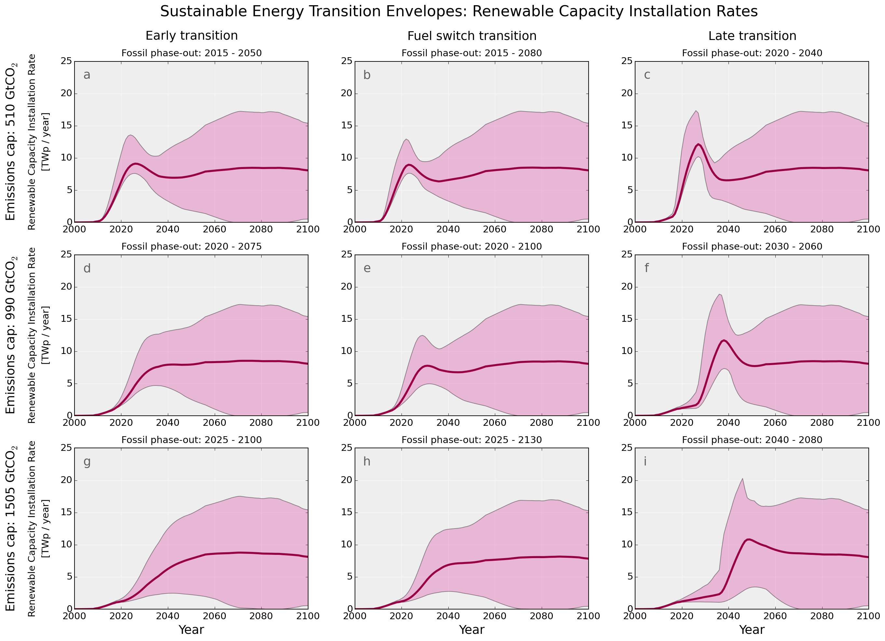

Figure ‎5‑13. Full envelope of renewable energy investment rates encountered in the simulation exercise. Each map depicts a combination of a fossil fuel phase-out strategy (early, fuel switch and late) and a fossil emission cap: 510 (a-c), 990 (d-f), 1505 (g-i) Gt CO2 as shown in Figure ‎2‑14. source: own work

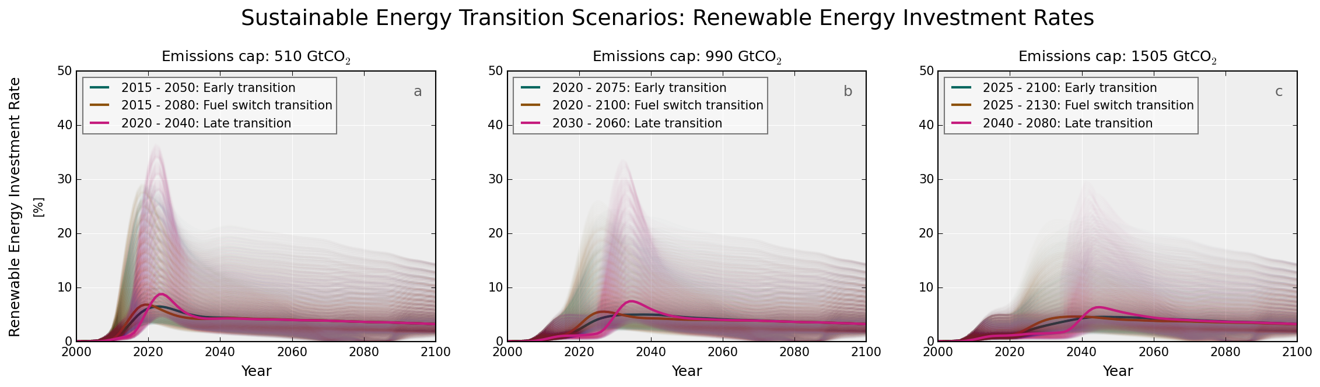

Figure ‎5‑14. Density plot of renewable energy investment rates under a combination of a fossil fuel phase-out strategy (early - green, fuel switch – brown and late - pink) and a fossil emission cap: 510 (a), 990 (b), 1505 (c) Gt CO2.  
source: own work

### Global SET histograms

#### Average renewable energy investment rate $\overline{ɛ}$ frequencies

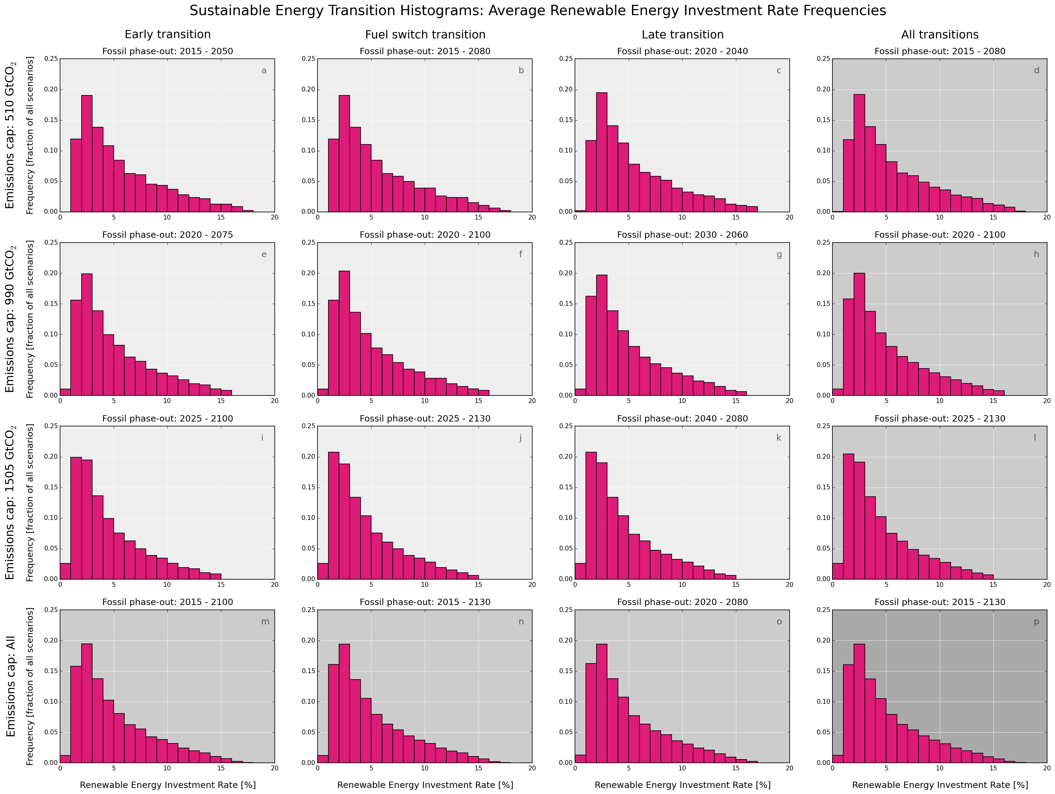

Figure ‎5‑15. Histograms of average renewable energy investment rates (in % per year on horizontal axis vs. encountered frequencies on the vertical axis) under a combination of a fossil fuel phase-out strategy (early – first column, fuel switch – second column and late – third column) and a fossil emission cap: 510 (first row), 990 (second row), 1505 (third row) Gt CO2. These histograms represent the frequencies of average renewable energy investment rates as a fraction in the total of the simulation envelope. We have also included row-wise (fourth column) and column-wise (fourth row) averages, as well as an absolute total (subplot p). source: own work

The average renewable energy investment rates – that is the sustained fraction of the energy system in constant building and replacement phase – over all EROEIs and all demand trajectories considered, follow a Gamma-type distribution with a peak frequency density at 3% per year, while still having values above 5% frequency for an investment rate of 8% per year. While it is hard to estimate today’s values because the infrastructure is yet in a constantly growing phase, we are talking about a magnitude of 10TWp of capacity constantly on the move.

#### Peak renewable energy investment rate $ɛ_{p}$ frequencies

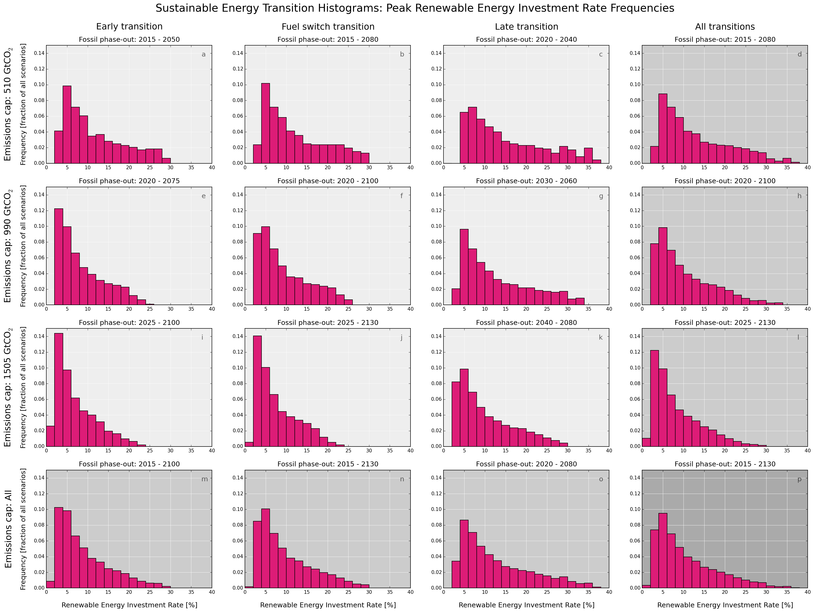

Figure ‎5‑16. Histograms of peak renewable energy investment rates (in % per year on horizontal axis vs. encountered frequencies on the vertical axis) under a combination of a fossil fuel phase-out strategy (early – first column, fuel switch – second column and late – third column) and a fossil emission cap: 510 (first row), 990 (second row), 1505 (third row) Gt CO2. These histograms represent the frequencies of peak renewable energy investment rates as a fraction in the total of the simulation envelope. We have also included row-wise (fourth column) and column-wise (fourth row) averages, as well as an absolute total (subplot p).   
source: own work

When looking at peak installation rates, out of all scenarios – all carbon caps, all phase-out profile, all EROEIs and all demand profiles, at least 10% of the time we would encounter peak renewable energy installation rates of 5% per year, a 28-fold increase from today’s values (0.18% in 2014). With a 5% frequency, these rates might be as high as double that, 10% per year, during peak transition years.

#### Peak renewable capacity installation rate frequencies

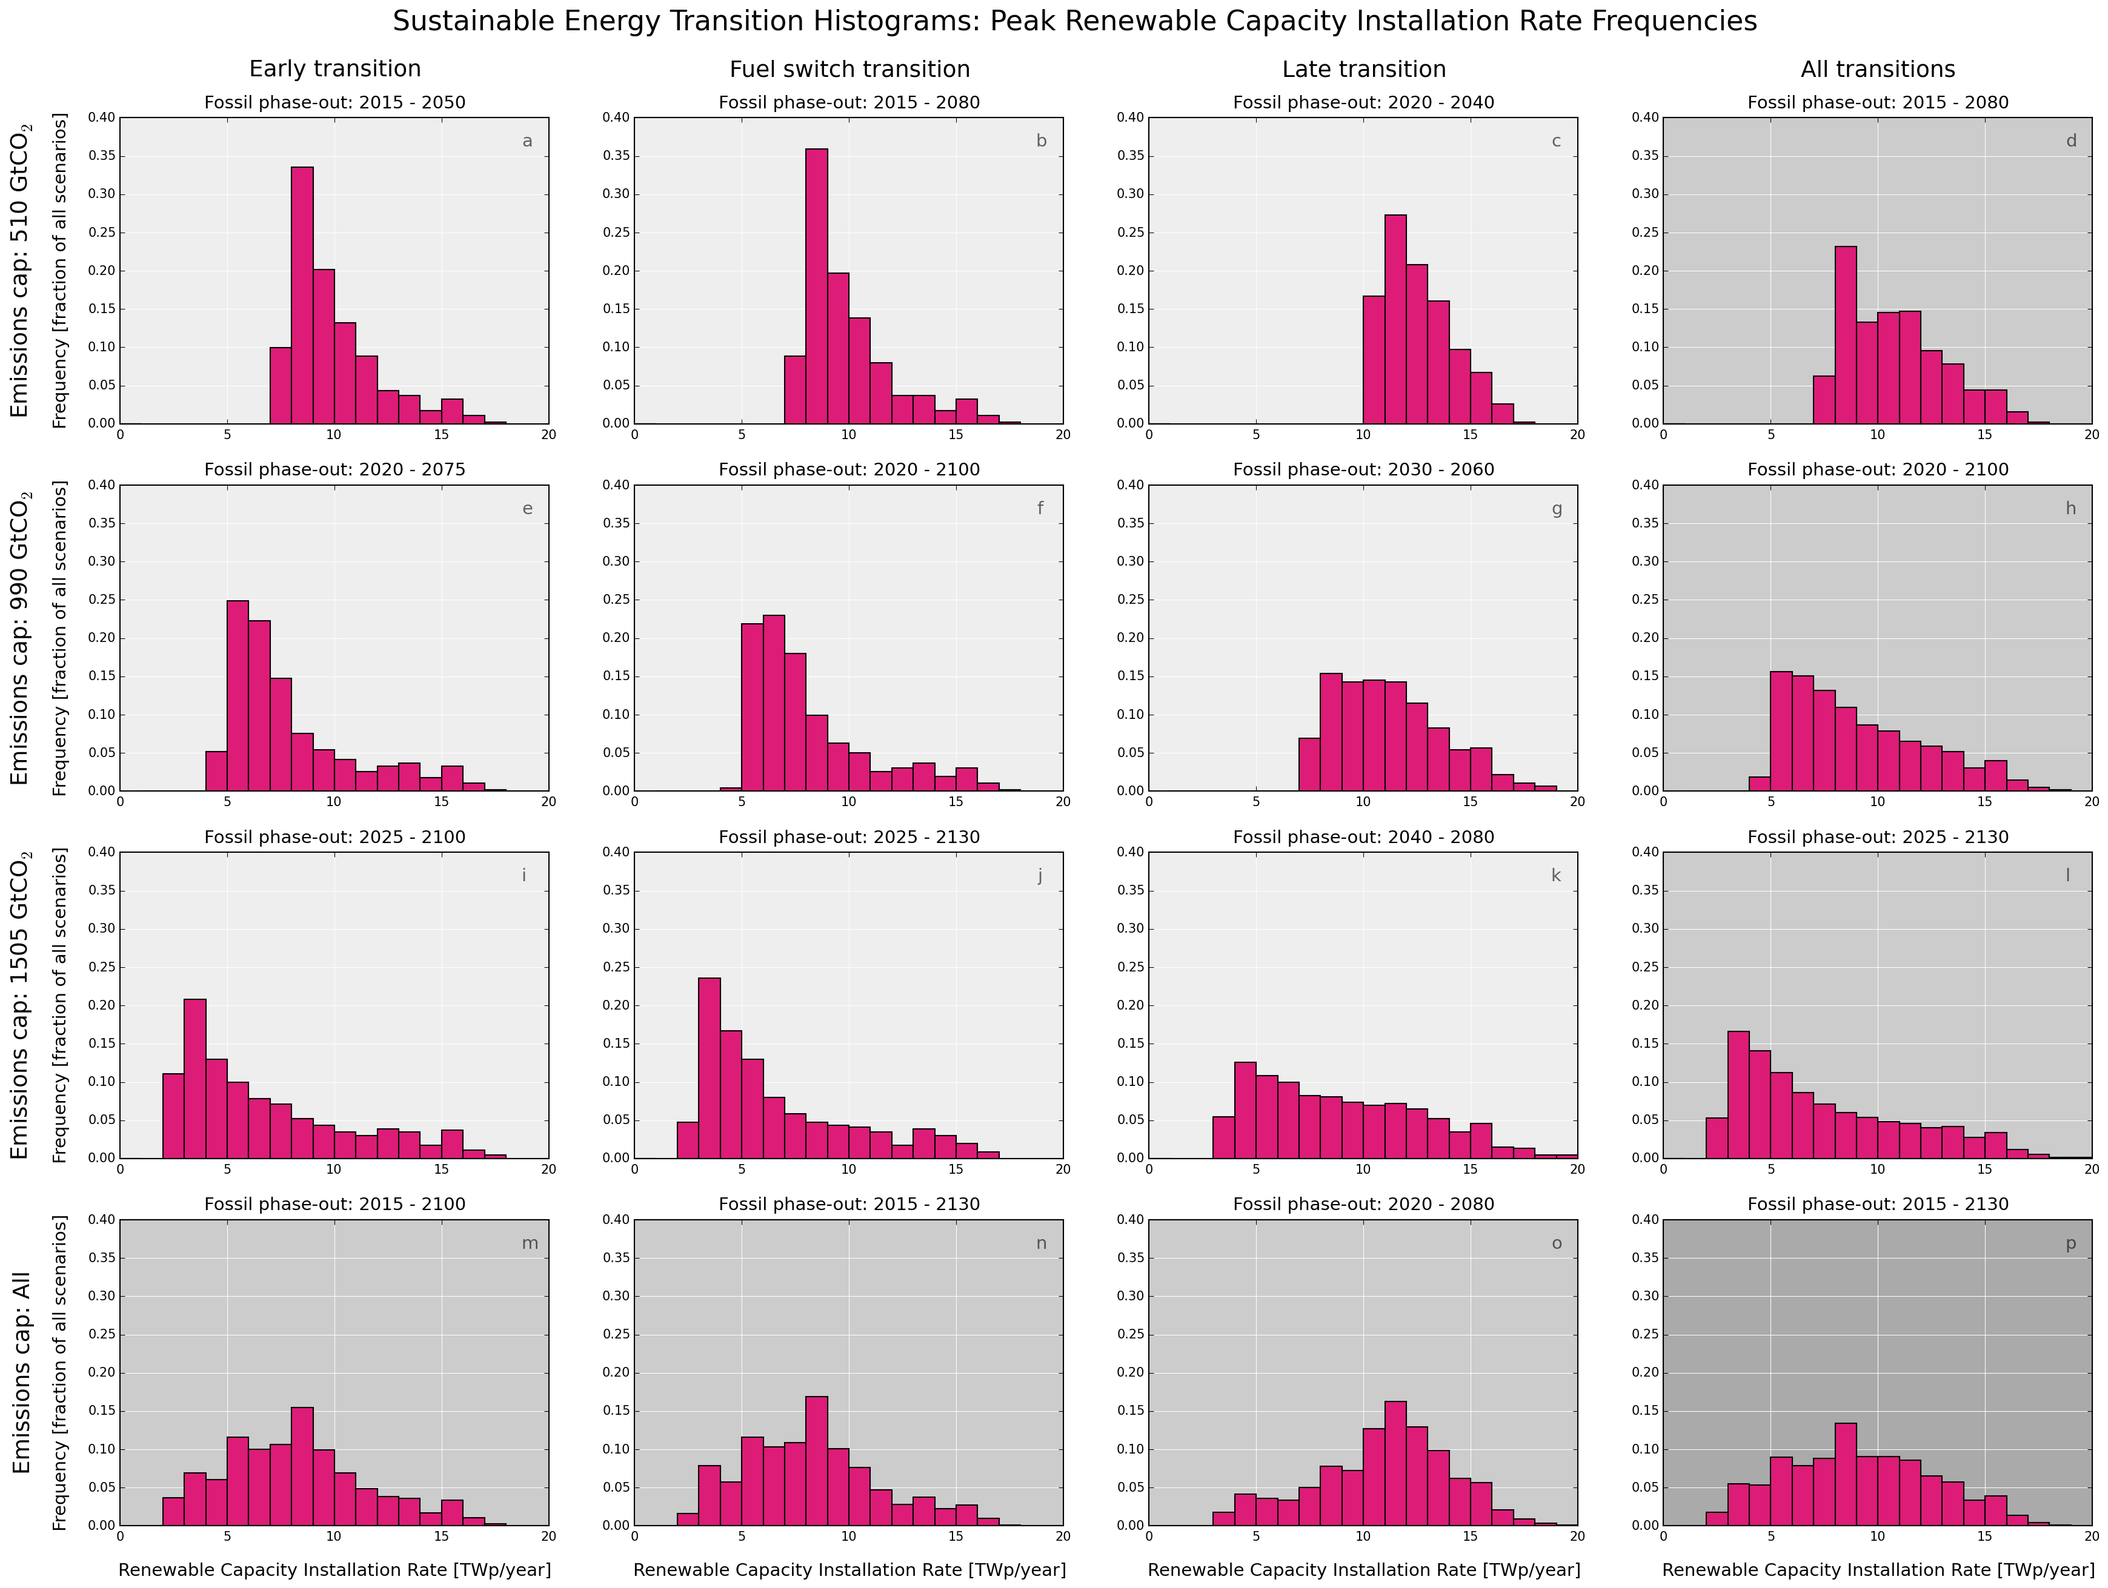

Figure ‎5‑17. Histograms of peak renewable capacity installation rates (in TWp per year on horizontal axis vs. encountered frequencies on the vertical axis) under a combination of a fossil fuel phase-out strategy (early – first column, fuel switch – second column and late – third column) and a fossil emission cap: 510 (first row), 990 (second row), 1505 (third row) Gt CO2. These histograms represent the frequencies of peak renewable capacity installation rates as a fraction in the total of the simulation envelope. We have also included row-wise (fourth column) and column-wise (fourth row) averages, as well as an absolute total (subplot p). source: own work

Looking at the capacity installation rates, we can see that the emissions cap and the fossil phase-out strategy play a very critical role. Under the smallest emissions cap, the histograms exhibit a narrow range – i.e. *regardless* of the demand profile expectation of the society *or* the EROEI of renewables, we have to plan for renewable capacity installation rates of at least 10TWp/year, and with a 5% frequency even 16TWp/year – which is a staggering 133 times more than today’s values.

### Feasible global SET paths

#### Histogram of all feasible SET paths

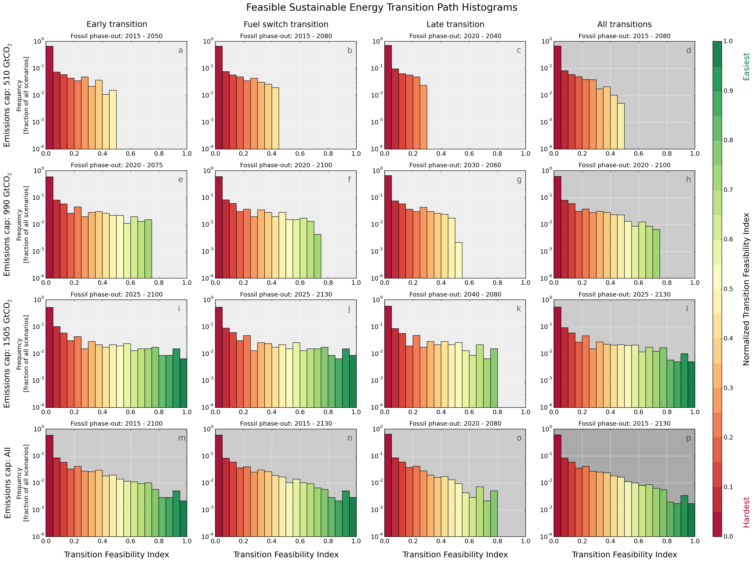

Figure ‎5‑18. Histograms of peak renewable energy investment rates (in % per year on horizontal axis vs. encountered frequencies on the vertical axis) under a combination of a fossil fuel phase-out strategy (early – first column, fuel switch – second column and late – third column) and a fossil emission cap: 510 (first row), 990 (second row), 1505 (third row) Gt CO2. These histograms represent the frequencies of peak renewable energy investment rates as a fraction in the total of the simulation envelope. We have also included row-wise (fourth column) and column-wise (fourth row) averages, as well as an absolute total (subplot p).   
source: own work

Following up on Figure ‎5‑2, here we present the frequencies of all TFIs. If we treat them as Gamma distributions, we can see that in this case their shape parameter is closer to 1 – leading exponentially decaying distributions. This means that the most feasible transition pathways are extremely rare, if taken from all simulations, trajectories with TFIs greater than 0.8 occur only with a frequency of 1% or less.

#### SET feasibility landscape

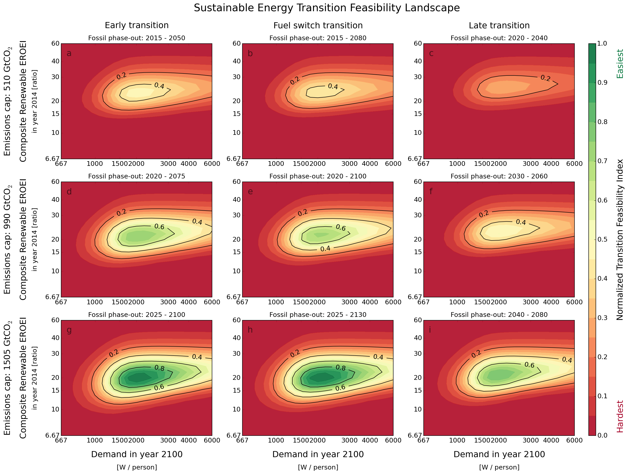

Figure ‎5‑19. Sensitivity map the normalized transition feasibility index (TFI) of all energy trajectories against varying demand and EROEI values. source: own work

In Figure ‎5‑19 we present the 2-dimensional sensitivity maps of the TFI with regard to EROEI and demand. The fairly narrow sweet spot indicated by the deeper green shades shows that average demand levels between 1500 and 2500 W/person and an EROEI range from 18 to 22 are needed for the least challenging transition trajectories. However, it is true that this maps depends on the construction of the TFI. Therefore in the next section (‎5.3.8) we present three alternative versions of this sensitivity map, after changing the transfer function shapes of its components *f* and *g* from Equation ( ‎4‑9 ).

### Additional global SET sensitivity plots

After presenting the main results, in this section we present additional plots on the sensitivity of SET paths against various parameters. First, to highlight the sensitivity of seed energy with regard to the transition timeline, we show an alternative cross-section for renewable energy generation of figure Figure ‎5‑1, corresponding to the alternative “dashed-line” on Figure ‎5‑3, this time taken from subfigure *a*.

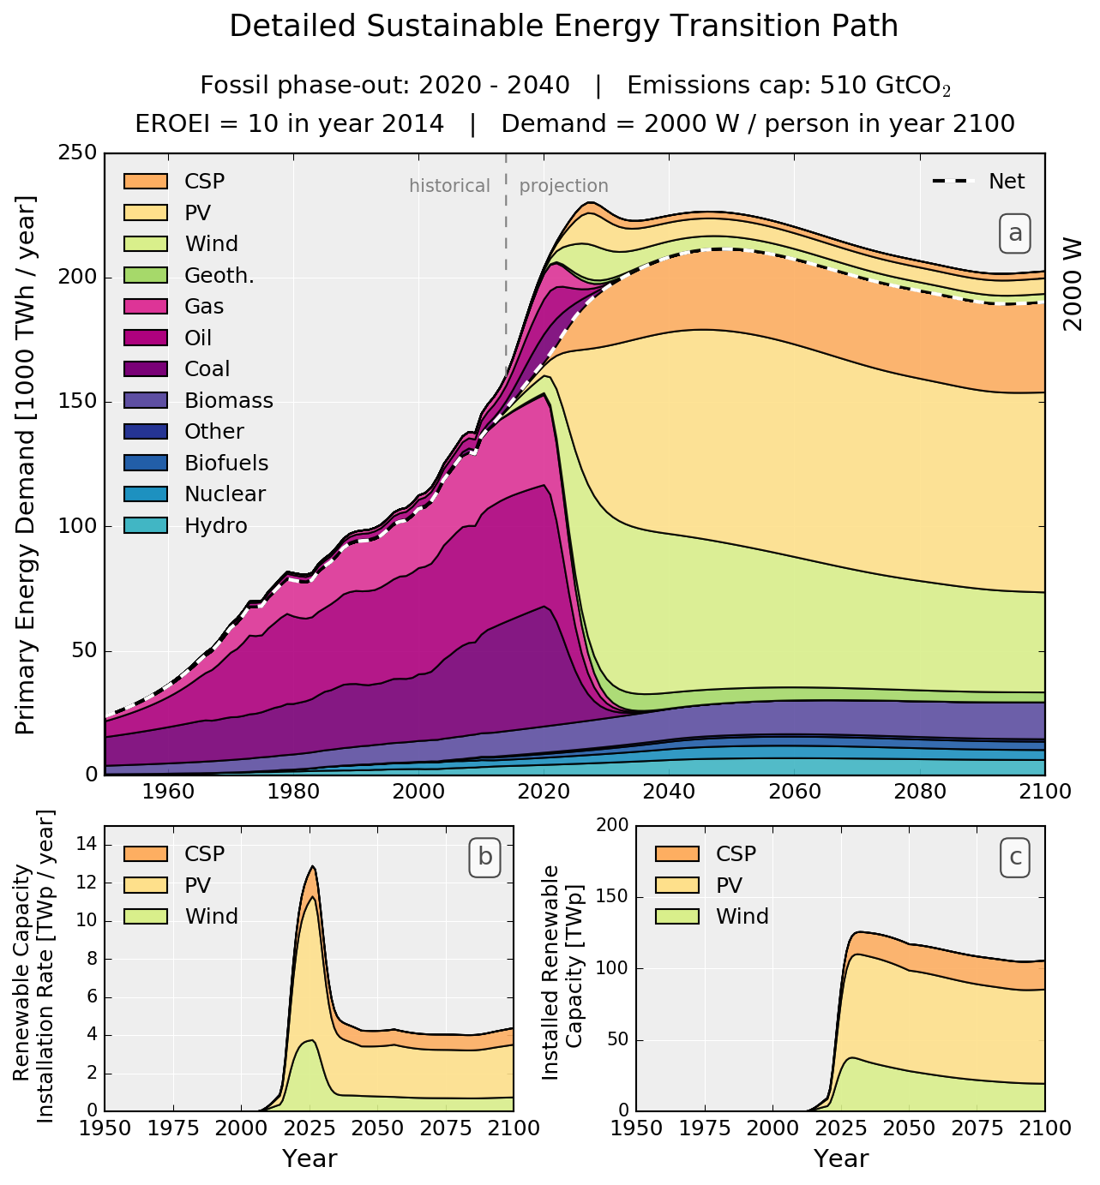

Figure ‎5‑20. (a) SET-compliant primary energy supply evolution (in PWh) for providing 2000W average net power per capita by 2100 to a population of 10.8 billion. Fossil fuel emissions comply with a 510 Gt CO2 cap peaking in 2020 and phased-out by 2040. The dashed line represents the net available energy while the values above it the energy investment in building and operating the energy system (“seed”). (b) RE portfolio installation rate profile (in TWp/year). (c) Installed RE Capacity (in TWp).

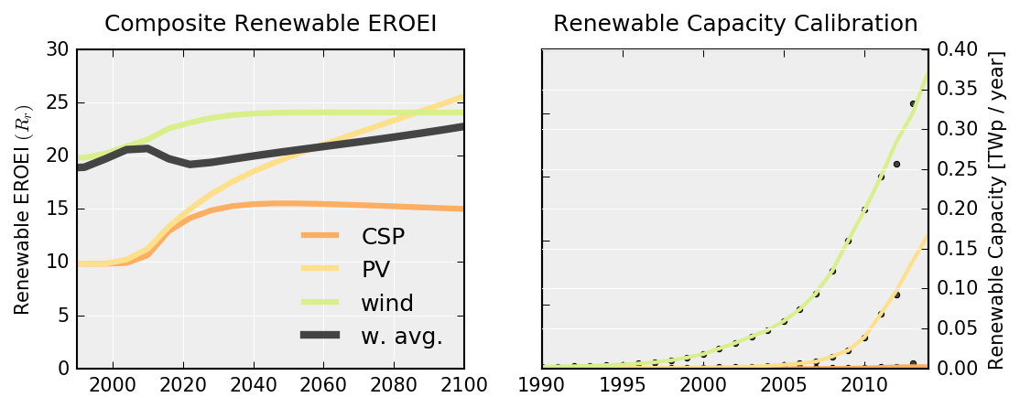

Figure ‎5‑21 Left: The ERoEI evolution of all RE resources and the composite weighted average ERoEI (black line) as output of the model accounting for their cumulative deployment. Right: Modeled (solid lines) and historical capacity additions of the three RE technologies used for initialization and calibration.

Figure ‎5‑21 Right shows the calibration of global SET model against historical values of renewable capacity, while Left shows the evolution of the EROEI of each renewable energy source, upon Wright-learning with deployment – the strong black line is the capacity-weighted average.

Following up on section ‎3.4, we also did a comparative representation of how the results of our analysis differ from IAM (in terms of ratio of RE to total primary energy – the 3 Luderer lines are for electricity only) shown in Figure ‎5‑22. The differences with the papers that have full primary energy comparisons the differences are stark. Bearing in mind that the SET trajectories are fitting into the global emission cap by design, based on Figure ‎5‑22, none of the IAM results would meet this cap. In fact, all 6 trajectories of the 2 scenarios of 3 simulated models by Wilkerson et al. only reach a maximum 20% renewable energy penetration by 2100, while the Luderer et al., electricity only (!) models reach to ~60% renewable energy share by the end of the century.

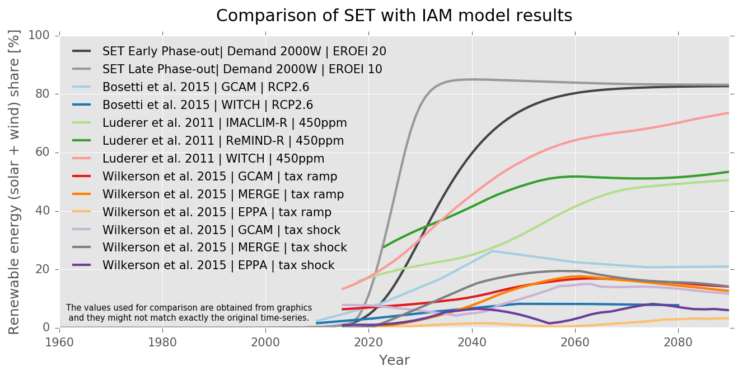

Figure ‎5‑22. Comparison of RE diffusion rates over the next century, expressed as a share of total primary energy  
source: own work based on data published by references, the model used and the scenario in the graph legend.

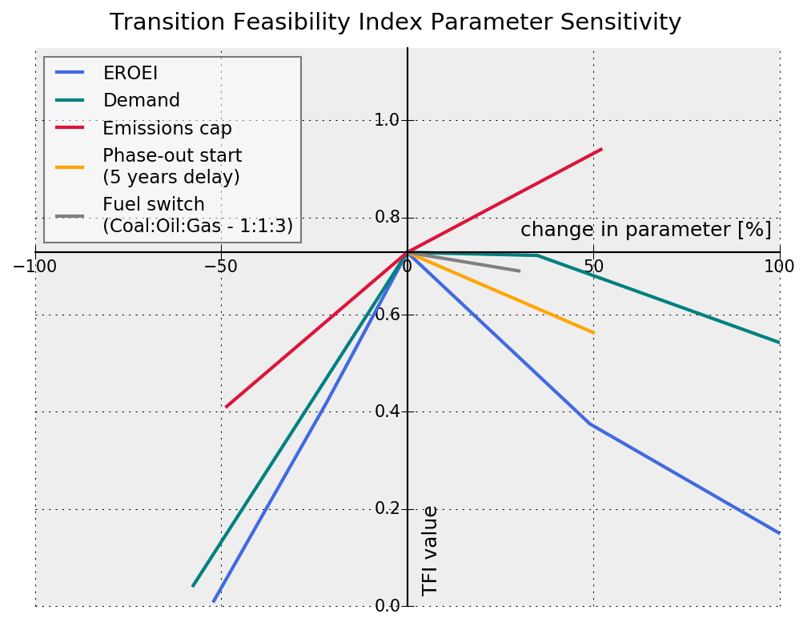

Figure ‎5‑23. Sensitivity diagram of TFI values to EROEI, Demand, emissions cap and fossil phase-out trajectory.

Finally, to be able to compare between effects of parameters acting upon the global SET model, we have created a sensitivity diagram (Figure ‎5‑23) that plots the changes in parameters (horizontal axis) vs. their effects on TFI (vertical axis) against each other. We can see that EROEI has the greatest effect on TFI, and 50% drop in its value would lead to near-zero TFIs – together with the Demand curve, clearly exhibiting the “sweet spot’ behavior of Figure ‎5‑19. Since the construction of the TFI does affect this sensitivity curves, we conclude this chapter by looking at the results constructed with two alternative TFI definitions.

Let us redefine two components related to EROEI and demand of the TFI, *f* and *g* as per Figure ‎5‑24. Let us assume that under this new definition, we allocate higher function *f* values to lower EROEIs, as method of “shielding” ourselves from the uncertainties of EROEI calculations. Furthermore, let us assume that high demand reduction from today’s values is easier than we initially assumed, thus allocating higher values for *g* for lower demands than before.

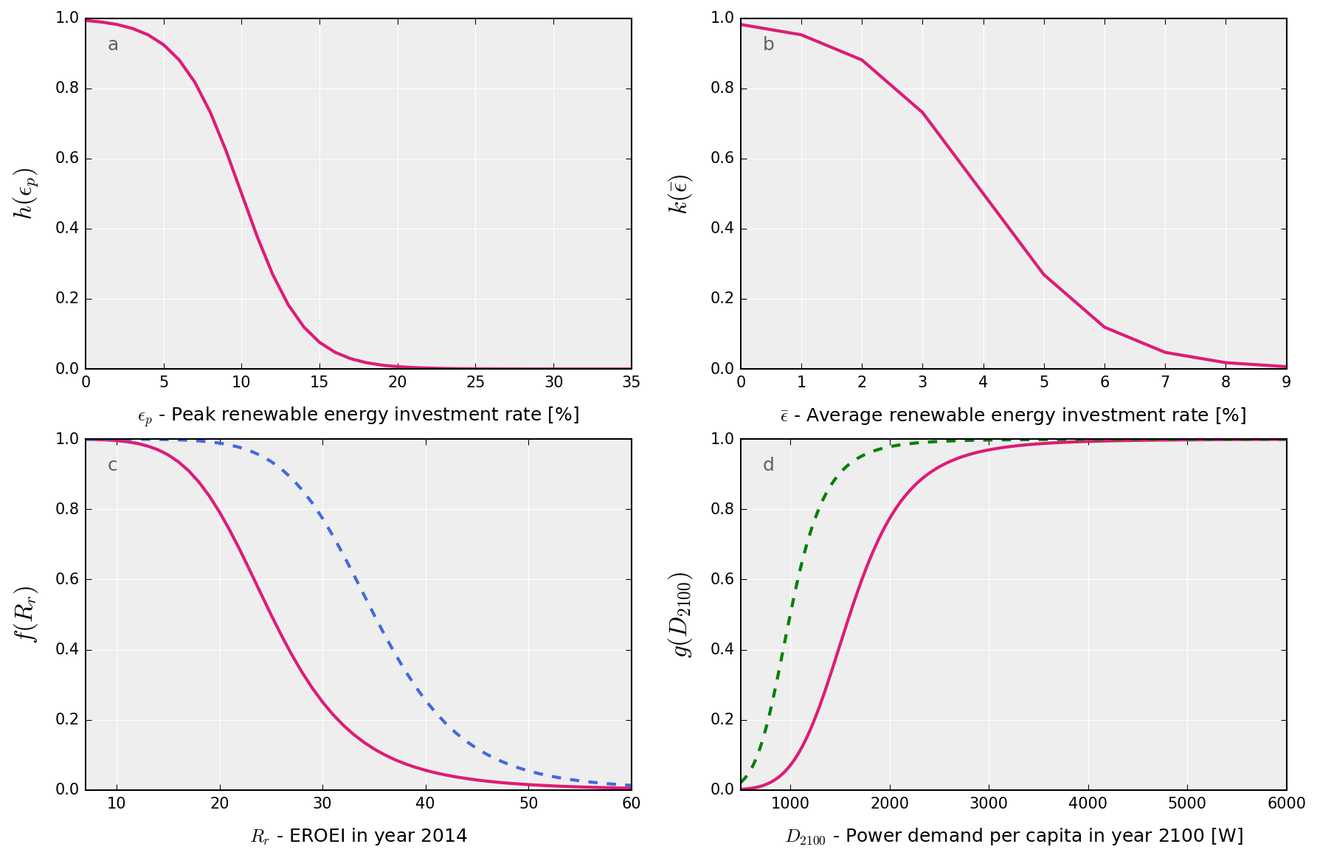

Figure ‎5‑24. Weighting distributions for the relative feasibility of: RE EROEI f(x), net energy demand g(x), peak renewable energy investment ratio h(x), and average renewable energy investment ratio k(x). The dotted lines show two alternative profiles to demonstrate the sensitivity of the TFI to the shape of the curve.

Then, using the new TFI transfer function definition for *f* and *g* from Figure ‎5‑24, we replot the sensitivity map of TFI over all EROEI and demand values (Figure ‎5‑19), first switching only the function *f* (Figure ‎5‑25), then only function *g* (Figure ‎5‑26) and finally both components in the definition of the TFI (Figure ‎5‑27).

Upon changing *f*, we can notice that the region with high TFI gets significantly larger, extending over the EROEI band of 15 to 30 (for the early transition, medium cap) and all demand values above 1500 W/capita (Figure ‎5‑25). Similarly, when switching *g* in the TFI, the feasible region moves downwards the demand axis, with trajectories with demands of 1000 W/capita and an EROEI of 20 already having TFIs larger than 0.8 (Figure ‎5‑26). (Figure ‎5‑27) exhibits a sizeable feasible region (EROEI 10-30, any demand above 1000 W/cap), combining both effects.

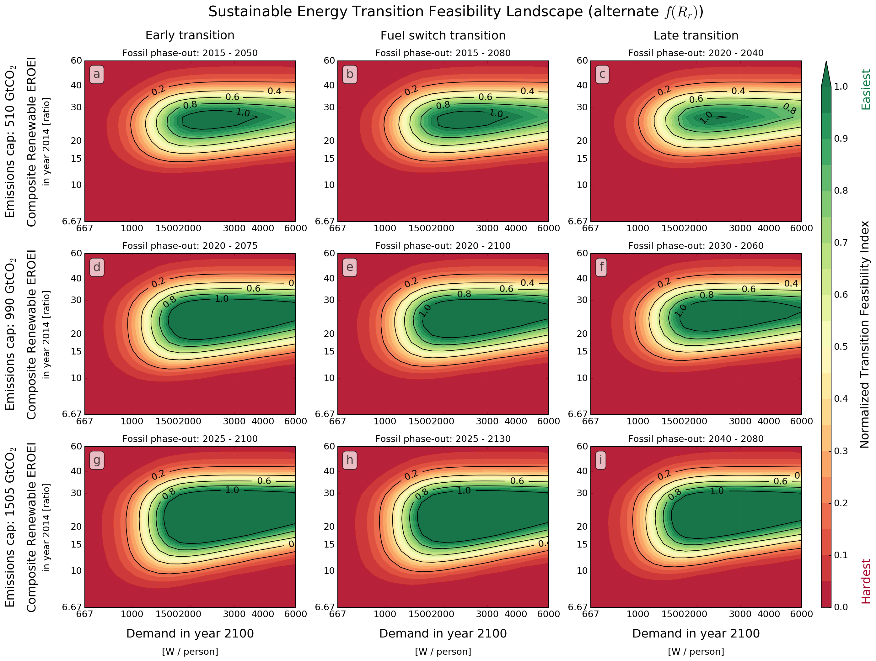

Figure ‎5‑25. Sensitivity map the normalized transition feasibility index (TFI) of all energy trajectories against varying demand and EROEI values.

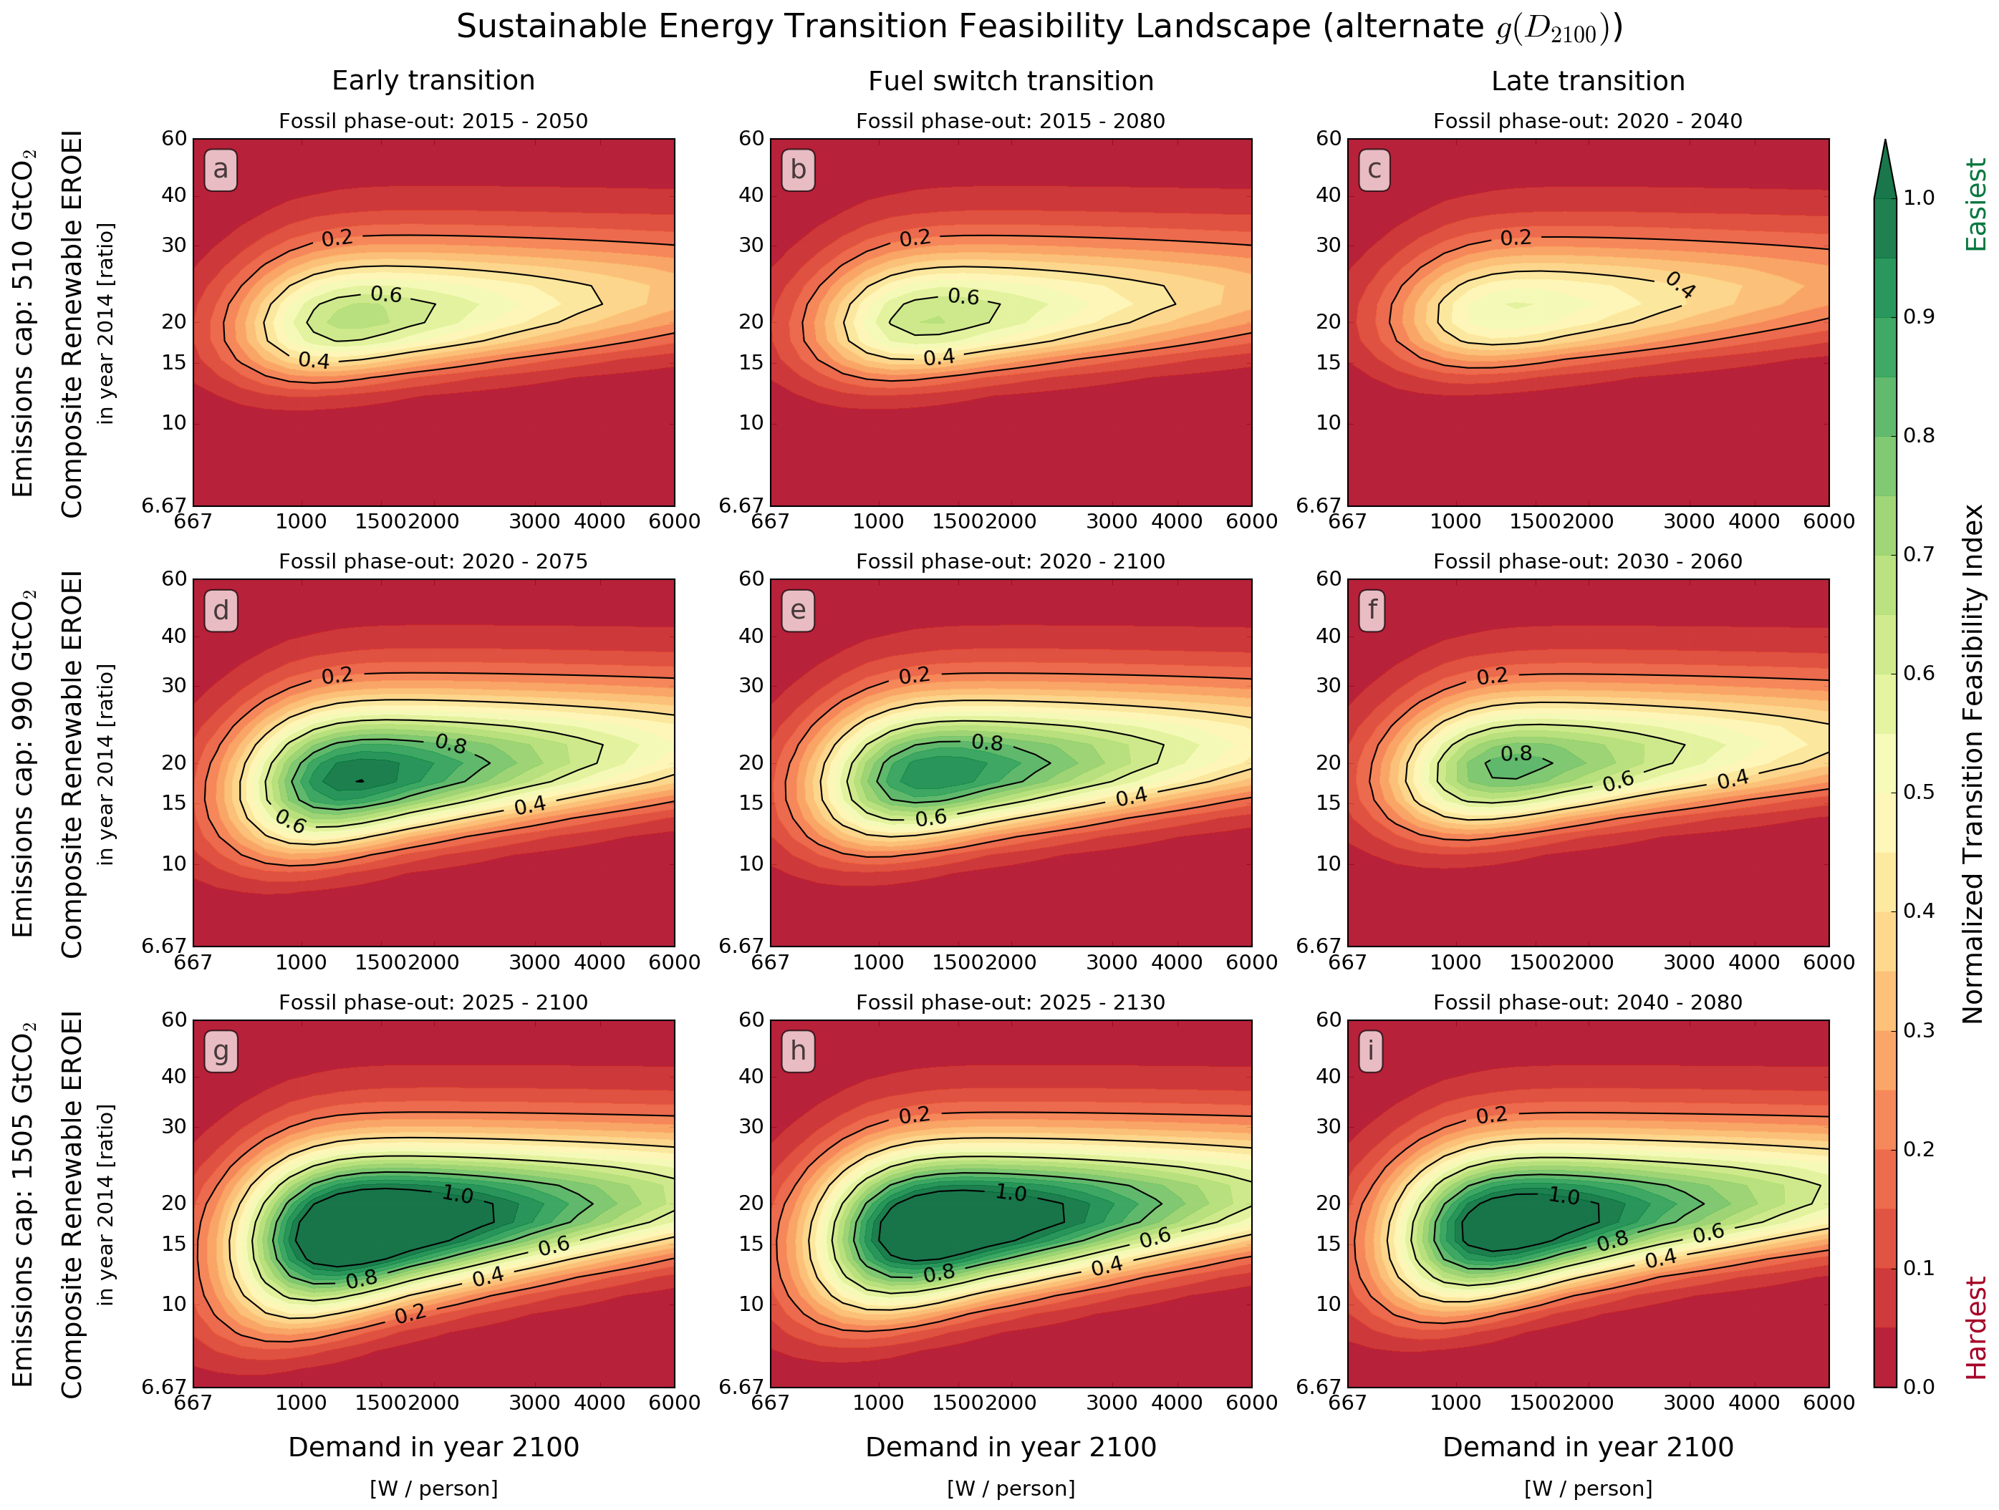

Figure ‎5‑26. Sensitivity map the normalized transition feasibility index (TFI) of all energy trajectories against varying demand and EROEI values using an alternative demand transfer function *g*.

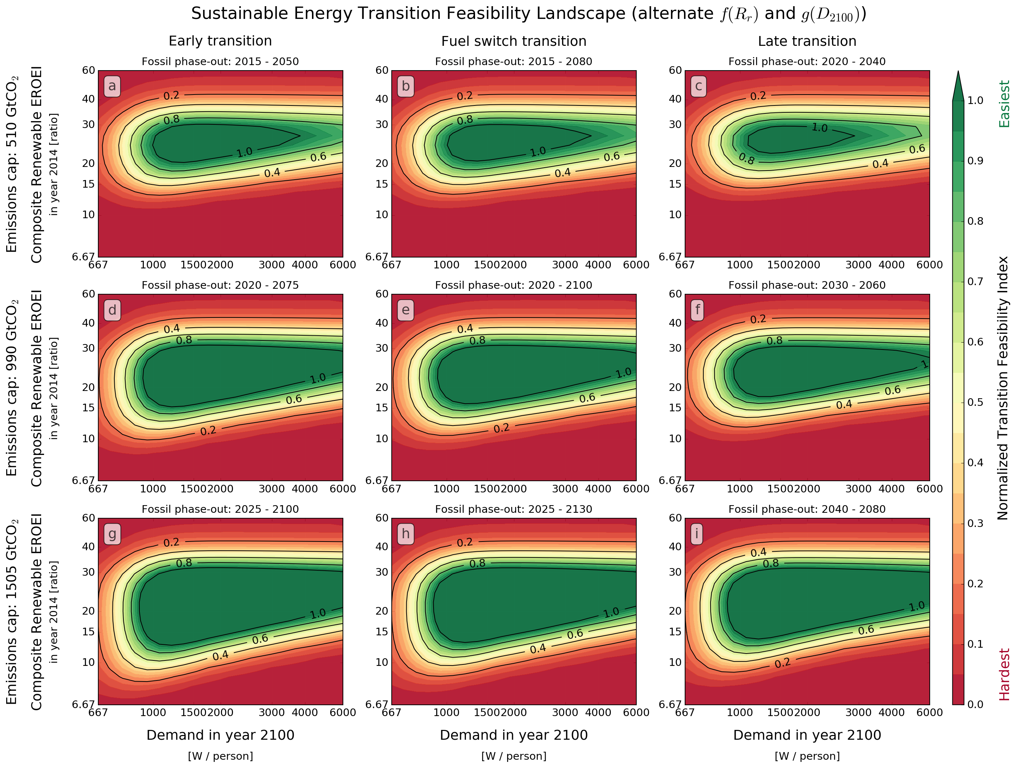

Figure ‎5‑27. Sensitivity map the normalized transition feasibility index (TFI) of all energy trajectories against varying demand and EROEI values using an alternative EROEI transfer function *f* and an alternative demand transfer function *g*.

## Global SET parameter tables

Table ‎5‑1. Parameter specifications for resource distribution and EROEI

|  |  |  |  |  |  |  |  |
| --- | --- | --- | --- | --- | --- | --- | --- |
| **Resource** | **Reported EROEIs in 2014 sources1** | **Norm. Resource Quality (θ)  in 2014** | **Technical EROEI (RT) in 2014** | **Norm. Resource Quality (θ)  in 2100** | **Relative average resource class  (out of 10)** | **Historical Share (ω) in 2014** | **Projected Share (ω) in 2100** |
| **Wind** | **22** | **1.09** | **20.18** | **1.1** | **3.15** | **0.827** | **0.256** |
| **PV** | **12** | **0.68** | **17.65** | **1.1** | **5.58** | **0.157** | **0.511** |
| **CSP** | **12** | **1.18** | **10.17** | **1.1** | **5.01** | **0.016** | **0.232** |

1. (Hall *et al* 2014), (Raugei *et al* 2012), (Barnhart *et al* 2013)

Table ‎5‑2. Parameter specifications for lifetime, learning and capacity factor

|  |  |  |  |  |  |  |  |
| --- | --- | --- | --- | --- | --- | --- | --- |
| **Resource** | **Lifetime (L)** | **Learning Rate (γ)** | **Capacity factor (ψ)  in 2014** | **Capacity factor (ψ)  in 2100** | **Resource utilization power (*s*)** | **Resource class  power (*z*)** | **Resource allocation power (w)** |
| **Wind** | **30** | **0.02** | **0.22** | **0.222** | **0.5** | **0.5** | **3** |
| **PV** | **25** | **0.04** | **0.12** | **0.195** |
| **CSP** | **30** | **0.04** | **0.2** | **0.2** |

Table ‎5‑3. Parameter specifications for storage

|  |  |  |  |  |  |  |
| --- | --- | --- | --- | --- | --- | --- |
| **Storage** | **ESOI (S)** | **125** | **Storage fraction (φ)** | **10** | **Storage efficiency (η)** | **0.78** |

Table ‎5‑4. Evolution assumptions for scale-limited resources

|  |  |  |  |  |
| --- | --- | --- | --- | --- |
| **Resource** | **Energy generation in 2014 [TWh]** | **2030** | **2050** | **2100** |
| **Nuclear** | **2541** | **3543** | **4900** | **4000** |
| **Hydropower** | **3853** | **5208** | **6900** | **6300** |
| **Biomass** | **9881** | **11492** | **13028** | **14805** |
| **Biofuels** | **1209** | **2097** | **3500** | **3340** |
| **Geothermal** | **234** | **4273** | **7135** | **5181** |
| **Other** | **406** | **728** | **955** | **1000** |

# NETWORKED SET – TRANSFORMING THE GLOBAL SET INTO COUNTRY-LEVEL TRANSITIONS: EXPLORATORIUM, APPLIED ANALYSIS & RESULTS

Using the results of the global SET simulations as indicative values for inputs for the NETSET, we have run the NETSET trade allocation algorithm following the stages summarized in section ‎4.6.9 of this dissertation. This sections presents the results of the simulations, demonstrating the functionings of the NETSET algorithm and highlighting the caveats that need to be addressed more carefully in possible future iterations.

## Guidelines for reading the NETSET transition graphs

We start the section with a set of clarifications regarding the NETSET graphs and a brief presentation of the Sustainable Energy Transitions Exploratorium (SETE).

Since the NETSET graphs contain multiple types of trade and energy storage flows, we have chosen only to represent the net energy flows on the graphs. The seed energy (the additional energy in order to complete the total) dynamics have been extensively discussed in the global SET results chapter (‎5) and do not qualitatively differ for the country-level transitions either. One must, however, bear in mind that the presented values are net flows, and thus imply an energy investment, three years prior as per Equation ( ‎4‑6 ). In case of trade energy amounts, the energy investment burden lies with the provider country. Knowing these assumptions, the nest graphs can be easily converted into totals for eh case of all countries. As discussed in section ‎4.6.7, in theory the energy investment could also be coming from the receiving country creating a form of “land rent for energy”, however this is a potentially very complex dynamic that we currently do not explore in this dissertation. Furthermore, by using only net flows, it will be easier to highlight the cases when the transition constraints cannot be met and therefore a successful transition is not possible for certain countries.

Under the networked SET, we constantly need to keep track of country energy balances. This implies tracking not only energy inflows into the country energy consumption pool, such as production, imports or re-imports, but also energy outflows, such as consumption, exports or re-exports. These type of balances are represented in the easiest way using a *violin plot*. We illustrate this concept using the historical and pre-calculated Argentinian natural gas flows between 1980 and 2030, as shown in Figure ‎6‑1.

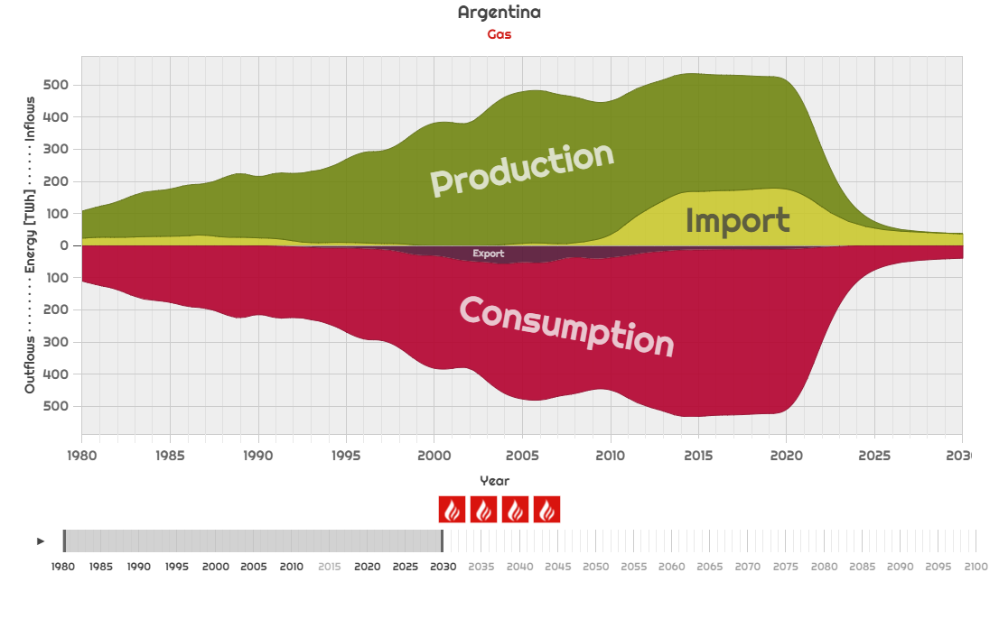

Figure ‎6‑1. Argentinian natural gas flows. Used as an example for violin plot.  
source: own work for the Sustainable Energy Flows Exploratorium, years: 1980-2030

The violin plot can be seen as two stacked-area charts, plotted over horizontal time axis. One of the stacked area charts is flipped, with the null value representing the highest on its vertical axis. The top stacked-area chart (above the horizontal axis) is called the inflows part and the bottom is the outflows part. Ideally, the top and bottom cumulatively should balance out at all times, while their composition changes. In Figure ‎6‑1 we can clearly see this in 2010-2015, when the domestic production of gas in Argentina waned, but consumption stayed the same therefore imports had to increase. In SETS, all country will have violin plots for all of their energy carriers. While the balances of individual energy carriers might not balance, the overall sum should.

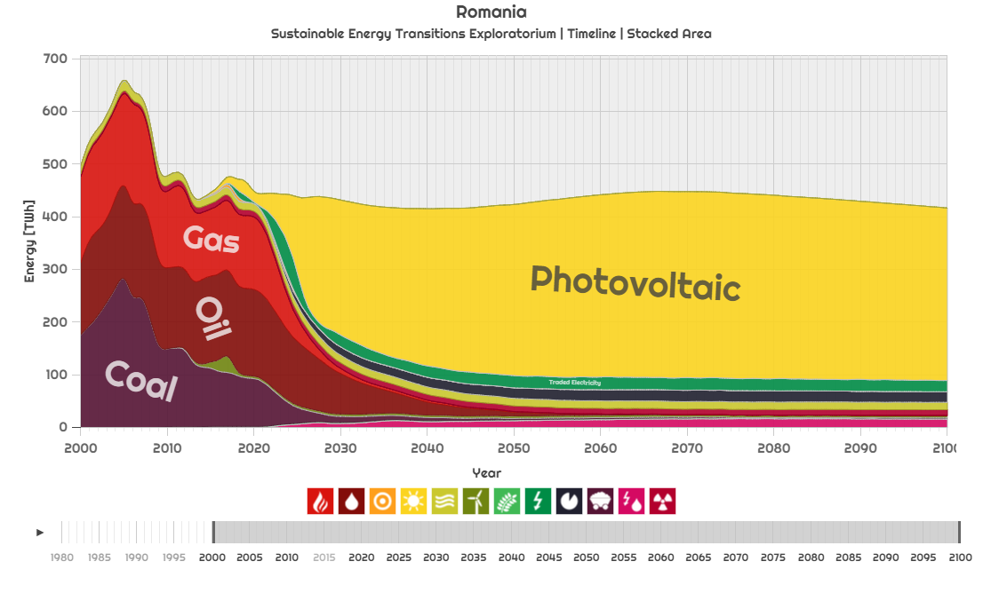

Gas

Oil

Solar Thermal

Photovoltaic

Hydropower

Wind

Bioenergy

Traded Electricity

Storage

Coal

Power-to-liquids

Nuclear

Figure ‎6‑2. Romanian energy dynamics. Used as an example for color-coding energy sources.  
source: own work for the Sustainable Energy Flows Exploratorium, years: 2000-2100

We consider 12 energy carriers in SETS, consistently color-coded over countries as shown in Figure ‎6‑2: Gas, Oil, Solar Thermal, Photovoltaic, Hydropower, Wind, Bioenergy, Traded Electricity, Storage, Coal, Power-to-liquids, Nuclear. When showing imports or exports breakdown based on countries, in turn these are also color-coded according to the representative colors of their flags.

While when studying energy balances of fossil fuels or direct generation and in-country consumption of electricity, both the inflow and outflow with show up as the energy source, when talking about regenerated electricity (see Figure ‎4‑9), we will depict the source and target differently, depending on the form of trade: any traded electricity, will show up as Power-to-liquid/Traded Electricity in the Inflow and as Photovoltaic/Wind/Solar Thermal in the Outflow for the *importer* country and Photovoltaic/Wind/Solar Thermal in the Inflow and Power-to-liquid/Traded Electricity in the Outflow for the *exporter* country. This follows the logic that the exporter *produces*, then exports the energy, while the importer country imports then *consumes* it. We illustrate this concept using Figure ‎6‑3:

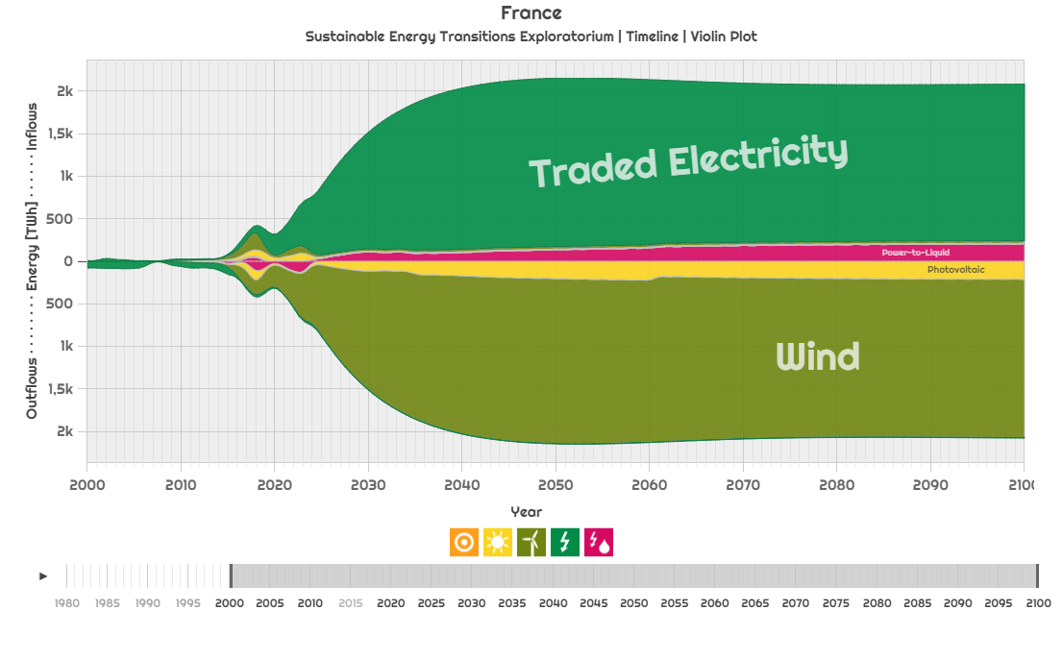

Figure ‎6‑3. French renewable energy production, consumption and trade. Used as an example for trade flow balance.  
source: own work for the Sustainable Energy Flows Exploratorium, years: 2000-2100

In this hypothetical example, most of France’s energy consumption is supplied through trading with other countries. Much of this trade comes through the electric grid, while some in the form of power-to-liquids. Between 2015 and 2025, there is also some domestic solar photovoltaic and wind energy production – this is the description of the Inflows. We can also see that the source of traded electricity is mostly wind, with a small share of solar power, and before 2015 France was exporting electricity (but we see that not from renewables as there is no corresponding production!), while between 2015 and 2025 was also exporting energy further than Europe (where the grid extends) in the form of power-to-liquids.

Before we move on the presentation of the simulation results, in this section, we briefly present the user interface elements of the SETE, as pictured in Figure ‎6‑4:

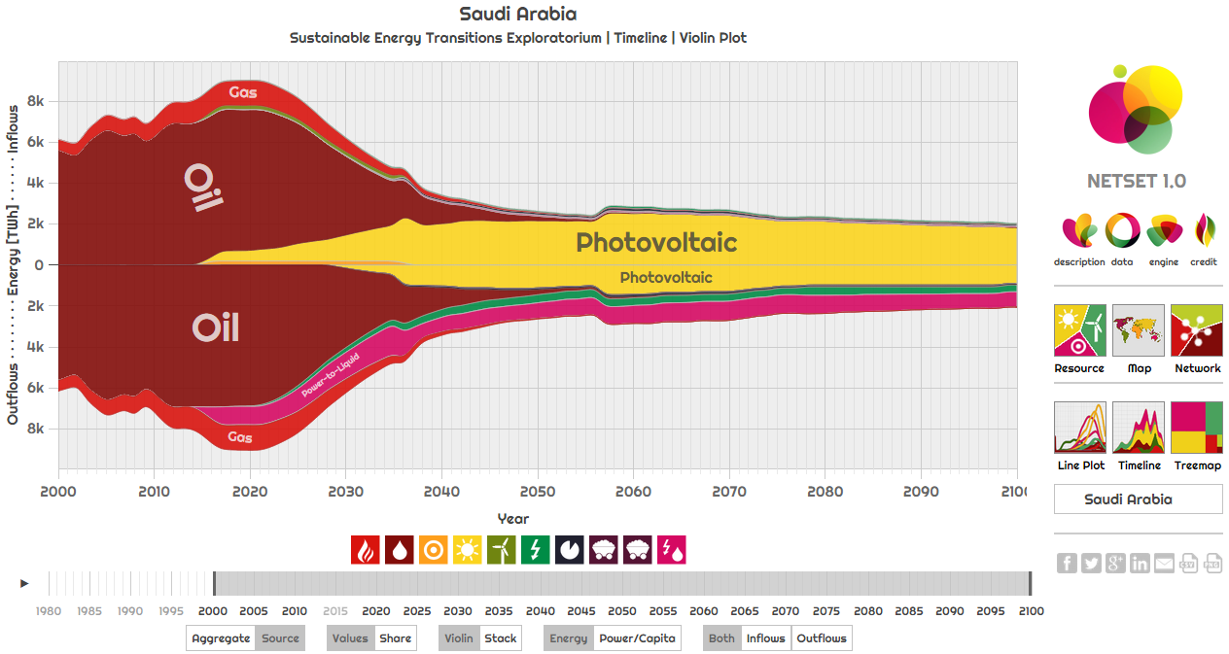

Figure ‎6‑4. User Interface of the Sustainable Energy Transition Exploratorium at <http://netset.csaladen.es>   
part 1, source: own work for the Sustainable Energy Flows Exploratorium

## A brief presentation of the Sustainable Energy Transitions Exploratorium (SETE)

SETE is the main data repository and an interactive data visualization interface developed for exploring the simulation produced upon implementing the NETSET model. It can be freely accessed online at <http://netset.csaladen.es> and it features 6 visualization types, selectable in a menu on the right. The top 3 options: *Resource*, *Map* and *Network* are global visualizations of the resource distribution (as pictured in Figure ‎4‑24), a choropleth map for visualizing static country-level data (such as Figure ‎4‑11) and a network visualization for trade networks (for example Figure ‎4‑34). The bottom 3 options are the all different tools to represent the NETSET transition paths, selectable for all countries included in the simulation. The *Line Plot* options displays data in a time series format, the *Timeline* (such as Figure ‎4‑18) produces a stack chart – which, by default is displayed in a violin plot style – and finally, a *Treemap* (such as Figure ‎4‑17) visualization for showing year-to-year data relationships in 2-dimensional format. In our result reporting, we will be mostly confined to using the *Timeline* chart.

Each visualization type displays a set of controls on the bottom of the chart area. Usually there is a set of pictograms that can be used to filter the data being displayed – as well as a timeline right below the pictograms, also used for filtering. On the bottom of the page, a set of buttons controls how the data should be displayed. These controls are from left to right:

* **Aggregate | Source**: controls whether to show individual energy sources or group them together according to Figure ‎4‑5.
* **Values | Share**: controls whether to display a normalized 100% scale for the vertical axis or use the actual values
* **Violin | Stack**: controls whether the outflows should be displayed “negatively”, stacked downwards from the horizontal axis.
* **Energy | Power/Capita**: controls whether to display energy values or normalize by population and average power, according to Figure ‎2‑3 and Figure ‎2‑12.
* **Both | Inflows | Outflows**: filters data according to its label

The main visualization interface is interactive and all data stacks are hierarchical – hence zoomable upon click. For example, upon clicking on the Traded Electricity (Inflow or Outflow) on the example of Figure ‎6‑4, produces Figure ‎6‑5, which upon clicking on the Export part turns into Figure ‎6‑6 and reveals the trade partners. A further click on any of the countries would show the traded energy source.

SETE also has embedded sharing and saving functions: in the bottom right corner we can share the current visualization over social media, or the save the displayed plot in data format (*csv*) or visually (*png*). SETE also uses *smart url*s – that is, a certain type of data visualization about a certain country can be shared with a specific link and then reopened on a different computer in the same form.

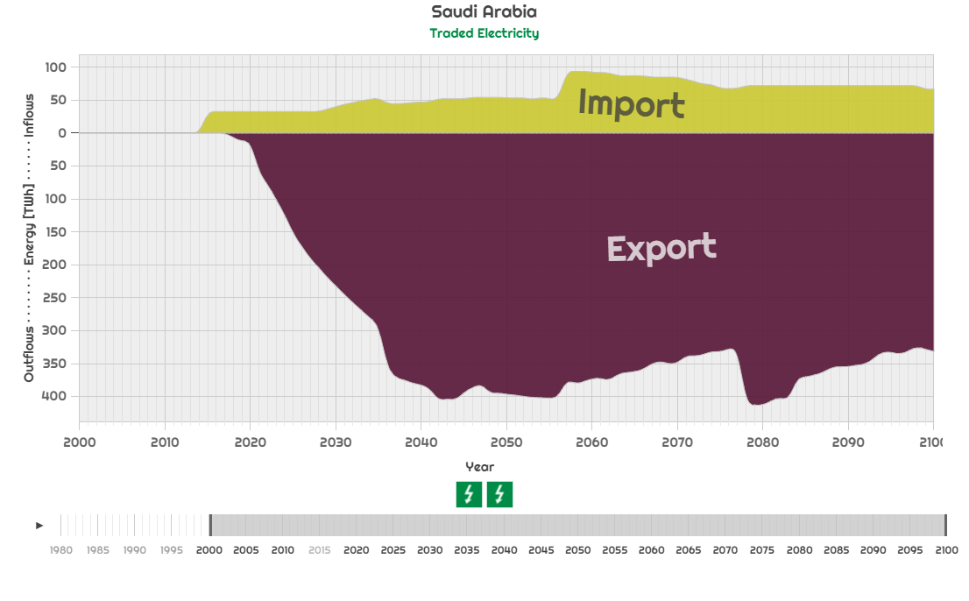

Figure ‎6‑5. User Interface of the Sustainable Energy Transition Exploratorium at <http://netset.csaladen.es>   
part 2, source: own work for the Sustainable Energy Flows Exploratorium

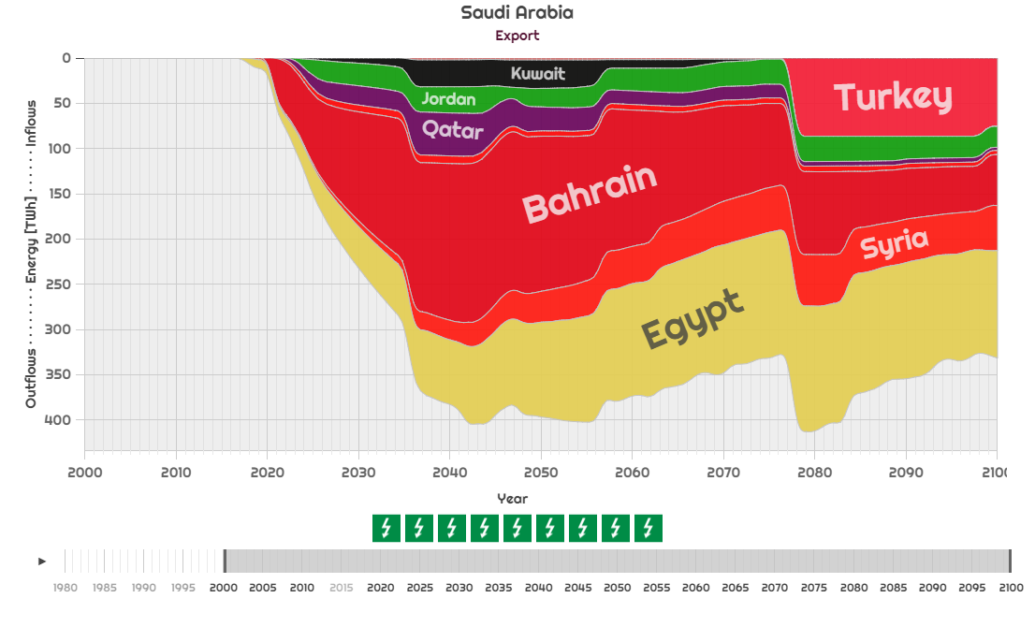

Figure ‎6‑6. User Interface of the Sustainable Energy Transition Exploratorium at <http://netset.csaladen.es>   
part 3, source: own work for the Sustainable Energy Flows Exploratorium

Programming-wise, SETE is built using a self-developed fork of *d3plus*, itself a fork of the *d3.js* *Javascript*-based data visualization library. Data is fed through a series of zipped *json* files generated in *Python* *pandas*, the source code for all of which is accessible freely at the SETE website.

## On the importance of country influence in NETSET

As discussed in section ‎4.6.6 and depicted as stage *F* in section ‎4.6.9, the way country influence is set is I major decider on the universal governing rules of trade. As we may recall, there are two global parameters through which the trade rules are governed: country self-influence and the country influence power factor. These parameters then yield the values of country influence in in the country influence matrix CI, to be used in the trade cost Equation ( ‎4‑22 ).

Changing the self-influence *q* controls the openness of trade. The mechanism thorough which this happens is easy to imagine: as *q* gets higher (the influence factor of a country compared to the average influence of its trade partners), the influence factor term in Equation ( ‎4‑22 ) grows as well, therefore prioritizing trade with self over other options – i.e. expanding capacity in-country. Also, another aspect that is crucial for the trade allocation order (as per section ‎4.6.7) is that changing the *q* would not change the country influence vector (defined as per ‎4.6.6.2), as the average influence of all countries would rise symmetrically (Table ‎6‑1, with q=4 vs. Table ‎6‑2 with q=8). Therefore, we do not investigate the effects of self-influence further than this point.

Table ‎6‑1. Country influence vector for q=4, p=3

|  |  |  |  |  |  |  |
| --- | --- | --- | --- | --- | --- | --- |
| **Nr.** | **Country** | **CIavg** |  | **Nr.** | **Country** | **CIavg** |
| **1** | USA | 1.7 |  | **96** | Dominican Republic | 0.28 |
| **2** | Russia | 1.17 |  | **97** | Cuba | 0.28 |
| **3** | Netherlands | 1.13 |  | **98** | Jordan | 0.28 |
| **4** | United Kingdom | 1.12 |  | **99** | Slovenia | 0.28 |
| **5** | Italy | 1.11 |  | **100** | Belarus | 0.28 |
| **6** | France | 1.09 |  | **101** | Iceland | 0.27 |
| **7** | Saudi Arabia | 1.04 |  | **102** | Niger | 0.27 |
| **8** | Singapore | 1 |  | **103** | Costa Rica | 0.27 |
| **9** | Germany | 0.98 |  | **104** | Sri Lanka | 0.27 |
| **10** | UAE | 0.94 |  | **105** | Georgia | 0.27 |
| **11** | China | 0.93 |  | **106** | Madagascar | 0.26 |
| **12** | India | 0.91 |  | **107** | Jamaica | 0.26 |
| **13** | Iran | 0.89 |  | **108** | Turkmenistan | 0.26 |
| **14** | Nigeria | 0.88 |  | **109** | Mali | 0.26 |
| **15** | Venezuela | 0.87 |  | **110** | Antigua & Barbuda | 0.26 |
| **16** | South Africa | 0.86 |  | **111** | Burkina Faso | 0.25 |
| **17** | Spain | 0.84 |  | **112** | Guatemala | 0.25 |
| **18** | Australia | 0.78 |  | **113** | Guinea | 0.24 |
| **19** | Japan | 0.74 |  | **114** | Namibia | 0.24 |
| **20** | South Korea | 0.72 |  | **115** | Albania | 0.24 |
| **21** | Trinidad and Tobago | 0.7 |  | **116** | Sierra Leone | 0.24 |
| **22** | Kuwait | 0.7 |  | **117** | Honduras | 0.24 |
| **23** | Indonesia | 0.69 |  | **118** | Uruguay | 0.24 |
| **24** | Greece | 0.65 |  | **119** | Barbados | 0.23 |
| **25** | Turkey | 0.65 |  | **120** | Bangladesh | 0.23 |
| **26** | Algeria | 0.65 |  | **121** | Zambia | 0.23 |
| **27** | Malaysia | 0.64 |  | **122** | Slovakia | 0.22 |
| **28** | Brazil | 0.63 |  | **123** | Bosnia & Herzegovina | 0.22 |
| **29** | Switzerland | 0.61 |  | **124** | Cape Verde | 0.22 |
| **30** | Canada | 0.59 |  | **125** | El Salvador | 0.22 |
| **31** | Colombia | 0.58 |  | **126** | Aruba | 0.22 |
| **32** | Belgium | 0.58 |  | **127** | Zimbabwe | 0.21 |
| **33** | Poland | 0.57 |  | **128** | Uganda | 0.21 |
| **34** | Ukraine | 0.55 |  | **129** | Djibouti | 0.21 |
| **35** | Egypt | 0.54 |  | **130** | Suriname | 0.21 |
| **36** | Bahrain | 0.53 |  | **131** | Nicaragua | 0.2 |
| **37** | Romania | 0.52 |  | **132** | Ethiopia | 0.2 |
| **38** | Iraq | 0.52 |  | **133** | Belize | 0.2 |
| **39** | Norway | 0.5 |  | **134** | Macedonia | 0.2 |
| **40** | Sweden | 0.49 |  | **135** | Seychelles | 0.2 |
| **41** | Ivory Coast | 0.48 |  | **136** | Mauritania | 0.2 |
| **42** | Portugal | 0.48 |  | **137** | CAR | 0.19 |
| **43** | Libya | 0.47 |  | **138** | Fiji | 0.19 |
| **44** | Thailand | 0.46 |  | **139** | Paraguay | 0.19 |
| **45** | Qatar | 0.46 |  | **140** | Gambia | 0.18 |
| **46** | Kazakhstan | 0.45 |  | **141** | US VI | 0.18 |
| **47** | Mexico | 0.44 |  | **142** | Somalia | 0.18 |
| **48** | Bulgaria | 0.44 |  | **143** | Papua New Guinea | 0.18 |
| **49** | Argentina | 0.44 |  | **144** | Rwanda | 0.18 |
| **50** | Denmark | 0.42 |  | **145** | Guyana | 0.17 |
| **51** | Panama | 0.41 |  | **146** | Guadeloupe | 0.17 |
| **52** | Malta | 0.4 |  | **147** | Bolivia | 0.17 |
| **53** | Gabon | 0.39 |  | **148** | Moldova | 0.17 |
| **54** | Israel | 0.39 |  | **149** | Martinique | 0.17 |
| **55** | Latvia | 0.39 |  | **150** | Kyrgyzstan | 0.17 |
| **56** | Kenya | 0.39 |  | **151** | Réunion | 0.17 |
| **57** | Angola | 0.38 |  | **152** | Chad | 0.17 |
| **58** | Morocco | 0.38 |  | **153** | St. Vincent & the Grn. | 0.16 |
| **59** | Azerbaijan | 0.38 |  | **154** | Guinea-Bissau | 0.16 |
| **60** | Oman | 0.38 |  | **155** | Saint Lucia | 0.16 |
| **61** | Bahamas | 0.38 |  | **156** | Brunei | 0.16 |
| **62** | Estonia | 0.37 |  | **157** | Burundi | 0.16 |
| **63** | Cyprus | 0.37 |  | **158** | Myanmar | 0.16 |
| **64** | Senegal | 0.37 |  | **159** | Vanuatu | 0.16 |
| **65** | Austria | 0.37 |  | **160** | Afghanistan | 0.16 |
| **66** | Togo | 0.36 |  | **161** | Cambodia | 0.16 |
| **67** | Congo | 0.36 |  | **162** | Malawi | 0.15 |
| **68** | Chile | 0.36 |  | **163** | Luxembourg | 0.15 |
| **69** | Yemen | 0.36 |  | **164** | New Caledonia | 0.15 |
| **70** | Cameroon | 0.35 |  | **165** | Montenegro | 0.14 |
| **71** | Lithuania | 0.35 |  | **166** | Armenia | 0.14 |
| **72** | Croatia | 0.35 |  | **167** | Haiti | 0.14 |
| **73** | Hungary | 0.35 |  | **168** | Nepal | 0.14 |
| **74** | Vietnam | 0.34 |  | **169** | Comoros | 0.13 |
| **75** | Finland | 0.34 |  | **170** | Samoa | 0.12 |
| **76** | Ghana | 0.33 |  | **171** | Macao | 0.12 |
| **77** | Liberia | 0.33 |  | **172** | French Polynesia | 0.12 |
| **78** | DRC | 0.33 |  | **173** | Maldives | 0.12 |
| **79** | Pakistan | 0.33 |  | **174** | French Guiana | 0.11 |
| **80** | Ireland | 0.33 |  | **175** | Eritrea | 0.11 |
| **81** | Syria | 0.33 |  | **176** | Solomon Islands | 0.11 |
| **82** | Hong Kong | 0.32 |  | **177** | Laos | 0.11 |
| **83** | Benin | 0.32 |  | **178** | Botswana | 0.11 |
| **84** | Tunisia | 0.32 |  | **179** | Kiribati | 0.1 |
| **85** | Tanzania | 0.31 |  | **180** | Tajikistan | 0.1 |
| **86** | Peru | 0.31 |  | **181** | Swaziland | 0.1 |
| **87** | Serbia | 0.31 |  | **182** | Sao Tome & Principe | 0.1 |
| **88** | Philippines | 0.31 |  | **183** | East Timor | 0.1 |
| **89** | New Zealand | 0.31 |  | **184** | Mongolia | 0.09 |
| **90** | Mozambique | 0.3 |  | **185** | Palestine | 0.09 |
| **91** | Sudan | 0.3 |  | **186** | Tonga | 0.08 |
| **92** | Ecuador | 0.3 |  | **187** | Grenada | 0.08 |
| **93** | Czech Republic | 0.29 |  | **188** | Bhutan | 0.06 |
| **94** | Mauritius | 0.28 |  | **189** | Lesotho | 0.05 |
| **95** | Lebanon | 0.28 |  |  |  |  |

Table ‎6‑2. Country influence vector for q=8, p=3

|  |  |  |  |  |  |  |
| --- | --- | --- | --- | --- | --- | --- |
| **Nr.** | **Country** | **CIavg** |  | **Nr.** | **Country** | **CIavg** |
| **1** | USA | 1.72 |  | **96** | Dominican Republic | 0.3 |
| **2** | Russia | 1.19 |  | **97** | Cuba | 0.3 |
| **3** | Netherlands | 1.15 |  | **98** | Jordan | 0.3 |
| **4** | United Kingdom | 1.14 |  | **99** | Slovenia | 0.3 |
| **5** | Italy | 1.13 |  | **100** | Belarus | 0.28 |
| **6** | France | 1.11 |  | **101** | Iceland | 0.3 |
| **7** | Saudi Arabia | 1.07 |  | **102** | Niger | 0.29 |
| **8** | Singapore | 1.02 |  | **103** | Costa Rica | 0.29 |
| **9** | Germany | 1 |  | **104** | Sri Lanka | 0.29 |
| **10** | UAE | 0.96 |  | **105** | Georgia | 0.29 |
| **11** | China | 0.96 |  | **106** | Madagascar | 0.28 |
| **12** | India | 0.93 |  | **107** | Jamaica | 0.28 |
| **13** | Iran | 0.91 |  | **108** | Turkmenistan | 0.28 |
| **14** | Nigeria | 0.9 |  | **109** | Mali | 0.28 |
| **15** | Venezuela | 0.89 |  | **110** | Antigua & Barbuda | 0.28 |
| **16** | South Africa | 0.88 |  | **111** | Burkina Faso | 0.27 |
| **17** | Spain | 0.86 |  | **112** | Guatemala | 0.27 |
| **18** | Australia | 0.8 |  | **113** | Guinea | 0.26 |
| **19** | Japan | 0.76 |  | **114** | Namibia | 0.26 |
| **20** | South Korea | 0.74 |  | **115** | Albania | 0.26 |
| **21** | Trinidad and Tobago | 0.72 |  | **116** | Sierra Leone | 0.26 |
| **22** | Kuwait | 0.72 |  | **117** | Honduras | 0.26 |
| **23** | Indonesia | 0.72 |  | **118** | Uruguay | 0.26 |
| **24** | Greece | 0.67 |  | **119** | Barbados | 0.25 |
| **25** | Turkey | 0.67 |  | **120** | Bangladesh | 0.25 |
| **26** | Algeria | 0.67 |  | **121** | Zambia | 0.25 |
| **27** | Malaysia | 0.66 |  | **122** | Slovakia | 0.24 |
| **28** | Brazil | 0.65 |  | **123** | Bosnia & Herzegovina | 0.24 |
| **29** | Switzerland | 0.63 |  | **124** | Cape Verde | 0.24 |
| **30** | Canada | 0.61 |  | **125** | El Salvador | 0.24 |
| **31** | Colombia | 0.6 |  | **126** | Aruba | 0.24 |
| **32** | Belgium | 0.6 |  | **127** | Zimbabwe | 0.23 |
| **33** | Poland | 0.59 |  | **128** | Uganda | 0.23 |
| **34** | Ukraine | 0.57 |  | **129** | Djibouti | 0.23 |
| **35** | Egypt | 0.56 |  | **130** | Suriname | 0.23 |
| **36** | Bahrain | 0.55 |  | **131** | Nicaragua | 0.23 |
| **37** | Romania | 0.55 |  | **132** | Ethiopia | 0.23 |
| **38** | Iraq | 0.54 |  | **133** | Belize | 0.23 |
| **39** | Norway | 0.52 |  | **134** | Macedonia | 0.23 |
| **40** | Sweden | 0.51 |  | **135** | Seychelles | 0.22 |
| **41** | Ivory Coast | 0.5 |  | **136** | Mauritania | 0.22 |
| **42** | Portugal | 0.5 |  | **137** | CAR | 0.21 |
| **43** | Libya | 0.49 |  | **138** | Fiji | 0.21 |
| **44** | Thailand | 0.48 |  | **139** | Paraguay | 0.21 |
| **45** | Qatar | 0.48 |  | **140** | Gambia | 0.2 |
| **46** | Kazakhstan | 0.47 |  | **141** | US VI | 0.2 |
| **47** | Mexico | 0.46 |  | **142** | Somalia | 0.2 |
| **48** | Bulgaria | 0.46 |  | **143** | Papua New Guinea | 0.2 |
| **49** | Argentina | 0.46 |  | **144** | Rwanda | 0.2 |
| **50** | Denmark | 0.45 |  | **145** | Guyana | 0.2 |
| **51** | Panama | 0.43 |  | **146** | Guadeloupe | 0.2 |
| **52** | Malta | 0.42 |  | **147** | Bolivia | 0.19 |
| **53** | Gabon | 0.41 |  | **148** | Moldova | 0.19 |
| **54** | Israel | 0.41 |  | **149** | Martinique | 0.19 |
| **55** | Latvia | 0.41 |  | **150** | Kyrgyzstan | 0.19 |
| **56** | Kenya | 0.41 |  | **151** | Réunion | 0.19 |
| **57** | Angola | 0.4 |  | **152** | Chad | 0.19 |
| **58** | Morocco | 0.4 |  | **153** | St. Vincent & the Grn. | 0.19 |
| **59** | Azerbaijan | 0.4 |  | **154** | Guinea-Bissau | 0.18 |
| **60** | Oman | 0.4 |  | **155** | Saint Lucia | 0.18 |
| **61** | Bahamas | 0.4 |  | **156** | Brunei | 0.18 |
| **62** | Estonia | 0.39 |  | **157** | Burundi | 0.18 |
| **63** | Cyprus | 0.39 |  | **158** | Myanmar | 0.18 |
| **64** | Senegal | 0.39 |  | **159** | Vanuatu | 0.18 |
| **65** | Austria | 0.39 |  | **160** | Afghanistan | 0.18 |
| **66** | Togo | 0.38 |  | **161** | Cambodia | 0.18 |
| **67** | Congo | 0.38 |  | **162** | Malawi | 0.17 |
| **68** | Chile | 0.38 |  | **163** | Luxembourg | 0.17 |
| **69** | Yemen | 0.38 |  | **164** | New Caledonia | 0.17 |
| **70** | Cameroon | 0.37 |  | **165** | Montenegro | 0.17 |
| **71** | Lithuania | 0.37 |  | **166** | Armenia | 0.16 |
| **72** | Croatia | 0.37 |  | **167** | Haiti | 0.16 |
| **73** | Hungary | 0.37 |  | **168** | Nepal | 0.16 |
| **74** | Vietnam | 0.36 |  | **169** | Comoros | 0.15 |
| **75** | Finland | 0.36 |  | **170** | Samoa | 0.15 |
| **76** | Ghana | 0.35 |  | **171** | Macao | 0.15 |
| **77** | Liberia | 0.35 |  | **172** | French Polynesia | 0.14 |
| **78** | DRC | 0.35 |  | **173** | Maldives | 0.14 |
| **79** | Pakistan | 0.35 |  | **174** | French Guiana | 0.13 |
| **80** | Ireland | 0.35 |  | **175** | Eritrea | 0.13 |
| **81** | Syria | 0.35 |  | **176** | Solomon Islands | 0.13 |
| **82** | Hong Kong | 0.34 |  | **177** | Laos | 0.13 |
| **83** | Benin | 0.34 |  | **178** | Botswana | 0.13 |
| **84** | Tunisia | 0.34 |  | **179** | Kiribati | 0.12 |
| **85** | Tanzania | 0.33 |  | **180** | Tajikistan | 0.12 |
| **86** | Peru | 0.33 |  | **181** | Swaziland | 0.12 |
| **87** | Serbia | 0.33 |  | **182** | Sao Tome & Principe | 0.12 |
| **88** | Philippines | 0.33 |  | **183** | East Timor | 0.12 |
| **89** | New Zealand | 0.33 |  | **184** | Mongolia | 0.12 |
| **90** | Mozambique | 0.32 |  | **185** | Palestine | 0.11 |
| **91** | Sudan | 0.32 |  | **186** | Tonga | 0.1 |
| **92** | Ecuador | 0.32 |  | **187** | Grenada | 0.1 |
| **93** | Czech Republic | 0.31 |  | **188** | Bhutan | 0.08 |
| **94** | Mauritius | 0.31 |  | **189** | Lesotho | 0.07 |
| **95** | Lebanon | 0.31 |  |  |  |  |

However, the other defining measure of country influence, the power factor, sets the power balance between importers and exporters and therefore it *does* affect the order in the influence vector (Table ‎6‑1 with p=3 vs. Table ‎6‑3 with p=5). Large energy exporter countries drop in the ranks (Russia from 2 to 6, Saudi Arabia from 7 to 9, UAE from 10 to 11, etc.) for more evenly distributed country influence – i.e. higher power factors.

Table ‎6‑3. Country influence vector for q=4, p=5

|  |  |  |  |  |  |  |
| --- | --- | --- | --- | --- | --- | --- |
| **Nr.** | **Country** | **CIavg** |  | **Nr.** | **Country** | **CIavg** |
| **1** | USA | 1.31 |  | **96** | Czech Republic | 0.31 |
| **2** | United Kingdom | 1.02 |  | **97** | Jordan | 0.31 |
| **3** | Netherlands | 1.01 |  | **98** | Niger | 0.31 |
| **4** | Italy | 1 |  | **99** | Slovenia | 0.31 |
| **5** | France | 0.98 |  | **100** | Belarus | 0.31 |
| **6** | Russia | 0.93 |  | **101** | Mauritius | 0.3 |
| **7** | Germany | 0.92 |  | **102** | Sri Lanka | 0.3 |
| **8** | Singapore | 0.9 |  | **103** | Dominican Republic | 0.3 |
| **9** | Saudi Arabia | 0.89 |  | **104** | Georgia | 0.3 |
| **10** | China | 0.87 |  | **105** | Madagascar | 0.3 |
| **11** | UAE | 0.84 |  | **106** | Jamaica | 0.28 |
| **12** | India | 0.83 |  | **107** | Burkina Faso | 0.28 |
| **13** | Iran | 0.83 |  | **108** | Costa Rica | 0.28 |
| **14** | Spain | 0.82 |  | **109** | Albania | 0.28 |
| **15** | Nigeria | 0.8 |  | **110** | Guinea | 0.27 |
| **16** | South Africa | 0.77 |  | **111** | Antigua & Barbuda | 0.27 |
| **17** | Venezuela | 0.76 |  | **112** | Bangladesh | 0.27 |
| **18** | South Korea | 0.72 |  | **113** | Uruguay | 0.27 |
| **19** | Japan | 0.72 |  | **114** | Guatemala | 0.27 |
| **20** | Australia | 0.7 |  | **115** | Namibia | 0.27 |
| **21** | Greece | 0.68 |  | **116** | Mali | 0.26 |
| **22** | Turkey | 0.68 |  | **117** | Turkmenistan | 0.26 |
| **23** | Indonesia | 0.67 |  | **118** | Aruba | 0.26 |
| **24** | Algeria | 0.66 |  | **119** | Honduras | 0.26 |
| **25** | Kuwait | 0.66 |  | **120** | Sierra Leone | 0.25 |
| **26** | Switzerland | 0.65 |  | **121** | Barbados | 0.25 |
| **27** | Trinidad and Tobago | 0.64 |  | **122** | Uganda | 0.25 |
| **28** | Belgium | 0.64 |  | **123** | Slovakia | 0.24 |
| **29** | Malaysia | 0.64 |  | **124** | Bosnia & Herzegovina | 0.24 |
| **30** | Brazil | 0.63 |  | **125** | Macedonia | 0.24 |
| **31** | Canada | 0.63 |  | **126** | Cape Verde | 0.24 |
| **32** | Poland | 0.59 |  | **127** | Zambia | 0.23 |
| **33** | Egypt | 0.57 |  | **128** | El Salvador | 0.23 |
| **34** | Colombia | 0.56 |  | **129** | Ethiopia | 0.23 |
| **35** | Romania | 0.56 |  | **130** | Mauritania | 0.23 |
| **36** | Sweden | 0.55 |  | **131** | Nicaragua | 0.23 |
| **37** | Ukraine | 0.55 |  | **132** | Belize | 0.23 |
| **38** | Norway | 0.53 |  | **133** | Paraguay | 0.23 |
| **39** | Bahrain | 0.53 |  | **134** | Suriname | 0.23 |
| **40** | Portugal | 0.52 |  | **135** | Zimbabwe | 0.22 |
| **41** | Iraq | 0.5 |  | **136** | Djibouti | 0.22 |
| **42** | Thailand | 0.49 |  | **137** | Seychelles | 0.21 |
| **43** | Ivory Coast | 0.48 |  | **138** | Gambia | 0.19 |
| **44** | Argentina | 0.48 |  | **139** | US VI | 0.19 |
| **45** | Libya | 0.48 |  | **140** | CAR | 0.19 |
| **46** | Denmark | 0.48 |  | **141** | Bolivia | 0.19 |
| **47** | Bulgaria | 0.47 |  | **142** | Moldova | 0.19 |
| **48** | Qatar | 0.47 |  | **143** | Fiji | 0.19 |
| **49** | Mexico | 0.47 |  | **144** | Afghanistan | 0.19 |
| **50** | Panama | 0.46 |  | **145** | Rwanda | 0.18 |
| **51** | Malta | 0.45 |  | **146** | Myanmar | 0.18 |
| **52** | Latvia | 0.45 |  | **147** | St. Vincent & the Grn. | 0.18 |
| **53** | Estonia | 0.44 |  | **148** | Chad | 0.18 |
| **54** | Morocco | 0.44 |  | **149** | Somalia | 0.18 |
| **55** | Bahamas | 0.44 |  | **150** | Luxembourg | 0.18 |
| **56** | Kazakhstan | 0.43 |  | **151** | Papua New Guinea | 0.18 |
| **57** | Gabon | 0.42 |  | **152** | Kyrgyzstan | 0.18 |
| **58** | Cyprus | 0.42 |  | **153** | Guyana | 0.18 |
| **59** | Kenya | 0.41 |  | **154** | Martinique | 0.18 |
| **60** | Austria | 0.41 |  | **155** | Réunion | 0.17 |
| **61** | Israel | 0.41 |  | **156** | Guadeloupe | 0.17 |
| **62** | Oman | 0.41 |  | **157** | Saint Lucia | 0.17 |
| **63** | Senegal | 0.41 |  | **158** | Vanuatu | 0.16 |
| **64** | Ireland | 0.4 |  | **159** | Cambodia | 0.16 |
| **65** | Azerbaijan | 0.4 |  | **160** | Burundi | 0.16 |
| **66** | Hungary | 0.4 |  | **161** | New Caledonia | 0.16 |
| **67** | Togo | 0.4 |  | **162** | Nepal | 0.16 |
| **68** | Lithuania | 0.4 |  | **163** | Armenia | 0.16 |
| **69** | Angola | 0.4 |  | **164** | Malawi | 0.16 |
| **70** | Congo | 0.39 |  | **165** | Montenegro | 0.16 |
| **71** | Finland | 0.39 |  | **166** | Guinea-Bissau | 0.16 |
| **72** | Yemen | 0.39 |  | **167** | Brunei | 0.15 |
| **73** | Chile | 0.39 |  | **168** | Haiti | 0.14 |
| **74** | Hong Kong | 0.38 |  | **169** | French Polynesia | 0.14 |
| **75** | Pakistan | 0.38 |  | **170** | Comoros | 0.13 |
| **76** | Liberia | 0.38 |  | **171** | Macao | 0.13 |
| **77** | Vietnam | 0.38 |  | **172** | Maldives | 0.13 |
| **78** | Cameroon | 0.38 |  | **173** | Samoa | 0.12 |
| **79** | Croatia | 0.37 |  | **174** | Eritrea | 0.12 |
| **80** | Ghana | 0.37 |  | **175** | Laos | 0.12 |
| **81** | Tunisia | 0.37 |  | **176** | Solomon Islands | 0.11 |
| **82** | Philippines | 0.35 |  | **177** | French Guiana | 0.11 |
| **83** | Syria | 0.35 |  | **178** | Mongolia | 0.11 |
| **84** | DRC | 0.35 |  | **179** | Swaziland | 0.11 |
| **85** | Tanzania | 0.35 |  | **180** | Kiribati | 0.1 |
| **86** | Benin | 0.35 |  | **181** | Tajikistan | 0.1 |
| **87** | Peru | 0.34 |  | **182** | Sao Tome & Principe | 0.1 |
| **88** | Sudan | 0.34 |  | **183** | Botswana | 0.09 |
| **89** | Mozambique | 0.34 |  | **184** | East Timor | 0.09 |
| **90** | New Zealand | 0.33 |  | **185** | Palestine | 0.09 |
| **91** | Serbia | 0.32 |  | **186** | Tonga | 0.08 |
| **92** | Lebanon | 0.32 |  | **187** | Grenada | 0.08 |
| **93** | Ecuador | 0.32 |  | **188** | Bhutan | 0.06 |
| **94** | Iceland | 0.32 |  | **189** | Lesotho | 0.05 |
| **95** | Cuba | 0.31 |  |  |  |  |

In Figure ‎6‑7, we have mapped the rank in the country influence vector for a few high-influence countries (namely, the top 16 when p=3) for different values of the power factor (1-green, 3-blue and 5-pink). While we can see that there is not much change in the ranks between the cases of p=3 and p=5 (and the ranking converges for higher values of p), for low power factor, the order is significantly reshuffled. Energy exporters (South Africa, Venezuela, Nigeria, India, UAE, Saudi Arabia) or re-exporters (Singapore) gain ranks for lower power factors, while importers (United Kingdom, China, Germany, France, Italy, Netherlands) lose ranks (Iran is an outlier, but a lot of its trade it’s through re-export and re-import, clouding the real picture). When looking at the values of the country influence, we can see that the USA is *by far* the most influential, however for low power factors, Russia gets close.

Replotting Figure ‎4‑36 for q=5 and p=2 (Figure ‎6‑8) changes the hierarchical clustering of countries as well – making them easier to detect visually, as the values are less dispersed with higher power factors (as per Equation ( ‎4‑24 )).

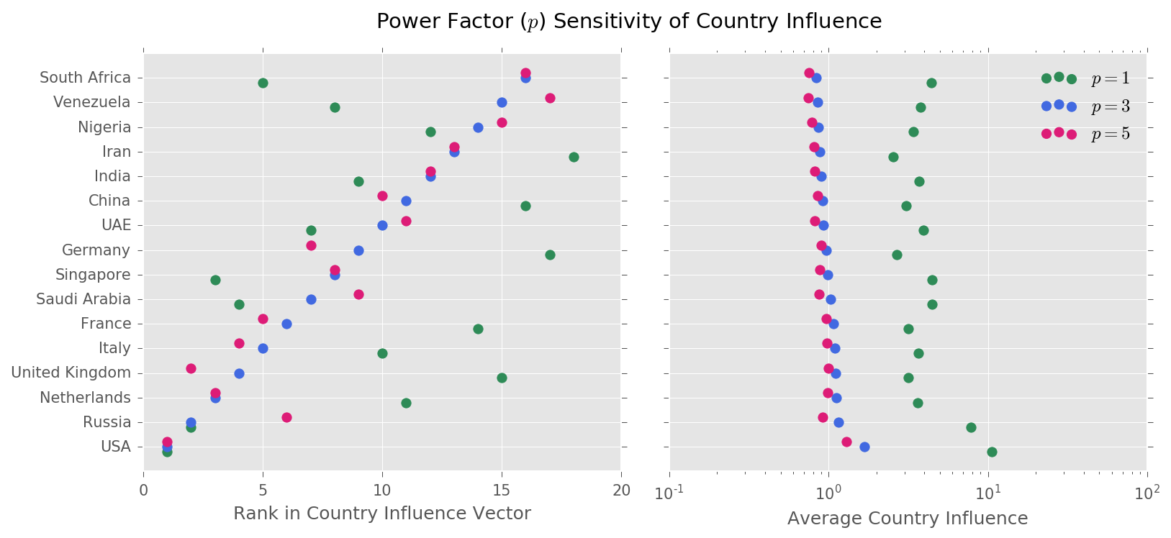

Figure ‎6‑7. Power factor (p) sensitivity of country influence. Left: Rank in country influence vector, Right: Average influence   
source: own work, data: normalized UN COMTRADE energy trade history, years: 1962-2015

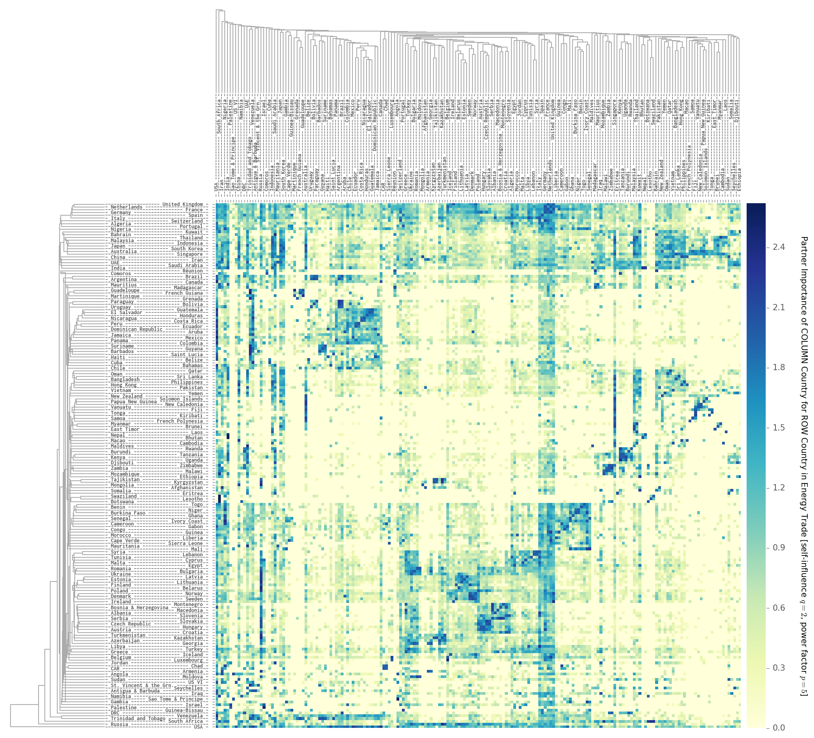

Figure ‎6‑8. Clustered country importance/influence matrix calculated for 189 countries with q=4 and p=5  
source: own work, data: UN COMTRADE, years: 1962-2014

## NETSET simulation results

### NETET parameter settings and key assumptions

Throughout the section, we will use the transition dynamics set of 6 representative countries to illustrate our findings, namely UAE, USA, UK, Germany, Argentina and China. However, the transition dynamics of all countries of the world (189) can be explored openly on the SETE web interface.

We simulated NETSET as per described in section ‎4.6.7 and summarized in section ‎4.6.9 to produce a coordinated set of sustainable energy transition paths for all countries, while keeping the global systemic goal of minimizing the total energy investment cost of the global transition as a whole always in sight.

As for parameters values on stage *F* in section ‎4.6.9, we demonstrate the outcomes of NETSET under two values of self-influence, q=4 and q=8. The power factor used in the simulations was p=3. This would qualify as an open trade (for q=4) world with an equitable power balance (both importers and exporters have influence).

Stage *G* parameters were set to: initial renewable energy installation (of each type) can be maximum 1% of total energy, once initialized, yearly growth rate is limited to maximum 50%.

At stage *H*, step *H1*, *ωmin* was set to 10% for the top two (out of 3) resources in the country (i.e. the two carrying the lowest trade costs). At steps *H2-H4*, the bid relaxation was done by distributing the available energy amount of the exporter amongst the bidders (to be importers) proportionally with their influence over the exporter country and hence only one tier was used. Bidding is set to continue until convergence with a 5% tolerance – i.e. until at least 95% of the demand of the importer is met. Plant and trade contract lifetimes were both set to a uniform random distribution around 30, with a range of ± 10 years.

On top of these conditions we also set a trade diversification constraint – as the weakest constraint – so the first to be violated if others were binding. Trade diversification was set such that at least 20% of all trade should come from a different sources than the other 80%.

### NETSET for the United Arab Emirates domestic net demand

First we present the beginning of trade cost vector for the UAE, calculated as per stage H and Equation ( ‎4‑22 ), highlighting the trade partners and the energy types to be traded, as well as the trade costs – the transaction cost, including the trade way, is already embedded in this trade cos. Bear in mind that the trade cost is changing year-to-year (in fact, step-to-step) as the in-country resource utilization and Wright-learning get updated.

Table ‎6‑4. Top of the trade cost vector of UAE in year 2015 for q=4, p=3

|  |  |  |  |  |
| --- | --- | --- | --- | --- |
| **Nr.** | **Country** | **Energy source** | **Tradeway** | **Trade cost** |
| **1** | UAE | solar photovoltaic | grid | 0.146 |
| **2** | Oman | solar photovoltaic | grid | 0.175 |
| **3** | Yemen | solar photovoltaic | grid | 0.190 |
| **4** | Pakistan | solar photovoltaic | ptl | 0.198 |
| **5** | Djibouti | solar photovoltaic | ptl | 0.217 |
| **6** | Qatar | solar photovoltaic | grid | 0.227 |
| **7** | Mauritania | solar photovoltaic | ptl | 0.229 |
| **8** | Kuwait | solar photovoltaic | grid | 0.237 |
| **9** | Iraq | solar photovoltaic | grid | 0.248 |
| **10** | Saudi Arabia | solar photovoltaic | grid | 0.271 |
| … | | | | |
| **25** | UAE | solar thermal | grid | 0.376 |
| … | | | | |
| **28** | Mauritania | wind | ptl | 0.415 |

Therefore, based on Table ‎6‑4, we would expect to see the UAE expanding its own solar photovoltaic capacity, followed by trading photovoltaic energy over the grid with Oman, Yemen and import liquids from Pakistan. Since the tradeable energy amounts from Djibouti and Mauritania (at least in the early days of the transition) are expected to be small, in order to meet the trade diversification requirements, we would also expect to see the UAE importing electricity over the gird with the rest of the GCC countries, Qatar, Saudi Arabia, Kuwait and Iraq.

In order to meet the in-country diversification constraint (at least 10% share in net energy for the top two resources), we also expect to see solar thermal energy capacity expanded, but only to the extent to meet the minimum requirement (since it is only the 25th best option in the trade cost vector).

Since the UAE will phase-out liquid fuels (oil and gas) fully around 2060 and their share is set drop below the minimum liquid fuel share of 14.6% (from Figure ‎4‑11) for the country, we would expect to see power-to-liquid imports and production grow from 2050 onwards until it hits the minimum share. Part of this power-to-liquid demand would be inherently fulfilled by the imports from Pakistan, but the rest would have be to produced. Therefore, a fraction of domestic solar power generation (both PV and CSP), as a well as a fraction of grid electricity imports will be diverted towards liquids production.

Finally, please disregard the pre-2012 oil exports data, as the COMTRADE database is patchy for these data points. However, we have decided to include the data points for the 2000-2015 period as a scale reference for the magnitude of the transition.

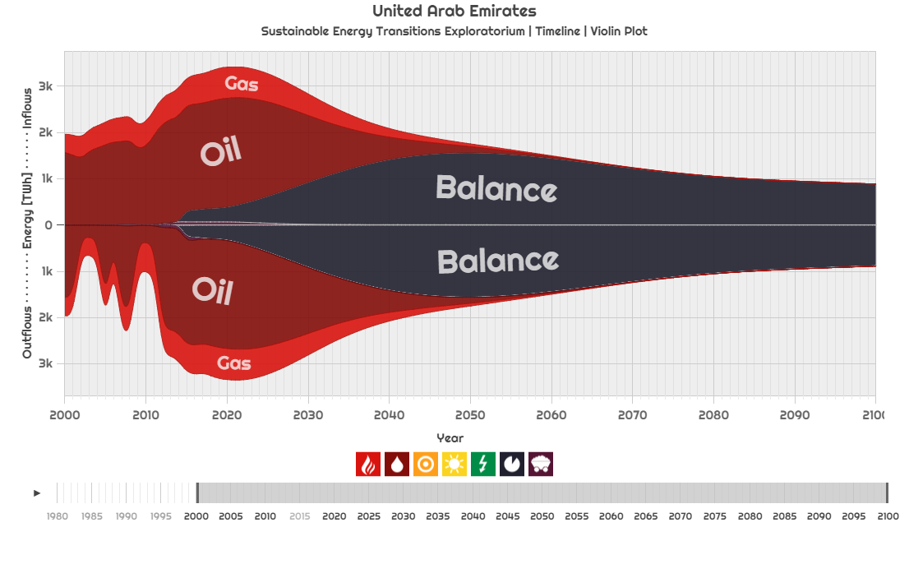

Figure ‎6‑9. UAE NETSET dynamics. Showing net energy balance to be fulfilled by renewable sources (without exports)  
source: own work for SETE, years: 2000-2100

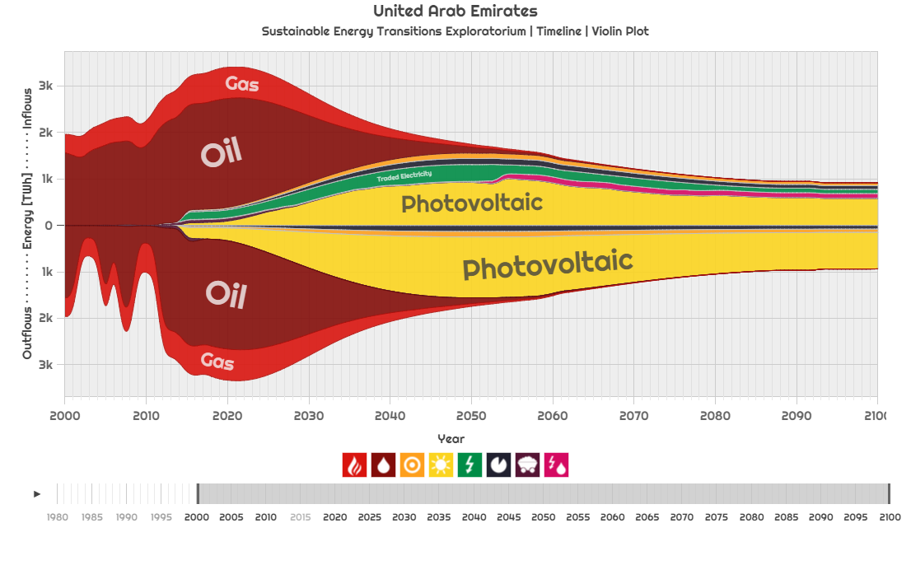

Figure ‎6‑10. UAE NETSET dynamics. Showing net energy balance filled by various renewable sources (without exports)  
source: own work for SETE, years: 2000-2100

Figure ‎6‑9 shows the UAE outstanding net energy balance, while Figure ‎6‑10 shows the energy transition of the country after executing the NETSET algorithm. We must mention that these graphs only refer to fulfilling domestic demand without exports. As postulated, the country relies mostly on domestically produced photovoltaic power, while fulfilling the transition constraints outlined in the previous paragraph.

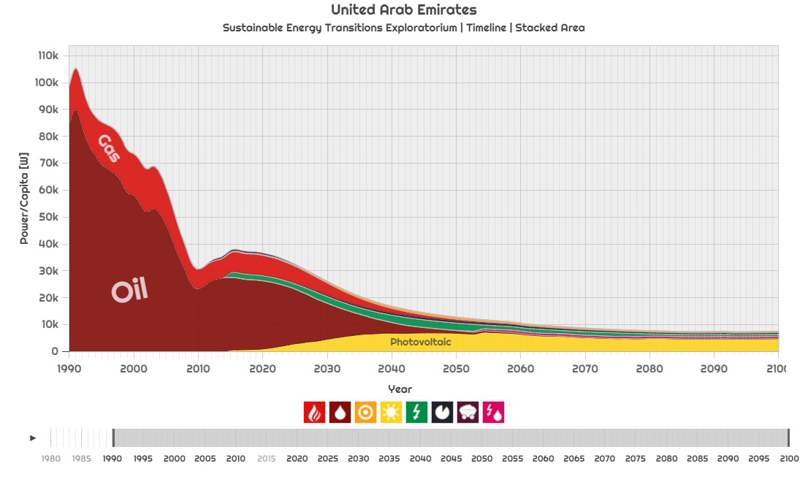

Figure ‎6‑11. UAE NETSET dynamics. Per capita average power demand in the UAE (without exports).   
The initially extremely high (100kW/capita in 1990, 38kW/capita in 2015) values diminish to 7.5kW/capita by 2100.  
source: own work for SETE, years: 1990-2100

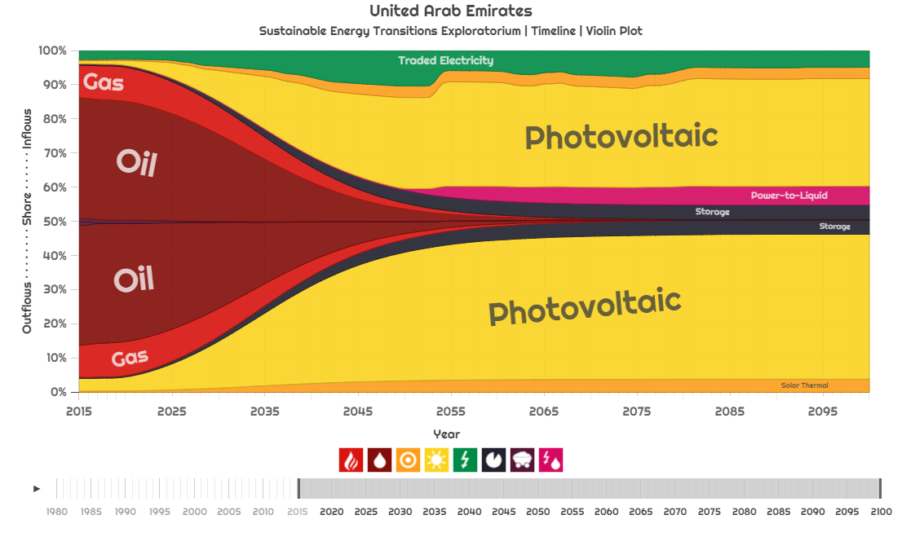

Figure ‎6‑12. UAE NETSET dynamics. Percentage breakdown of energy mix over time (without exports)  
source: own work for SETE, years: 2015-2100

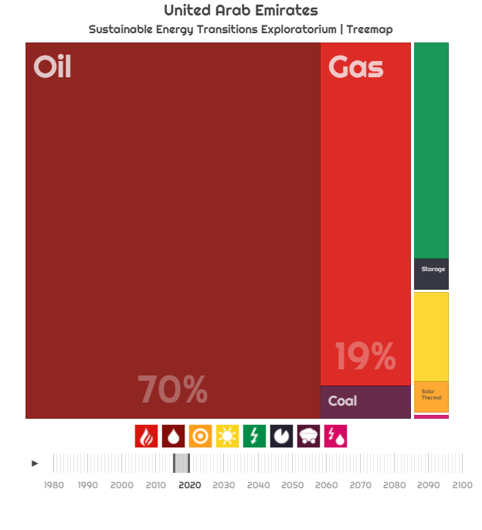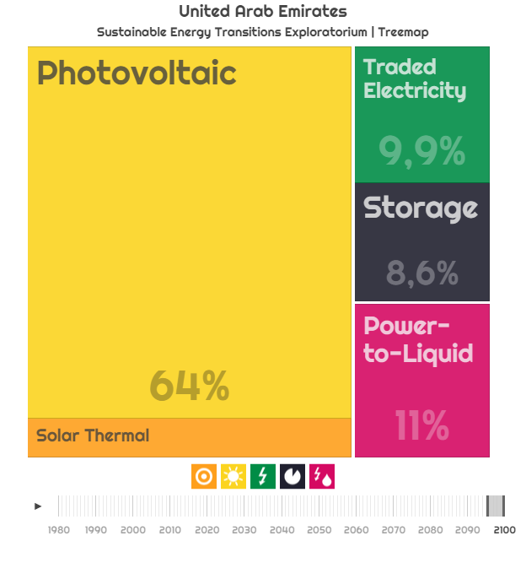

Figure ‎6‑13. UAE NETSET dynamics. Percentage breakdown of energy mix, average values for  
 2015-2020 (Left) and 2095-2100 (Right), source: own work for SETE, years: 2015-2020 and 2095-2100

In terms of the composition of the energy mix (Figure ‎6‑12 and Figure ‎6‑13), the UAE transitions from an oil (70%) and gas (19%) energy (in 2015-2020) to solar power-driven one (64% PV and 6.7% CSP in 2095-2100). Energy trade also starts to play an important role, traded electricity and power-to-liquids make up another 20% of the energy generation, with storage (needed to safely operate the large solar fraction) completing the rest. In terms of primary energy (before trade, the outflow breakdown on Figure ‎6‑12), solar power accounts for 91.6%, with the rest coming from storage (technically, also operated by solar power).

It is important to notice the sudden reduction in traded electricity in year 2053. Let us look at the composition of electricity imports, plotted on Figure ‎6‑14. This the time when the trade contracts expire and imported electricity lower down in the trade cost vector is replaced by: domestically produced solar power (1st in the cost vector) and more and more imports from Oman and Yemen (2nd and 3rd) – as the countries extends their capacity over time and hence they are able to trade more energy. Meanwhile, based on Equation ( ‎4‑16 ), they lower their production cost through learning as well and as Oman extends its production, it distances itself from Yemen and steals away its share in the Imports (Figure ‎6‑14).

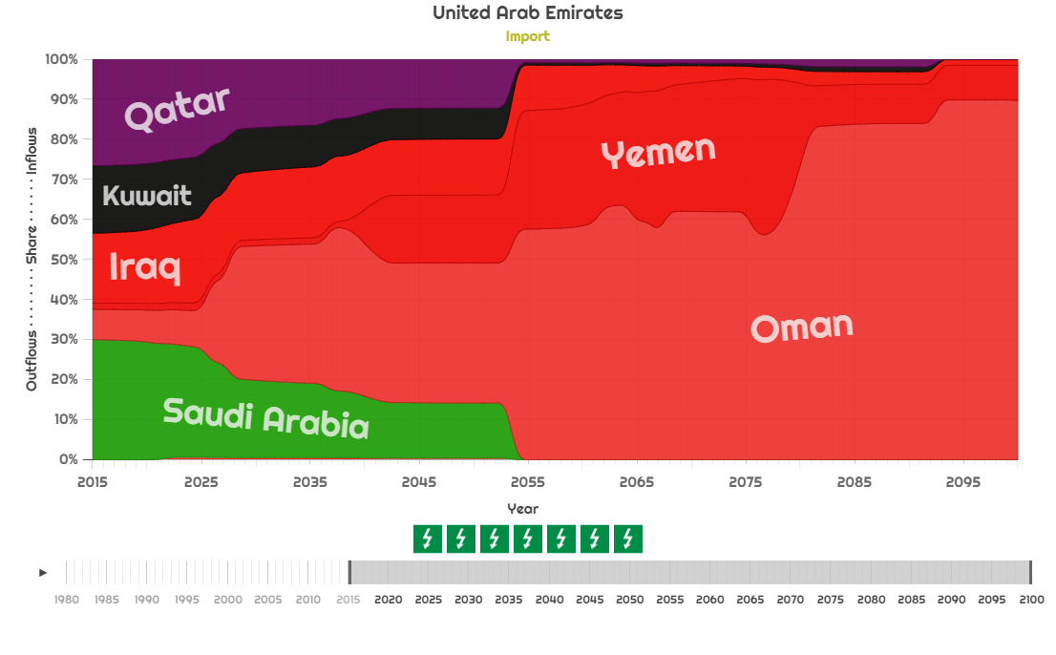

Figure ‎6‑14. UAE NETSET dynamics. Electricity imports over the grid  
source: own work for SETE, years: 2015-2100

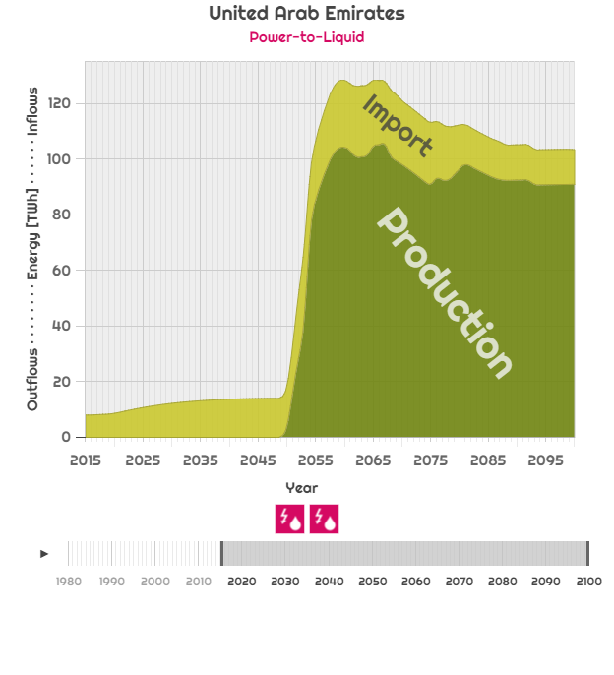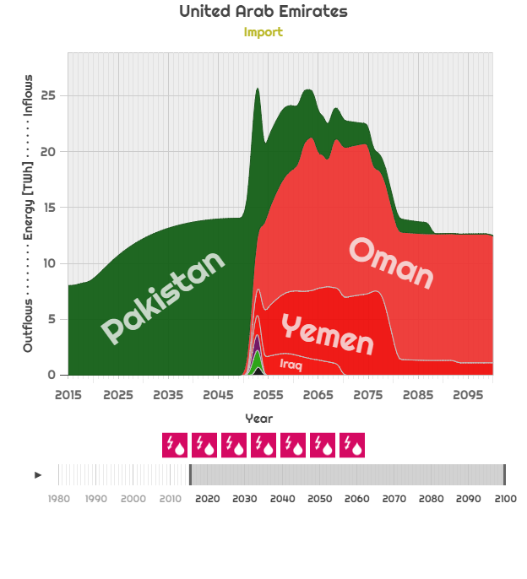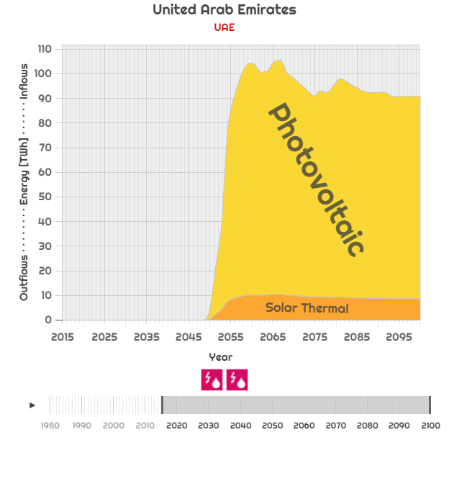

Figure ‎6‑15. UAE NETSET dynamics. Power-to-liquids (Left)   
Imports (center) and Production (Right) breakdown by source country, source: own work for SETE, years: 2015-2100

When looking at the PTL trade (Figure ‎6‑15), we can indeed see that before the constraint becomes binding – around 2049 – the only PTL energy present is imported and it is from Pakistan, based on the cost vector. Afterwards, a portion of the local solar power generation is diverted towards producing liquids, necessary for the economy in this form. As the country energy demand slowly shrinks over time, PTL trade with Pakistan (only 4th in trade cost vector) is phased out in favor of producing liquids from imported electricity over the grid from Oman and Yemen (2nd and 3rd in the cost vector).

### NETSET for the United States domestic net demand

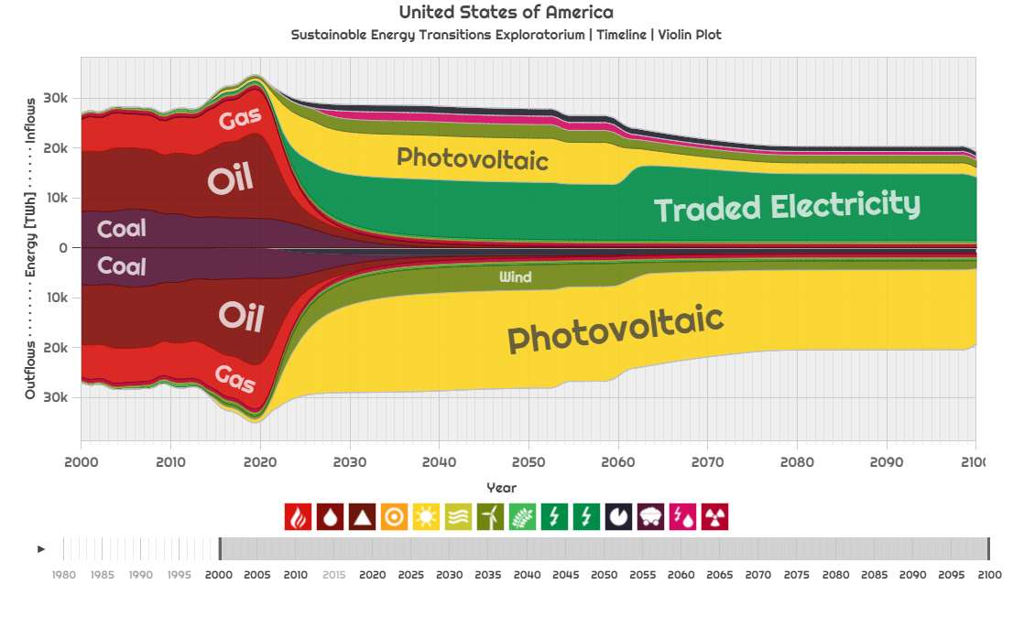

Figure ‎6‑16. USA NETSET dynamics. Showing net energy balance filled by various renewable sources (without exports)  
source: own work for SETE, years: 2000-2100

Under trade rules q=4 and p=3, the United States will have a balanced energy transition (Figure ‎6‑16). Initially it expands both the domestic photovoltaic and wind generation significantly, until 2060, when the expiration of the lifetime of older plants and a drop of demand leads to phasing out a few solar plants in favor of imported electricity – from Mexico carrying a lower cost (as per Table ‎6‑5). Now, we have also included the total tradeable resources for the plotted year (2015) in the last column of the table. As we can see we can expect that initially more of the imports will be coming from Canada, but as Mexico builds up its resources, it will be the preferred import source over Canada and even over domestic production, one the lifetime of the existing plants runs out. (Figure ‎6‑17).

Table ‎6‑5. Top of the trade cost vector of USA in year 2015 for q=4, p=3

|  |  |  |  |  |  |
| --- | --- | --- | --- | --- | --- |
| **Nr.** | **Country** | **Energy source** | **Tradeway** | **Trade cost** | **Tradeable [TWh]** |
| **1** | Mexico | solar photovoltaic | grid | 0.117 | 23 |
| **2** | Jamaica | solar photovoltaic | grid | 0.169 | <1 |
| **3** | USA | solar photovoltaic | grid | 0.181 | 227 |
| **4** | Canada | wind | ptl | 0.191 | 51 |
| **5** | Guatemala | solar photovoltaic | grid | 0.209 | <1 |
| **6** | Aruba | solar photovoltaic | ptl | 0.221 | <1 |
| **7** | El Salvador | solar photovoltaic | ptl | 0.222 | <1 |
| **8** | Haiti | solar photovoltaic | ptl | 0.222 | <1 |
| **9** | Chile | solar photovoltaic | grid | 0.223 | <1 |
| **10** | Bahamas | solar photovoltaic | ptl | 0.236 | <1 |
| … | | | | |  |
| **15** | USA | wind | grid | 0.263 | 275 |

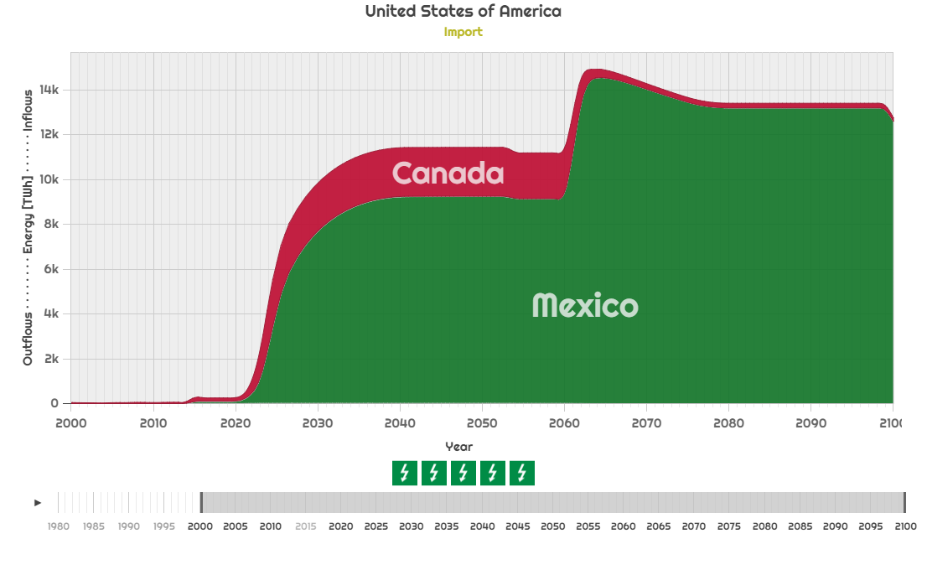

Figure ‎6‑17. USA NETSET dynamics. Breakdown of grid electricity imports, source: own work for SETE, years: 2000-2100

However, let us change the rules governing trade to q=1, p=5, creating a more open world, with higher importer-exporter influence balance. The trade cost vector changes accordingly, with domestic production relegated to the 49th (PV) and 87th (wind) ranks. Under these circumstances it is preferred that all of energy is imported from Mexico, carrying much lower costs (Table ‎6‑6). However, due to the in-country capacity extension limits imposed on countries, this is initially (at the peak of the transition, when fossil phase-out is already aggressive, but renewable growth is still quite limited by the year-to-year growth rate) not possible, therefore we see a growth in PTL imports to the US, from all over the world (Figure ‎6‑18, Figure ‎6‑19). As the Mexican capacity expands and the trade contracts expire, these are gradually phased out during the 2050s.

Table ‎6‑6. Top of the trade cost vector of USA in year 2015 for q=1, p=5

|  |  |  |  |  |  |
| --- | --- | --- | --- | --- | --- |
| **Nr.** | **Country** | **Energy source** | **Tradeway** | **Trade cost** | **Tradeable [TWh]** |
| **1** | Mexico | solar photovoltaic | grid | 0.117 | 23 |
| **2** | Jamaica | solar photovoltaic | grid | 0.169 | <1 |
| **3** | Chile | solar photovoltaic | grid | 0.181 | <1 |
| **4** | Canada | wind | ptl | 0.191 | 51 |
| **5** | El Salvador | solar photovoltaic | grid | 0.209 | <1 |
| **6** | Guatemala | solar photovoltaic | ptl | 0.221 | <1 |
| **7** | Haiti | solar photovoltaic | ptl | 0.222 | <1 |
| **8** | Aruba | solar photovoltaic | ptl | 0.222 | <1 |
| **9** | Bahamas | solar photovoltaic | grid | 0.223 | <1 |
| **10** | Honduras | solar photovoltaic | ptl | 0.236 | <1 |
| … | | | | |  |
| **49** | USA | solar photovoltaic | grid | 0.726 | 227 |
| **87** | USA | wind | grid | 1.055 | 275 |

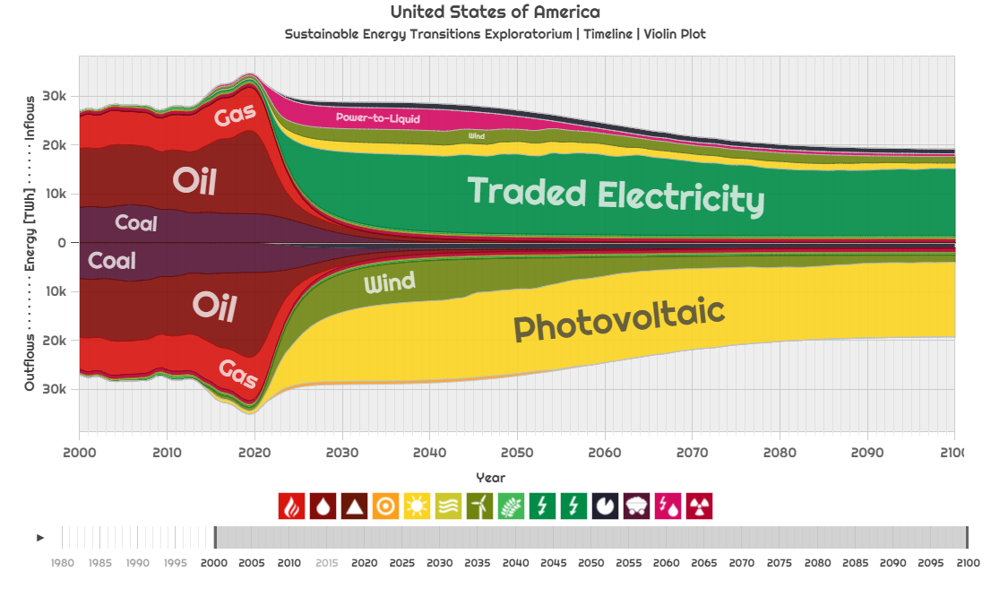

Figure ‎6‑18. USA NETSET dynamics. Showing net energy balance filled by various renewable sources (without exports) for alternative trade governing rules (q=1, p=5), source: own work for SETE, years: 2000-2100

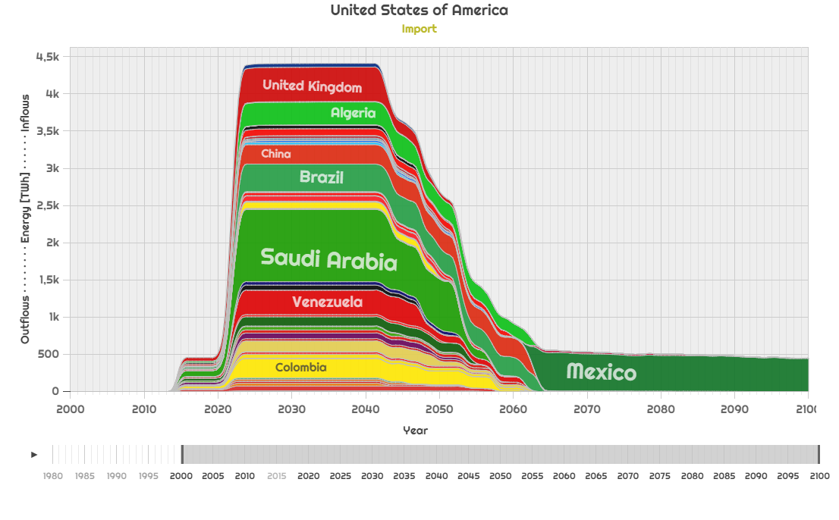

Figure ‎6‑19. USA NETSET dynamics. Breakdown of PTL imports during the peak transition period triggered to offset growth limitation in easily accessible countries, for alternative trade governing rules, source: own work for SETE, years: 2000-2100

### NETSET for the United Arab Emirates total net demand

After incorporating energy exports into the transition dynamics, Figure ‎6‑10 changes to Figure ‎6‑20. We can see that the energy generation grew because of the additional demand for exports that needs to be covered.

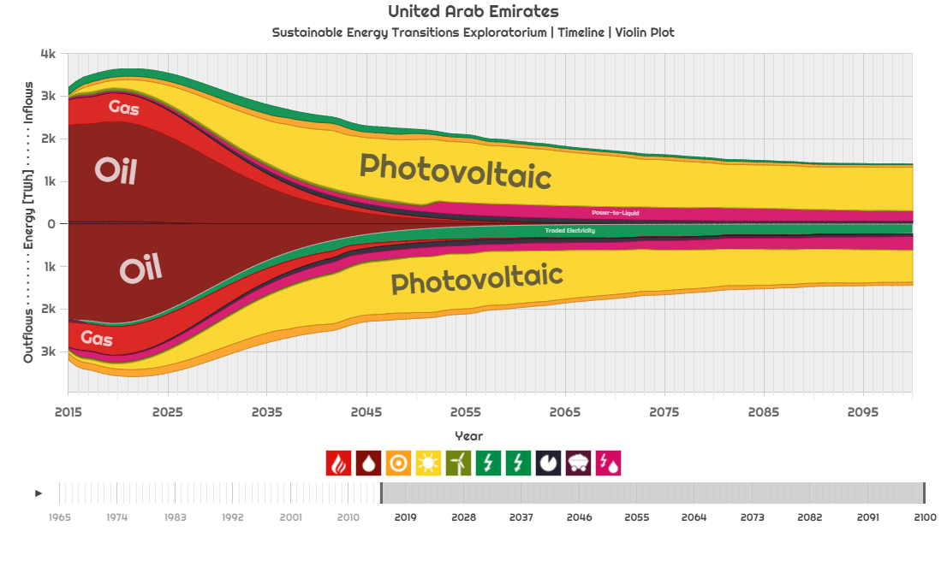

Figure ‎6‑20. UAE NETSET dynamics (including exports)   
source: own work for SETE, years: 2015-2100

Exports from the UAE come in form of both traded electricity as well as power-to-liquids. Their supplied is secured by additional photovoltaic capacity. In 2100, exported electricity accounts for 16% of all energy outflows, while power-to-liquids account for 23%. Electricity is mostly exported from the UAE to the other Gulf countries (Figure ‎6‑21), while liquids are delivered to a diverse clientele (Figure ‎6‑22).

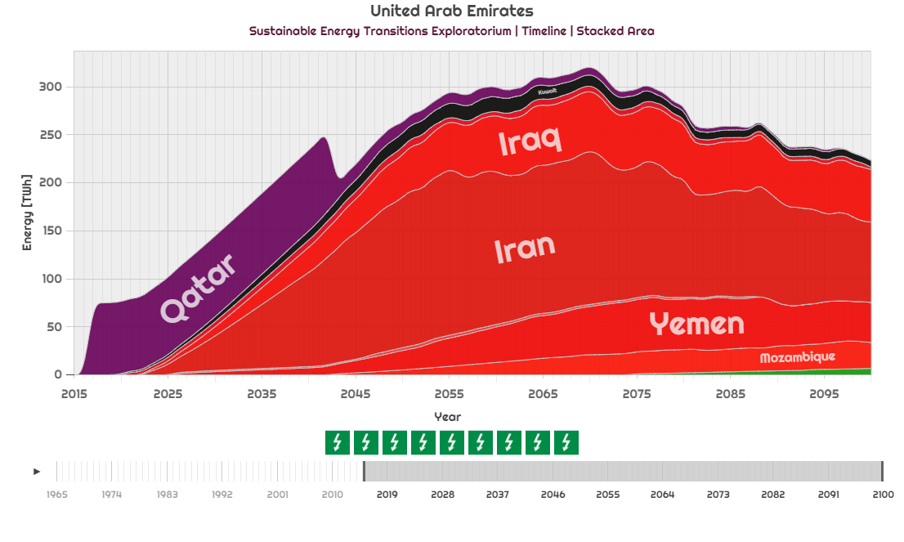

Figure ‎6‑21. UAE NETSET dynamics. Electricity exports through the grid  
source: own work for SETE, years: 2015-2100

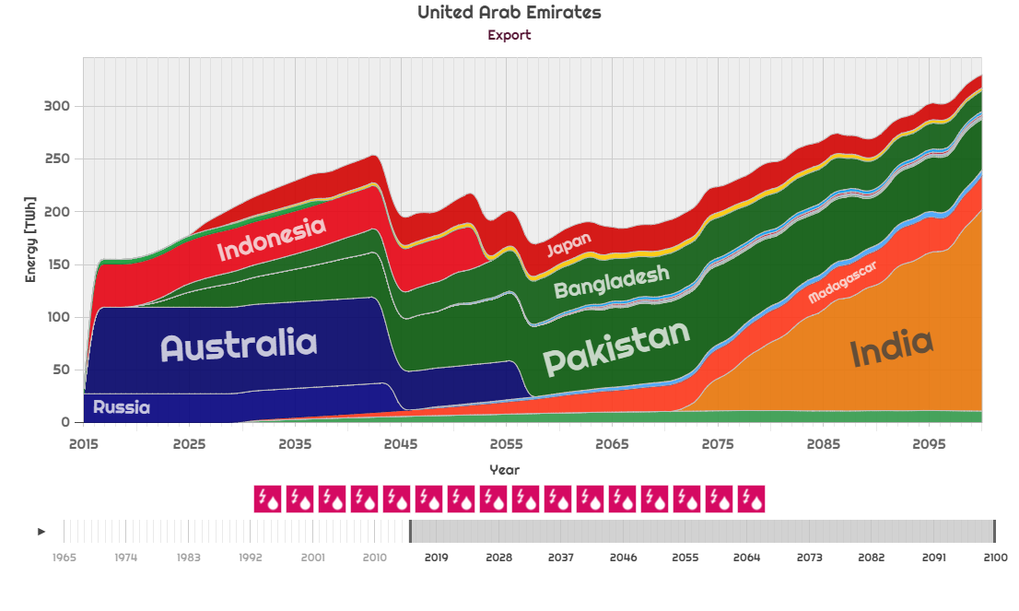

Figure ‎6‑22. UAE NETSET dynamics. Power-to-liquid exports  
source: own work for SETE, years: 2015-2100

### NETSET for the United States total net demand

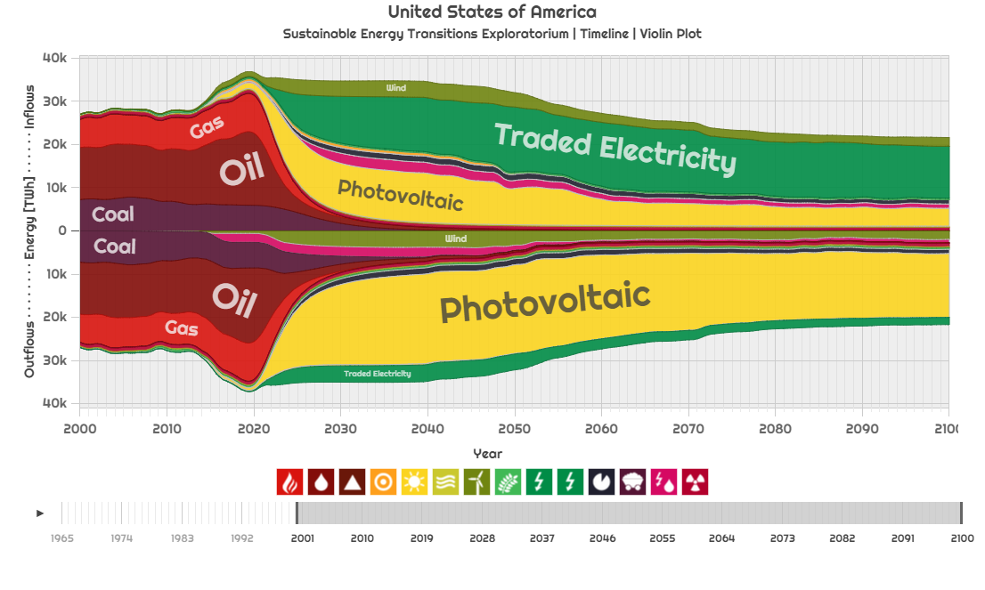

Figure ‎6‑23. USA NETSET dynamics (including exports)   
source: own work for SETE, years: 2000-2100

Figure ‎6‑23 presents the net energy transition for the United States after including energy exports. The US does not export a lot of energy under NETSET – 7.6% traded electricity of all energy outflows in 2100, plus an additional 3.7% PTL – and its trade it’s mostly confined to other member of the North American power grid connections, Mexico and Canada. In the model, currently there is dual-trading: that is Mexico exports solar power to the US, but it also imports (albeit much less). These flows could be relaxed (as described in step *H7* of section ‎4.6.9), however, they were kept explicit in order to demonstrate the functionings of the NETSET model, and they might as well as reflect reality.

The PTL exports of the US are sent mostly to Indonesia, Australia and Colombia during the early transition phase due to the easier capacity ramp-up in the US given the relatively large existing renewable energy generation quantities.

### NETSET for the United Kingdom total net demand

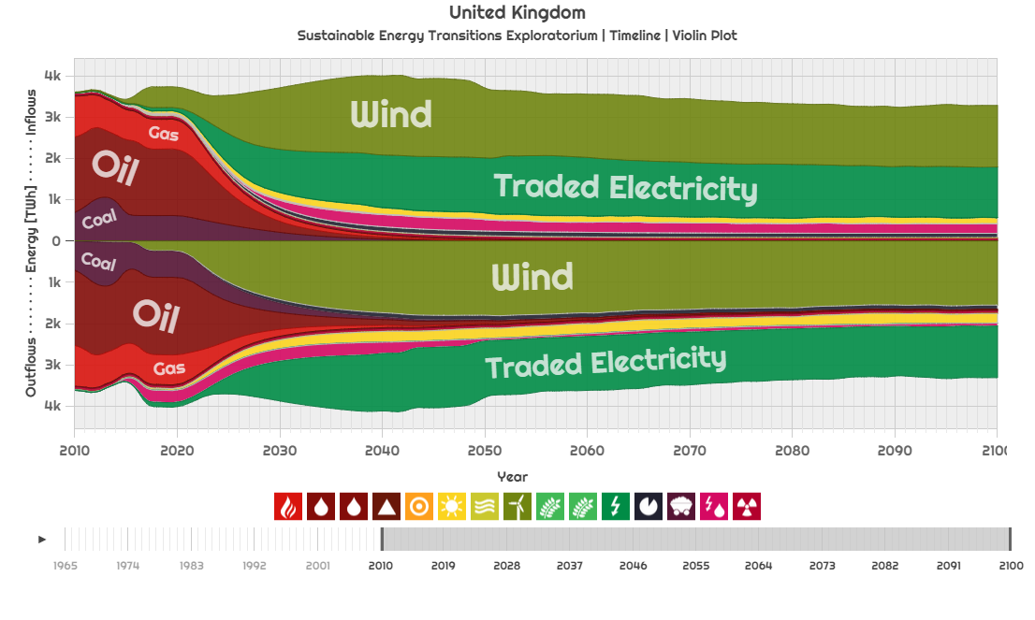

Figure ‎6‑24. United Kingdom NETSET dynamics (including exports)   
source: own work for SETE, years: 2010-2100

Figure ‎6‑24 presents the total net energy transition for the United Kingdom after including energy exports. UK is essentially an energy transit country, using its high country influence to import the re-export large quantities of wind electricity from Ireland – next to generating its own wind power in even larger quantities. The wind power is the sent through the European grid to France, Germany and the Netherlands. Because of the diversification constraint, the UK also generates solar photovoltaic energy. Just like the United States, the UK also exports PTL during, especially during the early transition phase, to Australia, Indonesia, US and Israel. These imports later shift towards serving Canada consistently.

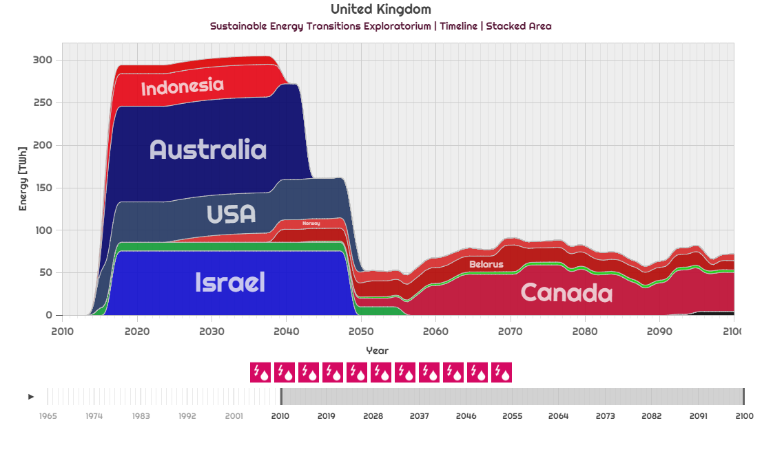

Figure ‎6‑25. United Kingdom NETSET dynamics. Power-to-liquid exports  
source: own work for SETE, years: 2010-2100

### NETSET for China total net demand

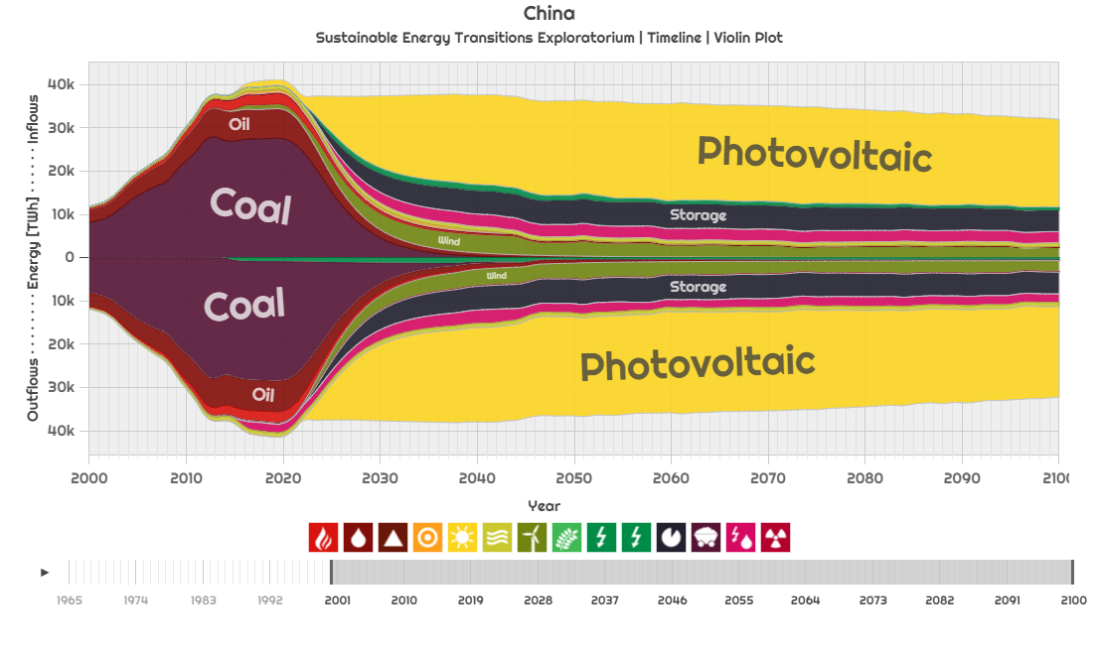

Figure ‎6‑26. China NETSET dynamics (including exports)   
source: own work for SETE, years: 2000-2100

Figure ‎6‑26 presents the net energy transition for China after including energy exports. China is remarkably autonomous, despite being 11th in country influence vector (Table ‎6‑1). 65% of energy need in 2100 is domestically produced photovoltaic power and 7% wind electricity. A minimal amount of electricity is imported through the grid from Vietnam, Mongolia and Myanmar, to meet the trade diversification criterion. Between 2015 and 2050, the country exports PV, CSP and wind power as well, to Russia, over the grid. Despite its size, China has only a limited number of grid partners (Myanmar, Laos, Vietnam, Mongolia and Russia – alongside Macao and Hong Kong), therefore most of its imported energy has to come through PTL – generated from solar photovoltaic power from Oman, Yemen, the Philippines and Sudan. To meet the liquids constraint, a significant amount (2TWh /year) of PV power is dedicated to PTL production.

### NETSET for Argentina total net demand

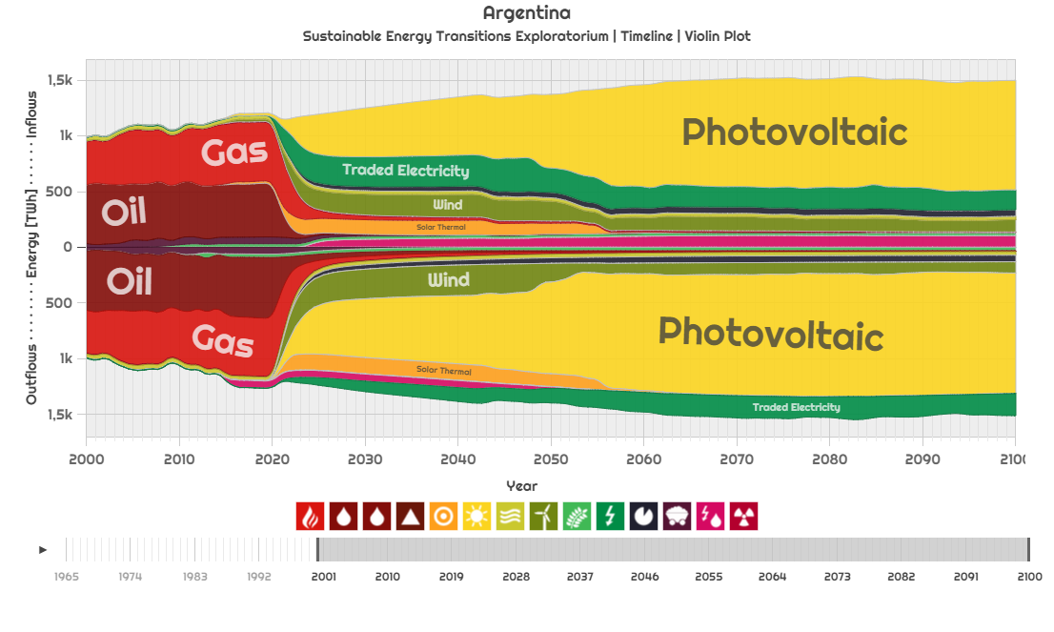

Figure ‎6‑27. Argentina NETSET dynamics (including exports)   
source: own work for SETE, years: 2000-2100

Figure ‎6‑27 presents the net energy transition for Argentina after including energy exports. The main source of are solar panels, but a large until the photovoltaic generation capacity gets built up, CSP and wind power are also deployed in significant quantities (15% wind and 10% CSP share in 2030). The additional energy required to offset the retracting fossil fuels in the early transition period is secured through grid trade (Figure ‎6‑28), PV and wind from Brazil, and through all three renewable energy sources from Bolivia and Chile.

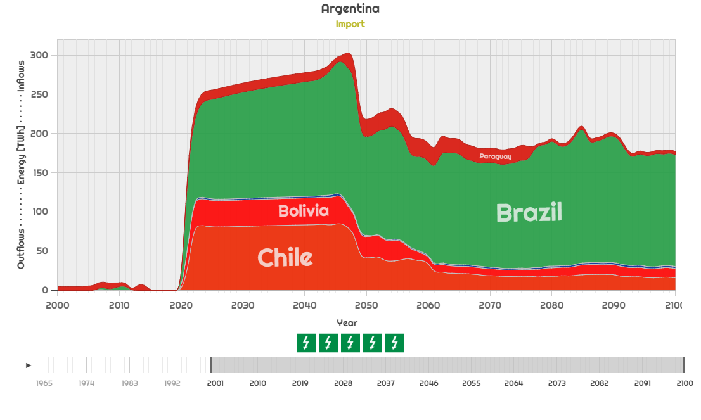

Figure ‎6‑28. Argentina NETSET dynamics. Electricity imports through grid.  
source: own work for SETE, years: 2000-2100

### NETSET for Germany total net demand

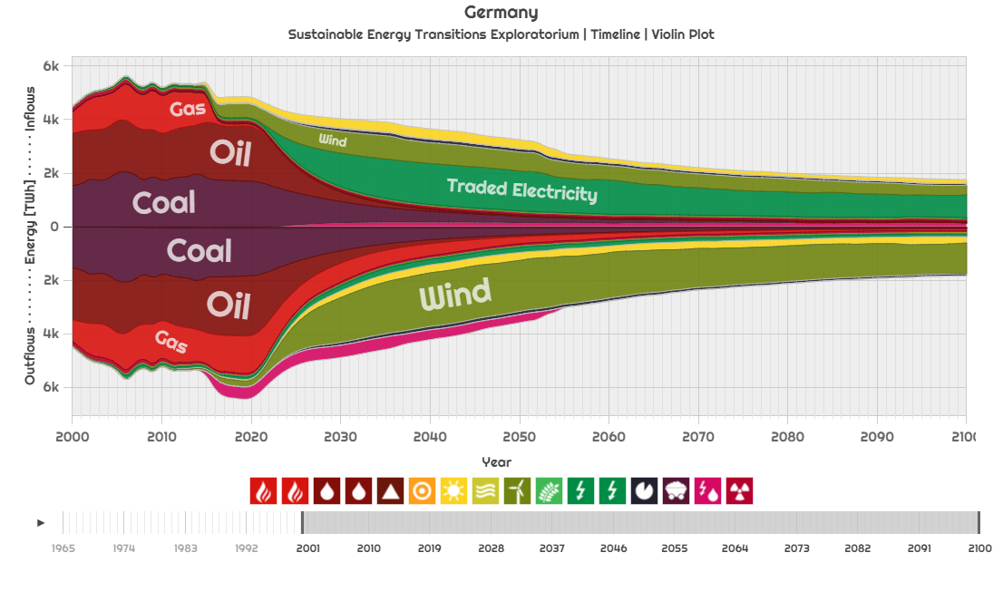

Figure ‎6‑29. Germany NETSET dynamics (including exports)   
source: own work for SETE, years: 2000-2100

Figure ‎6‑29 presents the net energy transition for Germany after including energy exports. The main source of electricity is wind, although in 2100, taking advantage of the European grid, only one third of it is domestically produced. The rest is imported from the Netherlands and the United Kingdom. Some domestically produced wind power is also exported, in small quantities to Czech Republic, Austria, France, Poland, Switzerland and Belgium. Between 2015 and 255, the country also exports energy in the form of PTL, mainly to Australia, Indonesia and South Africa.

## Comparing the NETSET results with global SET

#### Comparison with global SET

The global SET takes a top-down approach to determine the global renewable energy stocks and their corresponding rates necessary to offset a fossil-fuel phase-out. After executing the NETSET algorithm, however, it is possible to reconstruct the global paths by summarizing the energy generation dynamics over all countries. The results (Figure ‎6‑30) are remarkable similar to the global transition depicted in Figure ‎5‑1a.

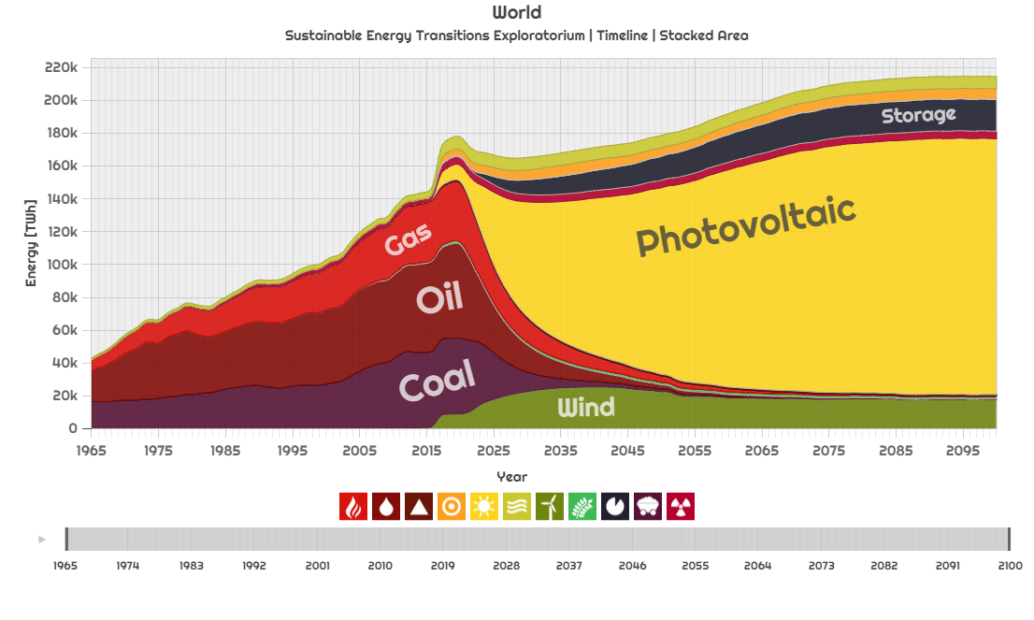

Figure ‎6‑30. Global SET net primary energy demand path reconstructed bottom-up from NETSET country paths.   
source: own work for SETE, years: 1965-2100

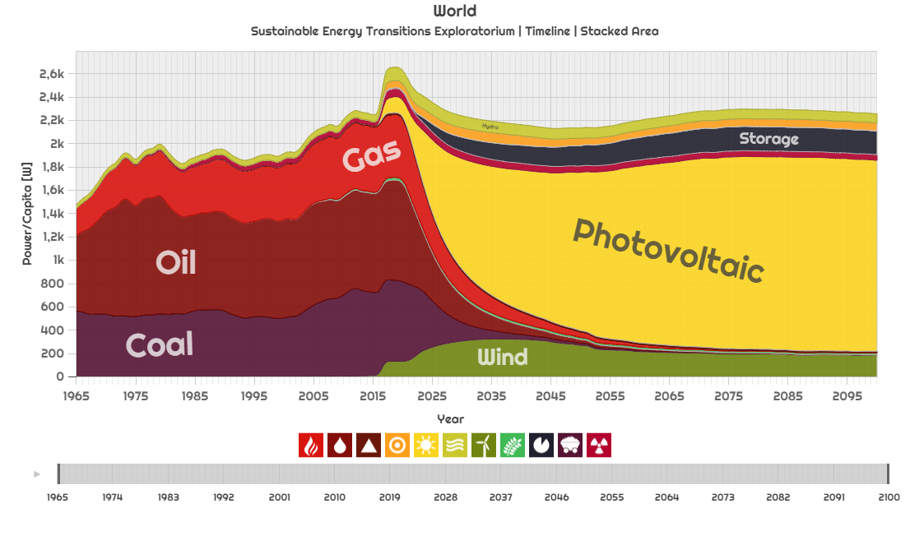

Figure ‎6‑31. Global SET net primary per capita power demand path reconstructed bottom-up from NETSET country paths.   
source: own work for SETE, years: 1965-2100

The fossil phase-out is coinciding with the global SET phase-out curves. The total demand is lower than the global values because not every country (only 189 – most notably Taiwan, North Korea are missing) is included in NETSET and the demand transition trajectory is different. The most important difference comes, however from the fact that we are adjusting for primary to secondary demand (see section ‎4.6.2), which effectively reduces the total demand (even if there are additional conversion losses in trade). In terms of net per capita power, NETSET reaches to 2300 W/person by 2100 (Figure ‎6‑31).

The most significant difference however, is that under NETSET, solar photovoltaics have a larger share in the energy mix than in the global SET, mostly stealing this away from CSP, while wind power is roughly halved. This suggests that for global SET we used a suboptimal relative renewable resource share evolution (in section ‎4.6.4.5) as more photovoltaic capacity would be deployed if countries are allowed to trade with each other.

Another important aspect is that because of the decreased demand and substituting primary energy with secondary energy directly, the energy investment (the “hump” at the peak of the transition) is lower in NETSET (Figure ‎6‑32) than in the Global SET. Because of the more efficient site utilization (effective increase of EROEI), the cumulative energy investment of the transition decreases from 701 TWh to 308 TWh (-56%).

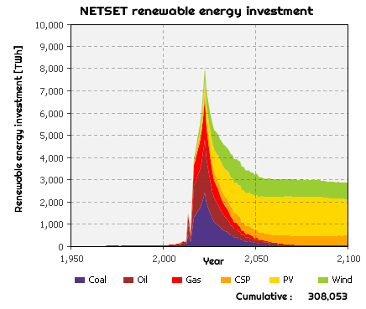 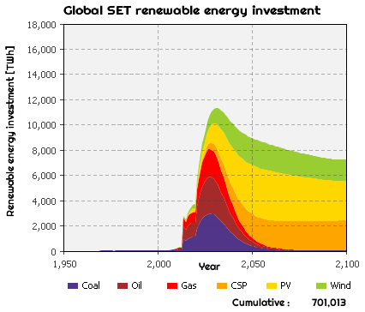

Figure ‎6‑32. NETSET (Left) and Global SET (Right) renewable energy investment.   
source: own work for SETE, years: 1950-2100

#### Comparison with DDPP

The Deep Decarbonization Pathways Project (DDPP) (2015b) is a multi-country scientific project to achieve the decarbonization of economies. 16 countries of the world are investigated by resident scientist teams (10-50) in each location, based on a set of common, coordinated scenarios broken down into economic sectors, using the GCAM integrated assessment model. In this section we briefly compare the NETSET results with DDPP. Unless otherwise mentioned we use the early fossil phase-out, medium carbon cap numbers and the *highest renewables* scenario from DDPP.

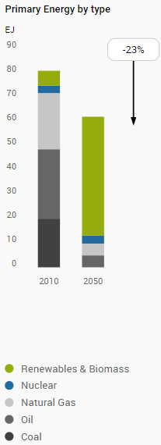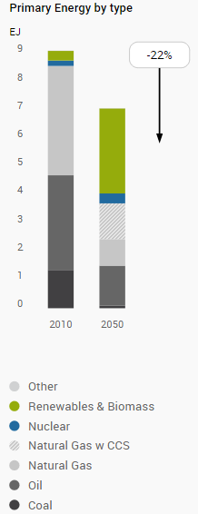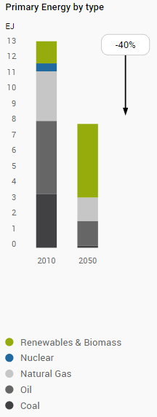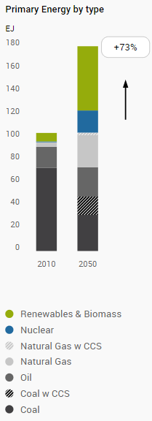

Figure ‎6‑33. Deep Decarbonization Pathway for the US (Left) Germany (Left Center), United Kingdom (Right Center) and China (Right), primary energy, highest renewables scenario, source: 2015 DDPP country reports, years: 2010, 2050

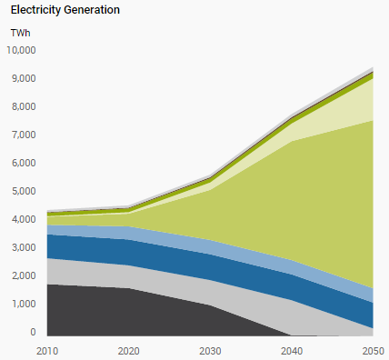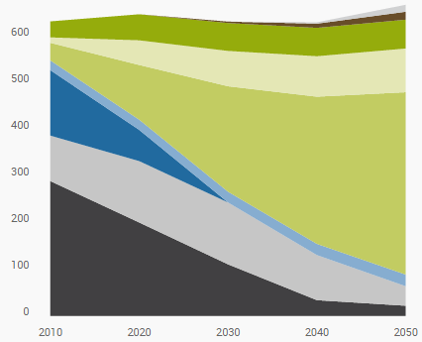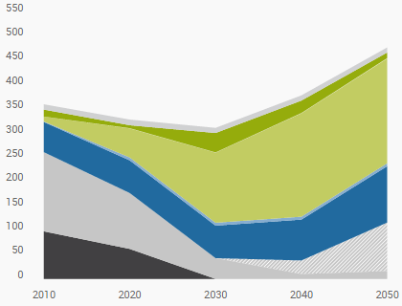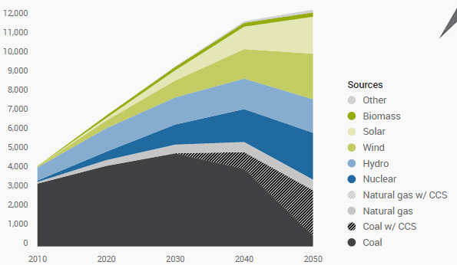

Figure ‎6‑34. Deep Decarbonization Pathway for the US (Left) Germany (Left Center), United Kingdom (Right Center) and China (Right), electricity, highest renewables scenario, source: 2015 DDPP country reports, years: 2010, 2050

Figure ‎6‑33 presents the Decarbonization pathways of the US, Germany, UK and China, as primary energy breakdowns in 2010 and 2050, while Figure ‎6‑34 presents the power generation mixes. Let us compare these results with the NETSET output. Under DDPP, the US primary energy supply in 2050 will be 78.9% renewables and biomass (mostly wind), 5.3% nuclear, 7.9% natural gas and 7.9% oil. From Figure ‎6‑23, we can see that under NETSET (Figure ‎6‑35 Left), after trade, by 2050, coal and gas must be almost completely phased-out (0%), almost oil as well (1.4%), nuclear power will account for 3.0%, wind will provide 15% of primary energy, and 77% will come from photovoltaics, and 1% from solar thermal and 1.3% from bioenergy. We must point out that while the trade priorities might change based on global trade rules (values of *p* and *q*), the energy sources themselves would not. While our results match the DDPP findings quite well (94.3% renewables and biomass in NETSET vs. 78.9% in DDPP), we must highlight a key difference when compared to the DDPP results: photovoltaic share must be much higher and this has to come earlier on, replacing natural gas and oil at a much faster pace (using a production-based emissions distribution scheme, as discussed in section ‎4.6.3.2) in order to fit into the global carbon cap.

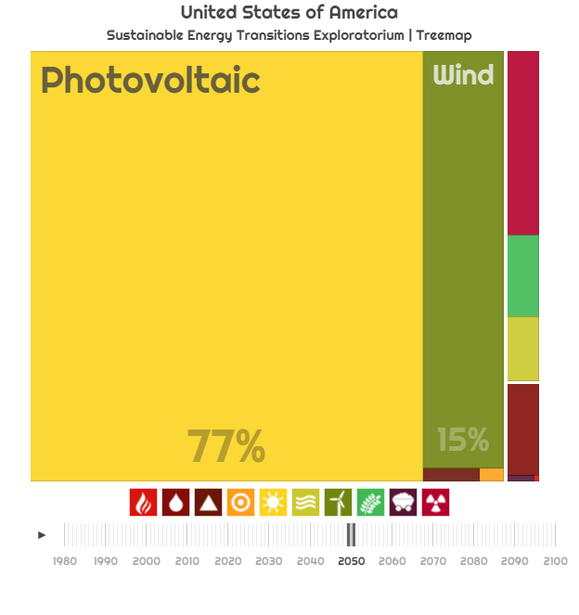 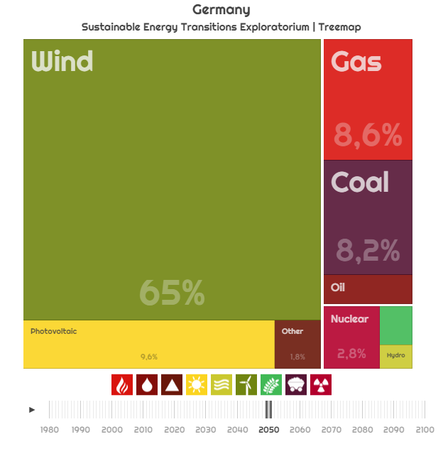

Figure ‎6‑35. Breakdown of primary energy consumption, after accounting for trade and storage.   
US (Left), Germany (Right), source: own work for SETE, year: 2050

When looking at the European and Chinese DDPP results, surprisingly we see lower renewable deployment. Germany’s primary energy demand will be fulfilled by renewables and biomass to a share of 59.4% (75% wind, 15% solar, 10% biomass and geothermal), while natural gas will stay at 19%, oil at 20.1%, coal at 1.5%. In NETSET (Figure ‎6‑35 Right), the results obtained are very similar, in 2050 the German energy demand will be fulfilled in 65% by wind, 9.6% by photovoltaics, 1% biomass, 8.6% natural gas, 2.0% oil and 8.2% coal. However, we must mention that about 40% of the wind energy is generated domestically and 60% is traded with the Netherlands, United Kingdom and Denmark.

The United Kingdom and China DDPP reports do not feature a fully renewable (i.e. one *without* CCS) scenario, yet we will show the results for comparison with NETSET. The UK will receive 42.5% of its energy from renewables and nuclear in 2050, almost exclusively in the form of wind. Oil will still account for 20%, coal for 1.3%, nuclear power for 5% and natural gas for 31.2% (20% with CCS). Under NETSET (Figure ‎6‑36 Left), we have a more aggressive transition, phasing out oil and natural gas in the 2030s. By 2050 the primary energy mix will be contain 80% wind, 11% PV, 2.9% nuclear power, 3.1% oil, 1% natural gas, and 0.6% coal. Heavy reliance on wind power is a common theme for the case of the UK both under DDPP and NETSET, however, in order to make the binding GHG emissions constraint imposed on countries in NETSET, the UK must start phasing fossil fuels earlier.

The DDPP report on China forecasts an energy increase for the country and 31.4% renewables and biomass share by 2050. 10.8% will be nuclear power’s share, oil 14.4%, 26.5% coal (8.9% with CCS), and 16.9% (1.3% with CCS). Solar power and wind energy and hydropower will contribute to the renewable share almost equally. In NETSET (Figure ‎6‑36 Right), China undergoes a heavy decarbonization through photovoltaics and in 2050 its primary energy will provided in 83% by solar power. Another 10% will be provided by wind, with hydropower accounting for 3.5% and nuclear for 0.5%. Oil is almost fully phased out, at 1.4%, and so is natural gas, with 0.7%. Coal has 0.1% remaining. For the case of China, a binding GHG emission constraint clearly makes a large difference as they must execute their transition for coal – mostly possible through exploiting their vast solar potential in the high deserts of the country.

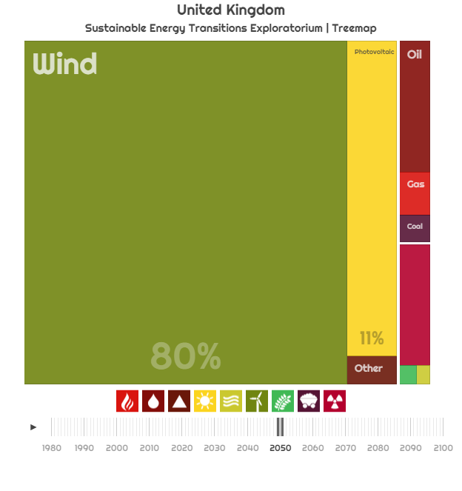 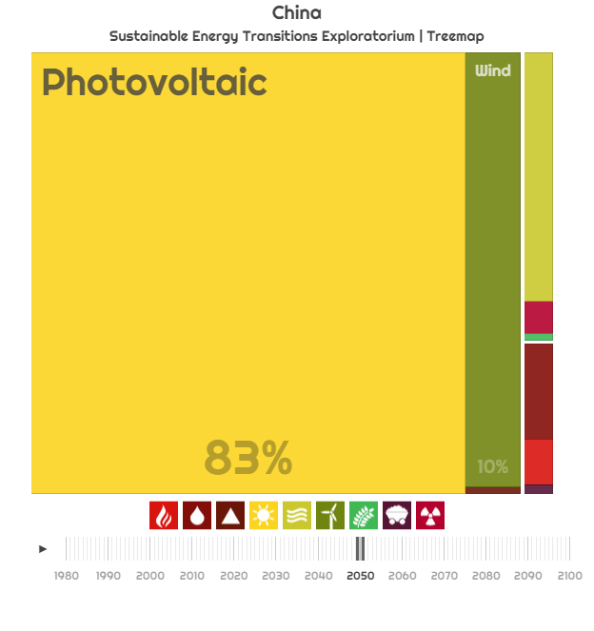

Figure ‎6‑36. Breakdown of primary energy consumption, after accounting for trade and storage.   
United Kingdom (Left), China (Right), source: own work for SETE, year: 2050

#### Comparison with the neo-carbon energy model

The neo-carbon energy model (NC) (Bogdanov and Breyer, 2016, [CSL STYLE ERROR: reference with no printed form.]; Pleßmann et al., 2014) is also capable of producing electricity (not primary energy!) transition paths for several aggregate regions of the world through a series of snapshots in a further point in time. It follows a LCOE based approach and an iteration over a set of predefined trade scenarios (region-wide trade, area-wide trade, integrated, integrated with gas production, etc. – somewhat similar to our universal trade rules through country influence). Since NETSET has by design PTL incorporated, we will be comparing our results with the integrated with gas production scenario.

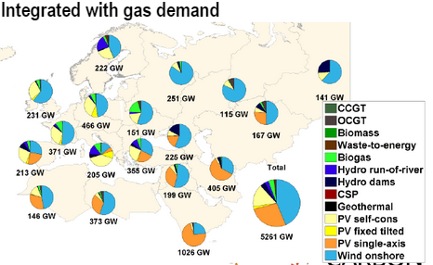

Figure ‎6‑37. 2030 breakdown of energy technologies in the European electricity grid.   
source: (Bogdanov and Breyer), year: 2030

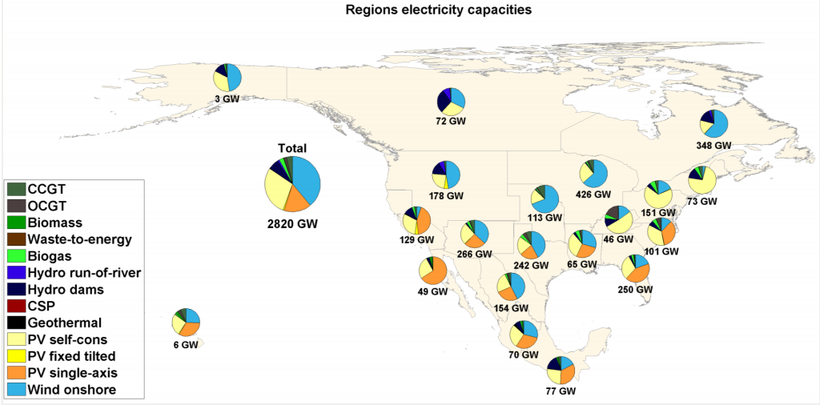

Figure ‎6‑38. 2030 breakdown of energy technologies in the North-American electricity grid.   
source: (Bogdanov and Breyer), year: 2030

In NC, when looking at North America, we get similar results to both DDPP and NETSET – with wind power and solar power providing 85% of electricity demand in 2030. However, the NC paints a picture of 2030 and only electricity, therefore it is hard to compare directly with the NETSET results (where we have primary energy). It worth mentioning though, that in the US fossil fuels are almost completely phased out by 2030 (<10%, Figure ‎6‑23) and the energy mix (now almost fully electric) is composed of 67% PV and 14% wind power, adding up (81%) to roughly the same level as the NC results.

Looking at Europe (again, comparing only electricity generation), Germany has 50% wind power supply and 35% solar PV, while the UK has 60% wind and 25% photovoltaics. In both cases, the rest of the electricity demand is served through bioenergy. In NETSET, neither the German nor the British fossil phase-out finishes by 2030, in Germany fossil fuels still have a share of 30%, while in the UK 20%. Interms of the composition of the generation mix, we have much more wind power in NETSET, due to trade from other regions of Europe and thus achieving lower cost factors than photovoltaics in at such a high latitude.

# IMPLICATIONS AND CONCLUSIONS

In this dissertation, we have set up an inclusive framework – both theory and application – to study and aim to understand and engineer sustainable energy transitions, both on the global and country levels, under the overarching goal of limiting the effects of climate change on society, while still maintaining the lifestyles we are accustomed to. Without doubt, this task is interlinked with the decarbonization – and hence the full fossil fuel phase-out – of our energy systems. Through net-energy analysis, we define and quantitatively estimate a global sustainable energy transitions path and from it derive coordinated, national SET paths that collectively meet the planetary GHG emissions constraints and minimize the total energy expenditure while doing so. Likewise, we provide the first net-energy based, biophysical, and fully data-driven approach towards deriving global and national sustainable energy transitions paths. When compared to the two other, main, energy based models of climate-energy-society, they usually only provide a snapshot image of the future energy mix in a predefined year, thus not showing the net-energy evolution dynamics. Our model is far more informative as it not only reaches the final energy mix target, – yielding comparable levels of energy installation with the other models – but it also delivers a dynamic trajectory ready to implement for energy policy makers. As such, this is the first model to transparently represent the dynamics of the energy transition on a physical rather than on an economic basis. Through the integration of global energy trade into the model, we were able to produce coordinated, country-level sustainable energy transition paths, under different assumptions for global trade influence.

If adapted by an international governing body or by policy makers of countries or regions, a coordinated global SET is proven to save north of 50% on the total cost of the global sustainable energy transition, while countries can use it to maximize their energy security based on physical energy flows or diversify their traded energy while minimizing the energy inputs into this trade – indirectly choosing the energy sources with the highest return. Since our model is open source, it can be easily re-run and simulated for various assumption for the rules governing global energy trade, depending on the preferences of these countries.

In recap, in Chapter 1 we set the objective of the research and provided a brief background on the importance of climate change modeling research.

We continued with Chapter 2, where dissected the Kaya Identity, one of the accepted methods of societal emissions modeling and examined its factors to identify the possible policy levers to reach the research objective. After examining all four factors, we identified two factor that can serve best as levers to induce a reduction in emissions and therefore progress towards a successful transition. These factors were power per capita and emissions intensity of energy. We concluded the chapter with a detailed analysis of future per capita power demand projections, for all countries, and the derivation of Hubbert emissions equivalent fossil fuel phase-out curves.

Having established the possible levers through which societal emission can be constrained within climate change imposed limits in Chapter 2, we continued with Chapter 3, with a review the existing climate change modeling practices, with a special focus on energy systems and GHG emissions accounting. We extensively discussed the flaws of integrated assessment models, the current “industry standard” for climate change modeling and highlighted their limited ability to accurately model transitions. We concluded the chapter with the justification and proposition to use numerical, differential equation-based models, rooted in biophysical economics and net-energy analysis to accurately model energy transitions on centennial scales and a finished with brief review of existing such models and hybrid-IAMs.

Chapter 4 is the main section to present our methodology for developing such a dynamic model in detail, starting by defining the theoretical framework in which the research objective gains significance and meaning (SET guidelines), defining and outlining the data sources, necessary data mining and processing and coding the dynamic simulation (differential equation) model. This framework is then extended through a dynamic trade allocation algorithm to reach to the national transitions. For the global transition, we designed a sensitivity analysis across a wide range of renewable EROEIs and possible future per capita power consumption profiles. And we introduced the concept of the Transition Feasibility Index (TFI) is introduced, in order to create a ranking systems of different SET paths. For incorporating trade into the global model we developed the concept of country influence, the main metric through which energy trade options priorities are governed, and we extended the framework of the global transition to include by modelling individual countries as autonomous agents deciding on their energy options placed in a dynamic global trade network. We have concluded the chapter with a visual summary of the NETSET algorithm.

After constructing the theoretical foundations of the global and regional SET, we constructed two dynamic simulation models and in the next two chapters, we presented the results of a set of experiments conducted with these simulation models. Chapter 5 is dedicated to the global analysis, where we explore a wide range of EOREI and per capita power demand options and present the optimal decision frontiers – with their respective renewable energy investment rates – to meet the planetary emissions constraints. We found that the easiest pathway requires installation of renewable energy plants to accelerate at least by a factor of 50 and perhaps more than 90 over current rates, at their peak, to mitigate climate change and sustain the economy and the basic energy demand of the population. Given the uncertainties in some of the critical parameters, through a mapping of a range of possible trajectories we show that the growth rates of RE installed capacity should continue unabated at 40%/year until at least 2020 and then slowly ease but still remain above 10% almost until 2030. In terms of absolute installation rates, this acceleration implies an increase from 0.12TW/year in 2013 to 6.6TW/year by 2038 (or a factor of 55) in RE installation rate if we are to stay on the least difficult compromise trajectory. This is robust across trajectories in early and fuel switch transitions but delays in picking up pace may lead to rates that exceed current by a factor of 95 and more, making them rather impractical.

Chapter 6 is dedicated to presenting and analyzing the results of the NETSET simulations. Due to high number of degrees of freedom of this model, as well as the sheer number of countries involved, we only present the aspects that crucially differentiate the NETSET model from the global SET are investigated and presented. First we describe the concept of the trade cost vector, the main gate through which the order of energy trade options gets decided, followed by the analysis of its sensitivity to changing trade parameters (self-influence q and power-factor p). We continue by presenting the Sustainable Energy Transitions Exploratorium, an interactive online data visualization interface that we have developed to explore the data generated through the NETSET simulations. We then present two examples for a successful net domestic energy transition, for the cases of the United Arab Emirates and the United States, using these as stepping stones towards the more complex graph that include energy exports as well. We demonstrate the validity of the NETSET model through highlighting its functionings while analyzing 6 more full country results of sustainable net energy transitions and explain the dynamics of trade – both Imports and Exports. We find that the network is very sensitive to the global trade governing parameters and conclude that further work must go into their estimation. Finally, we reconstruct the results of the global model bottom-up and find that by coordinating trade, 50% reductions can be achieved in the cumulative energy investment that enables the global sustainable energy transition. We conclude the chapter by comparing the results of our model to the outputs of two similar approaches (Deep Decarbonization Pathways Project and Neo Carbon Energy) and find a good match with their findings, but highlight the fact that these models only provide snapshot images of future energy mixes and fails to emphasize the extraordinary efforts needed during the early fossil phase-out phase of any energy transition. We also highlight the fact that higher renewable energy diffusion rates are needed than the ones reported by these models in order to fit into the GHG emissions cap.

This dissertation still has a lot of potential for developing it into a larger, internationally funded research project. We underline that particular SETs can be defined for each economic sector and with better calibration of the electrification rates, technology EOREIs, per capita consumption rates, parameters governing energy trade, ramp-up rates and diversification quotas, very accurate, climate-compliant energy policies can be constructed for all countries of the world, while at the same minimizing the total global energy input requirements for this transition and hence minimizing the GHG emissions. In an event of a globally coordinated, climate change-driven energy policy agreement, the results of such a work would be deemed invaluable

Since SET requires energy to construct the necessary RE infrastructure and to integrate the mostly variable RE resources in the energy system and since at present the world's energy derives primarily from fossil resources, *we need the energy from fossil fuels to transition away from their use*. This requirement is analogous to “the sower's strategy” (Bardi 2014b), the long-established farming practice to save a fraction of the current year's harvest as seeds for the next. Fossil fuels are finite but we can “sow” what these fuels provide: energy and minerals to create the capital needed for the transition (Bardi 2014a). The challenge of a sustainable energy transition before the end of the 21st century under climate constraints is unprecedented in magnitude, scope, and ambition. It is, nonetheless, doable if we adopt a global “sower's strategy” and proactively invest an appropriate amount of the fossil energy available today into building a sustainable energy future with concrete annual targets.

References

Agnew, S., and Dargusch, P. (2015). Effect of residential solar and storage on centralized electricity supply systems. Nature Clim. Change *5*, 315–318.

Alcott, B. (2005). Jevons’ paradox. Ecological Economics *54*, 9–21.

Aldy, J.E., Barrett, S., and Stavins, R.N. (2003). Thirteen plus one: a comparison of global climate policy architectures. Climate Policy *3*, 373–397.

Aldy, J.E., Pizer, W.A., and Akimoto, K. (2016). Comparing emissions mitigation efforts across countries. Climate Policy *0*, 1–15.

Armstrong, R.C., Wolfram, C., Jong, K.P. de, Gross, R., Lewis, N.S., Boardman, B., Ragauskas, A.J., Ehrhardt-Martinez, K., Crabtree, G., and Ramana, M.V. (2016). The frontiers of energy. Nature Energy *1*, 15020.

Arrow, K.J., Chenery, H.B., Minhas, B.S., and Solow, R.M. (1961). Capital-labor substitution and economic efficiency. The Review of Economics and Statistics *43*, 225–250.

Aslani, A., Helo, P., and Naaranoja, M. (2014). Role of renewable energy policies in energy dependency in Finland: System dynamics approach. Applied Energy *113*, 758–765.

Ayres, R. (2003). Exergy, power and work in the US economy, 1900–1998. Energy *28*, 219–273.

Ayres, R. (2016). New Perspectives on Capital, Work, and Wealth. In Energy, Complexity and Wealth Maximization, (Springer International Publishing), pp. 423–483.

Ayres, R.U., and Warr, B. (2005). Accounting for growth: the role of physical work. Structural Change and Economic Dynamics *16*, 181–209.

Baker, E., and Shittu, E. (2008). Uncertainty and endogenous technical change in climate policy models. Energy Economics *30*, 2817–2828.

Bogdanov, D., and Breyer, C. (2016). North-East Asian Super Grid for 100% renewable energy supply: Optimal mix of energy technologies for electricity, gas and heat supply options. Energy Conversion and Management *112*, 176–190.

Bogdanov, D., and Breyer, C. Eurasian Super Grid for 100% Renewable Energy power supply: Generation and storage technologies in the cost optimal mix.

Bosetti, V., Carraro, C., Galeotti, M., Massetti, E., and Tavoni, M. (2006). WITCH - A World Induced Technical Change Hybrid Model (Rochester, NY: Social Science Research Network).

Boyd, R., Turner, J., and Ward, B. (2015). Intended nationally determined contributions: what are the implications for greenhouse gas emissions in 2030?

BP (2014). Statistical Review of World Energy 2014.

Brecha, R. (2013). Ten Reasons to Take Peak Oil Seriously. Sustainability *5*, 664–694.

Breyer, C., Tsupari, E., Tikka, V., and Vainikka, P. (2015a). Power-to-Gas as an Emerging Profitable Business through Creating an Integrated Value Chain. Energy Procedia *73*, 182–189.

Breyer, C., Bogdanov, D., Komoto, K., Ehara, T., Song, J., and Enebish, N. (2015b). North-East Asian Super Grid: Renewable Energy Mix and Economics. Japanese Journal of Applied Physics *54*, 08KJ01.

Brown, M.., and Herendeen, R.. (1996). Embodied energy analysis and EMERGY analysis: a comparative view. Ecological Economics *19*, 219–235.

Brown, M.., and Ulgiati, S. (1997). Emergy-based indices and ratios to evaluate sustainability: monitoring economies and technology toward environmentally sound innovation. Ecological Engineering *9*, 51–69.

Burns, W.C.G. (2016). Loss and Damage and the 21st Conference of the Parties to the United Nations Framework Convention on Climate Change (Rochester, NY: Social Science Research Network).

Cai, Y., Newth, D., Finnigan, J., and Gunasekera, D. (2015). A hybrid energy-economy model for global integrated assessment of climate change, carbon mitigation and energy transformation. Applied Energy *148*, 381–395.

Caldeira, K., and Davis, S.J. (2011). Accounting for carbon dioxide emissions: A matter of time. Proceedings of the National Academy of Sciences *108*, 8533–8534.

Cavallo, A.J. (2004). Hubbert’s petroleum production model: an evaluation and implications for world oil production forecasts. Natural Resources Research *13*, 211–221.

Chakravarty, S., Chikkatur, A., Coninck, H. de, Pacala, S., Socolow, R., and Tavoni, M. (2009). Sharing global CO2 emission reductions among one billion high emitters. PNAS *106*, 11884–11888.

Chertow, M.R. (2000). The IPAT equation and its variants. Journal of Industrial Ecology *4*, 13–29.

Christensen, C. (1997). The innovator’s dilemma: when new technologies cause great firms to fail (Harvard Business Press).

Cleveland, C.J. (1987). Ecological Economics Biophysical economics: Historical perspective and current research trends. Ecological Modelling *38*, 47–73.

Cobb, C.W., and Douglas, P.H. (1928). A theory of production. The American Economic Review *18*, 139–165.

Cochran, J., Mai, T., and Bazilian, M. (2014). Meta-analysis of high penetration renewable energy scenarios. Renewable and Sustainable Energy Reviews *29*, 246–253.

Commoner, B. (1976). Poverty of power: energy and the economic crisis (Washington Univ., Center for the Biology of Natural Systems, St. Louis, MO).

Csala, D. (2015). Business as usual emissions scenarios for the Climate Colab Global Plan 2015.

Dale, M., and Benson, S.M. (2013). Energy Balance of the Global Photovoltaic (PV) Industry - Is the PV Industry a Net Electricity Producer? Environ. Sci. Technol. *47*, 3482–3489.

Dale, M., Krumdieck, S., and Bodger, P. (2011). A Dynamic Function for Energy Return on Investment. Sustainability *3*, 1972–1985.

Dale, M., Krumdieck, S., and Bodger, P. (2012a). Global energy modelling — A biophysical approach (GEMBA) part 1: An overview of biophysical economics. Ecological Economics *73*, 152–157.

Dale, M., Krumdieck, S., and Bodger, P. (2012b). Global energy modelling — A biophysical approach (GEMBA) Part 2: Methodology. Ecological Economics *73*, 158–167.

Davidsen, P.I., Sterman, J.D., and Richardson, G.P. (1990). A petroleum life cycle model for the United States with endogenous technology, exploration, recovery, and demand. System Dynamics Review *6*, 66–93.

Davis, S.J., and Caldeira, K. (2010). Consumption-based accounting of CO2 emissions. PNAS *107*, 5687–5692.

de Vries, B.J.M., van Vuuren, D.P., and Hoogwijk, M.M. (2007). Renewable energy sources: Their global potential for the first-half of the 21st century at a global level: An integrated approach. Energy Policy *35*, 2590–2610.

Després, J., Mima, S., Kitous, A., Criqui, P., Hadjsaid, N., and Noirot, I. Storage as a flexibility option in power systems with high shares of variable renewable energy sources: A POLES-based analysis. Energy Economics.

Donella H. Meadows, Dennis L. Meadows, Jorgen Randers, and William W. Behrens III (1972). Limits to Growth (Signet).

Dowlatabadi, H. (2007). On integration of policies for climate and global change. Mitig Adapt Strat Glob Change *12*, 651–663.

Dowlatabadi, H., and Morgan, M.G. (1993). A model framework for integrated studies of the climate problem. Energy Policy *21*, 209–221.

Edenhofer, O., Bauer, N., and Kriegler, E. (2005). The impact of technological change on climate protection and welfare: Insights from the model MIND. Ecological Economics *54*, 277–292.

Edmonds, J., Wise, M., and MacCracken, C. (1994). Advanced energy technologies and climate change: An analysis using the global change assessment model (GCAM) (Fondazione ENI Enrico Mattei).

Edwards, M.R., and Trancik, J.E. (2014). Climate impacts of energy technologies depend on emissions timing. Nature Clim. Change *4*, 347–352.

Ehrlich, P., and Holdren, J. (1972). ETHICS OF ENVIRONMENT.

EIA (2014). International Energy Statistics.

Elzen, M.G.J. den, Olivier, J.G.J., Höhne, N., and Janssens-Maenhout, G. (2013). Countries’ contributions to climate change: effect of accounting for all greenhouse gases, recent trends, basic needs and technological progress. Climatic Change *121*, 397–412.

Elzen, M.G.J.D., Schaeffer, M., and Lucas, P.L. (2005). Differentiating Future Commitments on the Basis of Countries’ Relative Historical Responsibility for Climate Change: Uncertainties in the “Brazilian Proposal” in the Context of a Policy Implementation. Climatic Change *71*, 277–301.

Fiddaman, T. (2007). Dynamics of climate policy. System Dynamics Review *23*, 21–34.

Fiddaman, T.S. (1995). Formulation Experiments with a Simple Climate-Economy Model. In System Dynamics Conference, p.

Fiddaman, T.S. (1998). A Feedback-Rich Climate-Economy Model. In System Dynamics Conference, p.

Fiddaman, T.S. (2002a). Exploring policy options with a behavioral climate–economy model. System Dynamics Review *18*, 243–267.

Fiddaman, T.S. (2002b). Exploring policy options with a behavioral climate–economy model. System Dynamics Review *18*, 243–267.

Forrester, J.W. (1971). World Dynamics (Wriht-Allen Press).

Forrester, J.W., Mass, N.J., and Ryan, C.J. (1976). The system dynamics national model: Understanding socio-economic behavior and policy alternatives. Technological Forecasting and Social Change *9*, 51–68.

Fouquet, R. (2010). The slow search for solutions: Lessons from historical energy transitions by sector and service. Energy Policy *38*, 6586–6596.

Fouquet, R., and Pearson, P.J.G. (2012). Past and prospective energy transitions: Insights from history. Energy Policy *50*, 1–7.

Gallagher, B. (2011). Peak oil analyzed with a logistic function and idealized Hubbert curve. Energy Policy *39*, 790–802.

Georgescu-Roegen, N. (1976). Energy and economic myths: institutional and analytical economic essays.

Gillingham, K., Nordhaus, W.D., Anthoff, D., Blanford, G., Bosetti, V., Christensen, P., McJeon, H., Reilly, J., and Sztorc, P. (2015). Modeling Uncertainty in Climate Change: A Multi-Model Comparison (National Bureau of Economic Research).

Godfray, H.C.J., Beddington, J.R., Crute, I.R., Haddad, L., Lawrence, D., Muir, J.F., Pretty, J., Robinson, S., Thomas, S.M., and Toulmin, C. (2010). Food Security: The Challenge of Feeding 9 Billion People. Science *327*, 812–818.

Gollier, C. (2002). Discounting an uncertain future. Journal of Public Economics *85*, 149–166.

Grubler, A. (2012). Energy transitions research: Insights and cautionary tales. Energy Policy *50*, 8–16.

Gupta, A.K., and Hall, C.A.S. (2011). A Review of the Past and Current State of EROI Data. Sustainability *3*, 1796–1809.

Hák, T., Janoušková, S., and Moldan, B. (2016). Sustainable Development Goals: A need for relevant indicators. Ecological Indicators *60*, 565–573.

Hall, C. a. S., and Cleveland, C.J. (1981). Petroleum Drilling and Production in the United States: Yield per Effort and Net Energy Analysis. Science *211*, 576–579.

Hall, C.A.S., and Klitgaard, K.A. (2011). Energy and the Wealth of Nations: Understanding the Biophysical Economy. (Springer).

Hamilton, J.D. (2008). Understanding crude oil prices (National Bureau of Economic Research).

Hardin, G. (1968). The Tragedy of the Commons. Science *162*, 1243–1248.

Hau, J.L., and Bakshi, B.R. (2004). Promise and problems of emergy analysis. Ecological Modelling *178*, 215–225.

Hertel, T.W., and Hertel, T.W. (1997). Global trade analysis: modeling and applications (Cambridge university press).

Hertwich, E.G., Gibon, T., Bouman, E.A., Arvesen, A., Suh, S., Heath, G.A., Bergesen, J.D., Ramirez, A., Vega, M.I., and Shi, L. (2015). Integrated life-cycle assessment of electricity-supply scenarios confirms global environmental benefit of low-carbon technologies. PNAS *112*, 6277–6282.

Howarth, R.B. (1998). An overlapping generations model of climate-economy interactions. The Scandinavian Journal of Economics *100*, 575–591.

Hubbert, M.K. (1956). Nuclear energy and the fossil fuel. Drilling and Production Practice.

Hubbert, M.K., District, A.P.I.D. of P.S., and Division, S.D.C.E. and P.R. (1956). Nuclear energy and the fossil fuels (Shell Development Co., Exploration and Production Research Division).

Huettner, D.A. (1976). Net Energy Analysis: An Economic Assessment. Science; (United States) *192:4235*.

Hyman, R.C., Reilly, J.M., Babiker, M.H., Masin, A.D., and Jacoby, H.D. (2003). Modeling non-CO2 Greenhouse Gas Abatement. Environmental Modeling & Assessment *8*, 175–186.

IPCC (2014). Fifth Assessmenteport (AR5).

Iyer, G.C., Edmonds, J.A., Fawcett, A.A., Hultman, N.E., Alsalam, J., Asrar, G.R., Calvin, K.V., Clarke, L.E., Creason, J., Jeong, M., et al. (2015). The contribution of Paris to limit global warming to 2 °C. Environ. Res. Lett. *10*, 125002.

Jacobson, M.Z., and Delucchi, M.A. (2009). A Path to Sustainable Energy by 2030. Scientific American *301*, 58–65.

Jacobson, M.Z., and Delucchi, M.A. (2011). Providing all global energy with wind, water, and solar power, Part I: Technologies, energy resources, quantities and areas of infrastructure, and materials. Energy Policy *39*, 1154–1169.

Jarvis, A.J., Jarvis, S.J., and Hewitt, C.N. (2015). Resource acquisition, distribution and end-use efficiencies and the growth of industrial society. Earth Syst. Dynam. *6*, 689–702.

J. Barnhart, C., Dale, M., R. Brandt, A., and M. Benson, S. (2013). The energetic implications of curtailing versus storing solar- and wind-generated electricity. Energy & Environmental Science *6*, 2804–2810.

Jones, A., Sterman, J.D., and Fiddaman, T.S. (2013). Energy – Rapid Overview and Decision-Support: En-ROADS Model (Climate Interactive).

Joskow, P.L. (2011). Comparing the costs of intermittent and dispatchable electricity generating technologies. The American Economic Review *101*, 238–241.

Kallis, G. (2011). In defence of degrowth. Ecological Economics *70*, 873–880.

Kang, C., Zhou, T., Chen, Q., Xu, Q., Xia, Q., and Ji, Z. (2012). Carbon Emission Flow in Networks. Scientific Reports *2*, 479.

Karl, T.R., and Trenberth, K.E. (2003). Modern Global Climate Change. Science *302*, 1719–1723.

Karp, L. (2005). Global warming and hyperbolic discounting. Journal of Public Economics *89*, 261–282.

Kates, R.W. (2000). Population and consumption: what we know, what we need to know. Environment: Science and Policy for Sustainable Development *42*, 10–19.

Kemp, R. (2011). The Dutch Energy Transition Approach. In International Economics of Resource Efficiency, R. Bleischwitz, P.J.J. Welfens, and Z. Zhang, eds. (Physica-Verlag HD), pp. 187–213.

King, E. (2015). The INDCs are a mess – and the UN needs to take control.

Kintisch, E. (2015). After Paris: The rocky road ahead. Science *350*, 1018–1019.

Komiyama, R., Shibata, S., and Fujii, Y. (2013). Simulation analysis for massive deployment of variable renewables employing an optimal power generation mix model. Journal of Energy and Power Engineering *7*.

Kozusko, F., and Bajzer, Ž. (2003). Combining Gompertzian growth and cell population dynamics. Mathematical Biosciences *185*, 153–167.

Lagi, M., Bar-Yam, Y., Bertrand, K.Z., and Bar-Yam, Y. (2015). Accurate market price formation model with both supply-demand and trend-following for global food prices providing policy recommendations. PNAS 201413108.

Lane, J.-E. (2016). The Cop21 Agreement: A Giant Illusion? Journal of Economics and Public Finance *2*, 34.

Le Quéré, C., Raupach, M.R., Canadell, J.G., Al, G.M. et, Al, C.L.Q. et, Marland, G., Bopp, L., Ciais, P., Conway, T.J., Doney, S.C., et al. (2009). Trends in the sources and sinks of carbon dioxide. Nature Geosci *2*, 831–836.

Leimbach, M., Bauer, N., Baumstark, L., and Edenhofer, O. (2009). Mitigation Costs in a Globalized World: Climate Policy Analysis with REMIND-R. Environ Model Assess *15*, 155–173.

Leontieff, V. (1965). The structure of the US economy. Scientific American *212*, 33.

Loulou, R., Goldstein, G., and Noble, K. (2004). Documentation for the MARKAL Family of Models.

Luderer, G., Pietzcker, R.C., Bertram, C., Kriegler, E., Meinshausen, M., and Edenhofer, O. (2013). Economic mitigation challenges: how further delay closes the door for achieving climate targets. Environmental Research Letters *8*, 34033.

Lund, H., and Mathiesen, B.V. (2009). Energy system analysis of 100% renewable energy systems—The case of Denmark in years 2030 and 2050. Energy *34*, 524–531.

Maggio, G., and Cacciola, G. (2009a). A variant of the Hubbert curve for world oil production forecasts. Energy Policy *37*, 4761–4770.

Maggio, G., and Cacciola, G. (2009b). A variant of the Hubbert curve for world oil production forecasts. Energy Policy *37*, 4761–4770.

Makhijani, A., Mills, P.D. with C., J.D., Ramana, M.V., and Ph.D. Renewable Minnesota: A technical and economic analysis of a 100% renewable-energy based electricity system for Minnesota - Institute for Energy and Environmental Research.

Manne, A.S., and Richels, R.G. (2005). Merge: An Integrated Assessment Model for Global Climate Change. In Energy and Environment, R. Loulou, J.-P. Waaub, and G. Zaccour, eds. (Springer US), pp. 175–189.

Manne, A., Mendelsohn, R., and Richels, R. (1995). MERGE: A model for evaluating regional and global effects of GHG reduction policies. Energy Policy *23*, 17–34.

Manolas, E. (2016). The Paris climate change agreement. International Journal of Environmental Studies *0*, 1–3.

Marechal, F., Favrat, D., and Jochem, E. (2005). Energy in the perspective of the sustainable development: The 2000 W society challenge. Resources, Conservation and Recycling *44*, 245–262.

Martino, J.P. (2003). A review of selected recent advances in technological forecasting. Technological Forecasting and Social Change *70*, 719–733.

McGlade, C., and Ekins, P. (2015). The geographical distribution of fossil fuels unused when limiting global warming to 2 °C. Nature *517*, 187–190.

Meadows, D.H., Randers, J., and Meadows, D.L. (2004). The limits to growth: the 30-year update (White River Junction, Vt: Chelsea Green Pub. Co.).

Michaelowa, A., and Michaelowa, K. (2015). Do rapidly developing countries take up new responsibilities for climate change mitigation? Climatic Change *133*, 499–510.

Moriarty, P., and Honnery, D. (2012). What is the global potential for renewable energy? Renewable and Sustainable Energy Reviews *16*, 244–252.

Murphy, D.J., Hall, C.A., Dale, M., and Cleveland, C. (2011). Order from chaos: a preliminary protocol for determining the EROI of fuels. Sustainability *3*, 1888–1907.

Nagy, B., Farmer, J.D., Bui, Q.M., and Trancik, J.E. (2013). Statistical Basis for Predicting Technological Progress. PloS ONE.

Naill, R.F. (1971). The Discovery Life Cycle of a Finite Resource: A Case Study of U.S. Natural Gas.

Naill, R.F. (1972). Managing the discovery life cycle of a finite resource: a case study of U.S. natural gas. Thesis. Massachusetts Institute of Technology.

Naill, R.F. (1992). A system dynamics model for national energy policy planning. System Dynamics Review *8*, 1–19.

Naill, R.F., Miller, J.S., and Meadows, D.L. (1974). Transition to coal (Dartmouth College, Thayer School of Engineering, System Dynamics Group, Hanover, NH 03755).

Neij, L. (2008). Cost development of future technologies for power generation—A study based on experience curves and complementary bottom-up assessments. Energy Policy *36*, 2200–2211.

Nemani, R.R., Keeling, C.D., Hashimoto, H., Jolly, W.M., Piper, S.C., Tucker, C.J., Myneni, R.B., and Running, S.W. (2003). Climate-Driven Increases in Global Terrestrial Net Primary Production from 1982 to 1999. Science *300*, 1560–1563.

Nemet, G.F., Grubler, A., and Kammen, D.M. (2016). Countercyclical energy and climate policy for the U.S. WIREs Clim Change *7*, 5–12.

Nordhaus, W.D. (1992). An Optimal Transition Path for Controlling Greenhouse Gases. Science *258*, 1315–1319.

Nordhaus, W., and Sztorc, P. (2013). DICE 2013R: Introduction and user’s manual. Retrieved November.

Norton, J.A., and Bass, F.M. (1987). A diffusion theory model of adoption and substitution for successive generations of high-technology products. Management Science *33*, 1069–1086.

Ottinger, R. (2015). Expanding COP21 INDCs to Include Non-National Contributions (Rochester, NY: Social Science Research Network).

Owens, S., and Driffill, L. (2008). How to change attitudes and behaviours in the context of energy. Energy Policy *36*, 4412–4418.

Palmer, T., Alessandri, A., Andersen, U., Cantelaube, P., and others (2004). Development of a European multimodel ensemble system for seasonal-to-interannual prediction (DEMETER). Bulletin of the American Meteorological Society *85*, 853.

Paltsev, S., Reilly, J.M., Jacoby, H.D., Eckaus, R.S., McFarland, J.R., Sarofim, M.C., Asadoorian, M.O., and Babiker, M.H. (2005). The MIT emissions prediction and policy analysis (EPPA) model: version 4 (MIT Joint Program on the Science and Policy of Global Change).

Peters, G.P., Andrew, R., and Lennox, J. (2011). CONSTRUCTING AN ENVIRONMENTALLY-EXTENDED MULTI-REGIONAL INPUT–OUTPUT TABLE USING THE GTAP DATABASE. Economic Systems Research *23*, 131–152.

Peters, G.P., Marland, G., Quéré, C.L., Boden, T., Canadell, J.G., and Raupach, M.R. (2012). Rapid growth in CO2 emissions after the 2008-2009 global financial crisis. Nature Climate Change *2*, 2–4.

Peters, G.P., Andrew, R.M., Solomon, S., and Friedlingstein, P. (2015). Measuring a fair and ambitious climate agreement using cumulative emissions. Environ. Res. Lett. *10*, 105004.

Pfeiffer, A., Koschenz, M., and Wokaun, A. (2005). Energy and building technology for the 2000 W society—Potential of residential buildings in Switzerland. Energy and Buildings *37*, 1158–1174.

Pickard, W.F., Hansing, N.J., and Shen, A.Q. (2009). Can large-scale advanced-adiabatic compressed air energy storage be justified economically in an age of sustainable energy? Journal of Renewable and Sustainable Energy *1*, 33102.

Pimentel, D., and Pimentel, M.H. (2007). Food, Energy, and Society, Third Edition (Boca Raton, FL: CRC Press).

Pindyck, R.S. (2013). Climate change policy: What do the models tell us? (National Bureau of Economic Research).

Plambeck, E.L., and Hope, C. (1996). PAGE95: An updated valuation of the impacts of global warming. Energy Policy *24*, 783–793.

Pleßmann, G., Erdmann, M., Hlusiak, M., and Breyer, C. (2014). Global Energy Storage Demand for a 100% Renewable Electricity Supply. Energy Procedia *46*, 22–31.

Polimeni, J.M. (2012). The Jevons paradox and the myth of resource efficiency improvements (Earthscan).

Popp, D. (2004). ENTICE: endogenous technological change in the DICE model of global warming. Journal of Environmental Economics and Management *48*, 742–768.

Popp, D. (2006). ENTICE-BR: The effects of backstop technology R&D on climate policy models. Energy Economics *28*, 188–222.

Princen, T., Manno, J.P., and Martin, P. (2013). Keep Them in the Ground: Ending the Fossil Fuel Era. In State of the World 2013, (Island Press/Center for Resource Economics), pp. 161–171.

Quadrelli, R., and Peterson, S. (2007). The energy–climate challenge: Recent trends in CO2 emissions from fuel combustion. Energy Policy *35*, 5938–5952.

Quéré, C.L., Moriarty, R., Andrew, R.M., Peters, G.P., Ciais, P., Friedlingstein, P., Jones, S.D., Sitch, S., Tans, P., Arneth, A., et al. (2015). Global carbon budget 2014. Earth System Science Data *7*, 47–85.

Raupach, M.R., Marland, G., Ciais, P., Quéré, C.L., Canadell, J.G., Klepper, G., and Field, C.B. (2007). Global and regional drivers of accelerating CO2 emissions. PNAS *104*, 10288–10293.

Raupach, M.R., Davis, S.J., Peters, G.P., Andrew, R.M., Canadell, J.G., Ciais, P., Friedlingstein, P., Jotzo, F., Vuuren, D.P. van, and Quéré, C.L. (2014). Sharing a quota on cumulative carbon emissions. Nature Climate Change *4*, 873–879.

Rayner, S., and Malone, E.L. (1997). Zen and the art of climate maintenance. Nature *390*, 332–334.

Reboredo, F.H., Lidon, F., Pessoa, F., and Ramalho, J.C. (2016). The Fall of Oil Prices and the Effects on Biofuels. Trends in Biotechnology *34*, 3–6.

Reif, C., and Schenker, O. (2015). The road to Paris: Towards a fair and effective climate agreement? (ZEW policy brief).

Rhodes, C.J. (2016). The 2015 Paris Climate Change Conference: COP21. Science Progress *99*, 97–104.

Robbins, A. (2016). How to understand the results of the climate change summit: Conference of Parties21 (COP21) Paris 2015. Journal of Public Health Policy.

Rockström, J., Steffen, W., Noone, K., Persson, Å., Chapin, F.S., Lambin, E.F., Lenton, T.M., Scheffer, M., Folke, C., Schellnhuber, H.J., et al. (2009). A safe operating space for humanity. Nature *461*, 472–475.

Roe, G.H., and Baker, M.B. (2007). Why Is Climate Sensitivity So Unpredictable? Science *318*, 629–632.

Rosa, E.A., and Dietz, T. (2012). Human drivers of national greenhouse-gas emissions. Nature Climate Change *2*, 581–586.

Russ, P., Ciscar, J., Saveyn, B., Soria, A., Szábó, L., Van Ierland, T., Van Regemorter, D., and Virdis, R. (2009). Economic assessment of post-2012 global climate policies–Analysis of greenhouse gas emission reduction scenarios with the POLES and GEM-E3 models. JRC Scientific and Technical Reports.

Sachs, J. (2016). The Sustainable Development Goals: from Vision to Reality. In 2016 AAAS Annual Meeting (February 11-15, 2016), (aaas), p.

S. Sgouridis, U. Bardi, and D. Csala (2015). A Net Energy-based Analysis for a Climate-constrained Sustainable Energy Transition. In Preparation.

Schill, W.-P. (2014). Residual load, renewable surplus generation and storage requirements in Germany. Energy Policy *73*, 65–79.

Schulz, T.F., Kypreos, S., Barreto, L., and Wokaun, A. (2008). Intermediate steps towards the 2000 W society in Switzerland: An energy–economic scenario analysis. Energy Policy *36*, 1303–1317.

Sgouridis, S. (2014). Defusing the energy trap: the potential of energy-denominated currencies to facilitate a sustainable energy transition.

Sgouridis, S.P., and Csala, D. (2014). Defining Sustainable Energy Transitions: Principles, Dynamics, and Implications. Sustainability *5*.

Sgouridis, S., Bonnefoy, P.A., and Hansman, R.J. (2011). Air transportation in a carbon constrained world: Long-term dynamics of policies and strategies for mitigating the carbon footprint of commercial aviation. Transportation Research Part A: Policy and Practice *45*, 1077–1091.

Sgouridis, S., Griffiths, S., Kennedy, S., Khalid, A., and Zurita, N. (2013). A sustainable energy transition strategy for the United Arab Emirates: Evaluation of options using an Integrated Energy Model. Energy Strategy Reviews *2*, 8–18.

Sgouridis, S., Bardi, U., and Csala, D. (2015). A Net Energy-based Analysis for a Climate-constrained Sustainable Energy Transition. Available at SSRN 2583732.

Sgouridis, S., Bardi, U., and Csala, D. (2016a). The Sower’s way. Quantifying the Narrowing Net-Energy Pathways to a Global Energy Transition.

Sgouridis, S., Kaya, A., and Csala, D. (2016b). The Constant Elasticity of Substitution Fallacy for Physical Transitions: Implications for Integrated Assessment Models and Climate Policy. In Preparation.

Sinclair, M.S. (1978). Net energy analysis. University of British Columbia.

Smith, D.A., and White, D.R. (1992). Structure and Dynamics of the Global Economy: Network Analysis of International Trade 1965–1980. Social Forces *70*, 857–893.

Solow, R.M. (1956). A contribution to the theory of economic growth. The Quarterly Journal of Economics 65–94.

Sorrell, S., Dimitropoulos, J., and Sommerville, M. (2009). Empirical estimates of the direct rebound effect: A review. Energy Policy *37*, 1356–1371.

Spreng, D. (2005). Distribution of energy consumption and the 2000 W/capita target. Energy Policy *33*, 1905–1911.

Statistics, C. on the N.E.M.S., Energy Engineering Board,Commission on Engineering and Technical Systems,Committee on National, Education, C. on B. and S.S. and, Systems, C. on E. and T., Sciences, D. on E. and P., and Council, N.R. (1992). The National Energy Modeling System (National Academies Press).

Sterman, J. (1982). The energy transition and the economy : a system dynamics approach. Thesis. Massachusetts Institute of Technology.

Sterman, J. (2000). Business dynamics (Irwin-McGraw-Hill).

Sterman, J.D. (1986). The economic long wave: Theory and evidence. System Dynamics Review *2*, 87–125.

Sterman, J., Fiddaman, T., Franck, T., Jones, A., McCauley, S., Rice, P., Sawin, E., and Siegel, L. (2012). Climate interactive: the C-ROADS climate policy model. System Dynamics Review *28*, 295–305.

Stern, N. (2016). Economics: Current climate models are grossly misleading. Nature *530*, 407–409.

Sullivan, P., Krey, V., and Riahi, K. (2013). Impacts of considering electric sector variability and reliability in the MESSAGE model. Energy Strategy Reviews *1*, 157–163.

Tainter, J.A. (2004). The collapse of complex societies (Cambridge University Press).

Tanzer, M. (1974). Energy crisis: world struggle for power and wealth.

Tol, R.S.J. (2002a). Estimates of the Damage Costs of Climate Change. Part 1: Benchmark Estimates. Environmental and Resource Economics *21*, 47–73.

Tol, R.S.J. (2002b). Estimates of the Damage Costs of Climate Change, Part II. Dynamic Estimates. Environmental and Resource Economics *21*, 135–160.

Trancik, J.E. (2014). Renewable energy: Back the renewables boom. Nature News *507*, 300.

Turner, M.E., Bradley, E.L., Kirk, K.A., and Pruitt, K.M. (1976). A theory of growth. Mathematical Biosciences *29*, 367–373.

Ueckerdt, F., Brecha, R., Luderer, G., Sullivan, P., Schmid, E., Bauer, N., Böttger, D., and Pietzcker, R. (2015). Representing power sector variability and the integration of variable renewables in long-term energy-economy models using residual load duration curves. Energy *90*, *Part 2*, 1799–1814.

UNSD (2012). World Population Prospects: The 2012 Revision (United Nations Population Division).

Waggoner, P.E., and Ausubel, J.H. (2002). A framework for sustainability science: A renovated IPAT identity. PNAS *99*, 7860–7865.

Waldhoff, S., Anthoff, D., Rose, S., and RSJ, T. The Marginal Damage Costs of Different Greenhouse Gases: An Application of FUND. Economics E-Journal.

Wang, Q., McKeller, B., Schewikart, R., and Sterman, J.D. (1983). A simple model of energy dynamics. In System Dynamics Conference, p.

Webber, M.E. (2012). More Food, Less Energy. Scientific American *306*, 74–79.

Weber, C., and Perrels, A. (2000). Modelling lifestyle effects on energy demand and related emissions. Energy Policy *28*, 549–566.

Wheeler, T., and Braun, J. von (2013). Climate Change Impacts on Global Food Security. Science *341*, 508–513.

William Forster Lloyd (1833). Two lectures on the checks to population.

Williams, J.H., DeBenedictis, A., Ghanadan, R., Mahone, A., Moore, J., Morrow, W.R., Price, S., and Torn, M.S. (2012). The Technology Path to Deep Greenhouse Gas Emissions Cuts by 2050: The Pivotal Role of Electricity. Science *335*, 53–59.

Wilson, C., and Grubler, A. (2011). Lessons from the history of technological change for clean energy scenarios and policies. In Natural Resources Forum, pp. 165–184.

Wright, T.P. (1936). Factors affecting the cost of airplanes. Journal of the Aeronautical Sciences *3*, 122–128.

Xiao, A. (2015). The Geopolitics of Oil Prices: Analyzing the Effects of Production and Investment on Global Oil Prices. Harvard International Review *36*, 26.

Yillia, D.P.T. (2016). Water-Energy-Food nexus: framing the opportunities, challenges and synergies for implementing the SDGs. Österr Wasser- Und Abfallw 1–13.

York, R. (2007). Demographic trends and energy consumption in European Union Nations, 1960–2025. Social Science Research *36*, 855–872.

Zakeri, B., Syri, S., and Rinne, S. (2015). Higher renewable energy integration into the existing energy system of Finland–Is there any maximum limit? Energy *92*, 244–259.

(1997). Kyoto Protocol.

(2014). World Development Indicators.

(2015a). Emissions-Impacts-Climate Change (UNEP).

(2015b). Deep Decarbonization Pathways Project.

Appendix 1

*Marginal Abatement of Fossil Energy under a Carbon Tax by using CES*

This section has been developed by Abdullah Kaya for our joint paper (Sgouridis et al., 2016b)

1. Derivation of Relative Price of Fossil Energy (F) with Respect to Renewable Energy (R) and Price Elasticity of Substitution

* Amount of Fossil Energy in use (Unit Energy): F
* Price of Fossil Energy ($/E): $P_{F}$
* Amount of Renewable Energy in use (Unit Energy): R
* Price of Renewable Energy ($/E): $P_{R}$
* Two-good (F and R) and perfectly competitive market setting: F $P_{F}$* + $P_{R}$*R = I

Following Arrow et al. (1961):

Energy Production Function (CES): $Y={\left[α*F^{-ρ}+\left(1-α\right)*R^{-ρ}\right]}^{-\frac{1}{ρ}}$ (1)

Elasticity of Substitution: 𝞼 = $\frac{1}{1+ρ}$ (2)

Elasticity of substitution shows how it is easy to substitute among two sources (F, R).

If:

1. 𝞺 approaches to negative infinity (-∞), then two sources become perfectly complementarity (Leontief Function)
2. 𝞺 approaches to positive infinity (+∞), then two sources become perfectly substitute to each other (Linear Function) and hence very easy to substitute
3. 𝞺 approaches to zero (0), then two sources become Cobb-Douglas substitutes

Lagrangian Function: 𝓛 = ${\left[α*F^{-ρ}+\left(1-α\right)*R^{-ρ}\right]}^{-\frac{1}{ρ}}$ + 𝞴 * [I – (F $P_{F}$* + $P_{R}$*R)] (3)

First-order conditions of optimal amount (F, R) without any restriction on the income imply that:

$\frac{∂L}{∂F}$ = $\frac{1}{-ρ}{\left[α*F^{-ρ}+\left(1-α\right)*R^{-ρ}\right]}^{-\frac{1}{ρ}-1}*(-ρ)*α* F^{-ρ-1}-$ 𝞴 $P_{F}$* = 0

$\frac{∂L}{∂R}$ = $\frac{1}{-ρ}{\left[α*F^{-ρ}+\left(1-α\right)*R^{-ρ}\right]}^{-\frac{1}{ρ}-1}*(-ρ)*α* R^{-ρ-1}-$ 𝞴 $P_{R}$* = 0

𝞴 = $\frac{{\left[α*F^{-ρ}+\left(1-α\right)*R^{-ρ}\right]}^{-\frac{1}{ρ}-1}*α* F^{-ρ-1}}{P_{F}}$ = $\frac{{\left[α*F^{-ρ}+\left(1-α\right)*R^{-ρ}\right]}^{-\frac{1}{ρ}-1}*α* R^{-ρ-1}}{P_{R}}$

Which implies that:

$\frac{P_{F}}{P_{R}}=\frac{α* F^{-ρ-1}}{(1-α)* R^{-ρ-1}}=\frac{α}{1-α}*{(\frac{F}{R})}^{-ρ-1}$ (4)

Rearranging Eq. 4 to solve for the F/R ratio this equation yields:

$\frac{F}{R}={(\frac{(1-α)}{α}*\frac{P_{F}}{P_{R}})}^{\frac{-1}{1+ρ}}$ (5)

The price elasticity of substitution of F with respect R can be found as:

$ϵ_{F,R}=\frac{\frac{∂F/R}{F/R}}{\frac{∂P_{F}/P_{R}}{P_{F}/P_{R}}}= \frac{P_{F}/P_{R}}{F/R}*\frac{∂\left(\frac{F}{R}\right)}{∂\left(\frac{P_{F}}{P_{R}}\right)}=\frac{\frac{P_{F}}{P_{R}}}{\frac{F}{R}}*\frac{∂\left({(\frac{(1-α)}{α}*\frac{P_{F}}{P_{R}})}^{\frac{-1}{1+ρ}}\right)}{∂\left(\frac{P_{F}}{P_{R}}\right)}$ = $\frac{\frac{α}{1-α}*{(\frac{F}{R})}^{-ρ-1}}{\frac{F}{R}}*{(\frac{(1-α)}{α})}^{\frac{-1}{1+ρ}}*\frac{∂\left({(\frac{P_{F}}{P_{R}})}^{\frac{-1}{1+ρ}}\right)}{∂\left(\frac{P_{F}}{P_{R}}\right)}$

$=\frac{α}{1-α}*{\left(\frac{F}{R}\right)}^{-ρ-2}*{\left(\frac{\left(1-α\right)}{α}\right)}^{\frac{-1}{1+ρ}}*\frac{-1}{1+ρ}*{\left(\frac{P_{F}}{P_{R}}\right)}^{\frac{-1}{1+ρ}-1}={\frac{-1}{1+ρ}*\left(\frac{\left(1-α\right)}{α}\right)}^{\frac{-1}{1+ρ}-1}*{\left(\frac{\left(1-α\right)}{α}*\frac{P_{F}}{P_{R}}\right)}^{\frac{2+ρ}{1+ρ}}*{\left(\frac{P_{F}}{P_{R}}\right)}^{\frac{-1}{1+ρ}-1}={\frac{-1}{1+ρ}*\left(\frac{\left(1-α\right)}{α}\right)}^{\frac{-1}{1+ρ}-1+\frac{2+ρ}{1+ρ}}*{\left(\frac{P_{F}}{P_{R}}\right)}^{\frac{2+ρ}{1+ρ}}*{\left(\frac{P_{F}}{P_{R}}\right)}^{\frac{-1}{1+ρ}-1}=\frac{-1}{1+ρ}*{\left(\frac{\left(1-α\right)}{α}\right)}^{\frac{-2-ρ}{1+ρ}+\frac{2+ρ}{1+ρ}}*{\left(\frac{P_{F}}{P_{R}}\right)}^{\frac{2+ρ}{1+ρ}-\frac{2+ρ}{1+ρ}}$

$ϵ_{F,R}=\frac{\frac{∂F/R}{F/R}}{\frac{∂P_{F}/P_{R}}{P_{F}/P_{R}}}=\frac{-1}{1+ρ}$ (6)

$ϵ_{F,R}= -\frac{1}{1+ρ}$, namely a 1 % increase in price of F relative to the price of R, would decrease the demand of F by $\frac{1}{1+ρ}$ relative to the R.

1. Derivation of the carbon tax

We find carbon tax for abatement of fossil energy through:

1. First decreasing gradually and exogenously amount of fossil fuel (F) for energy production in (1)
2. Calculating amount of R needed for decrease in F by using equation (1)
3. Finding relative price of F ($P_{F}$) with respect to the price of R ($P_{R}$) based on the quantities available for each technology by using equation 4. We assume three different cost scenarios for the $P_{R}$ as no decrease, or 0.5 % decrease per year, 1 % decrease per year. We also assume that cost of F is fixed throughout the lifetime of its use.

$P_{F}=P_{R}* \frac{α}{1-α}*{(\frac{F}{R})}^{-ρ-1}$ (7)

1. Carbon tax at period *t* will be equal to the price differential of relative price of F at period t ($P_{F,t}$) to the relative cost of F at period *t*, $C_{F,t}$ which is assumed to be fixed and labelled as $\overline{C_{F}}$:

$C_{t}= P_{F,t}- C_{F,t}= P_{F,t}-\overline{C_{F}}$ (8)

1. It has an outcome 16 national decarbonization pathways, produced bottom-up by research teams located in each country, a total of 46 people
2. Also referred to as “EROI” in the literature
3. NP-hard and APX-hard
4. Simulated annealing
5. In reality, energy investment varies with time, most probably coming in periodic batches of mass maintenance and component refurbishment. For the case of very long-life projects, the intrinsic energy intensities of each stage might change as well due to changes in regulations, technology, staffing efficiency, etc.
6. Average of the latest available five years of data for all countries, preferably 2010-2015
7. Please see the variable definitions of each function in the respective references, included in the bibliography
8. RICE is the regional version of DICE
9. Early version called MiniCAM
10. Interestingly, Paltsev et al. argue that their GDP growth rate calibration is in line with the period 1950-1973 when energy and resources were for all intents and purposes unconstrained and therefore had very little effect on growth although resources impact GDP only when constrained (R. U. Ayres & Warr, 2005), (Stern, 2011).
11. We use quotes as in reality the number and shapes of curves that could be fitted to these estimates is practically infinite.
12. Minimization, explained in more detail here: <http://www.egwald.ca/economics/cesgeneralized.php>
13. For the carbon price curves presented here we assume the following conditions (unless specifically mentioned otherwise here or in the soruce publication:

    - if there are multiple predictions, we use the RCP2.6 scenario or the lowest ppm concentration reported (stabilized around 400-420)

    - if ranges or confidence intervals are reported, the mean is taken

    - if the model reports price in dollar per ton of carbon, it is converted to dollar per ton of carbon dioxide

    - as it is widely accepted that in order to achieve RCP2.6 emissions track, global emissions must at least cease or turn into removals in the geological near-term (throughout this century), therefore whenever the carbon price is given in terms of percentage reduction from current levels, a linear 100% reduction is assumed from model start time (2000-2015) by 2100
14. GEMBA refers to energy return on energy invested as *EROI*
15. This is strictly true for a steady state when the installed capacity is significantly higher than the installation rate or for *t>>(t0+lifetime)*.
16. To illustrate this concept we can use a simple example for lighting: D is the amount of usable energy services (lumens) that can be produced if we invest d in constructing the lightbulb with efficiency *n*. The primary energy demand of a higher efficiency *n\** lightbulb (e.g. LED) would be lower all else being equal.
17. Used by IPCC, and EIA (we combined the EIA Residential and Commercial sectors into Buildings)
18. The additional available energy from storage at time reduces peak power demand, the additional necessary capacity to secure storage charge increases it. Therefore the direction of this change is particular for each region and their consumption profiles, energy mixes and geographic properties, such as wind patterns and insolation.
19. Energy investment costs grow with cumulative installed capacity due to Wright-learning, and shrink due to the cumulative use of high energy potential geographic sites.
20. Fossil fuels already distributed at the beginning of this section, resulting from the forced global emissions phase-out trajectory
21. *Buildings* is the sum of the *Residential* and *Commercial* categories in the EIA database. The IEA does not have a distinct *Buildings* category, but instead only has *Other*, which includes buildings. IEA also a category dubbed *Non-energy*, whose data is included in *Industry* in the EIA database. We consistently use EIA data in our analysis, but this is a point worth raising as it leads to slight differences with IEA data-based forecasts.
22. Measured in final consumed energy. However, we must also keep track of the sectoral shares measured in monetary terms, as the energy intensity of economy will be constantly changing upon the electrification of the energy mix. To maintain the existing societies as undisrupted as possible, it is desirable to keep a constant (or predefined) economic sectoral breakdown rather than an energy-based one – and we need to account for this in our model.
23. Including nuclear, noting that there technically electricity is the tertiary product only after heat and steam.
24. Created with the purpose-built, open source Sankey-diagram generator for this thesis: <http://sankey.csaladen.es>. For this special case of the figure, read and multiply factors from right to left. However, it is important to point out that this diagram is a non-flow-preserving diagram: meaning that the left sides of a node might not add up to the right sides, as the conversion efficiencies are not explicitly represented in the diagram in order to avoid clutter.
25. In order to have consistency in equation **Error! Reference source not found.**, where the cascading energy shares are defined level-by-level, with a step depth of 1, going from electricity (secondary) to regenerated electricity (quaternary), we would need an additional, tertiary electricity variable equal to regenerated electricity, to make the connection between levels 2 and 4. This will be represented by the *storage*.
26. No need for the emissions equivalency part, as the country-level (un)recoverable reserves presented by (McGlade and Ekins, 2015) fit into the 2 °C carbon cap by design. However, we must bear in mind that these are 2050 numbers, whereas the well-defined carbon caps are usually for 2100, therefore the carbon cap and the corresponding fossil fuel reserves needs to be adjusted accordingly – either based on their emissions intensities or brought forward from the global SET.
27. Large enough to span over multiple timezones, with distributed consumption peaks over time
28. We must note that we are replacing primary fossil energy with electricity. With the current conversion ratios, this results in at least double-sizing the system. However, given the intermittency and power quality problems of renewables today, this has been judged feasible and plausible – see section ‎4.6.2 for more.